

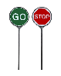
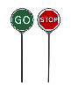
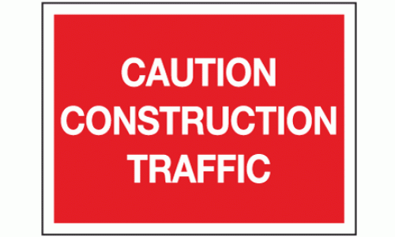
BANKSMAN EITHER SIDE OF GATES WITH STOP/GO SIGNS TO MANAGE TRAFFIC WHILST LORRIES ARE ENTERING/LEAVING SITE
CAUTION CONSTRUCTION TRAFFIC SIGNS

