Historic Google Imagery of 110 Hartland Drive
2018 – No outbuilding present
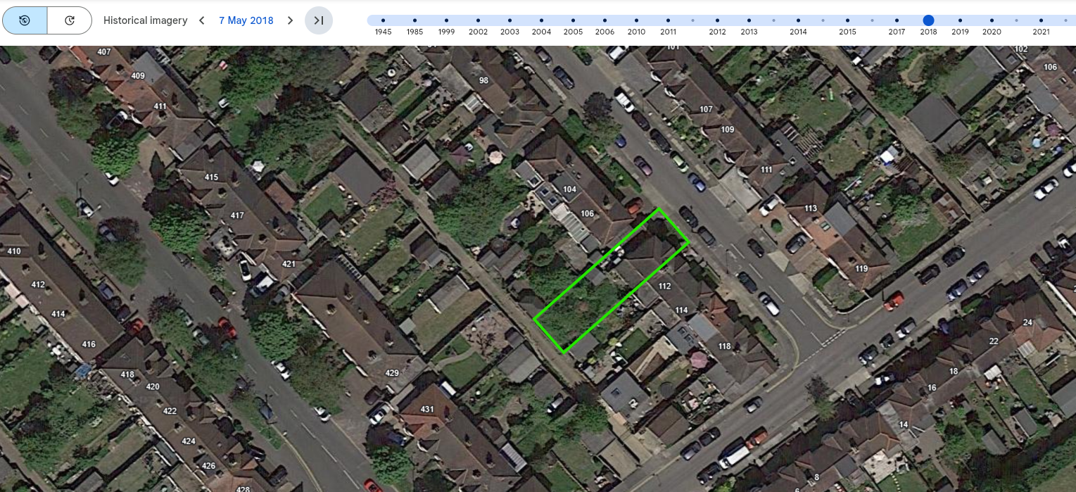
2019 – Outbuilding present (appears to be construction in progress)
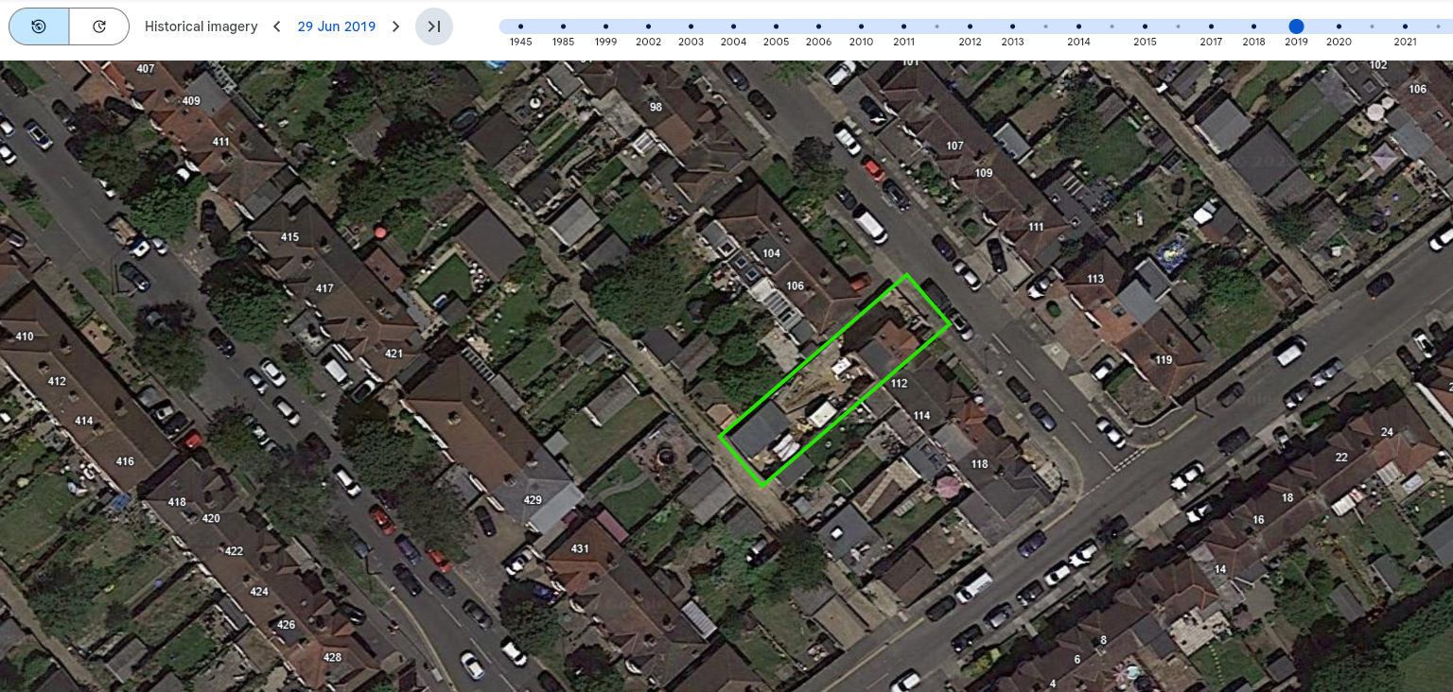

2020 – Outbuilding present
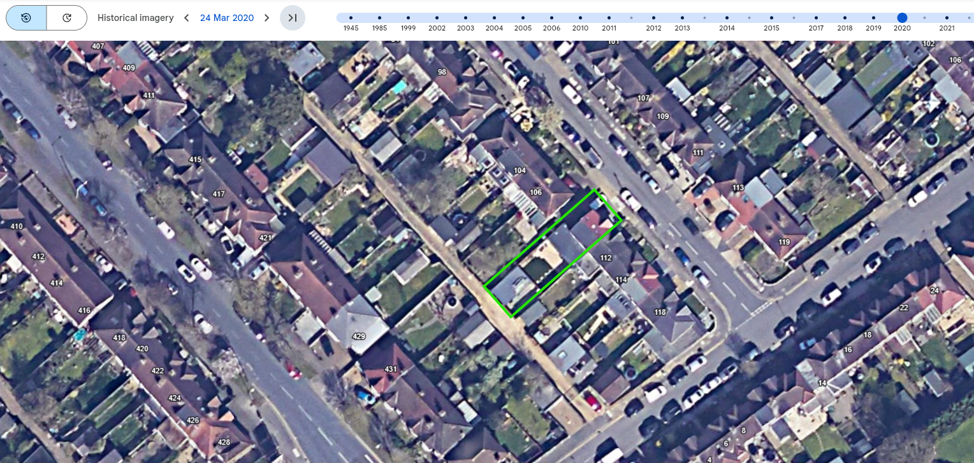
2021 – Outbuilding present
