6 Rogers Ruff, Northwood HA6 2FD

Submission of details pursuant to planning conditions

Application for two storey, 6-bed detached dwelling with habitable roof space
and annex, involving demolition of existing dwelling

Application Ref: 26104/APP/2018/2847

1. On 5 April 2019 planning permission was granted for the above development subject to a number of conditions. Conditions 3, 4, 5, 10 and 11 require details to be submitted to the Local Planning Authority for approval.

2. We now submit to the LPA the relevant details in respect of these planning conditions, as follows:

Condition 4 - External Materials

3. Condition 4 requires details and/or samples of external materials to be submitted to and approved by the LPA.

4. The proposed external materials are as follows:-

Roof - Marley Acme Double Camber plain clay roof tiles in 'Burnt Flame' colour
Walls - Freshfields Lane FLB First Quality multistock bricks
Stone Dressings - Light cream coloured reconstituted stone
Front Drive - Either dark coloured impressed concrete as existing or light buff resin bound gravel
Rear Patio - Meduim brown timber effect external quality ceramic tiles

5. A brick sample panel has been built on site and the LPA may visit site to inspect the panel if they wish.

Condition 5 - Landscaping Scheme

6. Condition 5 requires details of hard and soft landscaping to be submitted to and approved by the LPA.

7. The proposal is simply for a replacement dwelling and the applicant intends to retain the existing planting and landscaping which currently exists in his garden. The existing garden currently provides a significant amount of planting and landscaping, far more than would usually be provided for dwelling on a new building plot. Details of the landscaping are shown on the marked up copy of the following drawing. The three new trees are already approved (Drawing No. D0316 002 B) and the only new planting will be some herbaceous borders.

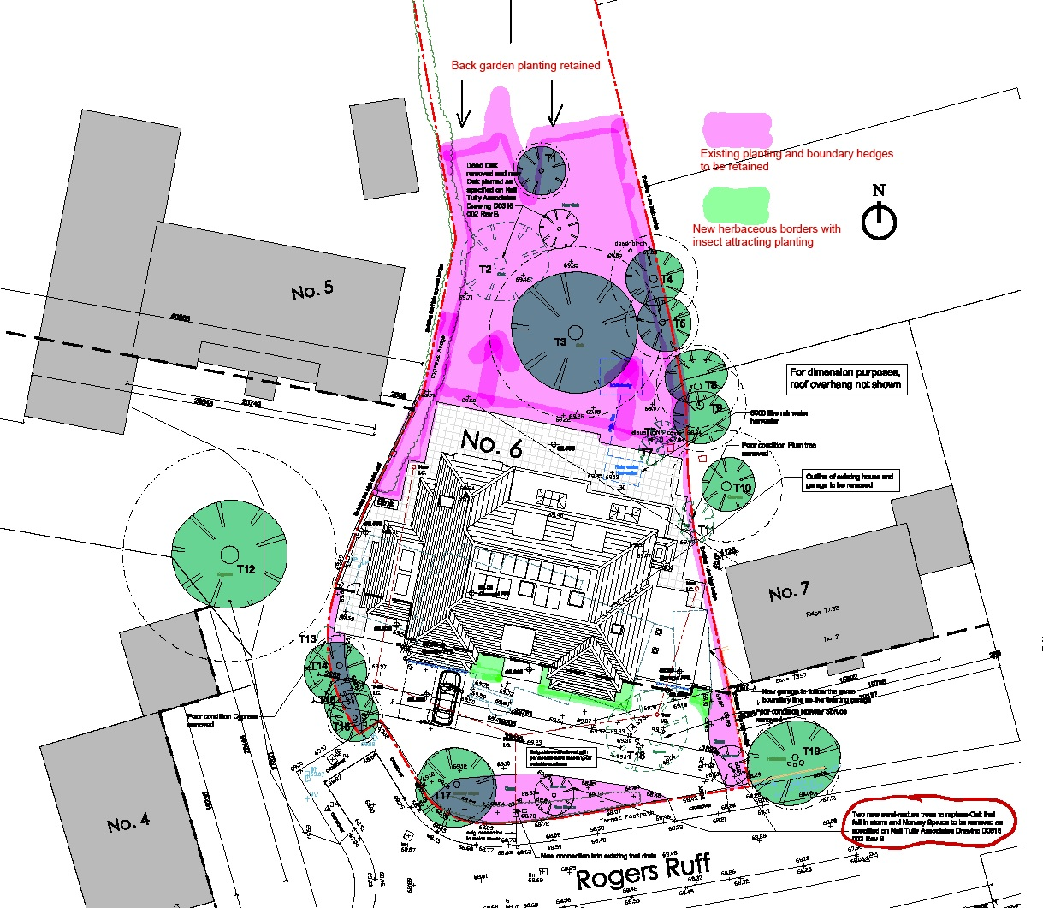

Existing Planting and Landscaping (shown in pink) will be retained and new herbaceous borders (shown in light green) will be provided, as well as three new trees already approved on drawing D0316 002 B.

Condition 10 - Surface Water

8. Condition 10 requires details of a scheme for the provision of sustainable water management to be submitted and approved. The reason for the condition is to ensure the development does not increase the risk of flooding.

9. The applicants structural engineer, HLS, has discussed the issue with Thames Water, who confirm that they have no requirements for SUDs or surface water runoff attenuation for a domestic residence that already has a surface water drainage connection. HLS have therefore provided a surface water drainage scheme that simply reuses the existing connection with the addition of a rainwater harvester.

10. We enclose a surface water drainage layout (copy also provided below) showing reconnection into the existing sewer. It should be noted that drain runs avoid Root Protection Areas. We also enclose an e-mail response from Thames Water indicating that they require no attenuation in this situation.

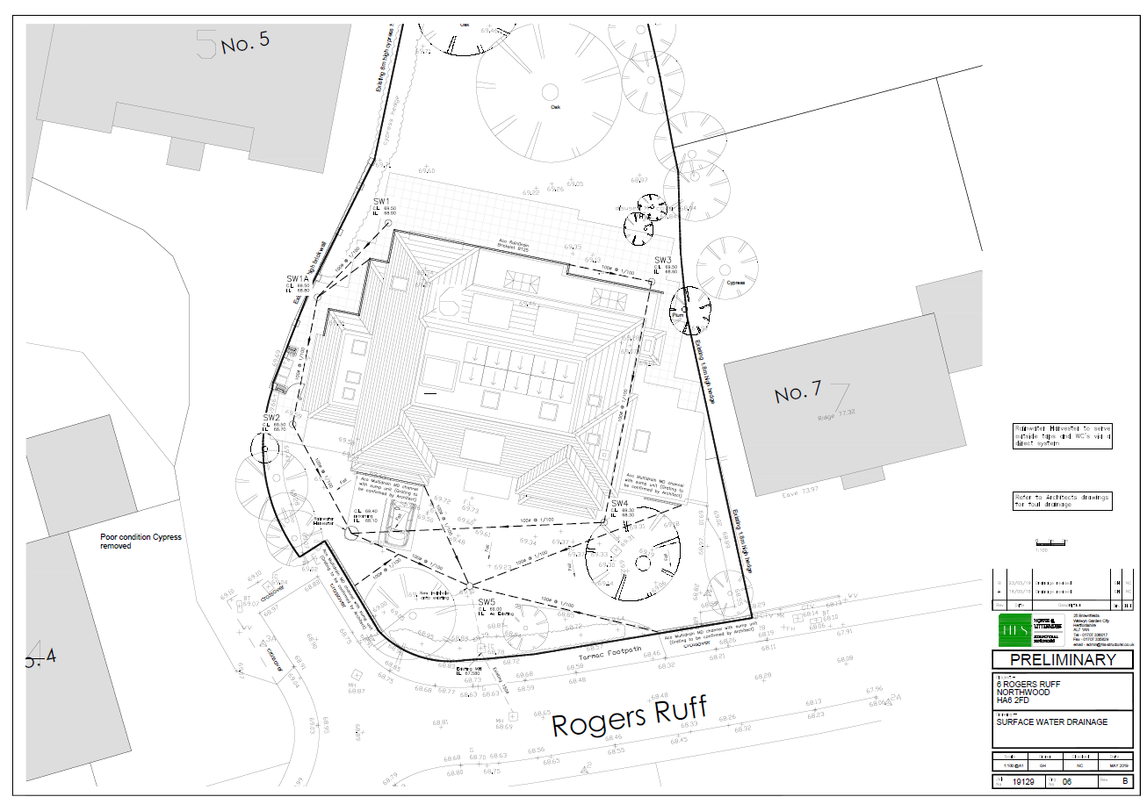
Plan of surface water drainage layout confirming reconnection into the existing sewer

Condition 11 - Ecology

11. Condition 11 states that Tree T2 shall not be removed unless re-entry bat surveys are submitted and any necessary mitigation is provided. It also states that demolition of the existing structures shall be carried out under the supervision of a licenced bat worker, unless a survey establishes that there is no potential for bat habitat within the building.

12. The enclosed Preliminary Roost Assessment Survey confirms that there are no viable bat roosts on site, either in the existing building or in the trees. It should be noted that although there was a potential bat roost feature in the southern side of tree T2, a pair of nesting blue tits was observed using this hole precluding the possibility of use by bats. This tree will not be felled until the blue tits have vacated the hole.

13. The submitted report demonstrates that the existing building can now be demolished.

