Design and Access Statement
for

Consent to ground floor rear extension for the patisserie and cake shop .

7 High Street , Harefield , Uxbridge , UB9 6BX

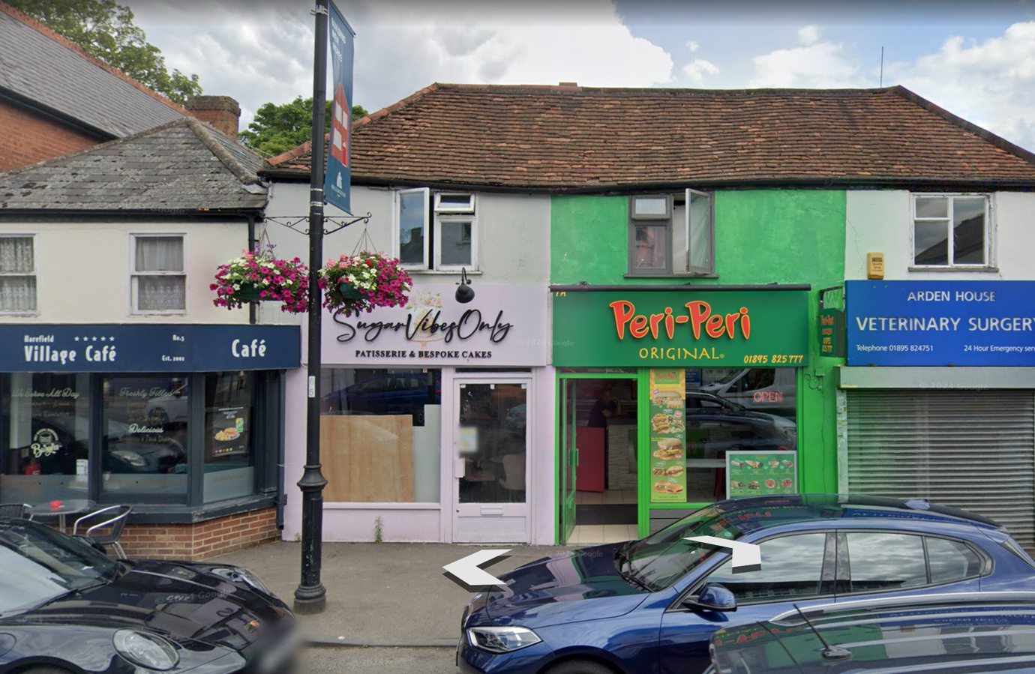

- Introduction

  - This Design and Access Statement is prepared by Saadet Eriten on behalf of the client Ayse Mazi

It seeks consent for a rear Kitchen extension.

The applicant is a tenant and wishes to run as Patisserie and Cake shop and it is SugarVibesOnly

2.00 The Site

2.01 The application site is located at 7 High Street , Harefield , Uxbridge , UB9 6BX

3.00 Use

3.01 The site in application last use was a office.

3.02 The SugarVibesOnly will provide the best quality patisserie and service to neighbourhood with respect to the town history and architecture .

We aim to bring vibe , more business and colour to the street and with high respect to the neighbourhood and also protected them privacy ,security and comfort .

Because of that reason the business owner would like to do the best for her guests and share her unique products to the neighbourhood.

However the previous shop kitchen size of the shop were extremely small and never had any change to do proper baking.

Because of that reason they have to do rear extension for the kitchen.

There is street parking on the high street .There isn’t any lift in the building . The shop is situated on the ground floor .

4.00 Proposal

4.01 This application seeks consent to following:

Consent to full planning application approved for the ground floor rear extension .

5.00 Appearance

5.01 The proposed kitchen situated on the back side of the premises and not visible from the high street and sidewalk

The materials and details used on external wall will not conceal of the building and architecture or any features about the building.

6.00 Access

6.01 There is street parking on the site .

There isn’t any lift in the building and shop is situated on the ground floor.

The shop is accessible for wheelchairs .

