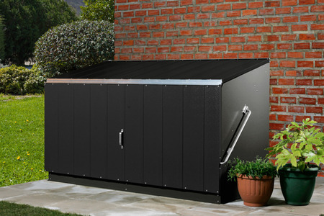

Features
- Unique and Patented Design
- Spring-Assisted Opening Action
- Maintenance-Free
- 25 Year Panel Guarantee
- PVC-Coated Galvanised Steel Construction
- Fire-Resistant
- Simple, Rapid Construction
- Clear Step by Step Instructions
- Range of Accessories
- Complete "WALK IN" Access
- Two Padlock Points as Standard (4 MAX)
- A new version is available with wood-effect finish

Description
The Storeguard is the largest of the dedicated garden storage units (although the Bicycle Store is larger) and is ideal for storing a large quantity of garden equipment.
Can be supplied in a choice of two tone green, cream, anthracite or wood effect.
Due to its size this is the most popular unit in the range and it is available with a range of accessories including exterior grade wooden floor, shelving, padlocks and hasp and padlock sets.
The Storeguard is supplied in a convenient flat pack and is extremely simple to construct as all major components are factory assembled for you, they come complete with all necessary fixings and easy to follow illustrated assembly instructions.
The Storeguard storage box is perfect for siting on both garden lawns and patios.

Dimensions
Internal Dimensions in Metric (Metres)
Height (front) | 0.89
Height (back) | 1.09
Width | 1.80
Depth | 0.84
External Dimensions in Metric (Metres)
Height | 1.13
Width | 1.96
Depth | 0.89
Weight | 52kg

