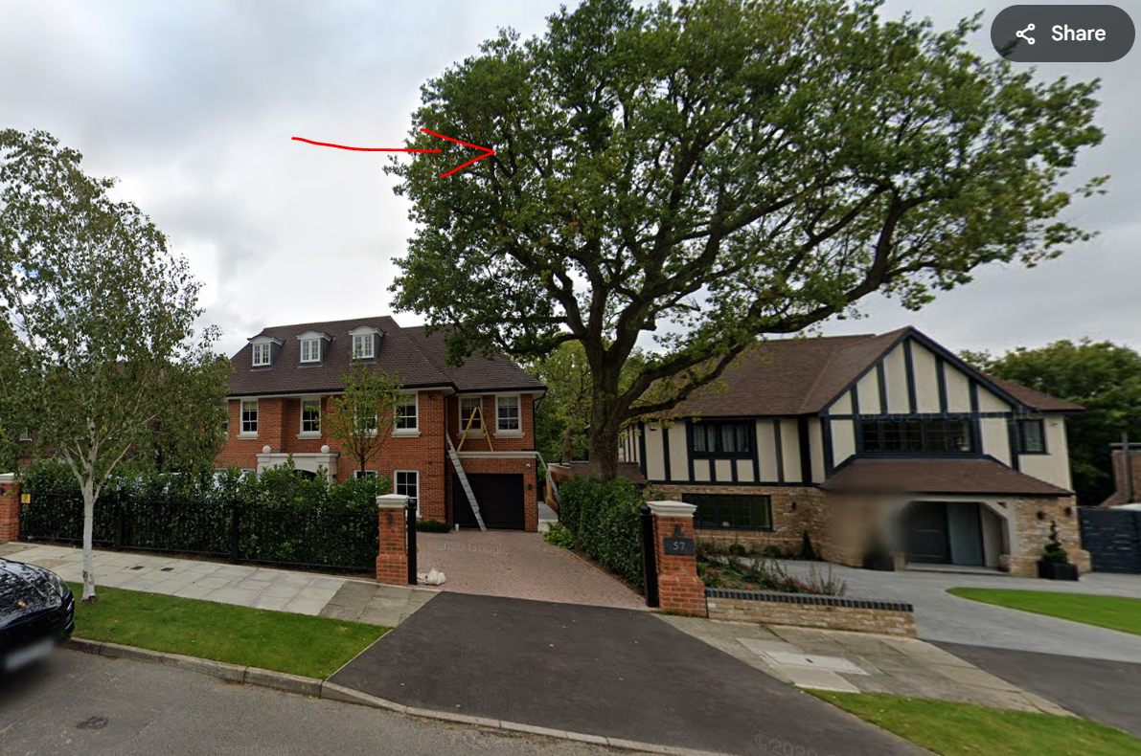
Carry out overall Crown reduction around 8meters in heigh.

