English Oak TPO 698 visual climbing inspection
Site address: 25 Grosvenor Crescent, Uxbridge, UB10 9ER.
Tree location: Service alley rear of 25 Grosvenor Crescent, Uxbridge, UB10 9ER.
Current estimated height and spread: Height approximately 20 metres from ground level – width from North to South approximately 10 metres – width from West to East approximately 20 metres.
New proposed Height and spread: Height approximately 18 metres from ground level – width from North to South approximately 9 metres – width from West to East approximately 17 metres. All new height and spread are to growth points and approximate maximum diameter of pruning wounds to be 50mm within BS:3998-2010 guidance
Work advised: English Oak - Crown reduction of up to 2 metres in height and spread, remove deadwood 25mm>
Reasons for work advised: Upon completing an onsite visit from the rear of 25 Grosvenor Crescent there are very visible cavities in the main stems approximately 12-13 metres from ground level on the south side of the tree. The tree has had heavy pollarding on the lateral limbs on the North and South side in the past, leaving the upper crown exposed to potential wind throw and risk to property and persons in gardens (reports of smaller limb failures in past from all surrounding residents we spoke with). We suggested a 2-metre crown reduction in height to relive weight and wind sail with lighter pruning on lateral limbs to bring tree into proportion with a natural flowing crown.
Climbing inspection carried out: We undertook a climbing inspection of the cavities we could see from the ground on the south side of the tree. We used a 19.6-inch screwdriver with zero resistance to measure each of the larger cavities (photos below)
Photo 1: Cavity A approximately 12 metres from ground level with stem leaning west - stem diameter of 20 inch – screwdriver at zero resistance reached a depth of 9 inches.
Photo 2/3: Cavity B approximately 10 metres from ground level with stem leaning South old storm damage - stem diameter of 18 inch – screwdriver at zero resistance ran out of length down stem.
Photo 4/5: Cavity C approximately 12 metres from ground level with stem leaning South - stem diameter of 17 inch – screwdriver at zero resistance reach a depth of 15 inches upwards and ran out of length down stem believed to meet decay from cavity B at union.
Photo 6: Tree from rear garden of 25 Grosvenor Crescent (south side of tree)
Photo 7: Shows tree from service alley where previous poor pruning on lateral limbs has misshapen trees natural form.
Photo 8: Photo showing length of screwdriver used for zero resistance test of cavities.
Impact on tree/amenity value: Undertaking the proposed work would limit the risk of limb failure and shaping the tree into a more natural shape which currently it is not, giving the tree more amenity value and contributing to the local environment more than its current shape from poor pruning in the tree’s earlier life. (See photo 7 from service alley showing the trees current shape)

Photo 1 Photo 2
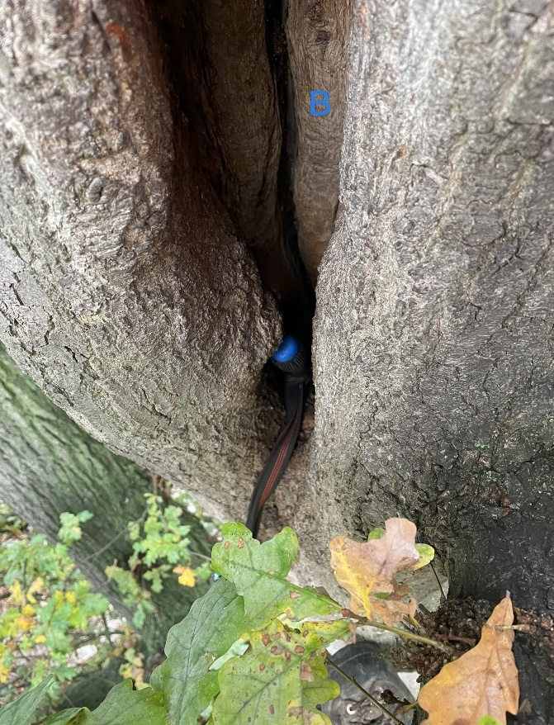
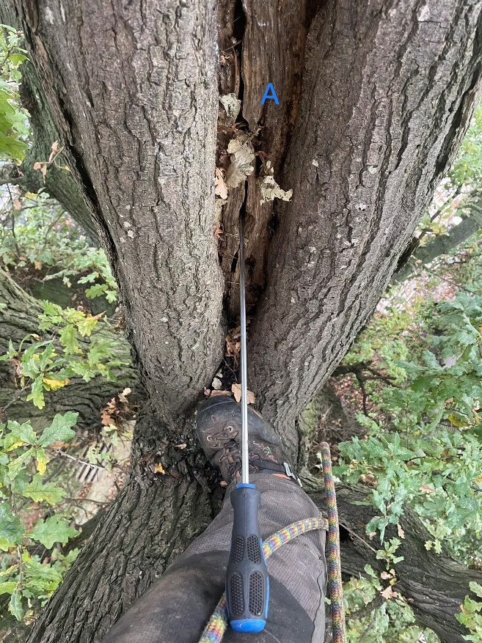

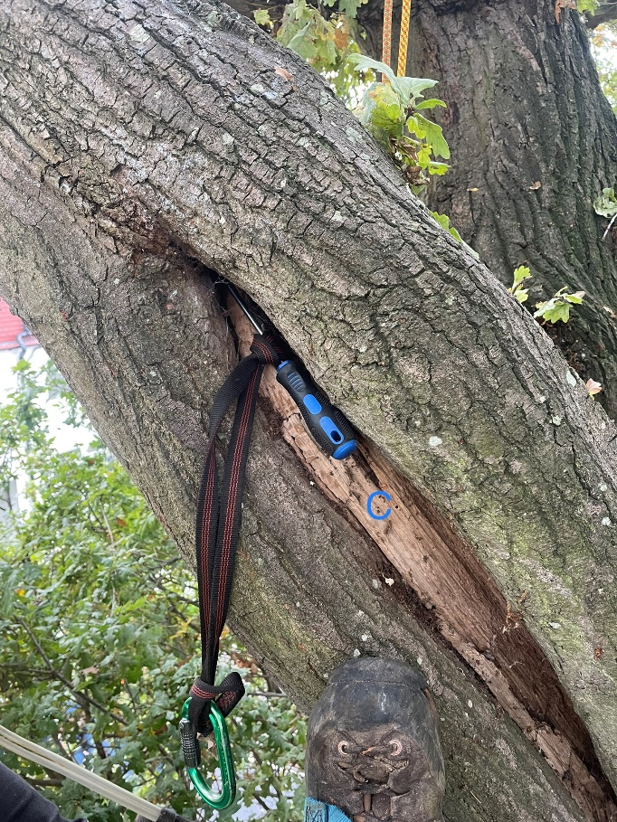
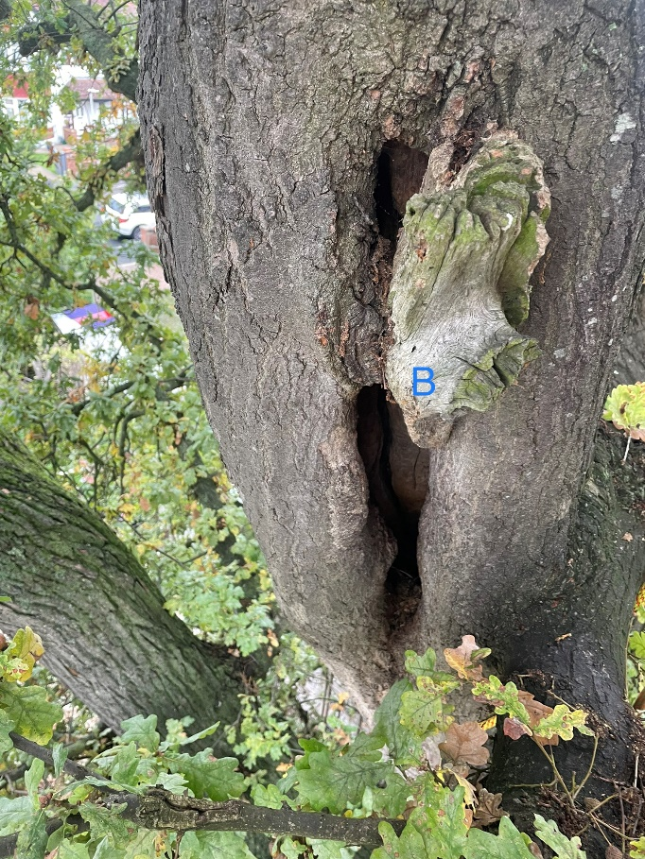
Photo 3 Photo 4

Photo 5 Photo 6
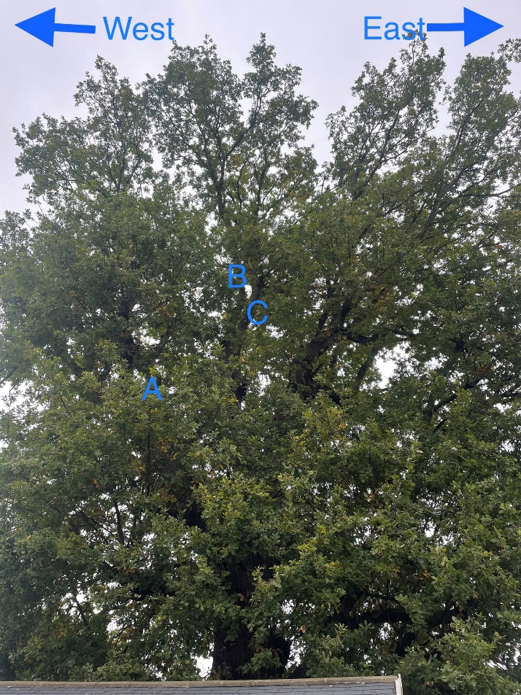
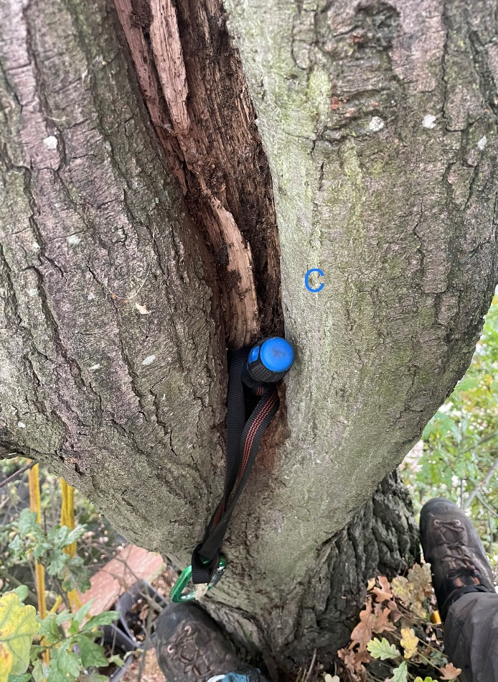

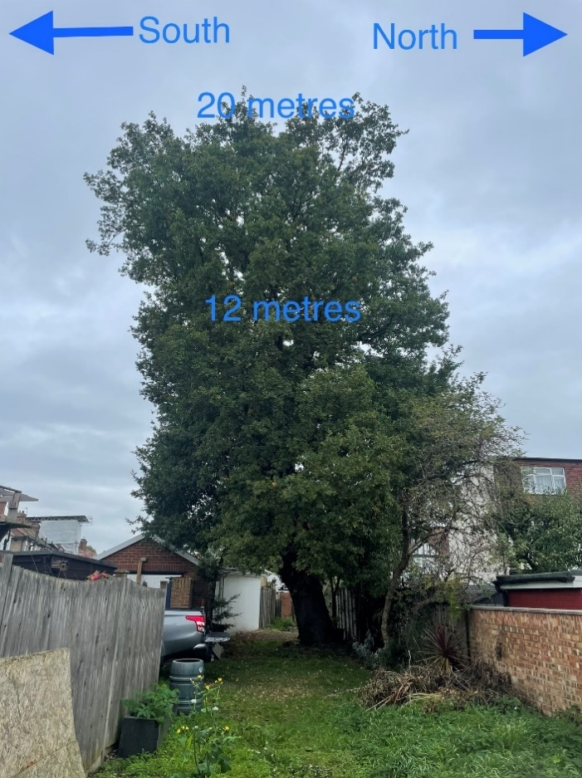
Photo 7 Photo 8
