151 Queens Walk
Requested photos for rear extension

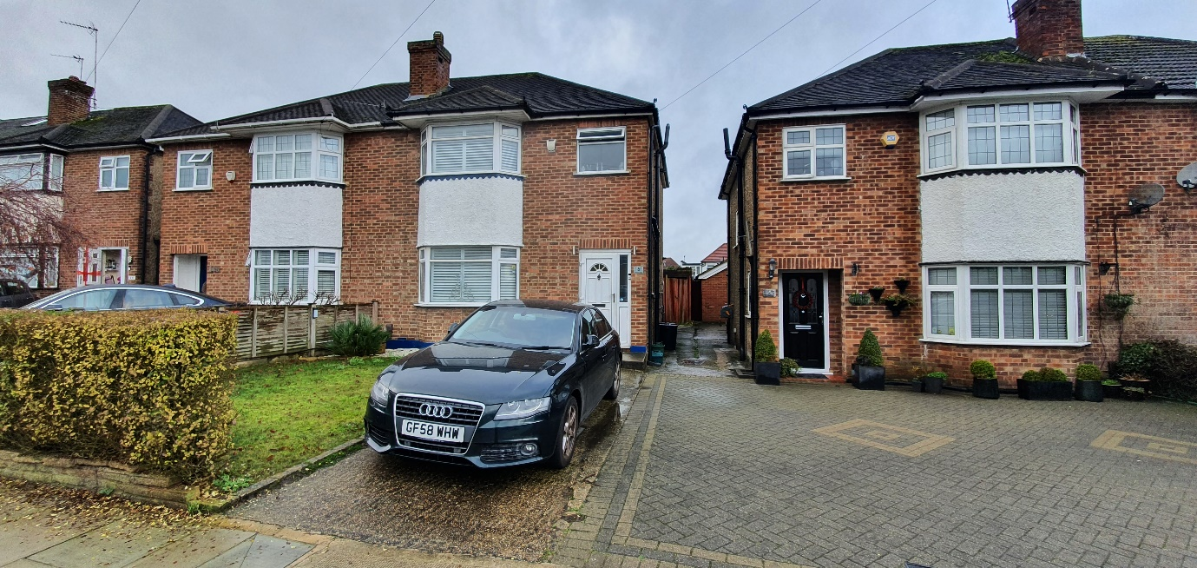
Front elevation of 151 Queens Walk (car on drive)

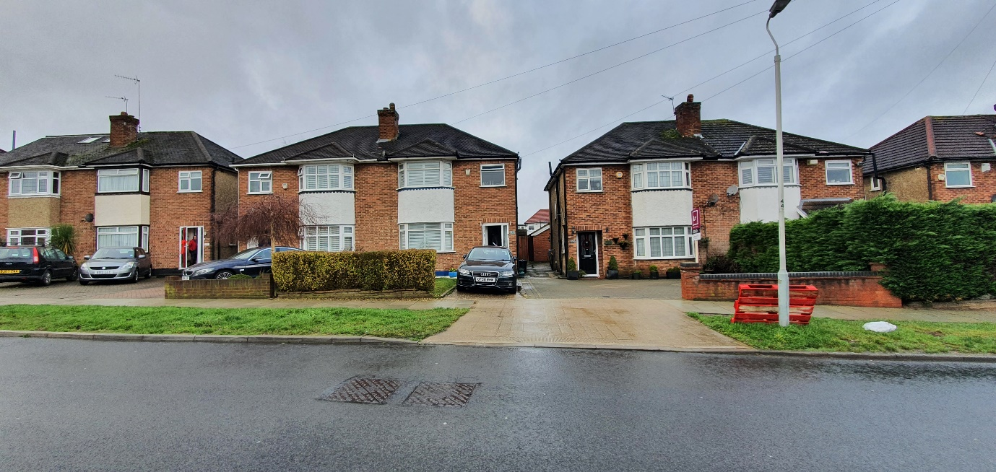
Street scene around 151 Queens Walk

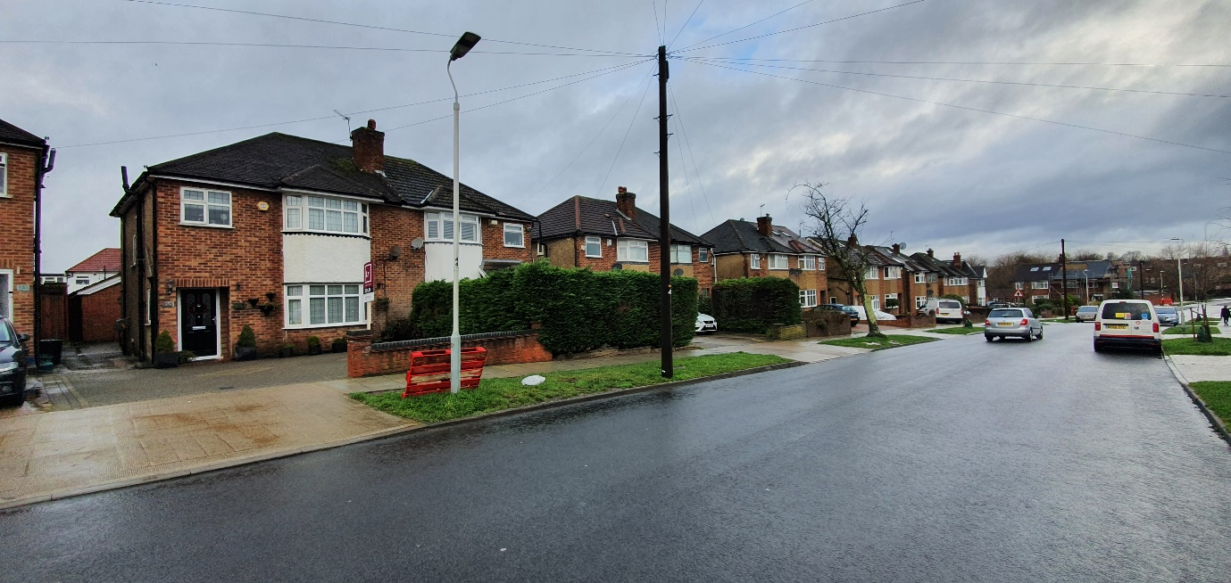
153 Queens Walk and Street scene

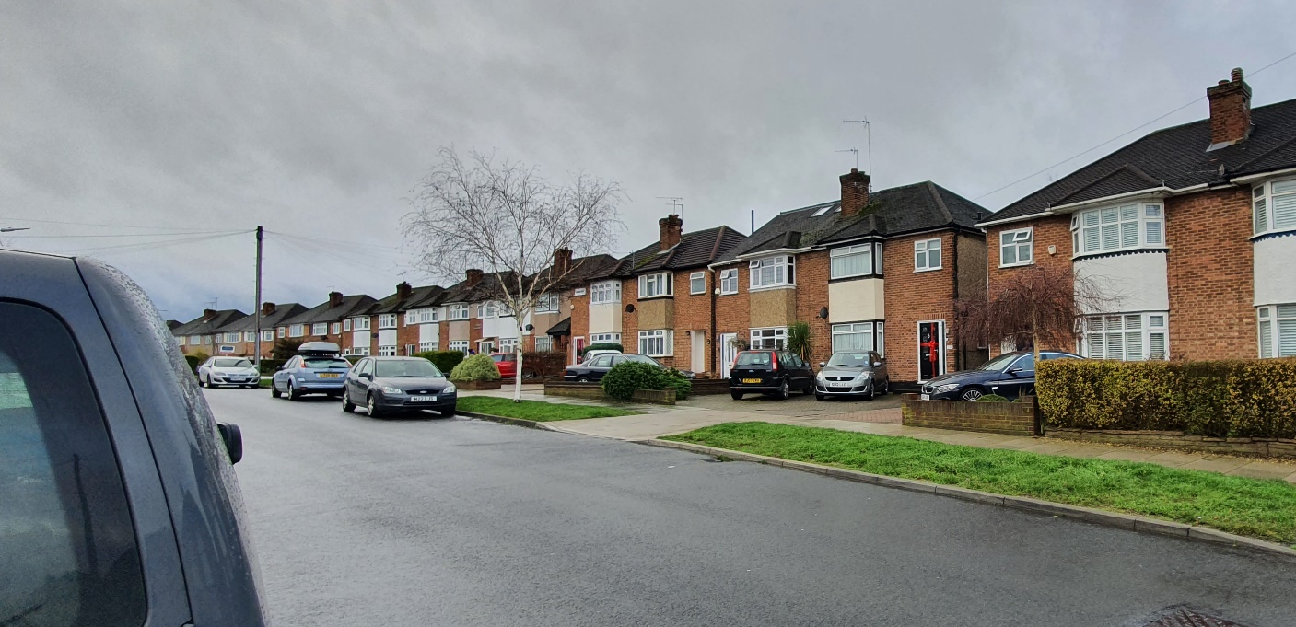
149 Queens Walk and Street scene

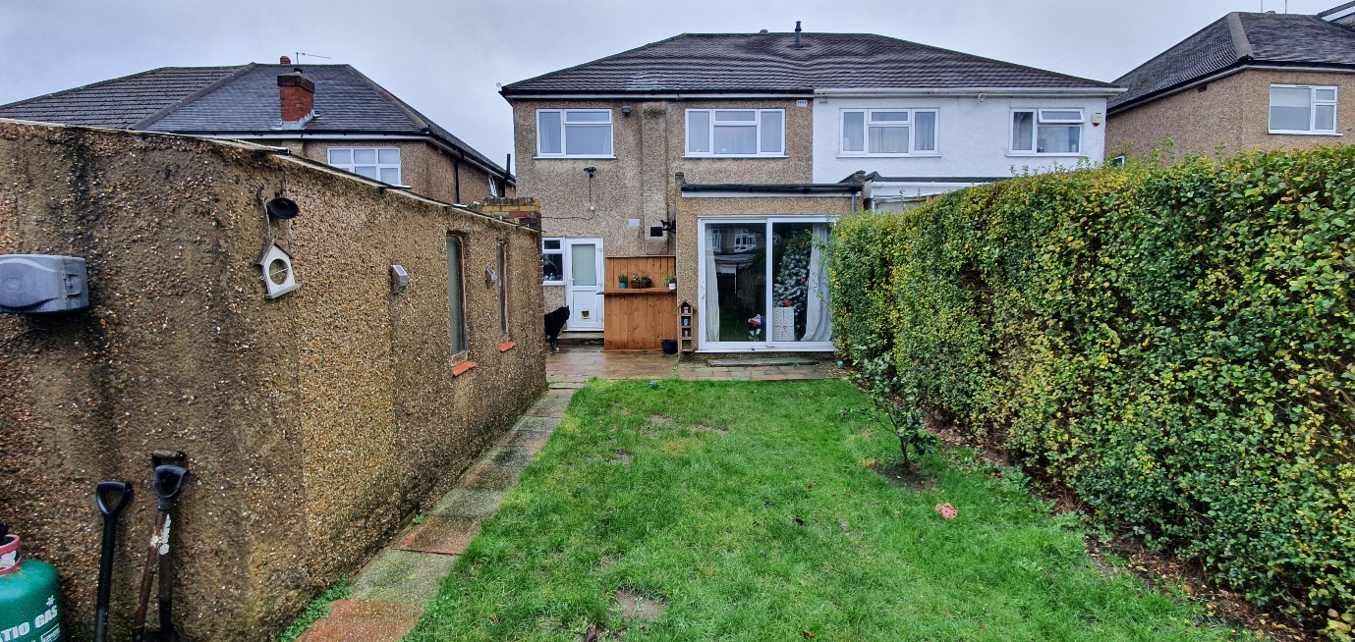
Rear elevation Including garage showing current single storey extension

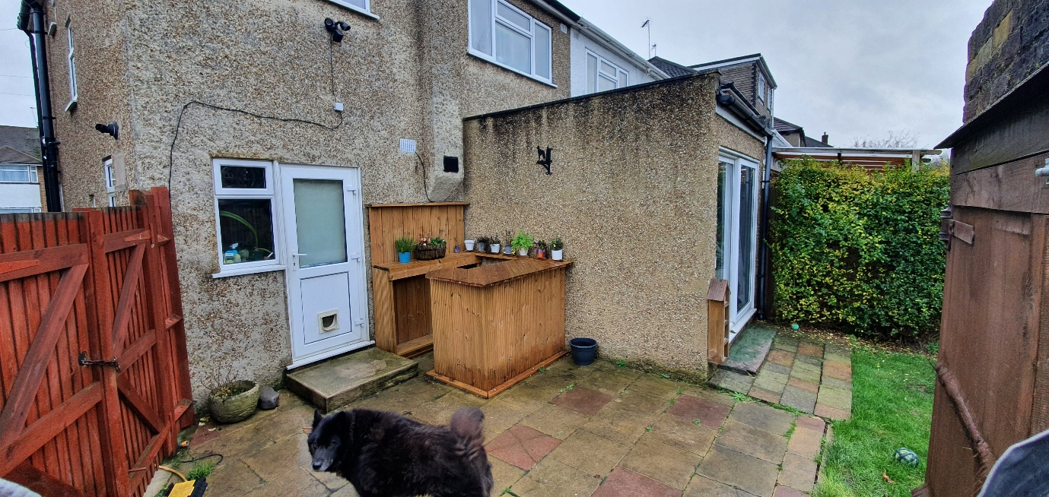Site of proposed rear extension

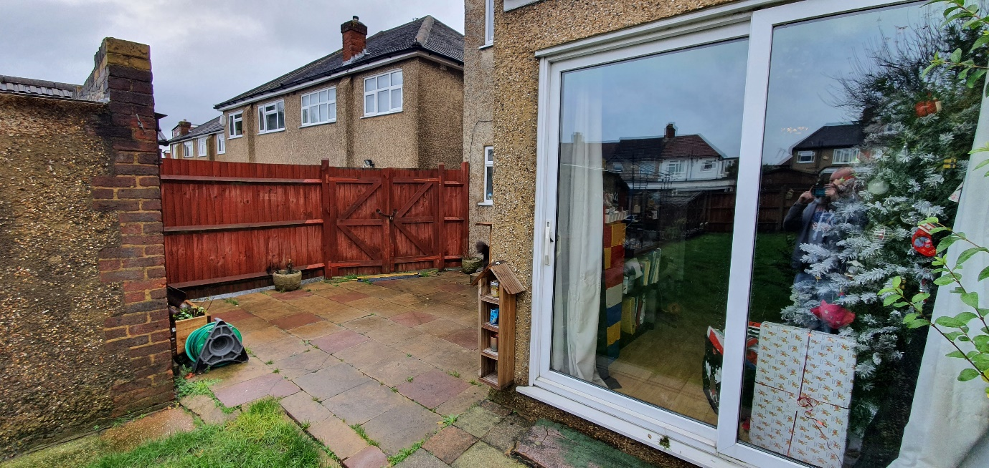
Site of proposed rear extension

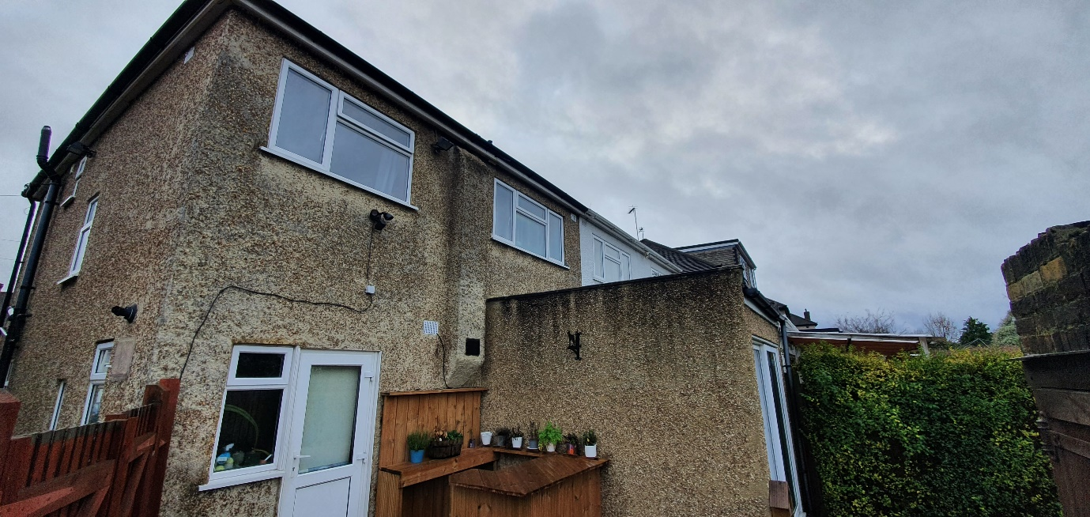
Rear elevation

