No. 20 Church Avenue, Ruislip, Middlesex.

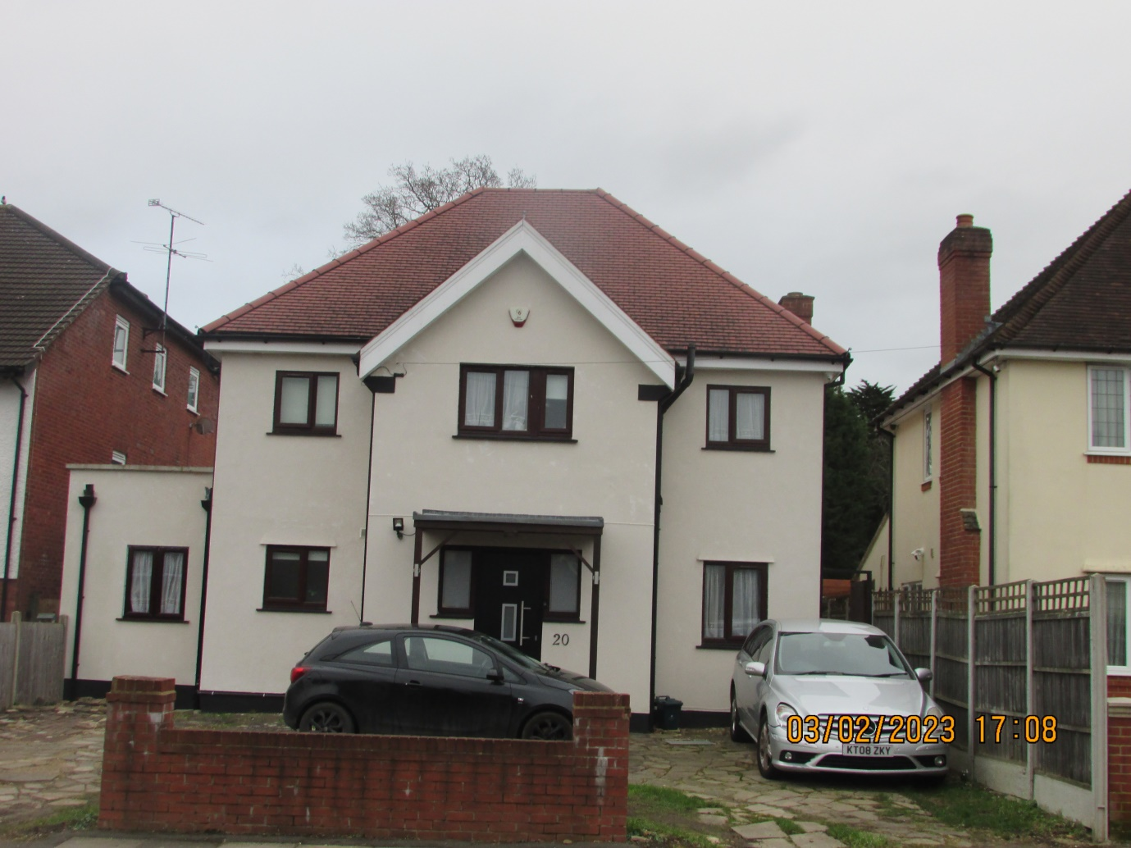
Street Elevation of Property
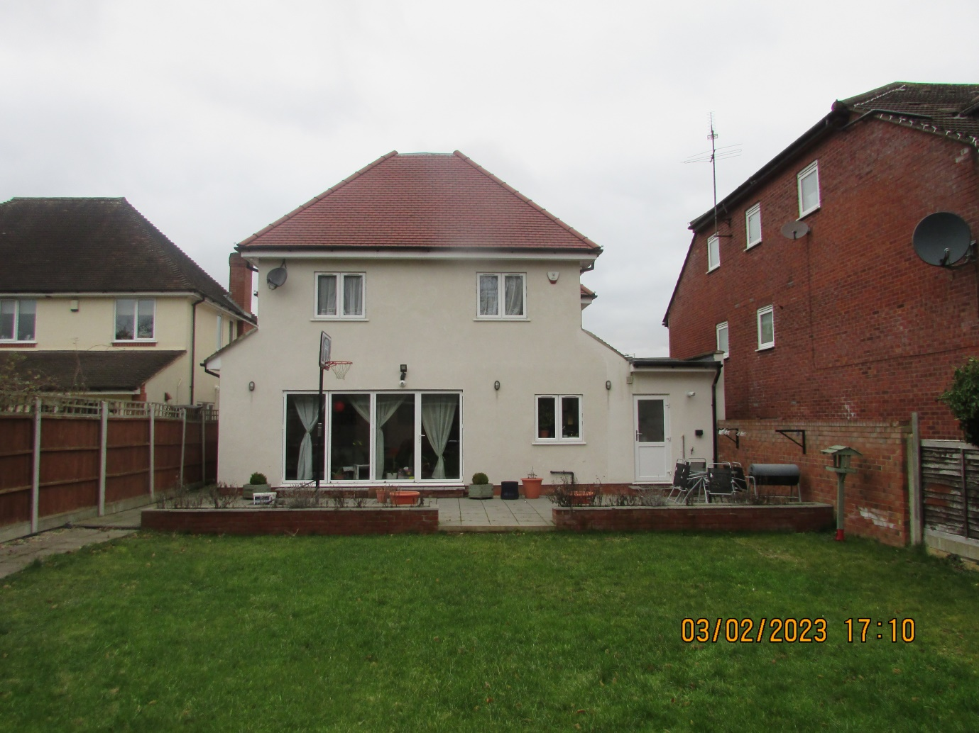
Rear Elevation of Property

