Design & Access Statement

LOCATION:
20
Church Avenue,
Ruislip, HA4 7HT.

APPLICANT:
Mr/Mrs. Magon
20
Church Avenue
Ruislip, HA4 7HT

LPA:
London borough of Hillingdon
3N/04
Civic Centre
High Street, UXBRIDGE
Middlesex, UB8 1UW

AGENT:
Bowmann Associates Limited
15 Allhallows Road
London, E6 5SZ

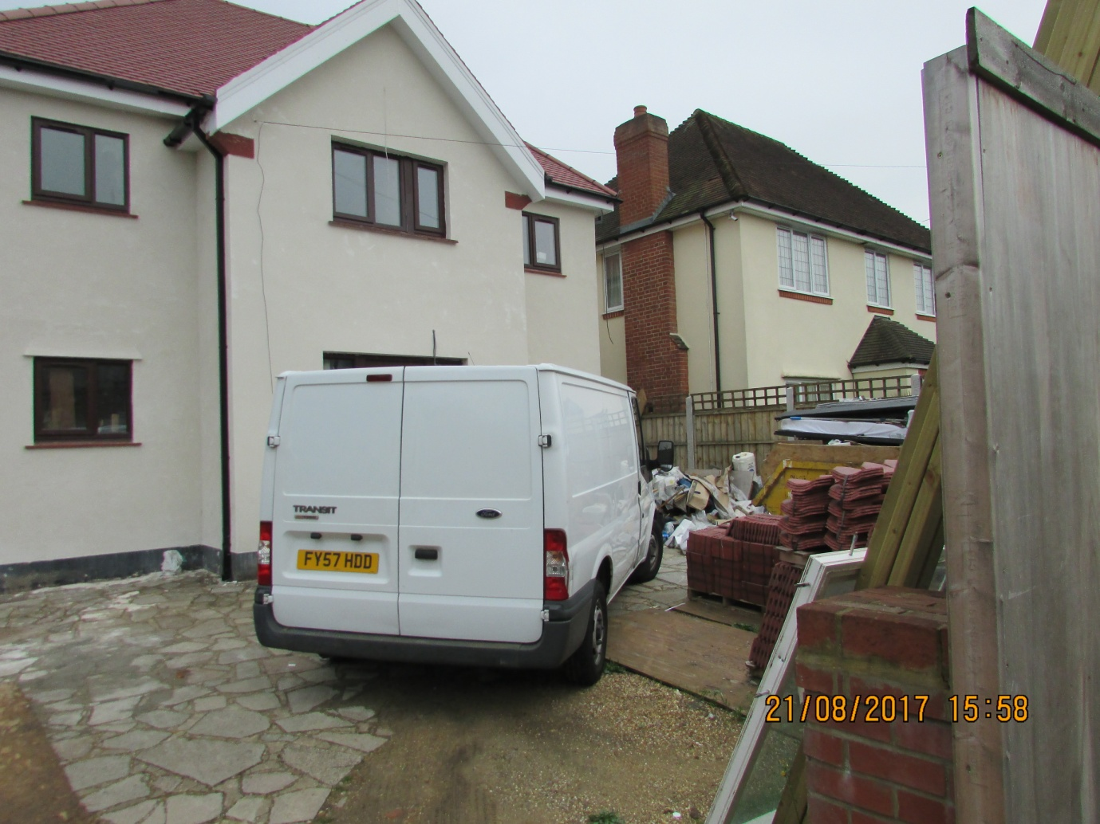
Front of Application Building

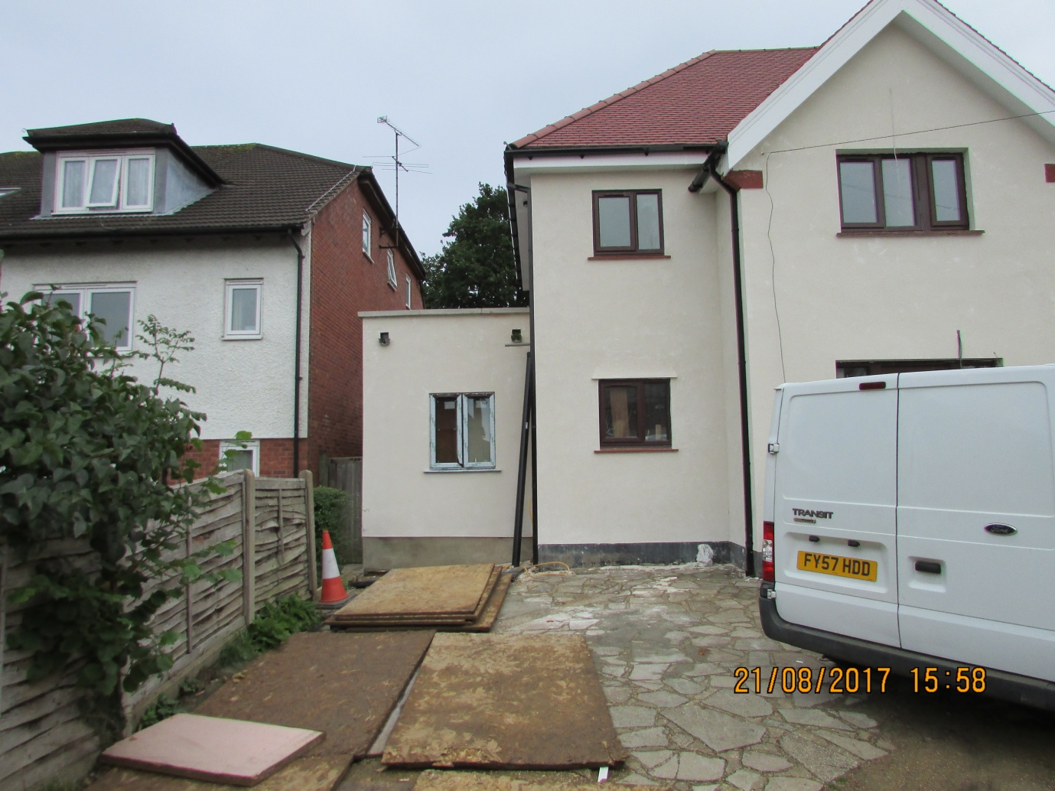
Front of Application Building (Parts)

PROPOSAL:
The proposal seeks to amalgamate two previous applications for planning permission with respect to the above site. Both applications we granted consent by the council. To further clarify the proposal we have enclosed layout plans of the approved applications as well as the current application.
Retention of rear extension on the ground, as well as on the first floor.
Reduction and reconfiguration of the roof, to become similar in proportion as all the neighbouring properties.

USE:
Residential. Single family, two storey, detached house.

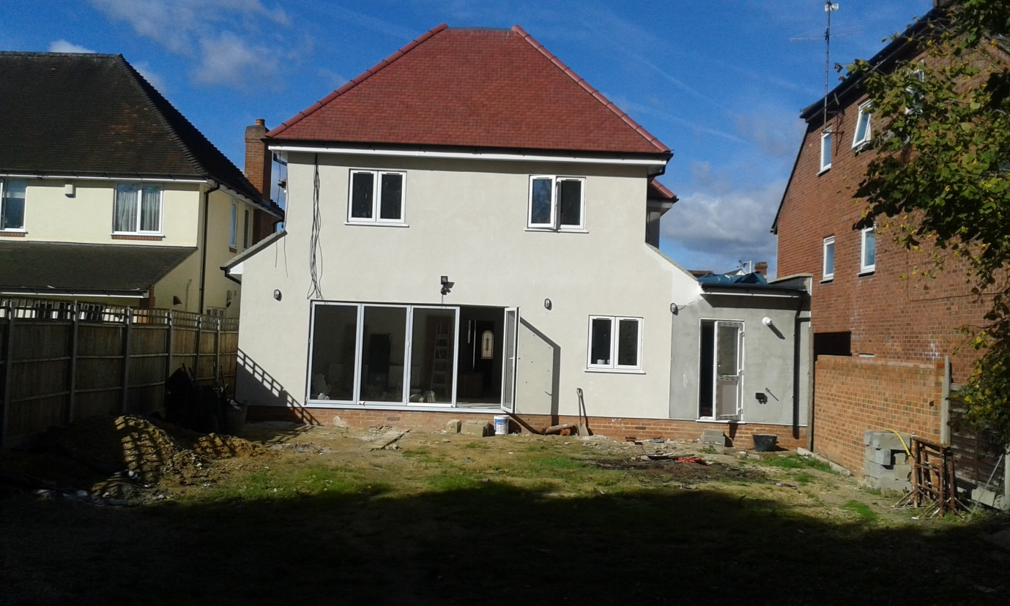
Rear of Application Building as Built

AMOUNT:
Site Area – 2 HA
Building Footprint – 110 sq. m.

ACCESS:
As existing.

APPEARANCE:
Reduction, and reconfiguration of the roof structure, will bring about a building with similar proportions as the neighbouring properties, when calculated as the relationship of the wall surface and the roof height.

ACCESS:
Remains as existing.

LANDSCAPING:
Front of building – Hard Landscaping.
Rear of Building – Soft Landscaping.

