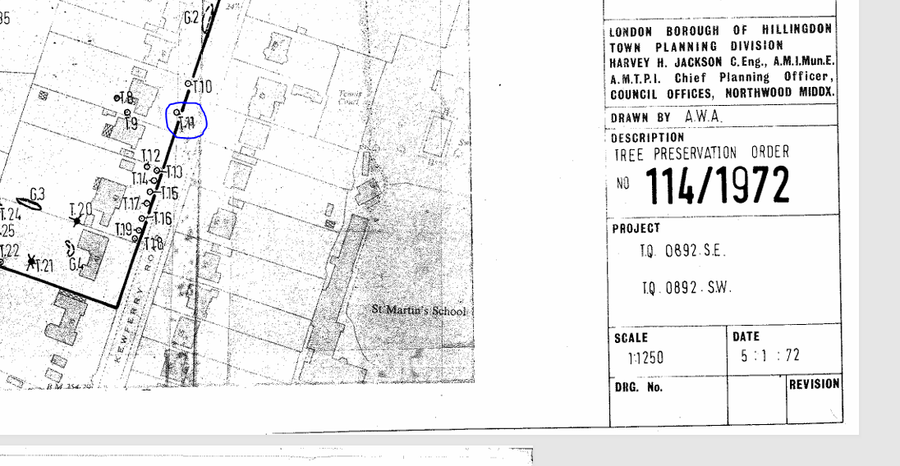
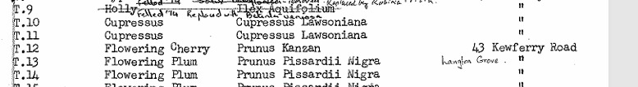
Tree is entering onto a Mortality Spiral of Decline: see 3x photos below

T11 photo taken from the north (in front garden)
Note sparse dead foliage in mid & upper crown
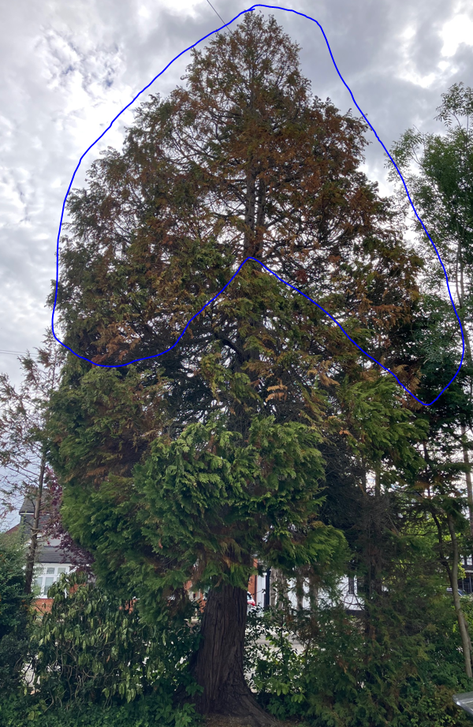
T11 photo taken from the south (in road)
Note sparse dead foliage in mid & upper crown
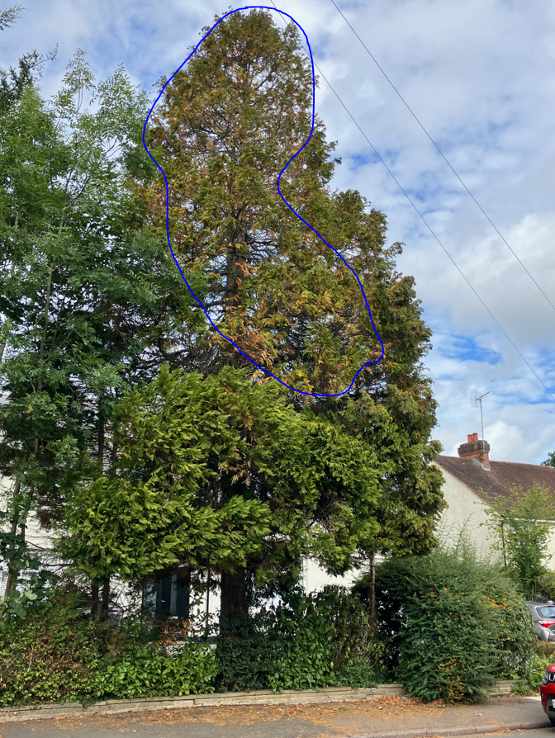

T11 photo taken from the east
Note sparse dead foliage in mid & upper crown

