Bldg 27 Maps
Hybrid satellite picture / map showing location of building.
Pictures taken from the Hillingdon Council Website. The recent work to the camp means that some of the surrounding buildings are no longer as shown. I trust that this will have no impact on our request to have the windows put back to their original configuration from the installed 1990’s UPVC.
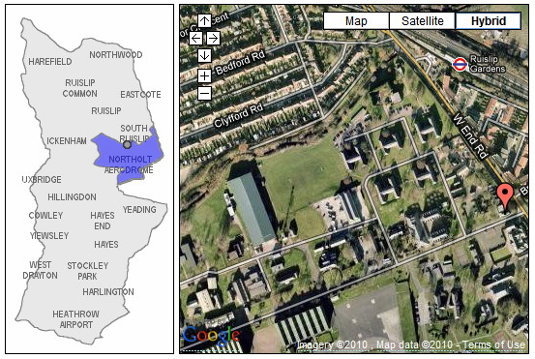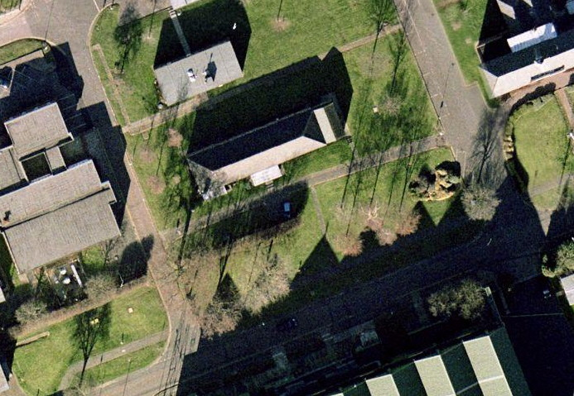
N
500’
100m
1:500 at A4

