

DESIGN AND ACCESS STATEMENT
2 ST MARTINS APPROACH, RUISLIP, HA4 7QD.

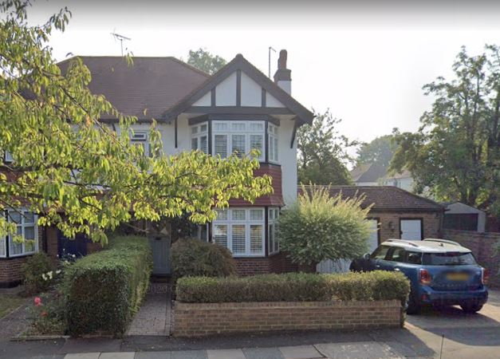

- EXISTING PROPERTY.
The property is a semi-detached single family dwelling house. The property lies within the Moat Drive Area of Special Local Character.

- PROPOSED SCHEME.
This Lawful Development application is to convert to loft with a hip-to-gable build up and a rear dormer, plus to convert the existing garage into a habitable room.

- DRAWINGS.
The drawings included with application are:

1747 / 01 AS EXISTING floor plans
1747 / 02 AS EXISTING elevations and section
1747 / 03 LOCATION PLAN
1747 / 04a AS PROPOSED floor plans
1747 / 05a AS PROPOSED elevations and section

- PRE-APPLICATION ADVICE.
Pre-application advice was sought from Hillingdon planners to check whether the property had full permitted development rights. On 12th and 13th October 2021 Richard Buxton advised as follows:

LOFT CONVERSION
“Just the right side of the road for a permitted development hip to gable end with rear dormer as the ASLC zoning has no bearing on permitted development, unlike the Conservation Area designation opposite. We would always recommend a Lawful Development Certificate prior to starting work on such a structure.”

GARAGE CONVERSION
“I am pleased to confirm that the side garage was built under a Building Regs approval so there are no restrictive planning conditions controlling its use so no planning permission will be required for its conversion-just Building Regs.”

- DISABLED ACCESS.
The proposed works will have no effect on the disabled access to the property.

