TOWERS ASSOCIATES LTD
towers
Harefield Oil Terminal
Harvil Road,
UB9 6JL
01895 812822

REF:3353-01
DATE 17th Aug 2024

Design and Access Statement
20 Chichester Avenue

Introduction :
This statement has been prepared by Towers Associates Ltd, to be submitted alongside a householder planning application to Hillingdon Council for permission for the construction of a two storey side extension, single storey front extension and rebuild of garage with internal and external alterations.
This application has been prepared to comply with policies set out in the Local Plan and those set out in National Planning Policy.
This planning statement is to be read alongside the planning application which consists of the following documents: Planning Statement 3353-01 3353-SK1, , 3353-02, CIL additional information form,the ecology and trees checklist and BS5837:Tree Survey Arboricultural Report and Plan.

Site and Surroundings:
The site is located on the north side of Chichester Avenue at its junction with Whitstable Close and comprises a two storey detached house with a front gable, front and side canopies, ground floor side covered walkway with an attached double garage to the west side, part single storey rear and part two storey rear extensions with flat roofs. To the east of the application property and sited on a lower ground level is 18 Chichester Avenue. To the west of the application site and on the opposite side of Whitstable Close is 22 Chichester Avenue, located on higher ground level .
The application site lies within the 'developed area' as identified in the adopted Hillingdon Unitary Development Plan The application site is covered by TPO23 .
A complete tree survey and arboricultural impact assessment was commissioned for the site which advised the removal of one Category 'U' tree and pruning of a Category 'C' tree affecting the house on the property site. Advice regarding tree protection measures is also given for the retained trees as well as future maintenance of the trees according to arboricultural advice at the time. Following this advice the principal arboricultural features within the site can be retained and adequately protected during development activities. No significant or important trees will be lost to facilitate the proposed scheme. Subject to precautionary measures as detailed in the report, the proposal will not be injurious to trees to be retained and will be maintained according to aboricultural advice.

Proposal:
This proposal requests the grant of planning permission for a two-storey side extension, single storey front extension and rebuild of garage.
The Hillingdon Local Plan: Part One Strategic Policy BE1 seeks a quality of design in all new development that enhances and contributes to the area in terms of form, scale and materials; is appropriate to the identity and context of the townscape; and would improve the quality of the public realm and respect local character. Policy DMHB 11 of the Hillingdon Local Plan: Part Two - Development Management Policies (2020) advises that all development will be required to be designed to the highest standards and incorporate principles of good design. It should take into account aspects including the scale of the development considering the height, mass and bulk of adjacent structures; building plot sizes and established street patterns; building lines and streetscape rhythm and landscaping. It should also not have an adversary impact on the amenity, daylight and sunlight of adjacent properties and open space. Policy DMHD 1 requires that alterations and extension of dwellings would not have an adverse cumulative impact on the character and appearance of the street scene, and should appear subordinate to the main dwelling. It also required that there is no unacceptable loss of outlook to neighbouring occupiers.
With regards to front extensions,
Policy DMHD 1 states that: 1) Alterations and extensions to the front of a house must be minor and not alter the overall appearance of the house or dominate the character of the street. – This has been carefully considered and the canopy at the front compliments the existing building of the house and is in keeping with the street scene.
With regard to side extensions Policy DMHD 1 requires: 1) side extensions should not exceed half the width of the original property; 2) extensions to corner plots should ensure that the openness of the area is maintained and the return building line is not exceeded; 3) garages should reflect the size guidelines set out in Appendix C Parking standards; 4) two storey side extensions should be set in a minimum of 1 metre from the side boundary or in the case of properties in the Copse Wood and Gatehill Estates, at least 1.5 metres, but more if on a wider than average plot, in order to maintain adequate visual separation and views between houses; 5) two storey side extensions to detached and semi-detached properties should be set back a minimum of 1 metre behind the main front elevation; 6) where hip to gable roof extensions exist, a two storey side extension will not be supported; and vii) in Conservation Areas, single storey side extensions may be required to be set back.
All the above items have been adhered to as required, ensuring our application is within guidelines set out within the policy.
With regards to rear extensions,
Policy DMHD 1 states that: 1) single storey rear extensions on terraced or semi-detached houses with a plot width of 5 metres or less should not exceed 3.3 metres in depth or 3.6 metres where the plot width is 5 metres or more; 2) single storey rear extensions to detached houses with a plot width of 5 metres or more should not exceed 4.0 metres in depth; 3) flat roofed single storey extensions should not exceed 3.0 metres in height and any pitched or sloping roofs should not exceed 3.4 metres in height, measured from ground level; 4) in Conservation Areas and Areas of Special Local Character, flat roofed single storey extensions will be expected to be finished with a parapet; 5) balconies or access to flat roofs which result in loss of privacy to nearby dwellings or gardens will not be permitted; 6) two storey extensions should not extend into an area provided by a 45-degree line of sight drawn from the centre of the nearest ground or first floor habitable room window of an adjacent property and should not contain windows or other openings that overlook other houses at a distance of less than 21 metres; 7) flat roofed two storey extensions will not be acceptable unless the design is in keeping with the particular character of the existing house; 8) pitched roofs on extensions should be of a similar pitch and materials to that of the original roof and subordinate to it in design. Large crown roofs on detached houses will not be supported; and 9) full width two storey rear extensions are not considered acceptable in designated areas or as extensions to Listed Buildings or Locally Listed Buildings.
The above items have been carefully considered and our proposal is within keeping of the above.

The proposed two-storey side extension, single storey front extension and rebuild of garage will fully integrate in to the original dwelling, The two-storey side is set in more than 1m from the boundary as required. The proposed two-storey side will essentially mirror and be similar to the two-storey side extension at No. 22 (Application Approved under 29008/APP/2015/4545) and will bring symmetry to either side of Whitstable Close in keeping with the street scene and bring the currently side located front door to the front of the house to match and harmonise with the surrounding street scene. The rebuild of garage, which will essentially become the day room, has a width footprint that is even less than the current existing double garage building it will replace . It is also set on a lower elevation to No. 22 and Whitstable Close and so the side and rear will remain similarly screened from the street scene as is the case currently.
The proposed small single storey front extension will essentially infill the already existing canopy and link with the two projecting gables similar to that approved for No. 22.
The proposed extension will essentially mirror the two-storey side extension at No. 22 located directly west of the site on the other side of Whitstable Close. In further support of this application, there are also other examples of similar approved two-storey side extensions east of the site at No. 14 Chichester Avenue (Application Approved under 9491/APP/2023/324), No. 12 Chichester Avenue (Application Approved under 9412/APP/2015/2311) and No. 8 Chichester Avenue (Application Approved under 10114/APP/2014/2127). Pictures of some of these houses are submitted as evidence in support of this application. It is therefore considered that the two-storey side would be in keeping with the form and general character of the street, where several other examples are clearly visible. Taking the above into consideration, the proposal would not have an unacceptable impact on the street scene and the surrounding area and would in fact enhance and harmonise with the street scene particularly by bringing the side located front door to the front of the property.

Picture: 22 Chichester Avenue

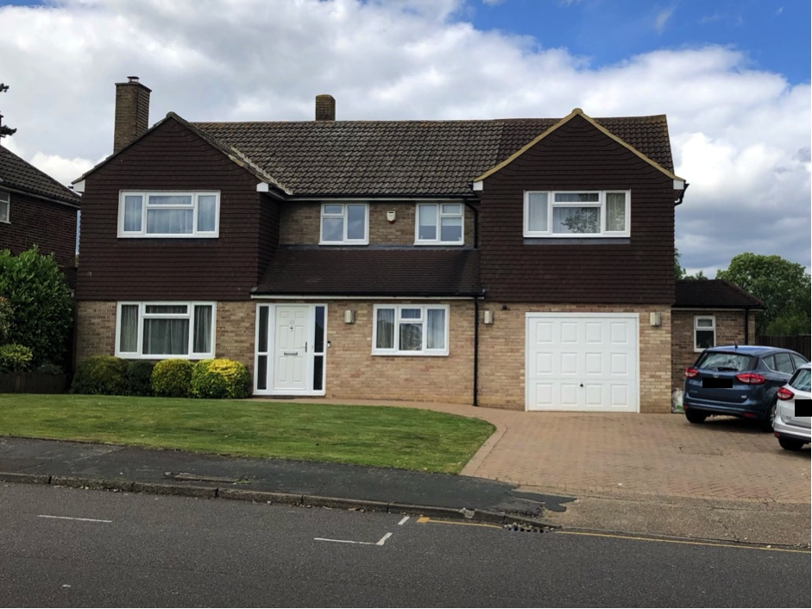

Picture: 8 Chichester Avenue

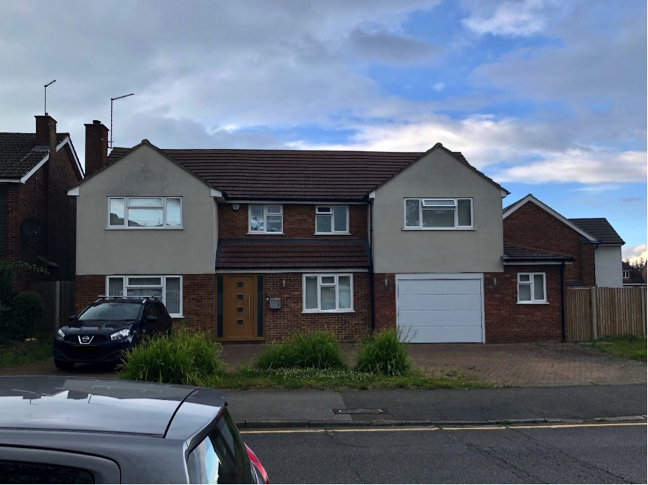

Picture: 12 Chichester Avenue

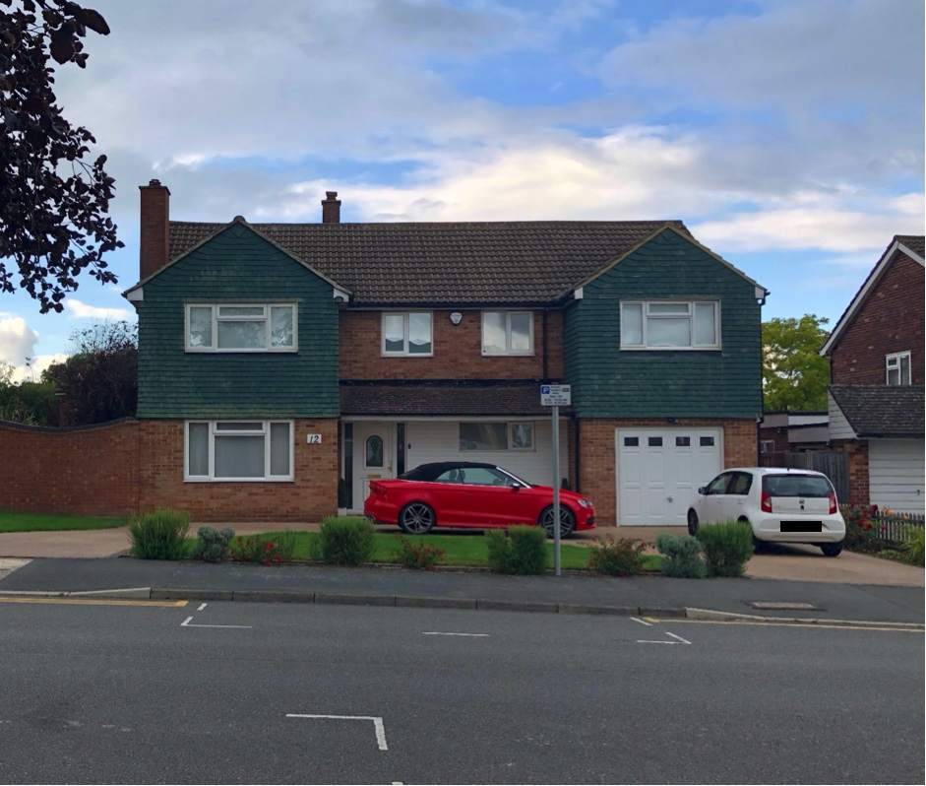

Access:
No access or parking changes are proposed. There will be a retention of 3/4 parking spaces. The requirements of Appendix C, set out in the Hillingdon Local Plan Part Two (2020), would be met with this number of off-road parking spaces. It is therefore considered the aims of Policy DMT 6 of the Hillingdon Local Plan Part Two (2020), would be met. ‘

Conclusion:
In summary, it is clear the above proposal will positively influence the current site and will be sympathetic to the existing character of the area particularly by bringing the currently side located front door to the front aspect of the property and the proposal will overall provide positive symmetry and harmony to match and enhance the street scene. It has already been determined that the principle of the proposal is acceptable by the grant of previous permissions of similar proposals both up and down the road of the subject property.
The features of the existing building have been retained and the overall scheme has been carefully considered to ensure there are no negative impacts on the street scene or surrounding buildings and has been carefully designed in consideration with all relevant planning policy/guidance and we trust you will find the attached proposal acceptable.

