SAMPLE FOF MATERIALS

115 Laburnum Road, Hayes, Middlesex, UB3 4JZ

- External Finish

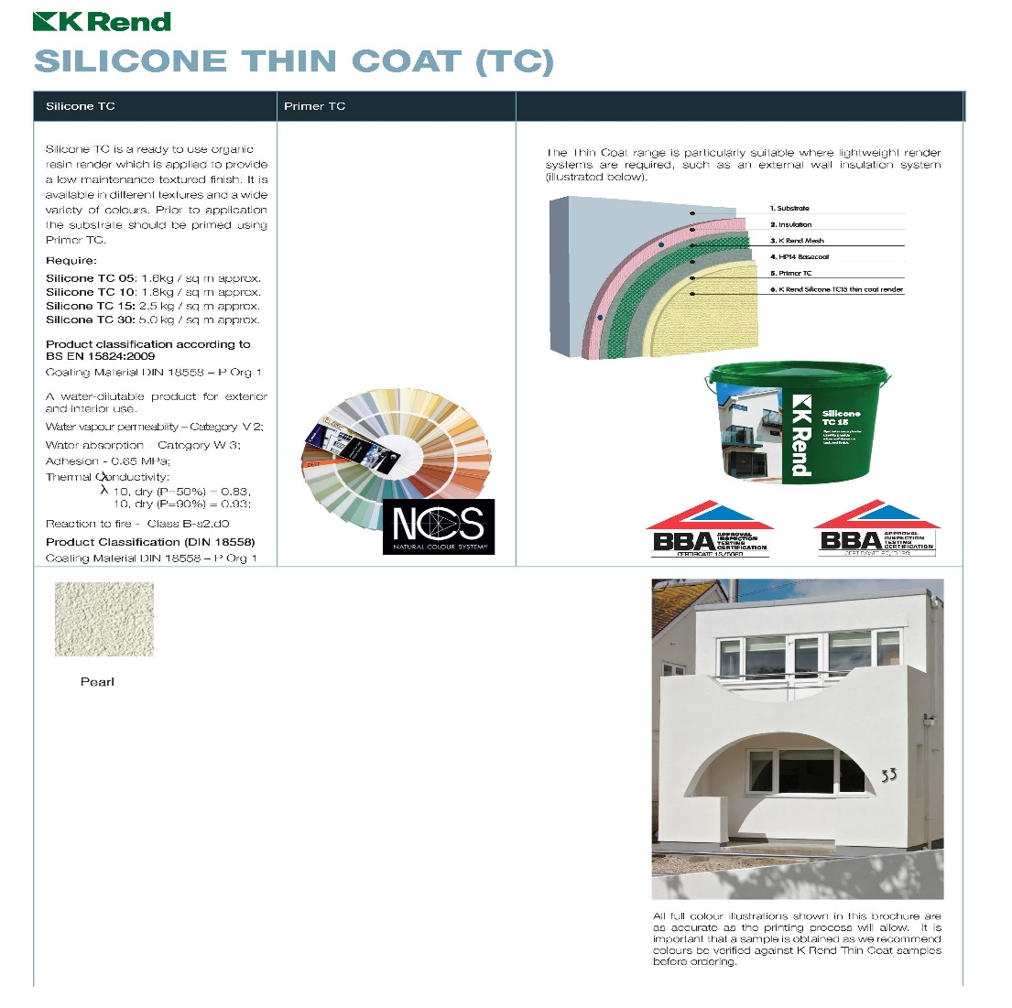

- Roof Tiles

BMI Redland 49 30 Slate Grey (Smooth) 1101-30
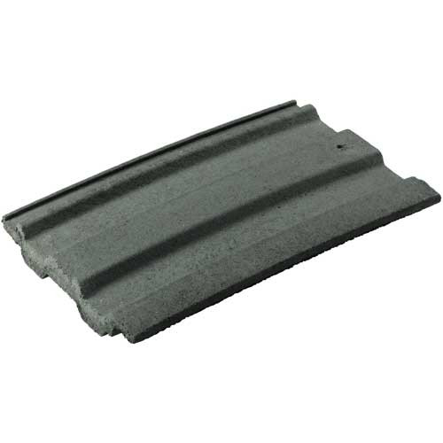
- Windows

Top Opening Double Glazed Casement White UPVC Window

