EXISTING BRICKWORK AT REAR
Appears to be a blend of bricks.

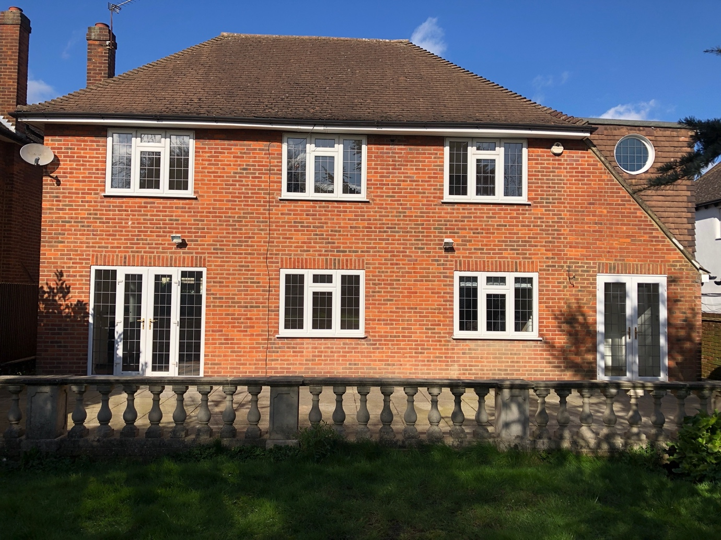

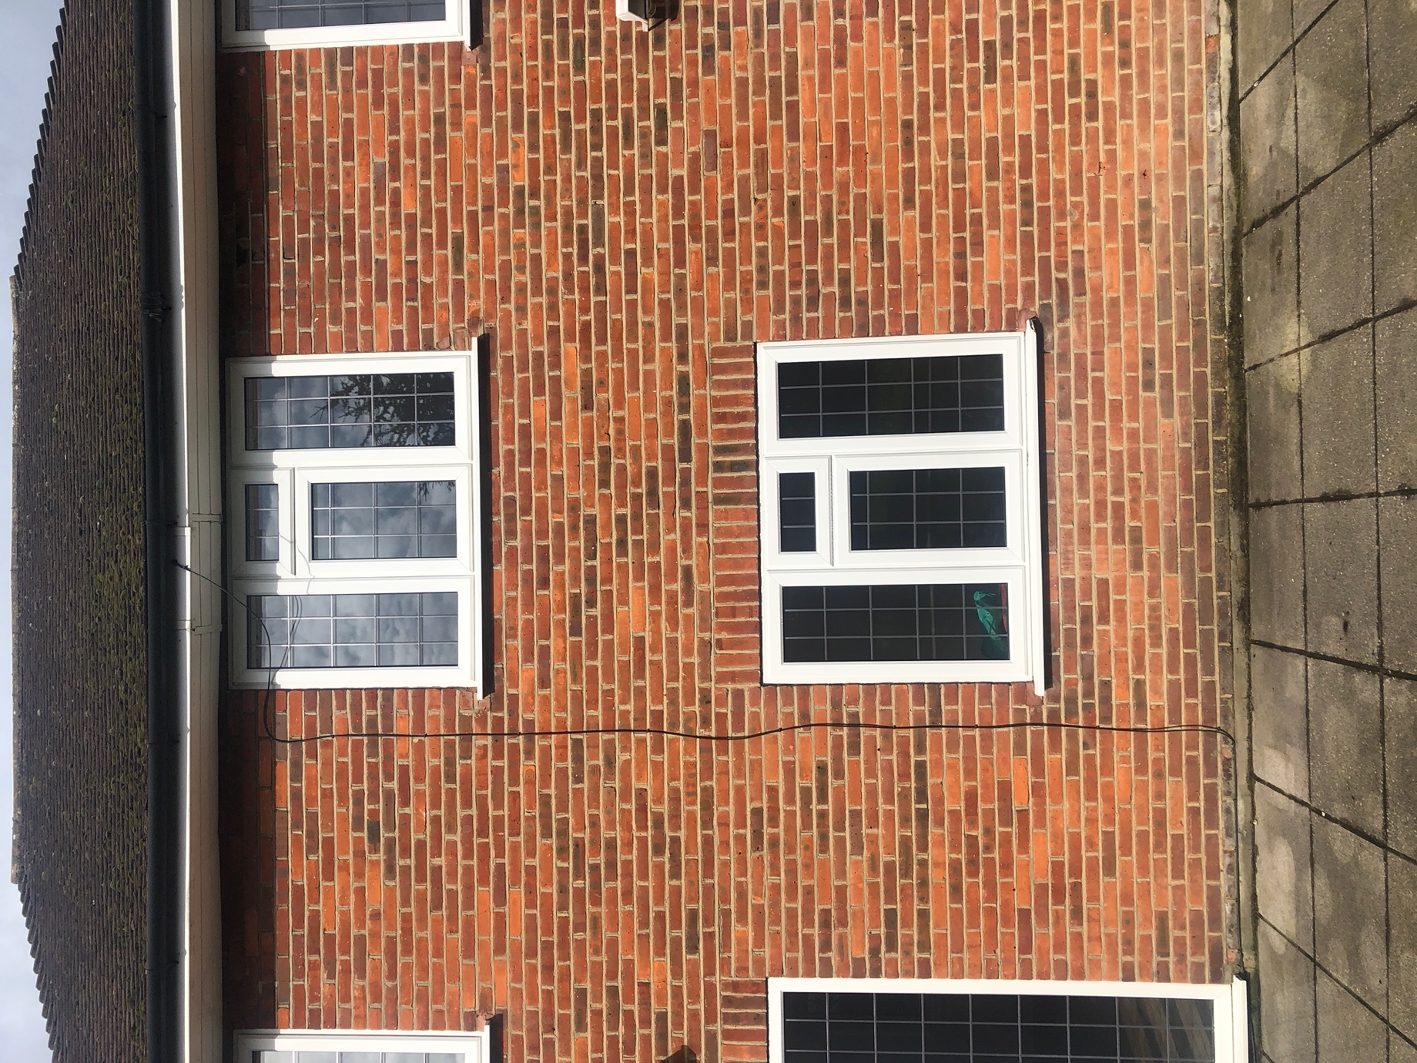

PROPOSED BRICKS

TBS WAVENY RED BLEND STOCK FACING BRICK

https://brickwholesale.co.uk/tbs-waveney-red-blend-stock-facing-brick-pack-of-600/

