WINDOWS

PROPOSED REHAU TOTAL 70 UPVC CASEMENT WINDOWS

EXISTING 70mm PROFILECASEMENT WINDOWS AND INSTALLED DETAIL

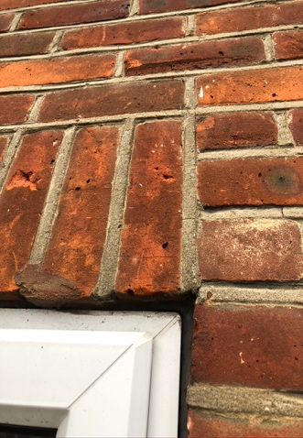
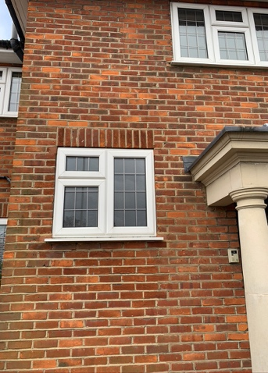

Please see the specification and accreditation info is attached as PDFs.

You can see that the appearance of the proposed window is almost identical to the existing windows installed. The windows presently installed are of approx 70mm profile, same as the proposed. Therefore finish and appearance post installation should be identical as the REHAU TOTAL 70 can be set into the window openings in exactly the same way as the existing ones.

