ROOF TILES AND FLAT ROOFS

The roof tiles, although you did not mention it in you email, I have attached below photos of the roof tiles presently in place. They have been identified as BMI REDLAND Plain Tile NATURAL RED (SANDED/GRANULAR) Tile.
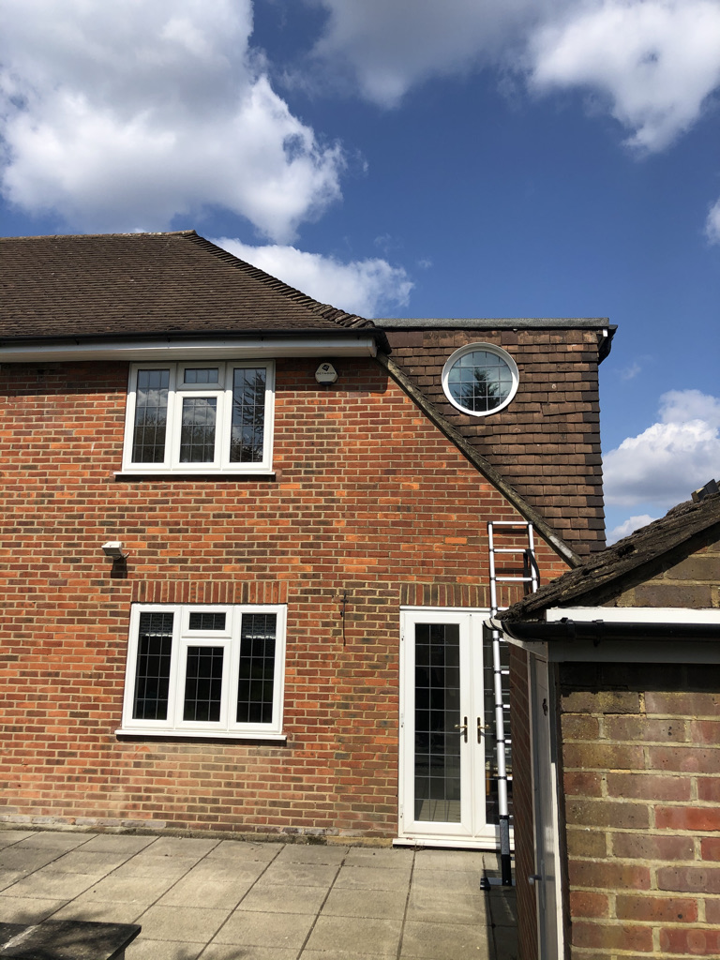

EXISTING ROOF TILES ON THE ROOF AND DORMER CHEEKS

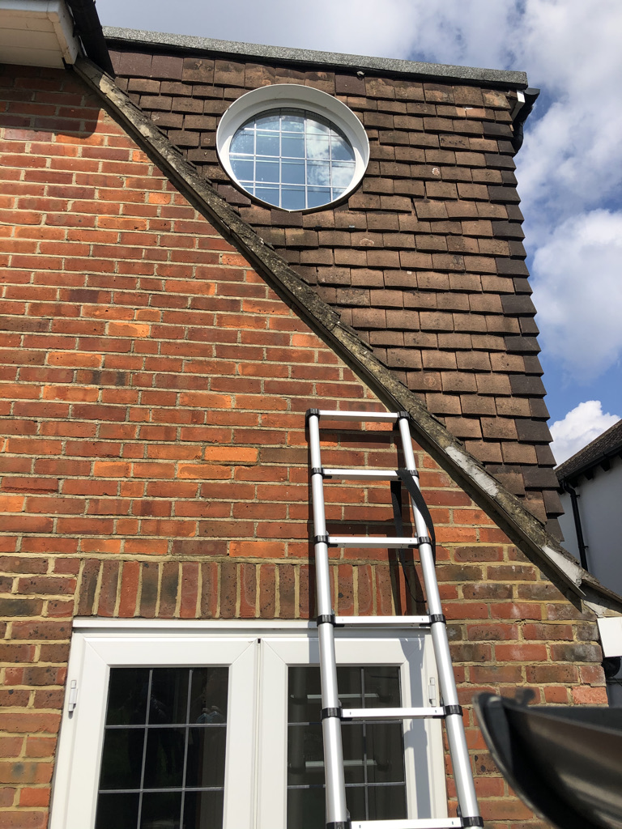

PROPOSED: BMI REDLAND Natural Red (Sanded/Granular)

GRP ROOF SINGLE MEMBRANE ROOFING FOR CROWN AND FLAT ROOF AREAS
