The Existing Site
Description
The Rosedale College site has approximately 3.2 Hectares of natural grass playing fields and is located off Wood End Green Road in the Hayes area of the London Borough of Hillingdon.

The site is currently a fully functioning secondary mixed secondary school and will remain open to the local community throughout the development of the site.

The Pitches
The existing natural grass pitches at the Rosedale College site can be identified as one senior football pitch as well as a small multi-use training area. The detailed information on sizes, characteristics and other information can be found within the performance quality standards section of this document.

Please see below image showing approximate location of the pitches on the day of the visit.
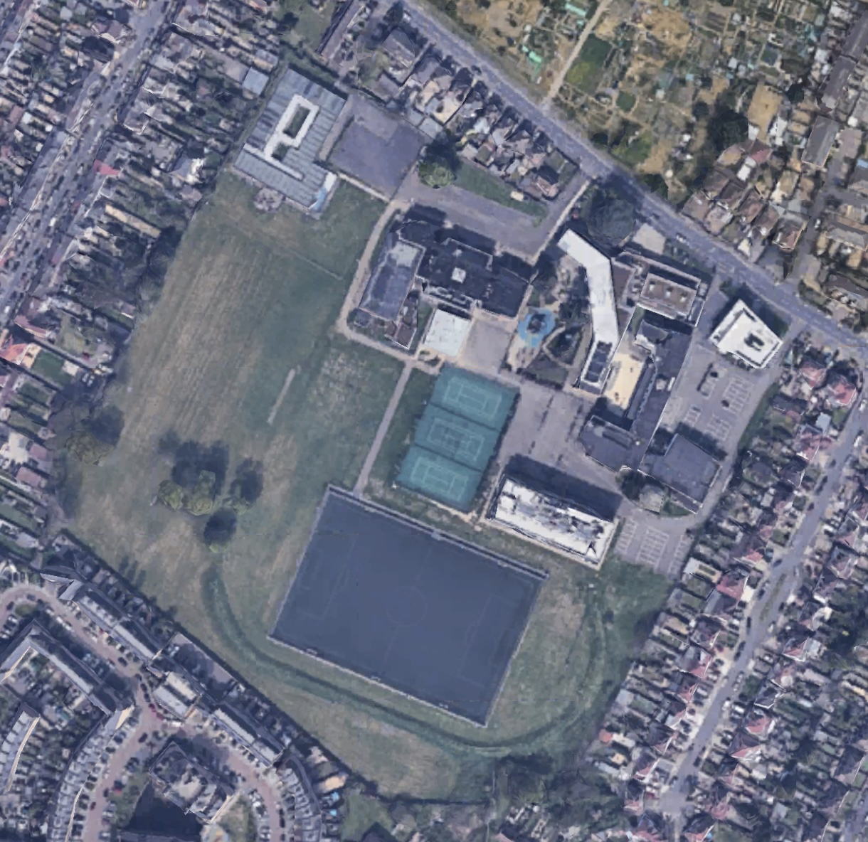

Multi-use training area

Senior pitch

Existing Maintenance Overview
We have been provided with an overview of current maintenance practice at Rosedale College. Currently the in-house maintenance regime consists of mowing only. This is carried out once a week between April and September and once every two weeks from October to March. In this context typically an external grounds maintenance contractor is employed to carry out more specialist maintenance activities, although the extent of which is unknown at this time.

Taking this into account, and the visual observations commented on below we are highly confident in stating the suggested maintenance proposals for the site will improve on the existing quality outcomes and resulting PQS measurements of the site.

Overarching Quality Agronomic Comment
Whilst recognising the efforts employed by the current maintenance provider, the site could be further improved with some infrastructure investment and a defined/detailed maintenance specification. This would enhance the playing surfaces and no doubt playability, as well as increasing carrying capacity.

Carrying Capacity
Carrying capacity is a term used to indicate availability of winter sports pitches (particularly football) expressed as the number of hours per week that a pitch would be available considering design, age range of users, and time of year. In simple terms, better design improves availability. Ongoing maintenance is essential in providing this availability and should not be underestimated. PQS measurements can also be used to monitor maintenance on an ongoing basis.

Any future design recommendations at the site will improve carrying capacity by design, and recommended maintenance will ensure that overall pitch quality and availability are optimised.

Soils Map
Landis.org.uk is the host of a free, publicly available soils map developed by Cranfield University and sponsored by the Department for Environment, Food and Rural Affairs (DEFRA).

The images below taken from their soilscapes viewer, show us the two types of soil found in the local area as well as the specific area of the Rosedale College site. The information provided by the soilscapes viewer is confirmed to be true and accurate by the onsite samples taken which have been sent to an independent laboratory for testing. Details of the results can be found appended to this report.
Soilscape 22:
Loamy soils with naturally high groundwater

Texture:
Loamy
Drainage:
Naturally wet
Fertility:
Low
Landcover:
Arable grassland and woodland
Habitats:
Wet acid meadows and woodland
Carbon:
Low
Drains to:
Local shallow groundwater
Water protection:
Soils are mostly drained. Shallow groundwater and marginal ditches to most fields mean that the water resource is vulnerable to pollution from nutrients, pesticides and wastes applied to the land
General cropping:
Most land is used for arable and root cropping but this is replaced by grass where soils are excessively stony or too wet. Although subject to groundwater inundation in the subsoil, these soils can be droughty in the summer.

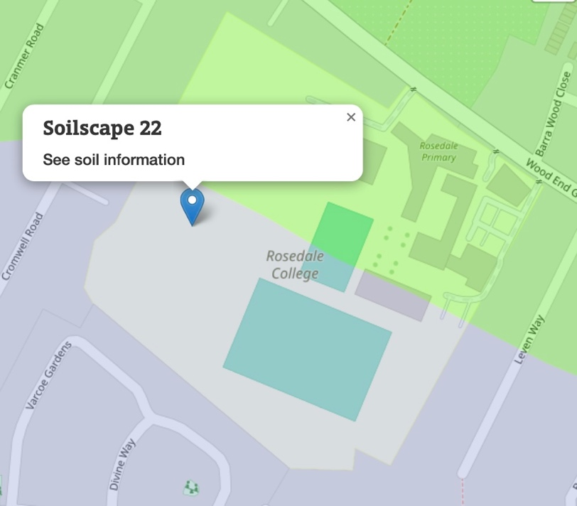

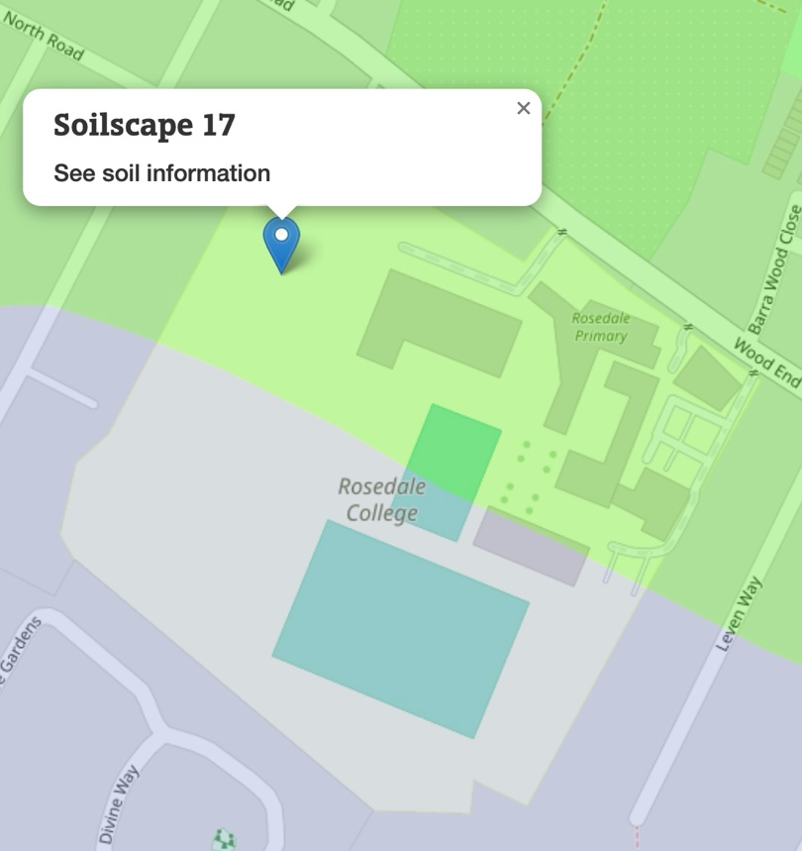
Soilscape 17:
Slowly permeable seasonally wet acid loamy and clayey soils

Texture:
Loamy and clayey
Drainage:
Impeded drainage
Landcover:
Grassland with some arable and forestry
Habitats:
Seasonally wet pastures and woodlands
Carbon:
Medium
Drains to:
Stream network
Water protection:
Main risks are associated with overland flow from compacted or poached fields. Organic slurry, dirty water, fertiliser, pathogens and fine sediment can all move in suspension or solution with overland flow or drain water
General cropping:
Mostly suited to grass production for dairying or beef; some cereal production often for feed. Timeliness of stocking and fieldwork is important, and wet ground conditions should be avoided at the beginning and end of the growing season to prevent damage to soil structure. Land is tile drained and periodic moling or subsoiling will assist drainage

Performance Quality Standards (PQS) Testing
Traction Sports have carried out performance quality standard (‘PQS’) testing on the natural grass pitches at the Rosedale College site as well as an agronomic assessment. The pitches have been identified as shown on the map above in ‘The Pitches’ section.

The areas that have been identified for testing are formal sports pitches, and as such will be tested against the relevant governing body standards in place. Traction Sports in-house agronomist and PQS technician have produced this report after the visit, which details findings concerning the quality and performance of the existing facilities at the Rosedale College Site.

Please note: the data may indicate that the pitches are within governing body standards, but comments may be made to consider other equally important aspects such as presentation for example. Some of the limits are fairly broad within the governing body standards. Hardness for a football pitch for example, has a large range (35 – 200 gravities) that is deemed acceptable. Traction Sports will quantify the data as either a pass or fail based on the relevant governing body limits but may include comments as to the optimum or target numbers for each test based on our own experience as qualified sportsturf consultants. The relevant governing body standards will be determined by the time of year, season and sport played on the pitch at the time of the test. All tests were carried out using industry approved calibrated apparatus and equipment, by qualified and experienced technicians.

Governing Body Standards for PQS Testing

Element | Limits adopted by:  Football Association | Limits adopted by:  Rugby Union  Rugby League | Limits adopted by:  Cricket
Element | Limits adopted by:  Football Association | Limits adopted by:  Rugby Union  Rugby League | Square | Pitch | Outfield
Grass height (mm) | 30-60 GS  20-70 NGS | 25-65 GS  25-75 NGS | 8-14 GS  16-25 NGS | 6-7 GS | 16-25 GS  18-38 NGS
Ground cover (%) | >75 | >70 | >80 | 50-70 | >80
Broad-leaved weeds (%) | <10 | <10 | Nil | Nil | <3
Thatch depth (mm) | <15 | <15 | <2 | Nil | <15
Water infiltration rate | >5 (mm/h) | >2 (mm/h) | N/A | N/A | 2 (mm/d)
Evenness  - 2 m straight edge (mm) | <25 | <25 | <10 | <10 | <20
Slope  Direction of play (%)  Across play (%) | <1.00 - 1.25  <1.25 - 2.00 | <1.00 - 1.25  <1.25 - 2.00 | <1.11  1.25 - 1.67 | <1.11  <1.67 | <1.67  <1.67
Hardness (gravities) | 35-200 | 40-180 | N/A | >200 | 30-200
Key:
GS = Growing season
NGS = Non-growing season
Sport England (2011). Natural Turf for Sport. 2nd Ed.

PQS Results
Natural Turf Football Pitch and Multi-Use Training Area
The tests that were carried out on the natural grass playing fields were as follows:

- Grass height of cut
- Sward ground coverage
- Weed percentage
- Worm cast percentage
- Infiltration (drainage) rate
- Ground hardness
- Surface regularity / evenness
Location Map
The sixteen test locations (blue stars) were chosen at random to provide a data set that represents the true nature of the surface. The locations for the infiltration testing are indicated by the orange squares.
4
3
2
1
16
15
14
13
12
11
10
9
8
7
6
5
4
3
2
1

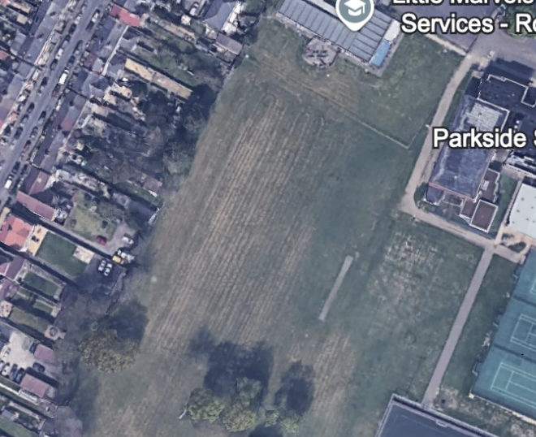
Test Results
The test results will be measured against the governing body limits for football during the growing season. This is due to football being the sport the field was prepared for at the time of testing and also due to the time of year.

Height of Cut (mm):
Location | Result | Pass / Fail
1 | 20 | Fail
2 | 18 | Fail
3 | 17 | Fail
4 | 30 | Pass
5 | 24 | Fail
6 | 21 | Fail
7 | 26 | Fail
8 | 25 | Fail
9 | 20 | Fail
10 | 20 | Fail
11 | 22 | Fail
12 | 24 | Fail
13 | 18 | Fail
14 | 15 | Fail
15 | 17 | Fail
16 | 17 | Fail
Average | 20.875 | Fail
Comments: the height of cut was found to be variable across the outfield but all fall outside of or right on the lower end of the range indicated above by the governing body of 30mm in the growing season (March – October). This results in an overall failure of the average for this test, coming in at 9.125mm lower than the required minimum of 30mm.

Sward Ground Coverage (%):
Location | Result | Pass / Fail
1 | 100 | Pass
2 | 99 | Pass
3 | 99 | Pass
4 | 98 | Pass
5 | 99 | Pass
6 | 99 | Pass
7 | 98 | Pass
8 | 97 | Pass
9 | 100 | Pass
10 | 99 | Pass
11 | 100 | Pass
12 | 100 | Pass
13 | 100 | Pass
14 | 100 | Pass
15 | 98 | Pass
16 | 98 | Pass
Average | 99 | Pass
Comments: ground coverage was excellent in all locations tested. It was noted that there were some areas that were damaged that landed outside of the testing locations but within the development areas.
See below image for example.
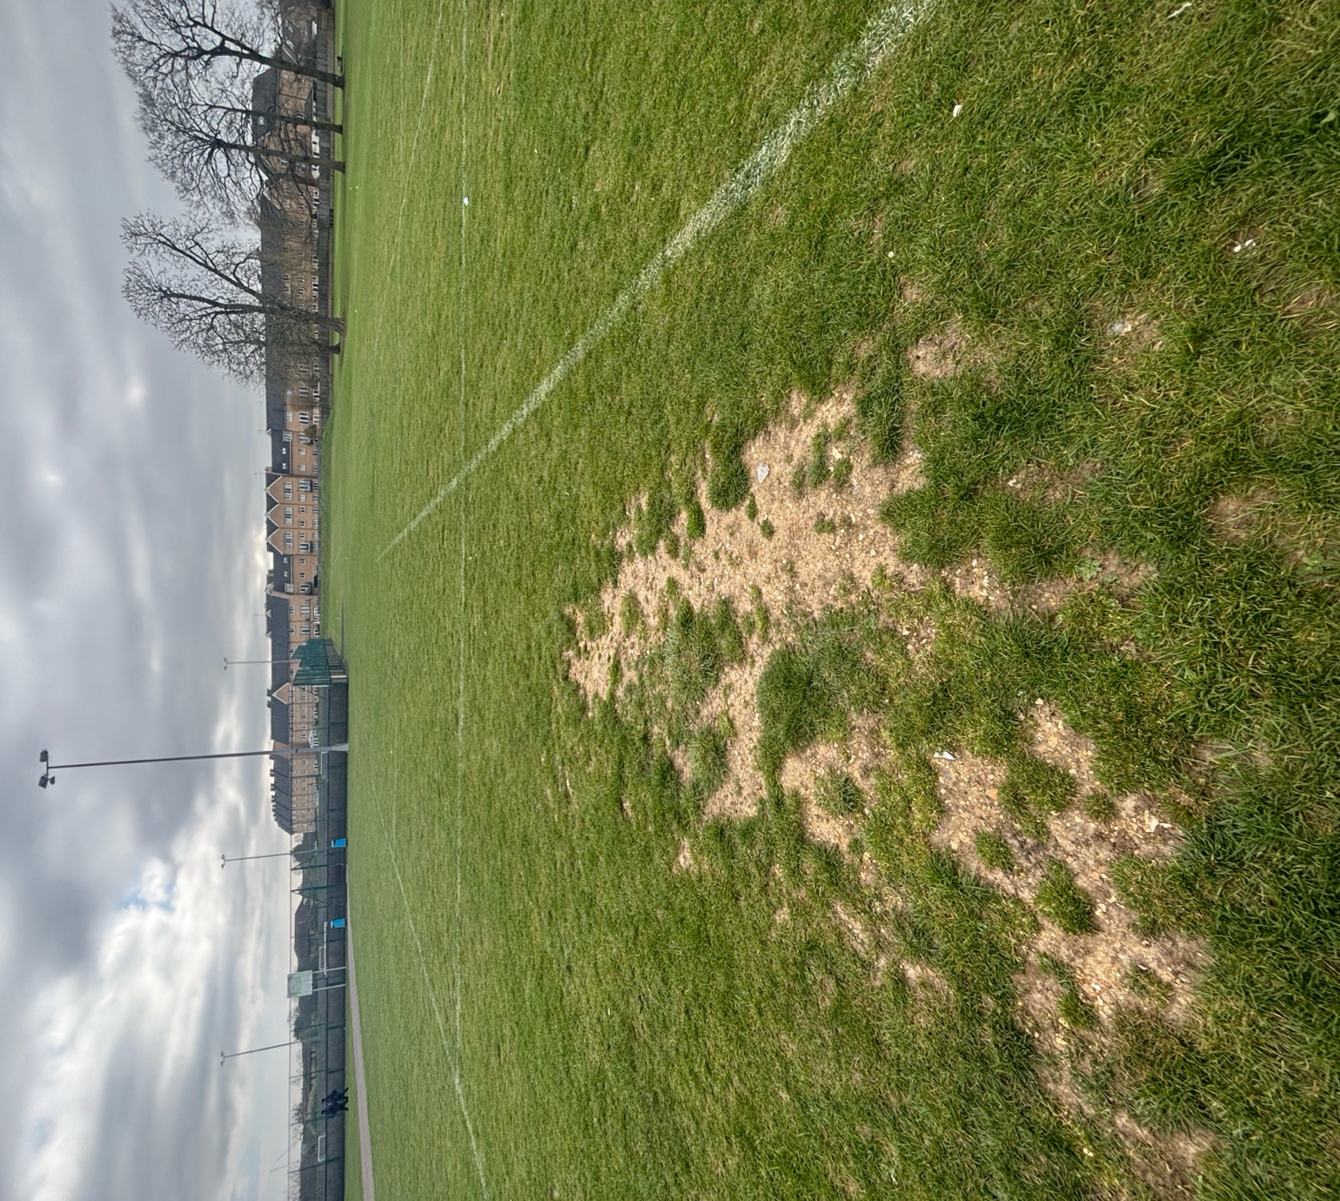

Damage to an area of ground within the multi-use training area but outside of testing locations

Worm Casting (%):
Location | Result | Pass / Fail
1 | 0 | n/a
2 | 0 | n/a
3 | 0 | n/a
4 | 1 | n/a
5 | 0 | n/a
6 | 0 | n/a
7 | 0 | n/a
8 | 2 | n/a
9 | 0 | n/a
10 | 2 | n/a
11 | 0 | n/a
12 | 0 | n/a
13 | 0 | n/a
14 | 1 | n/a
15 | 0 | n/a
16 | 1 | n/a
Average | 0.4375 | n/a

Comments: Minimal worm casts were seen on the day of the testing. Worm casting is not a measured test but is useful in understanding agronomic condition and quality of a sports turf. It is generally said within sports turf agronomy that any more than 3% casts per square metre is unacceptable and the playing characteristics of the surface may become affected by worm casting. Given that statement and the results recorded above, we can see that in no areas are the existing pitches at Rosedale College adversely affected by worm casting.

Weeds (%):
Location | Result | Pass / Fail
1 | 2 | Pass
2 | 2 | Pass
3 | 1 | Pass
4 | 3 | Pass
5 | 0 | Pass
6 | 1 | Pass
7 | 0 | Pass
8 | 2 | Pass
9 | 1 | Pass
10 | 3 | Pass
11 | 3 | Pass
12 | 1 | Pass
13 | 0 | Pass
14 | 3 | Pass
15 | 4 | Pass
16 | 1 | Pass
Average | 1.6875 | Pass

Comments: in all but three of the locations tested weed presence was noted. Although the number of weeds is low (4%) in relation to the upper limit of 10%, it suggests a consistency across the pitches that can be eliminated with the playing fields restoration scheme, and appropriate aftercare from the maintenance team.

Infiltration Rate (mm/hr):
Location | Result | Pass / Fail
1 | 90 | Pass
2 | 75 | Pass
3 | 120 | Pass
4 | 30 | Pass
Average | 78.75 | Pass
Comments: infiltration of the pitches was found to be much greater than the required amount of 5mm/h stipulated by the football association (FA). There is evidence of some existing drainage to the pitches but the extent and full condition is currently unknown. Damage can be seen in two locations where the drainage runs have sunk over time as evidenced by the below photographs.

We estimate the current carrying capacity (hours use per week) to be 1 – 2 hours, but with the drainage improvements recommended below expect this to rise to 3 – 4 hours.

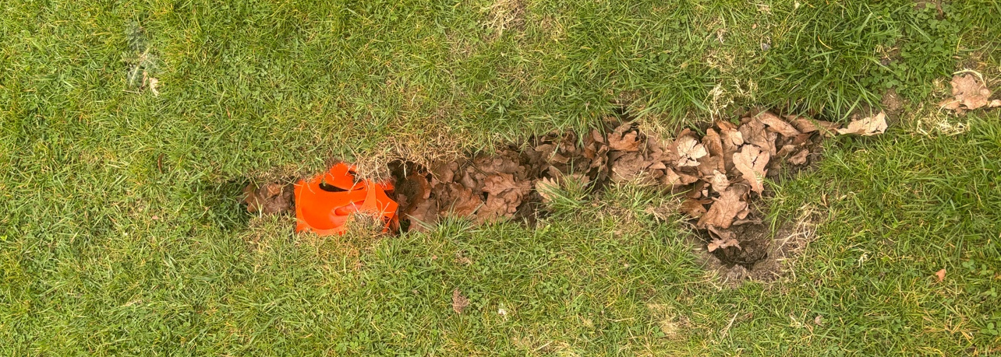
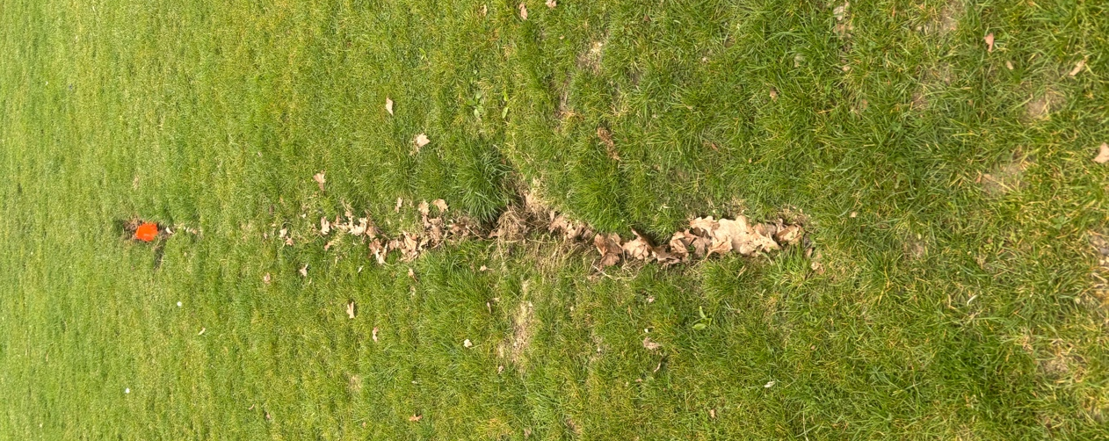

Hardness (Gravities):
Location | Result | Pass / Fail
1 | 81 | Pass
2 | 84 | Pass
3 | 92 | Pass
4 | 90 | Pass
5 | 98 | Pass
6 | 105 | Pass
7 | 93 | Pass
8 | 93 | Pass
9 | 101 | Pass
10 | 95 | Pass
11 | 109 | Pass
12 | 115 | Pass
13 | 125 | Pass
14 | 118 | Pass
15 | 124 | Pass
16 | 121 | Pass
Average | 102.75 | Pass

Comments: the recommended range for hardness of a football pitch is 30 - 200 gravities. The results above all fall within this range. The recent spell of heat prior to the testing visits and also the free draining soil may lead to the results increasing over the dry summer months.

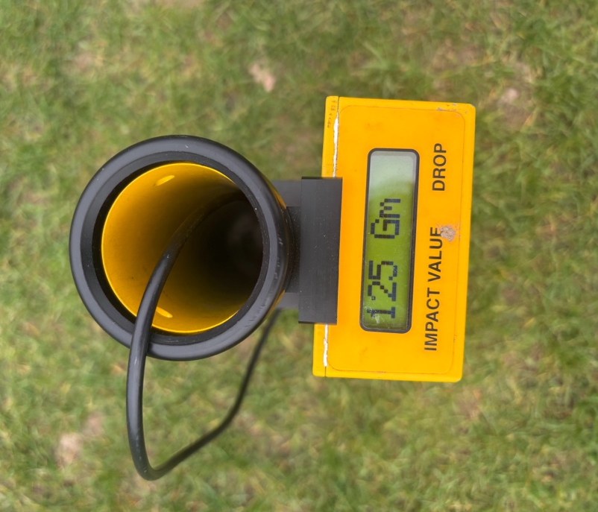

Surface Regularity / Evenness:
Across the pitch a 2m straight edge was used to measure the surface regularity and evenness of the surface. Upon inspection, multiple undulations were found to exceed the 25mm limit and the surface regularity is outside of the standards in place. Improvements in maintenance practice will be needed to eliminate the surface undulations found. This may come in the form of training, investment or other means. See maintenance sections below for further detail.

