Planning Statement
62 Hillingdon Hill Hillingdon, UB10 0JD
Planning application to add a frosted window to the side elevation
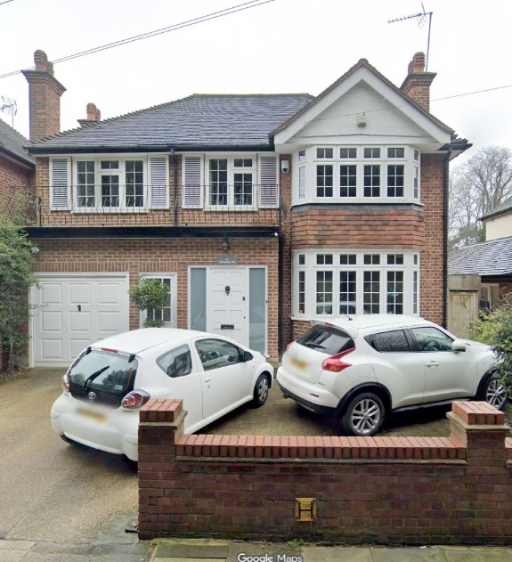

Contents
1.0 Introduction 2
2.0 Description of Proposed Amendment 2
3.0 Justification …………………………………………………………………………………….2
4.0 Application Site and Property Description 3,4
5.0 Conclusion………………………………………………………………………………………4

1.0 Introduction and Purpose of the Proposal
1.1. The Addition of a new frosted window (uPVC, white frame) to the side elevation that does not provide any overlooking issues to the neighbour and privacy issues
2.0 Description of Proposed Amendment

2.1 The additional window 600mm (width) × 1200mm (height) to the side elevation.
2.2. The proposed window does not provide any overlooking issues to the neighbour, moreover, it’s not more than 1 metre from the adjacent wall and therefore does not present any privacy issues

3.0 Justification
3.1. Minimal visual impact:
The change in orientation and dimension does not materially alter the character or appearance of the elevation.

3.2. Impact on neighbouring amenity:
There is going to be minimum impact to the neighbouring amenity. Furthermore, the window can be blocked by the erection of a 2m(H) obscure fence (close boarded panel fence)

4.0 Application Site and Property Description
4.1 The Detached property is located on a residential road, Hillingdon Hill Uxbridge, London. It is surrounded by other similar properties and is also surrounded by a mix of Semi-Detached houses which are built in a similar style.

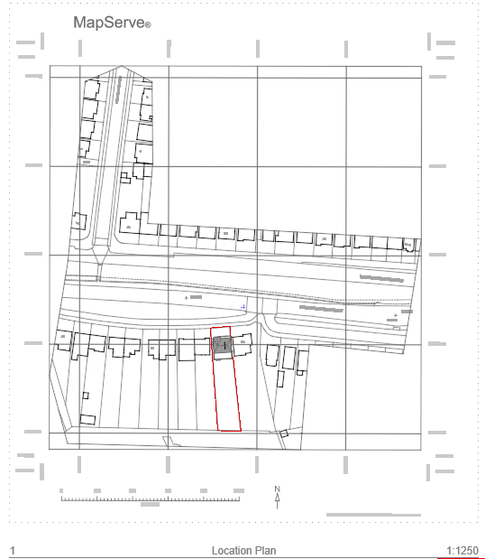

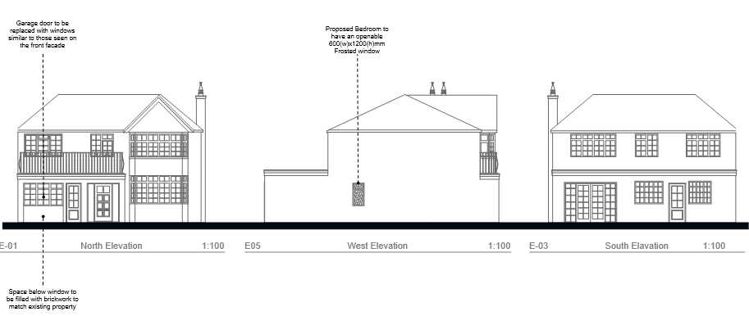

5.0 Conclusion
The proposed amendment doesn’t not result in any significant changes to the property. For this reason, we trust that London Borough of Hillingdon-Planning will look upon it favourably.

