09 11 22
Yr Ref: 15783/TRE/2022/223
ADDITIONAL PHOTOS OF ASH TO SUPPORT MY PROPOSAL
Ref 5/5:

Numerous problems sending original photo file so forced to send additional photos in word
Given the photos were shot at the beginning of dispersal of leaf fall and in the meantime the amount of debris has increased substantially:

1. Photos 1-8/19 excessive leaf debris dispersion and extent of mess created

2. Photos 10-14 further evidence as seen in previous photos to show consecutive drivers park under the tree and this space is frequently in use

3. Photos 14-19 further excessive dispersal of leaf fall and debris

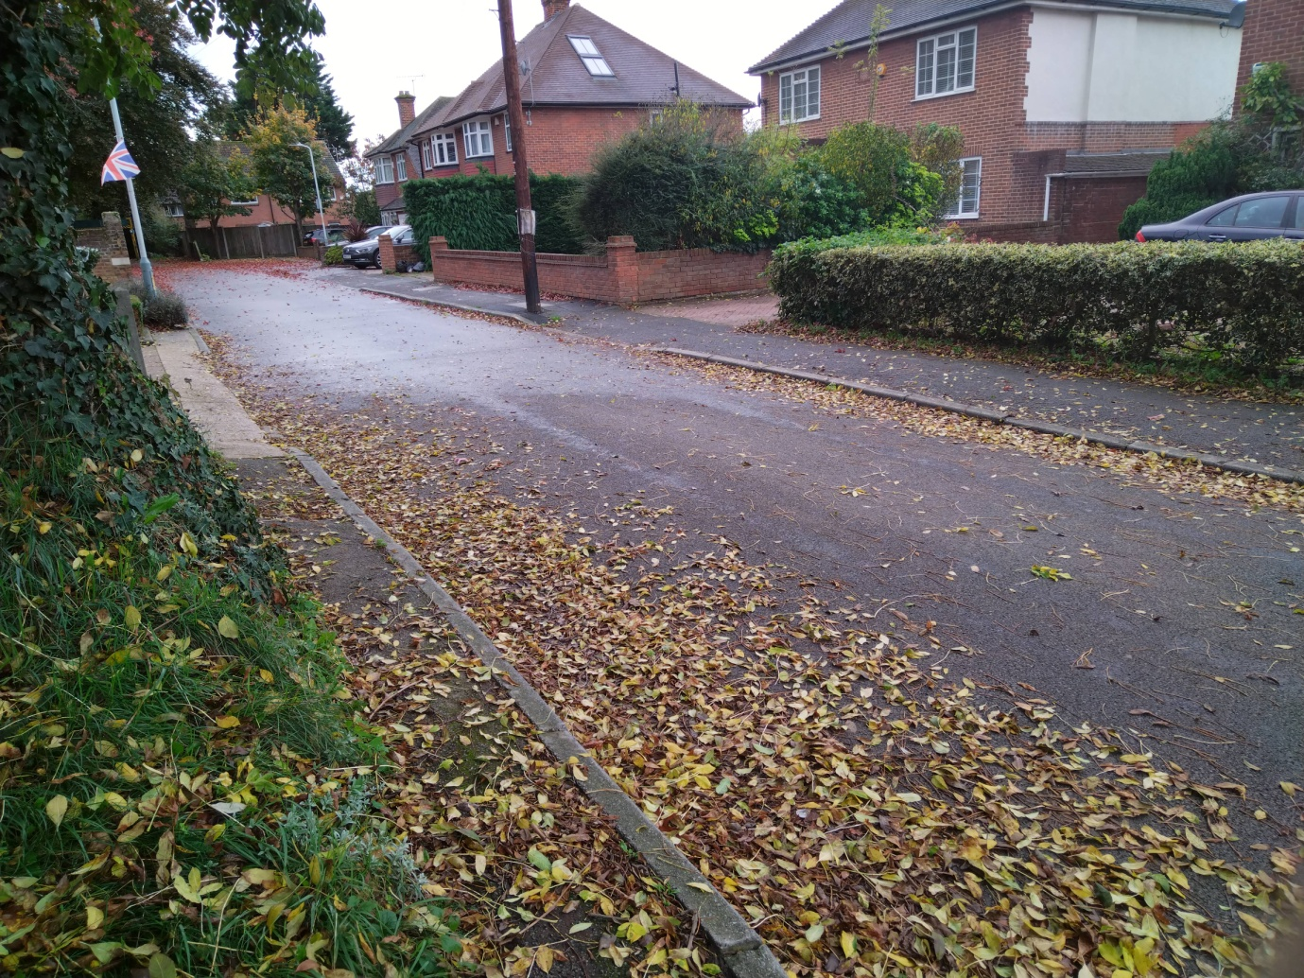
Photo 1/19

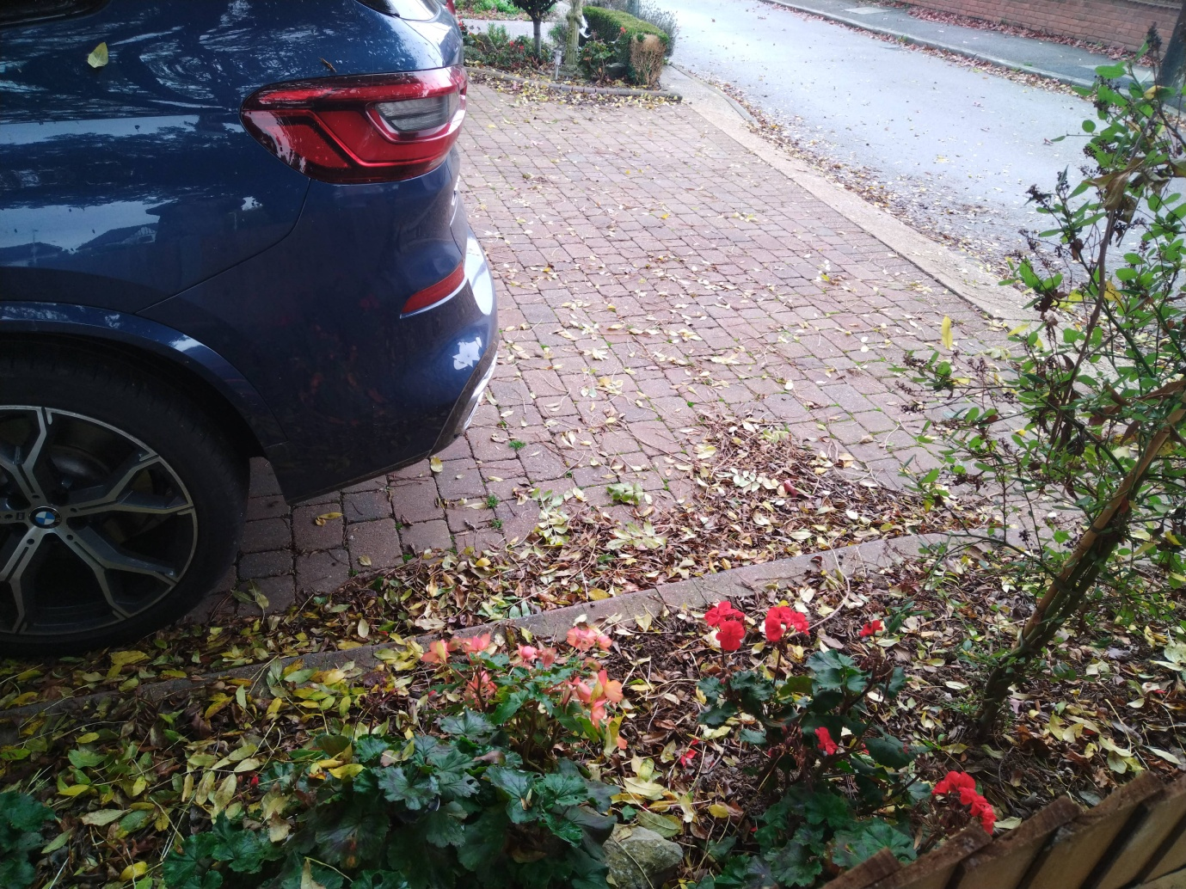
Photo 2/19

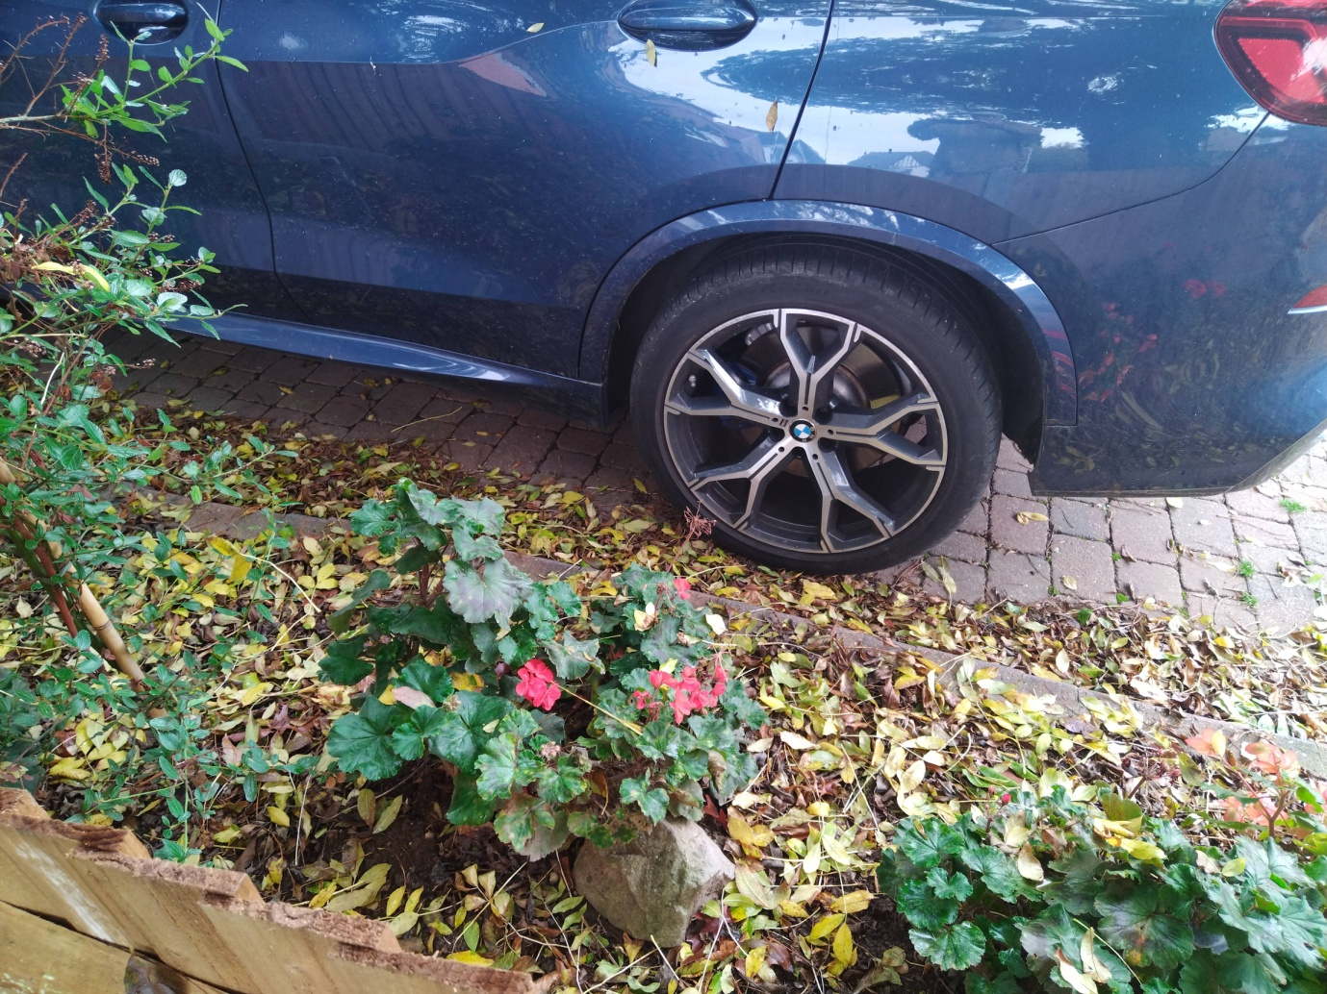
Photo 3/19

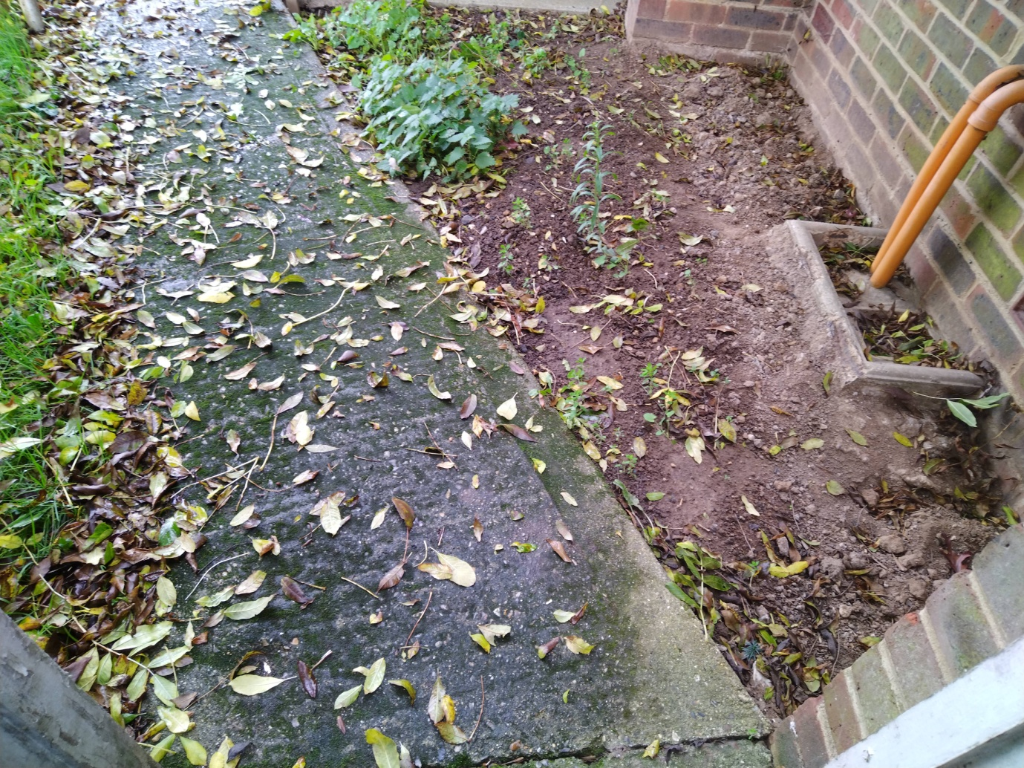
Photo 4/19

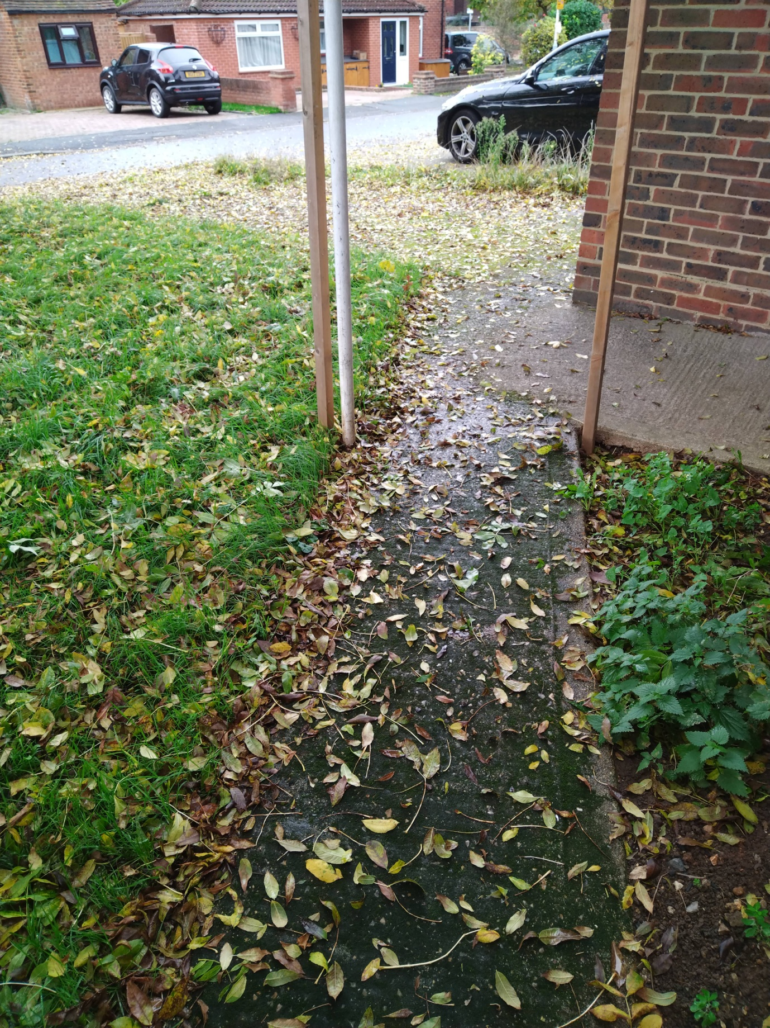
Photo 5/19

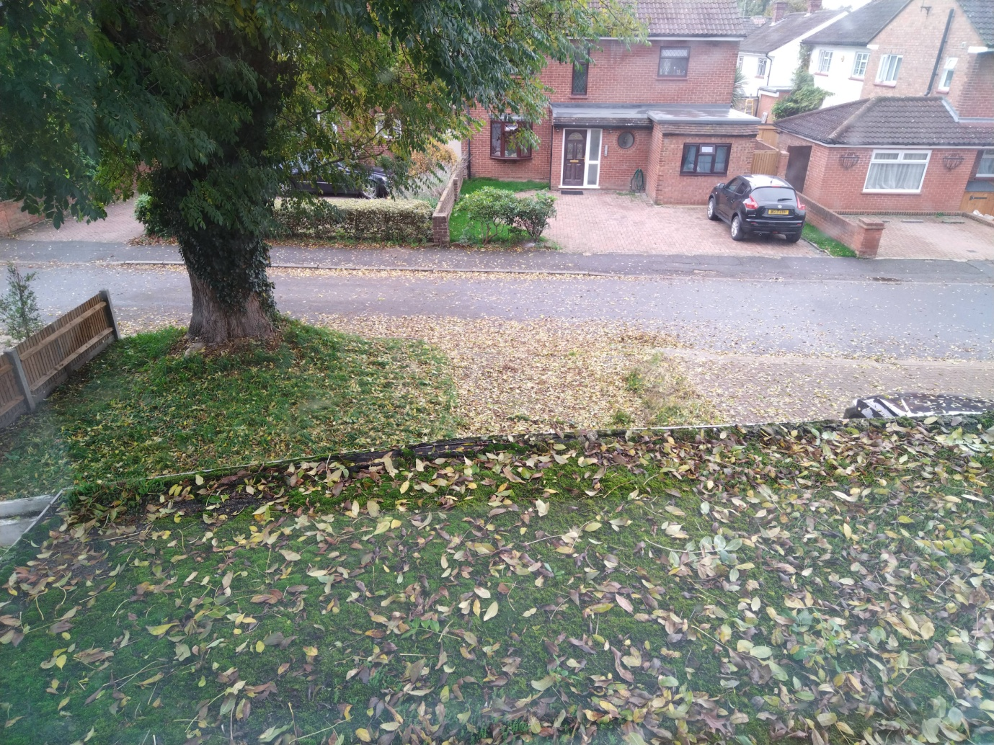
Photo 6/19

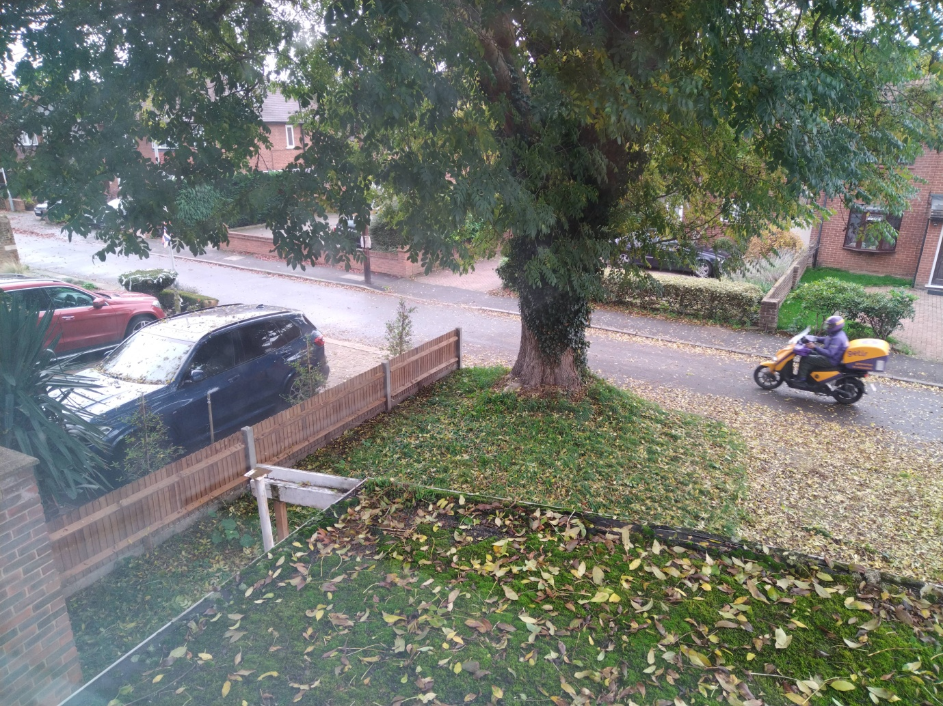
Photo 7/19

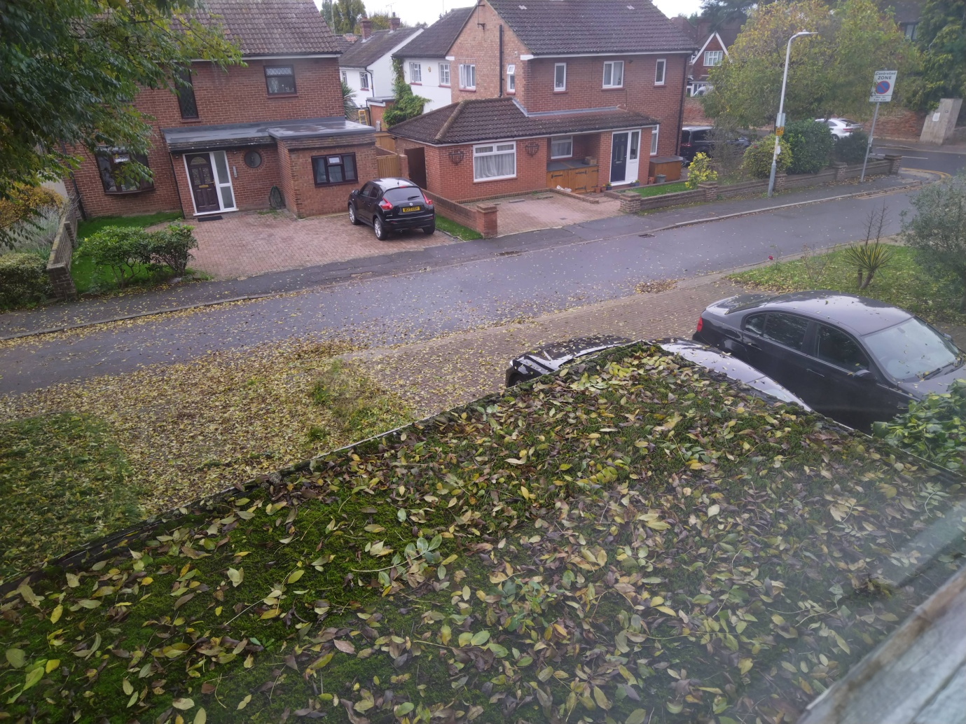
Photo 8/19

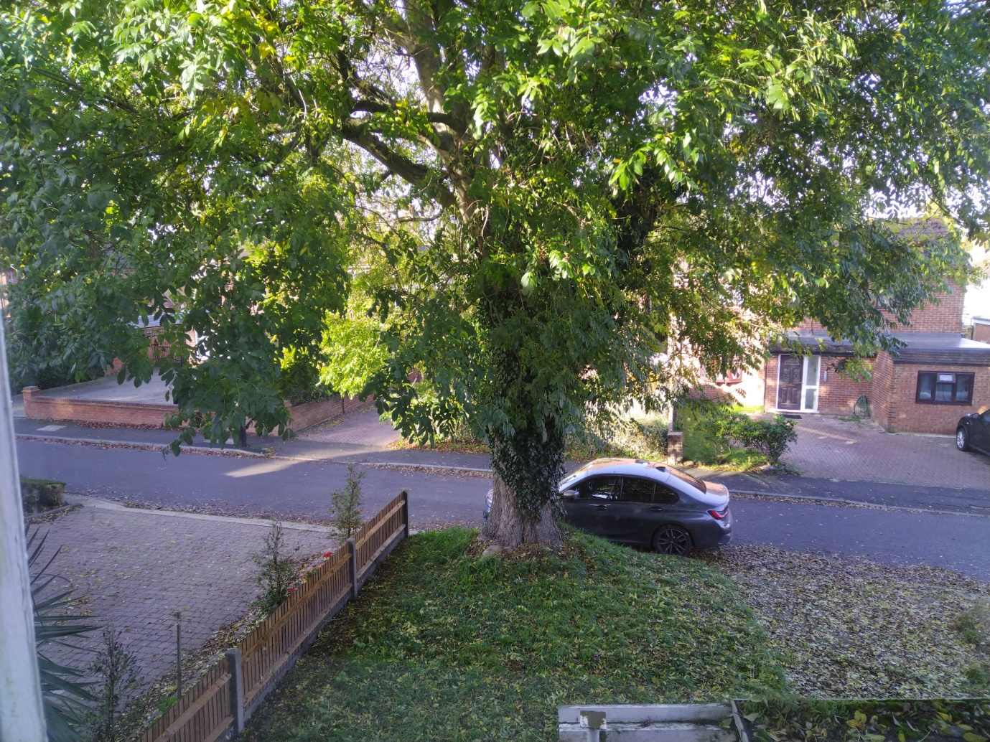
Photo 9/19
My neighbours, notably no.13 (and no. 9) had recently swept the excessive amount of leaves from her drive when this shot was taken but is forced to spend most days and many hours during leaf fall sweeping the leaves and debris from their drive(s) and only reason it appears leaf free. However, on closer inspection her flower beds are continuously full of leaves (See page 4,5 photos 3 & 4)
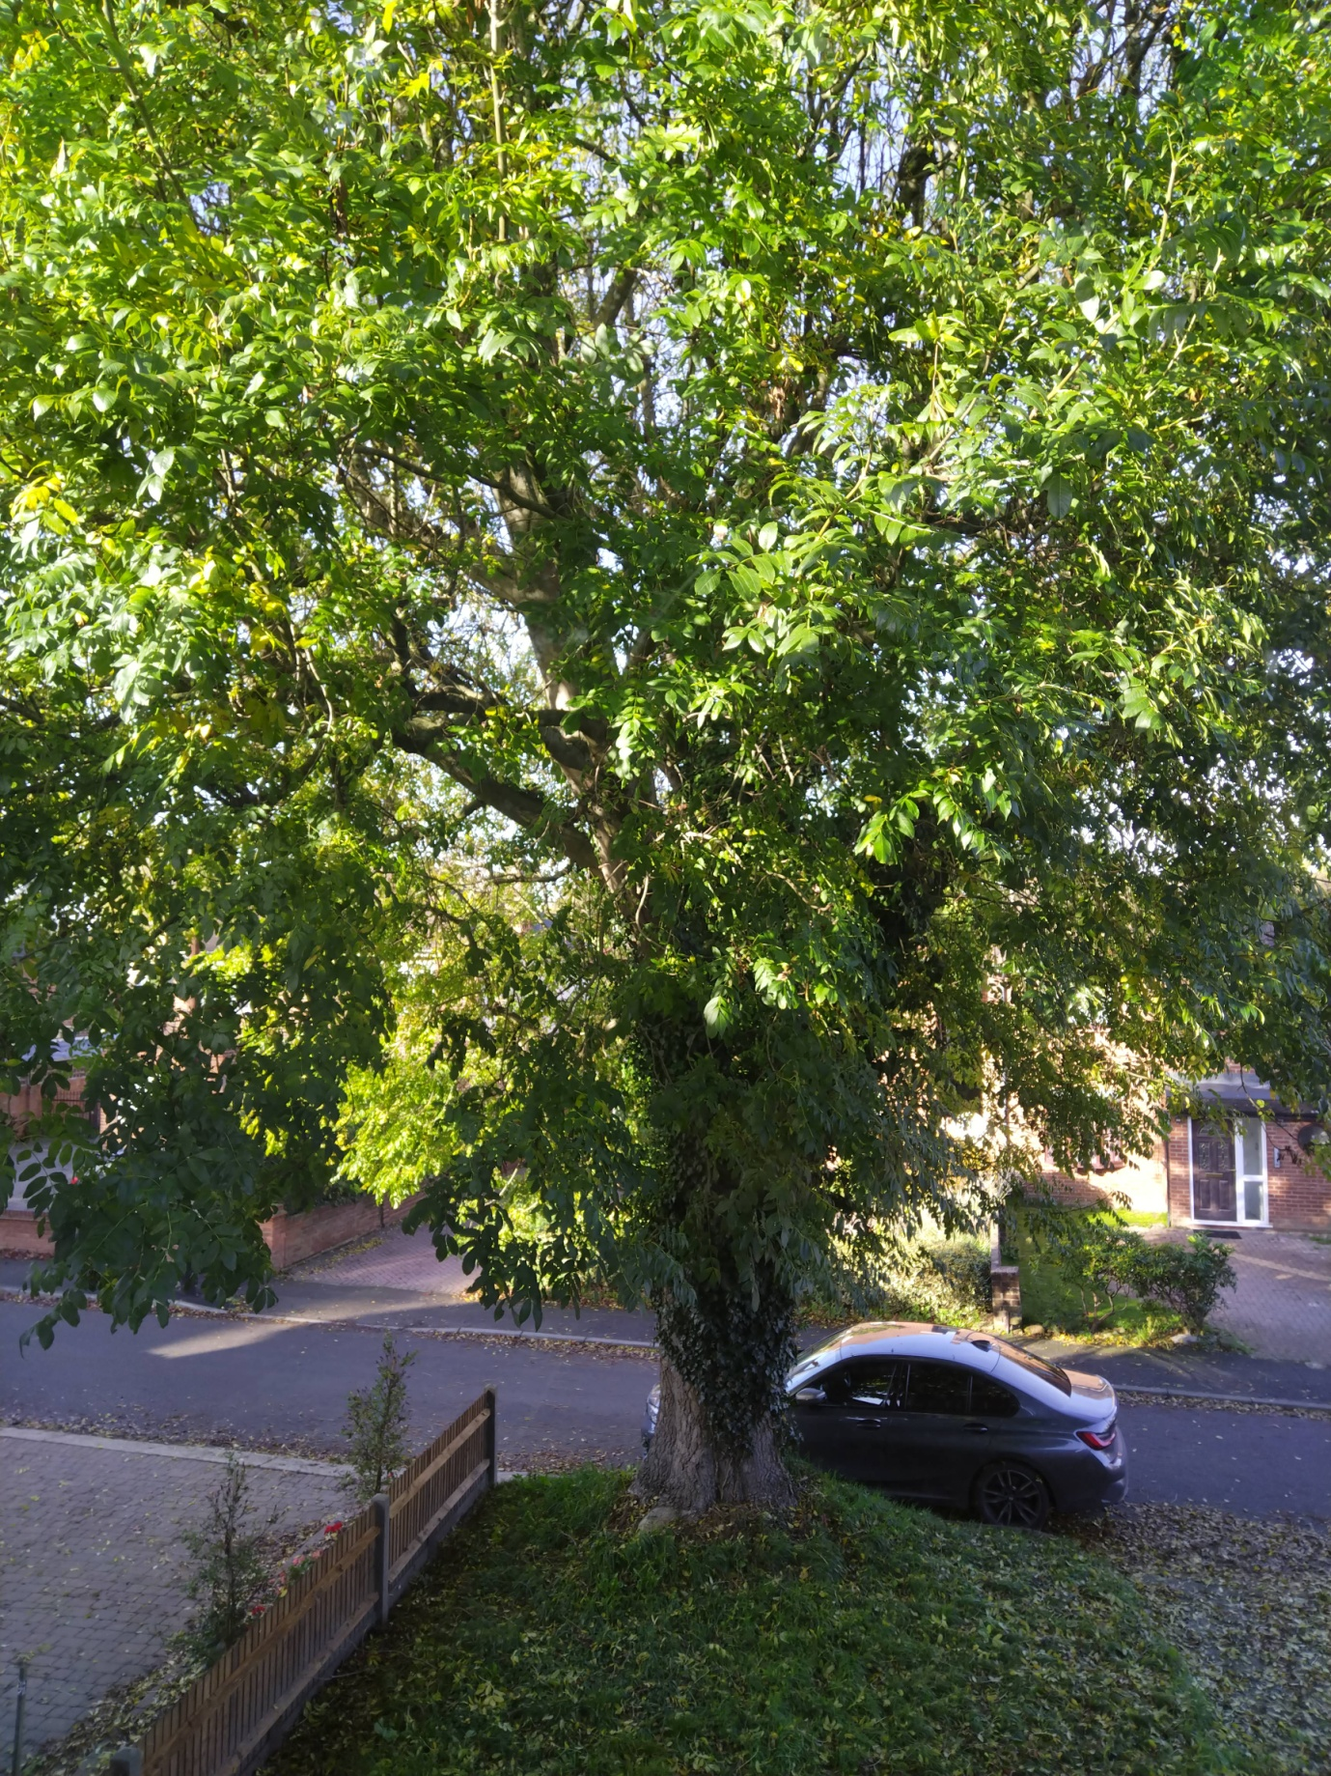
Photo 10/19
OCCLUSION LIGHT DURING ‘SUNSHINE’

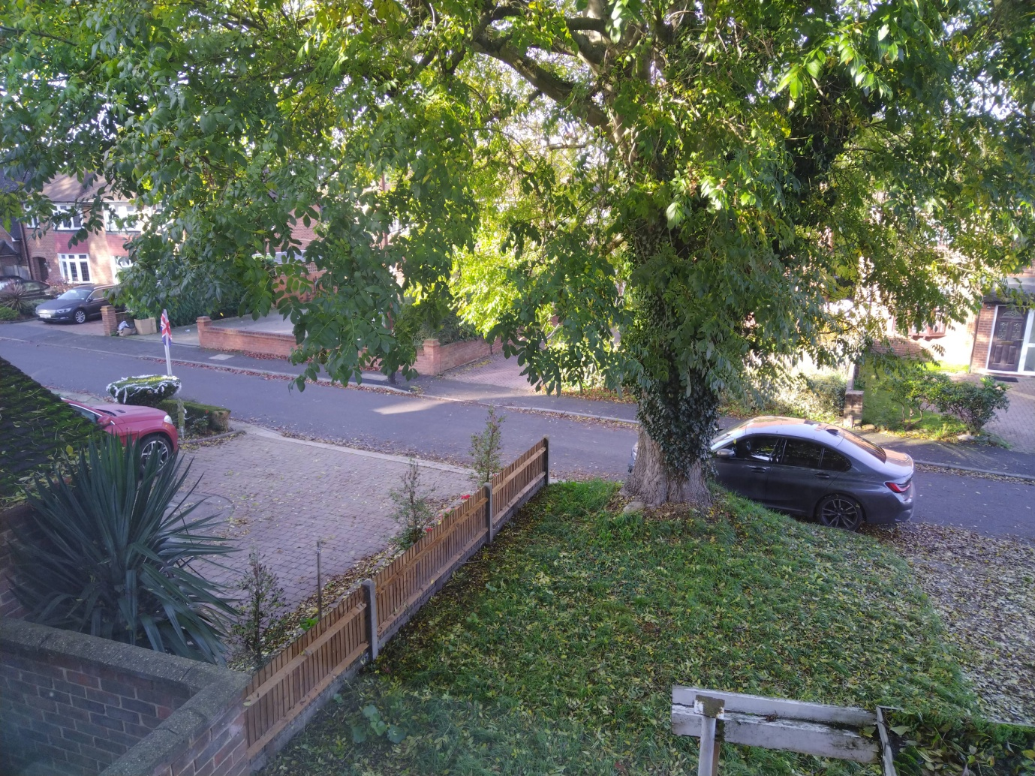
Photo 11/19
INCREASED OCCLUSION LIGHT: REAR OF MY PROPERTY
The ash excessive occlusion light is compounded by the fact a neighbour’s tree of the same height but different species not subject to a TPO is situated opposite my ash tree at the rear of my property!
Their tree has grown virtually the entire width of my garden for the fact it has never been pruned and equally out of control. The excessive occlusion light has dramatically obstructed my view and means I am sandwiched between both trees with minimal sunlight and cold with no views front and rear of my property. Given the lack of sunlight my house has been reduced to a dark, damp, cold, very oppressive cave and is very distressing and unreasonable
As evidenced in these photos, I am also unable to see my neighbours’ houses opposite in full view when the tree is in full leaf
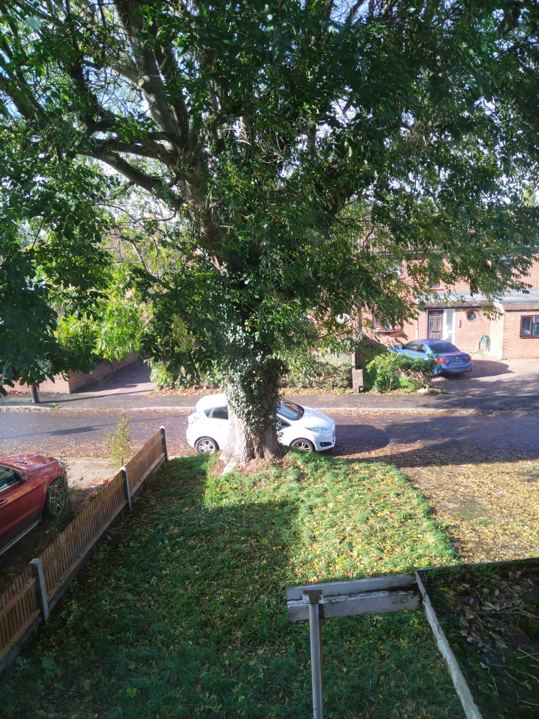
Photo 12/19
ONGOING OCCLUSION LIGHT DURING ‘SUNSHINE’

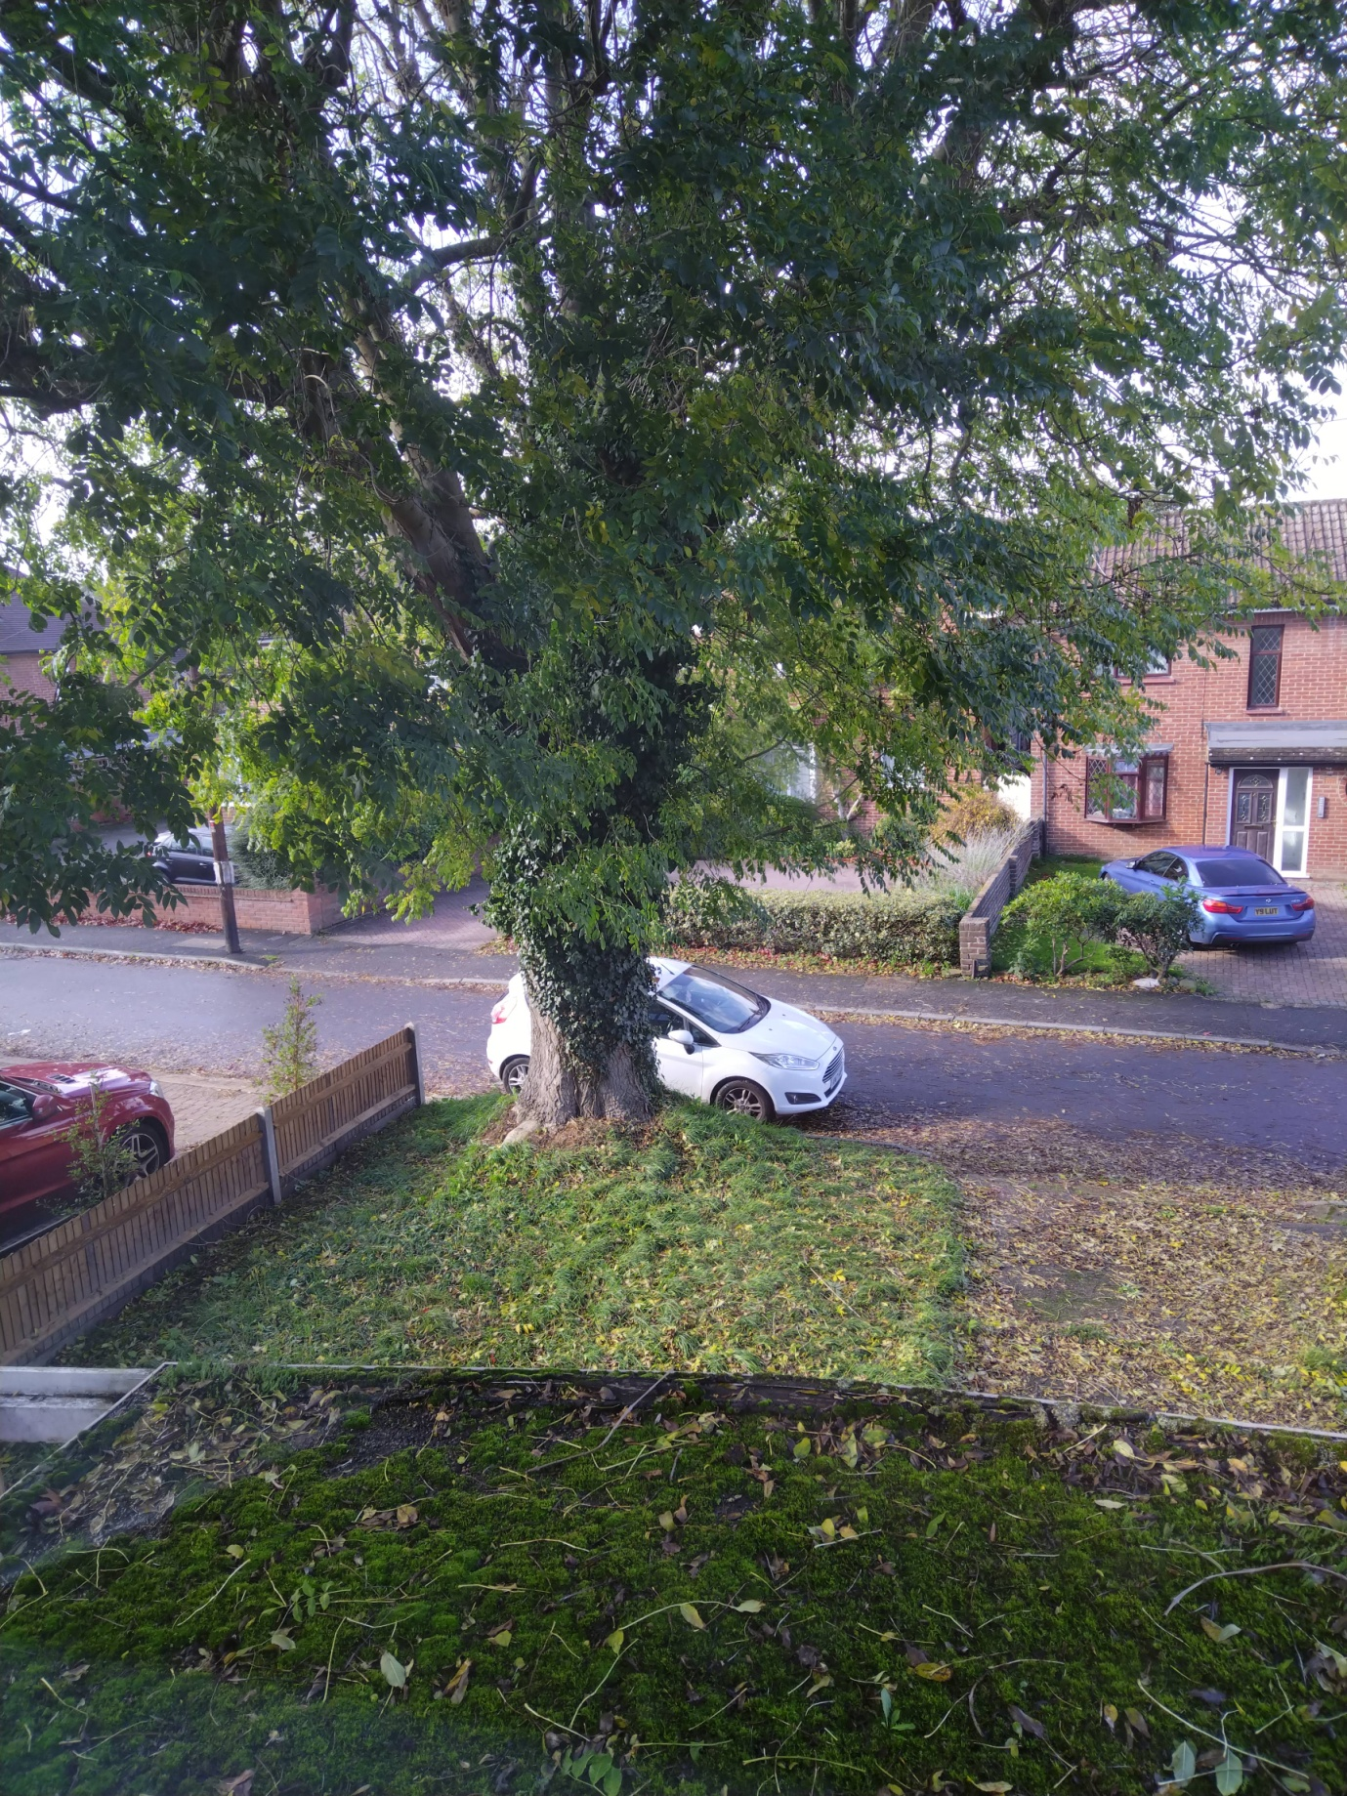
Photo 13/19

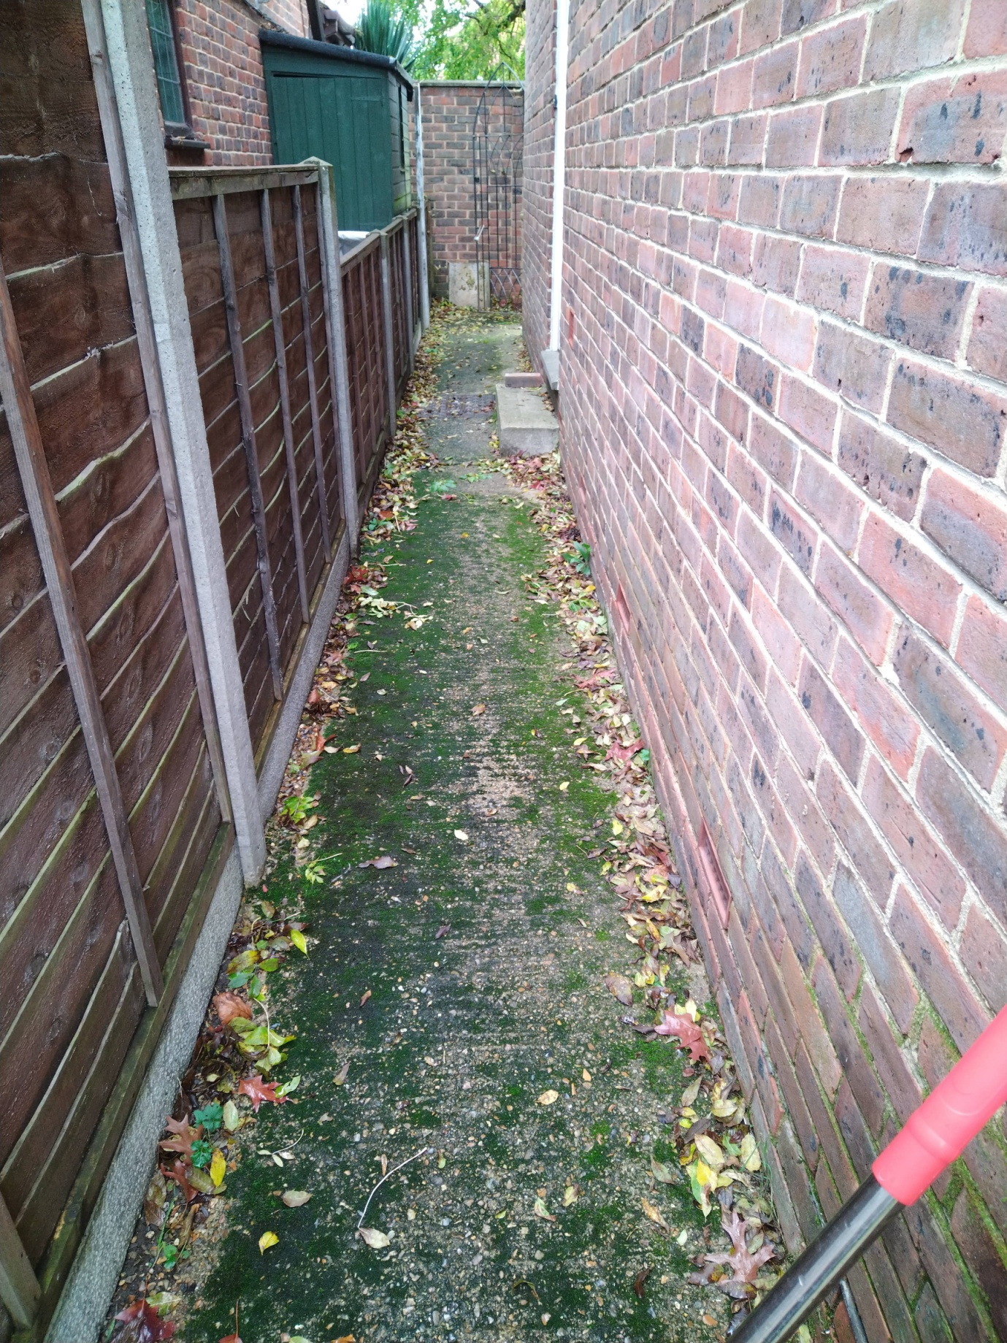
Photo 14/19

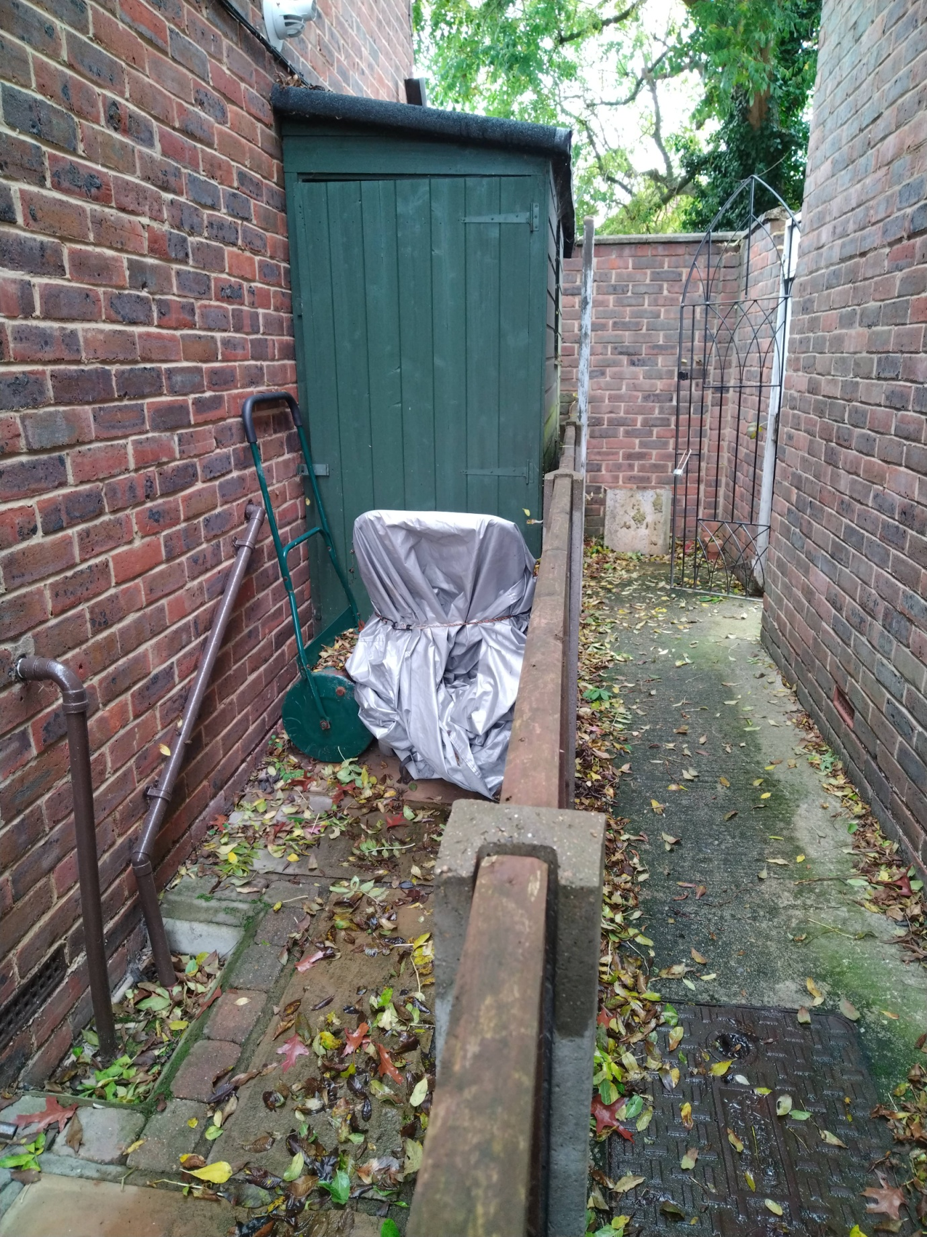
Photo 15/19

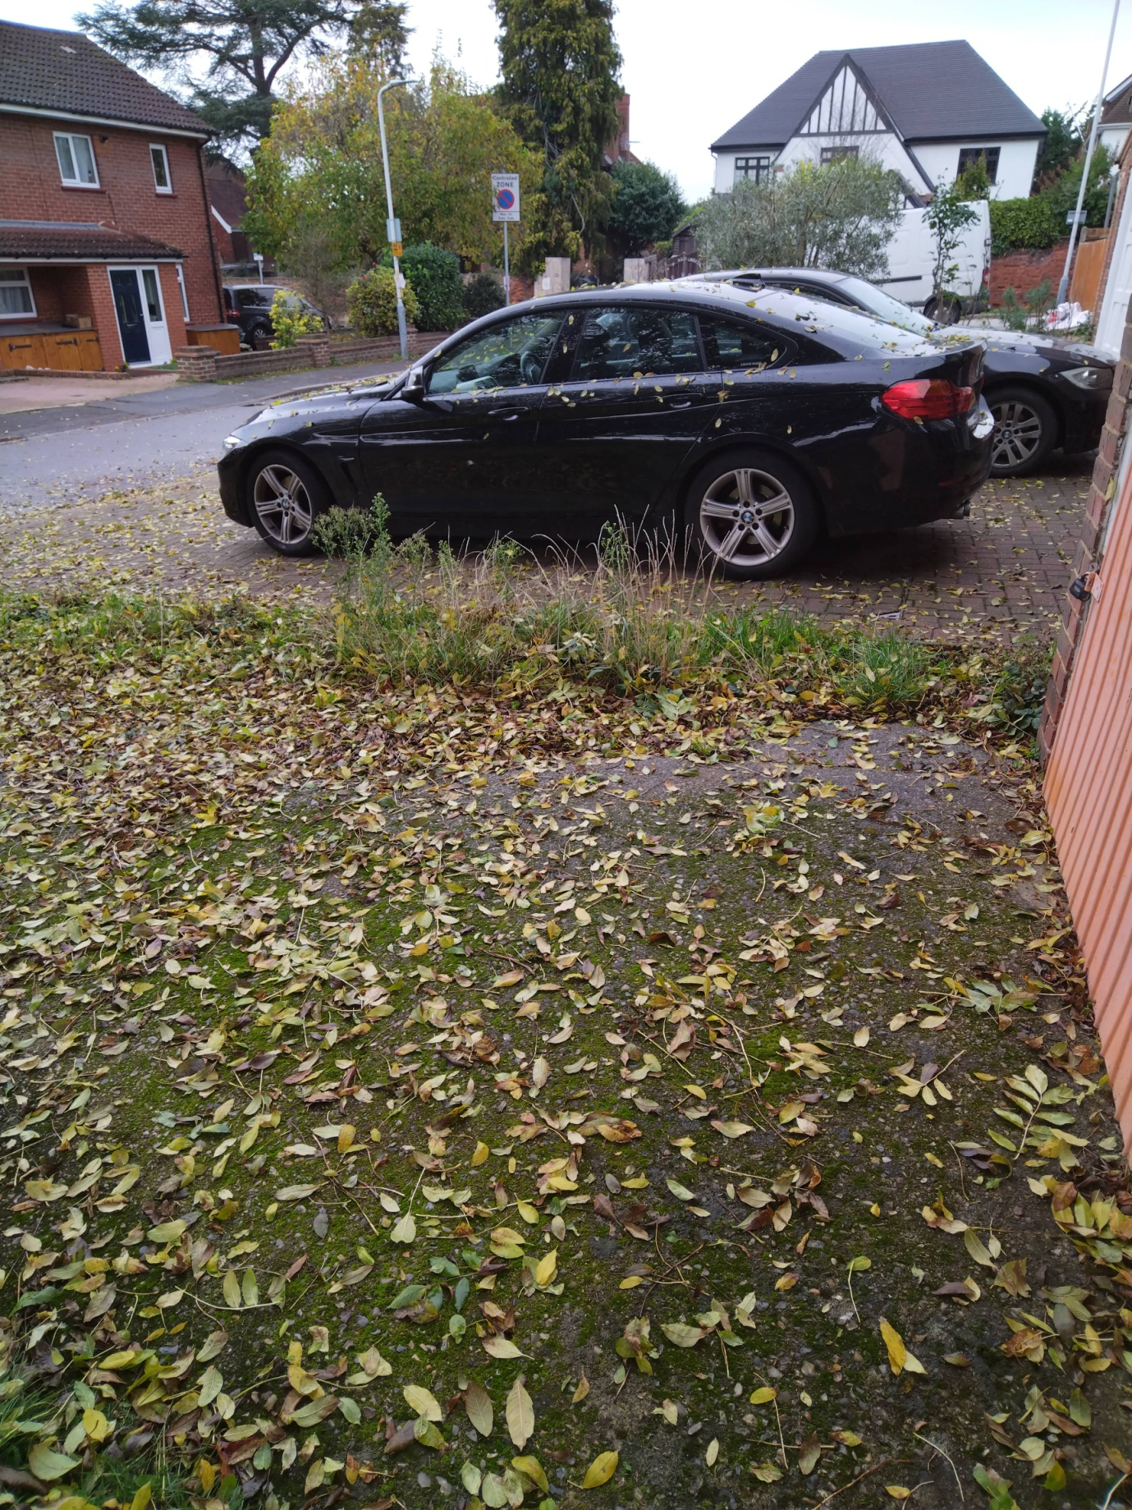
Photo 16/19

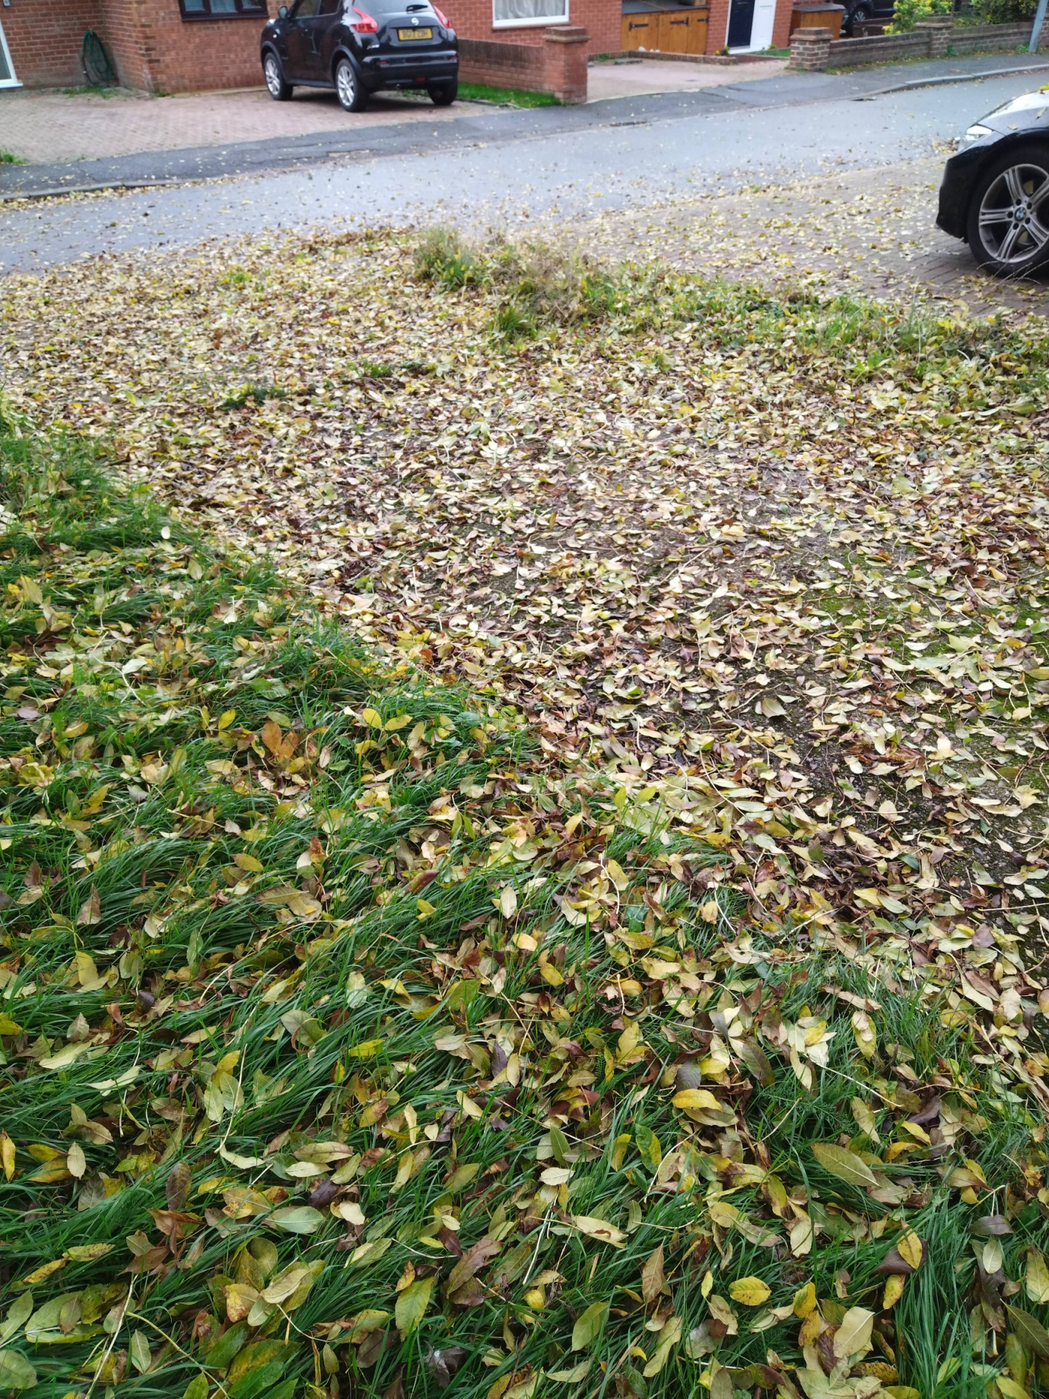
Photo 17/19

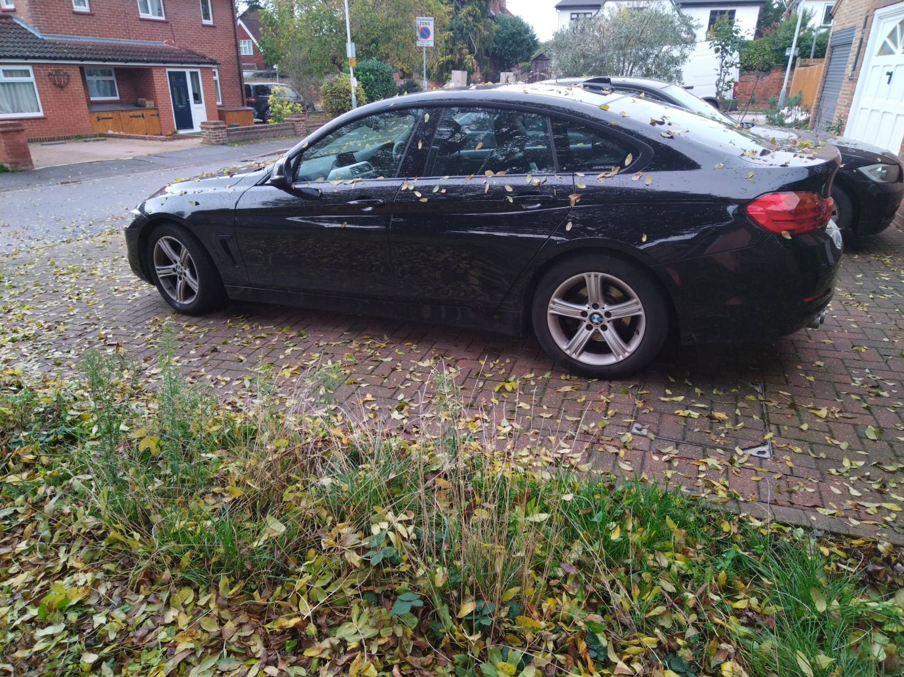
Photo 18/19

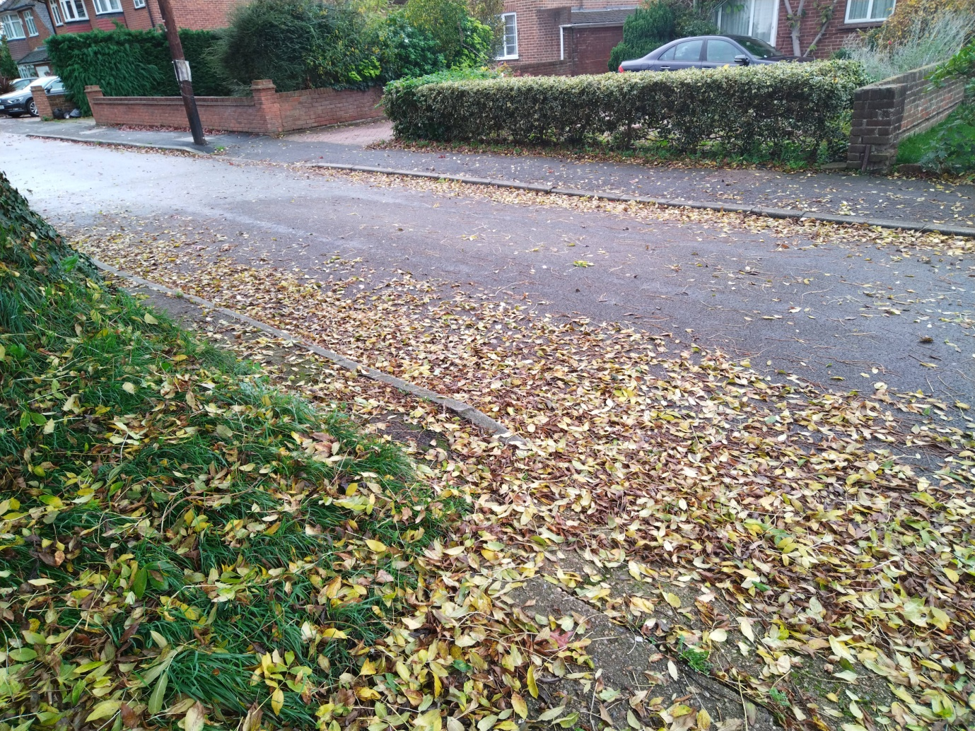
Photo 19/19

E Baxter

