Design and Access Statement - Civic Forecourt upgrades and Former Fraud office entrance area.

- Introduction
1.1 Purpose of the Design and Access Statement
This Design and Access Statement has been prepared to support a planning application for proposed changes to the public realm surrounding the Council Civic Centre, a listed building of architectural and historic significance. The purpose of the Design and Access statement is to:
- Explain the design rationale behind the proposed alterations ensuring they respect and enhance the character and setting of the Civic Centre.
- Demonstrate how the proposals respond to the building’s heritage status.
- Provide context and justification for the materials, layout and landscaping.
  - Site Location
The site is located within the public realm surrounding the Hillingdon Civic Centre, High Street, Uxbridge, UB8 1UW. See Site Location plan scale 1:1250.

2. Context
  - Context of the Proposals
In July 2025 Hillingdon Council formally adopted the Uxbridge Vision. The Vision provides a long-term strategy for enhancing Uxbridge town centre, attracting investment, supporting the high street and businesses, providing greater amenity for residents and visitors and a framework for investment decisions. It contains a number of short, medium, and long term interventions – some of which will be Council-led and others as principles to guide market-led interventions. These Council-led interventions focus on where we can make better use or diversified use of assets, and enhance the public realm, public transport and highways network in Uxbridge to support the priorities of the Vision.

The Civic Centre Forecourt is a public open space within Uxbridge’s bustling High Street. It provides a public bookend to a parade of shops and associated public realm. It has significant potential as a public asset which bookends the high street and as a space for markets and events drawing people down the High Street.

The Vision document outlines a range of enhancements to the Forecourt aimed at realising its potential and creating a more vibrant, active public space. The proposals presented in this Design and Access Statement have been developed by the Design Officers. These are Phase 1 of the improvements to the Civic Centre Campus public realm. Future phases will be subject to further applications in due course (where applicable)

Broadly, the purpose of the proposed changes is to improve legibility, accessibility, allow the Forecourt to play a more active role in the life of the high street through provision of markets and events, and to support access to numerous council services, including Uxbridge Library, Registry Office and Family services. The Civic Forecourt is identified in the Uxbridge Vision as being well suited to host events and markets, bringing activity to the town centre and supporting the economic viability of the high street.
This proposal and implementation of any changes is funded by grant funding, specifically the UK Shared Prosperity Fund (UKSPF) high streets regeneration.
2.1 Historic Context
The Hillingdon Civic Centre is Grade II listed. The office Historic England’s listed entry includes integrated hard landscaping, including paving, planters, steps and walls. Although these elements are not included in the blue area on the List entry map as the map is only schematic.
A separate Heritage Statement is submitted to support this application.
2.2 Site Context
The areas covered by the proposals are the public realm area of the Civic Forecourt and area beyond the arch leading to the former Fraud Office. See Block Plan Scale 1:500.
2.2.1 Existing Civic Centre Forecourt Context – See Existing Forecourt drawing 1:250.
The Civic Forecourt is a generous public space enclosed on three sides by buildings and ramp with open edge onto the High Street. The materials and detailing were designed to complement the architecture of the Civic Centre, creating a cohesive and well-integrated designed space.
This space has few available dwell opportunities, and suffers from poor wayfinding, partly due to obstructed views of key entrances caused by existing trees and the poor placement of signage directing users to various Council service entrances within the Civic Centre campus. The area is also less suitable for hosting markets or events, as the centrally positioned trees restrict the use of the Forecourt.

Additionally, the undefined frontage along the High Street lacks clear spatial definition, blending into the street rather than presenting itself as a distinct civic or social space.
2.2.2 Existing Former Fraud Office entrance Area - See Existing Ramp Plan, Sections and Elevations.
The fraud office entrance area was originally designed to create a discrete separate entrance area. It consists of a staircase from a lower level up approximately 1.6m (half a storey) to an upper level to the office door. The top landing area is generous and includes a large planter.
However, the stair landing area and planter are structurally unsound and require remedial works (with a growing crack clearly visible, suggesting incremental subsidence). In addition, the space does not meet accessibility standards lacking step-free access inside or out. As a result, the office has remained vacant for some time.

      - Design Proposals
3.1 Civic Forecourt Design Proposals introduction
The Civic Forecourt proposals covered by this submission are part of a wide programme of proposed public realm improvements in Uxbridge town centre which the Council is exploring. While grant funding has been committed to the proposals in this submission, the wider programme is funding-dependent; therefore this submission can be seen as ‘Phase 1’ of a proposed programme where officers will be seeking grant funding to move forward with further improvements. Later phases and projects have not yet been designed in more detail than provided in the Uxbridge Vision.
'Phase 1’ will be achieved due to the proposed part removal and part replacement of three existing disabled parking bays at the northeast corner of the Forecourt subject to statutory consultation of the Traffic Regulation Order. These car parking bays are located at a key pedestrian entry point into the space (see Fig 1) Relocating these bays creates an enhanced entrance from the High Street to the forecourt space with clear views to key entrances to the buildings (Library and Main Reception).
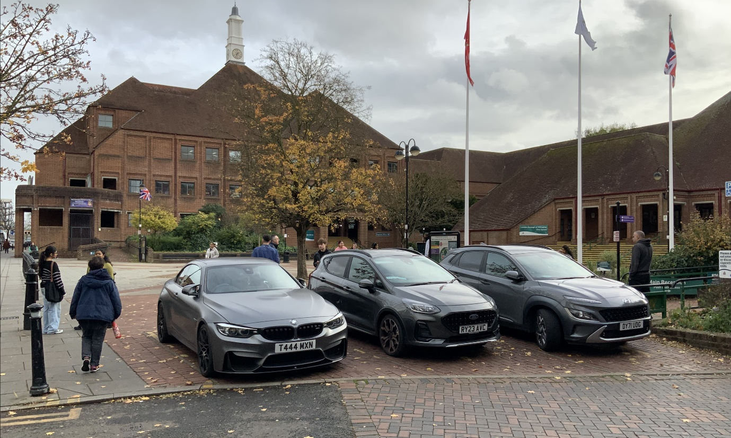
3.2 The Forecourt Design Proposals – see drawing Proposed new trees and surfacing works.
The Forecourt Proposals include the following:
- Two trees within the Forecourt are proposed for removal, one of which is diseased and must be taken down for safety reasons. These will be replaced with three new trees along the High Street edge.
This approach removes the two trees currently obscuring key views of building entrances and restricting space for events and markets within the Forecourt. The new trees will instead help to define and enclose the Forecourt, providing a strong green edge that enhances the setting and creates an attractive visual transition between the High Street and the Civic Centre.
The replacement trees will be planted with generous soil volumes to support healthy growth, allowing them to reach full maturity and ensure long-term longevity. See drawing Tree pit plan and section.
- Relocation of the existing bollards to the edge of the paving to avoid ad hoc informal parking.
- Reinstatement of the paving surfacing to original pattern using like for like materials.
3.3 The Ramp Design Proposals Introduction
The purpose of the ramp proposals is to address structural issues and make the former Fraud Office space accessible, thereby increasing its potential for use by the Council and ensuring that this part of the building remains in occupancy and avoiding further deterioration over time (see Fig 2).
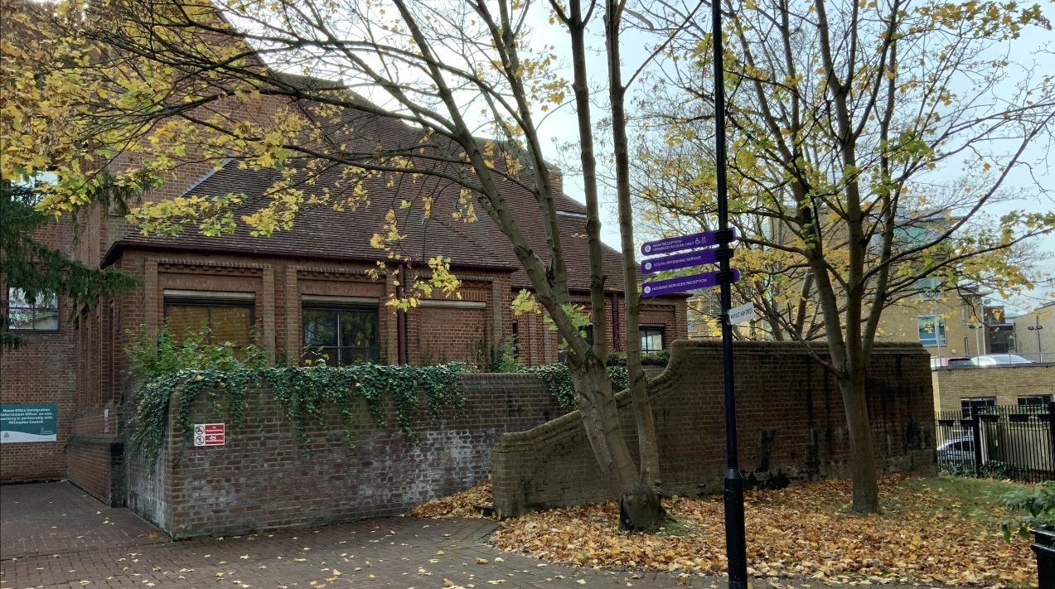
3.4 The Ramp Design Proposals– see drawings Proposed Ramp Plan, Proposed Ramp Elevations and Sections.
The proposed ramp is designed to fit within the footprint of the existing planter, landing area, and stairs, resulting in minimal alterations to the external walls.
An accessible ramp has been incorporated within the external walls to provide inclusive access for all users. The design integrates a planter that complement the hard landscaping and is consistent with the original design intent and heritage character of the Civic Centre.
The door to the former Fraud office will be increased in size to include the existing window and will be accessed via a small ramp up the existing approximately 100-150mm level difference between the landing and interior floor level, (see Fig 3).
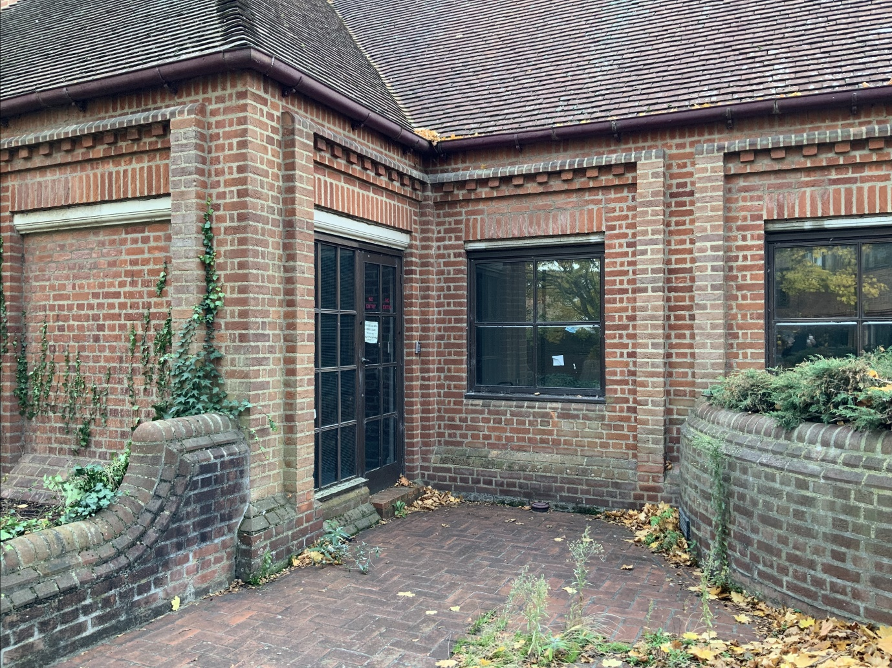
The proposed materials will be recycled from the existing stairs and external walls. The material of the ramp will be a bounded gravel colour matched to the brick retaining walls.
4. Conclusion
The proposals for this Listed Building submission aim to enhance the Civic Forecourt by creating a clearly defined entrance space, improving sightlines to the building entrances, and introducing tree planting along the High Street to provide a sense of enclosure. These works form the first set of the works to deliver a more multi-functional public space. This approach is fully compliant with relevant planning policies.

