Highford Design and Build Ltd
1 Peel Way, Hillingdon
Planning Application for front porch
info@highforddesign.co.uk

Design Statement
- The proposal is to build a pitched roof front porch.
- The proposal has been designed in the same way as the previously constructed schemes at

20 Peel Way
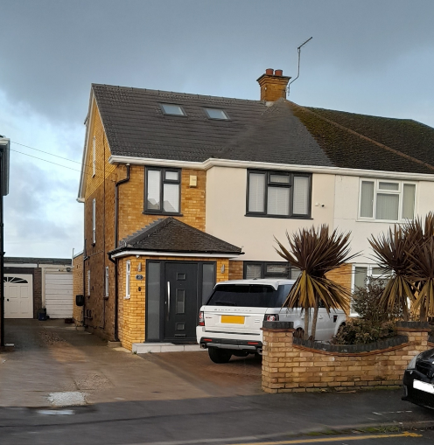

21 Peel Way
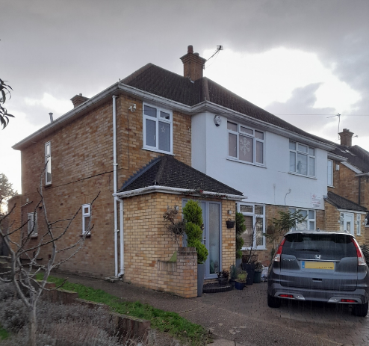

The Building
1 Peel way is a semi detached corner plot property in a residential road in Hillingdon. The property has been recently extended to the rear and has planning permission for a single storey side extension approved under application numbers 14702/APP/2022/2957 and 14702/APP/2023/6

