Highford Design and Build Ltd
1 Peel Way, Hillingdon
Planning Application for Single Storey Side Extension
info@highforddesign.co.uk

Design Statement
- The proposal is to build a pitched roof single storey side extension to the building.
- The proposal has been designed in the same way as the previously approved schemes at 31 and 33 Peel Way and the scheme recently approved at appeal on 29th April 2022 at 15 Peel Way

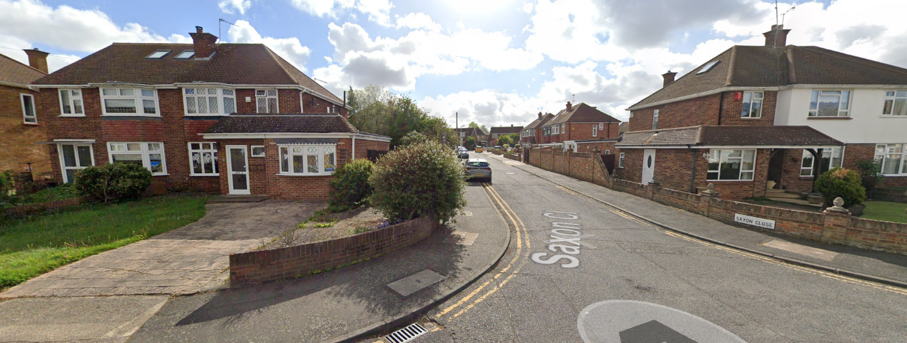
Previously approved extensions at 31 and 33 Peel Way

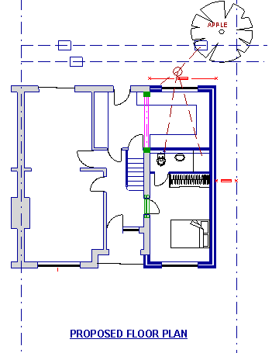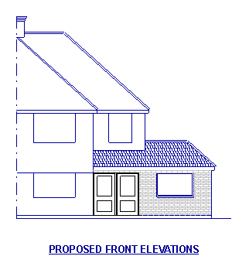
Previously approved by appeal at 15 Peel Way

- The extension is required, initially to provide ancillary accommodation for use by an elderly member of the family.
- The proposal has been designed to provide living/sleeping space and a shared ground floor shower room/WC
- The extension has been designed to match as closely as possible the existing elevation, with similar materials. The proposed materials will match existing

The Building
1 Peel way is a semi detached corner plot property in a residential road in Hillingdon. The property has been recently extended to the rear.

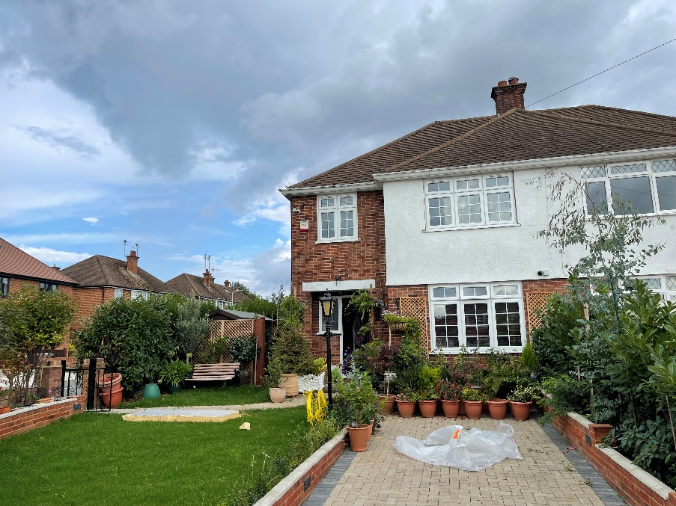
Front Elevation of 1 Peel Way

Previous Applications
- 31st January 2012 – 2.8m wide single storey side extension APPROVED at appeal ref 14702/APP/2011/1153
- 14th November 2019 - 3.85m wide single storey side extension REFUSED reference 14702/APP/2019/3106
- 3rd March 2020 - 3.1m wide single wide storey side extension REFUSED reference 14702/APP/2020/37
- 30th April 2020 - 3m deep single storey rear extension APPROVED reference 14702/APP/2020/902
- 11th May 2020 - 2.8m wide single storey extension REFUSED reference 14702/APP/2020/901

Summary
A scheme (1) similar in width to the currently proposed scheme was approved in 2012, and although subsequent attempts for larger extensions have been refused.
The current proposal has been designed with the same aesthetic and dimensions as the recent scheme approved at 15 Peel Way (Appeal decision for that project has been appended to this application)

