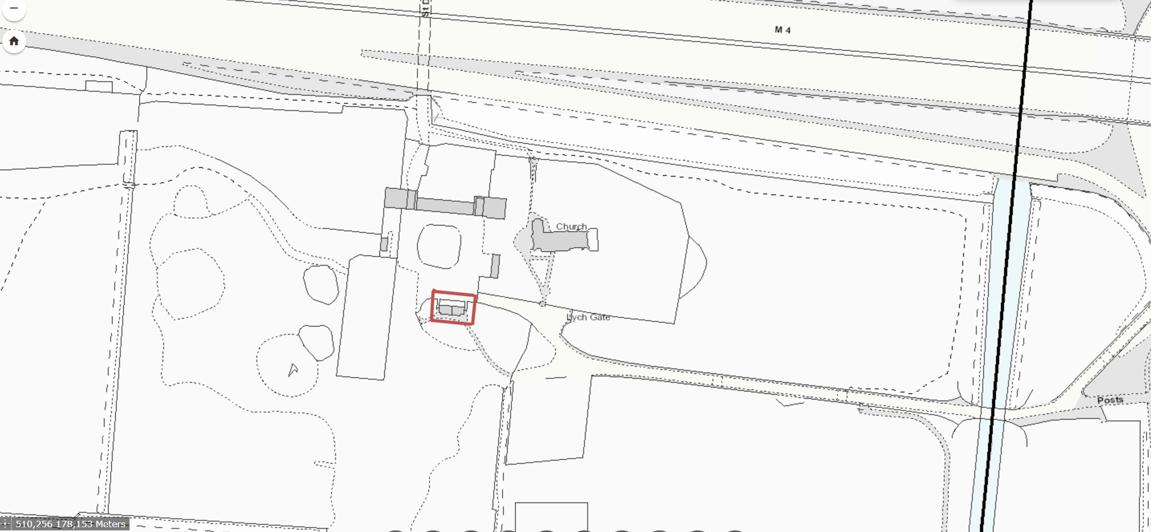

Location of Information Centre at Cranford Park, The Parkway, Hayes, TW5 9RZ

