DESIGN AND ACCESS STATEMENT

Cranford Park Stables, The Parkway, TW5 9RZ

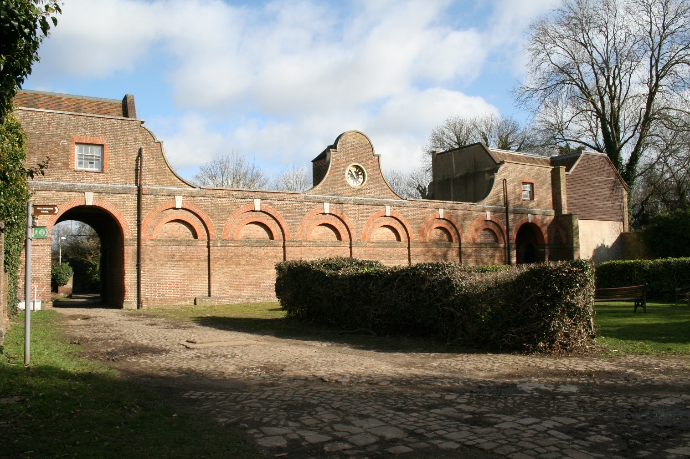

Charmian Baker
BA, BTP, MA, MRTPI, IHBC
Project Manager
Cranford Park Project

May 2021

Contents

- Introduction

- A Brief History

- The Stables (Grade II)
  - Description of the Stables
  - Condition of the Stables
  - Proposals for the Stables

- Garden Walls to North of Stables (Grade II)
  - Description of the Garden Walls
  - Condition of the Garden Walls

- Significance of the Listed Buildings
  - South Façade
  - Ground Floor Stables
  - Historical Connection of the Stables with the Berkeley Family and the story of Cranford Park.

- Design Concept
  - Condenser Enclosures
  - Insulation

- Accessibility

- Conclusion

1.0 Introduction
This document relates to the planning and listed building applications for the Stable Block at Cranford Park, within the London Borough of Hillingdon.
The scheme forms part of the proposed restoration of Cranford Park, which will enhance the heritage significance of both its architecture and its landscape. This project, funded with a contribution from the National Heritage Lottery Fund, will include:
- The restoration and reinstatement of key historic buildings, features and landscapes.
- The provision of restored and new visitor facilities with interpretation
- An Activity Plan which will encourage and engage new diverse audiences to the park.

2.0 A Brief History
Cranford Park was owned by the Berkeley Family for 300 years, from 1618, when Elizabeth Berkeley, a great niece of Anne Boleyn, bought the estate, right up until 1918. A longer history has been set out in the Heritage Statement, and in detail in the Conservation Management Plan.
Cranford House and its hunting Stables were built by the third Earl in the early 18th century. The house was eventually demolished in 1945 as was the southern wing of the stables. In the 1930’s, Cranford Park was sold to the local district councils of Hayes and Harlington and Heston and in 1949 the estate was opened as a public park.
The surviving north wing of the Stables is the only building to survive from the Berkeley days. It has lain vacant since the early 20th century, although one room was used by St. Dunstan’s Church for a few years, in the 1980’s.
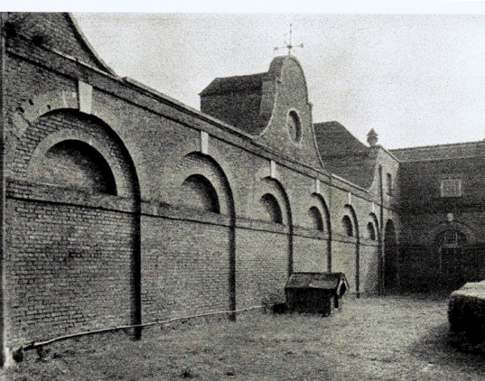
Stables in 1935
3.0 The Stables (Grade II)
3.1 Description of the Stables
The stable block lies to the north of the original mansion site and dates from the early to mid1700’s. The stables were built of brick with a tiled roof and stand on the northern and eastern sides of a large, cobbled courtyard.
The surviving part, the northern wing, was built of brown brick with red dressings with the central section having a facade with parapet, large semi-circular blind arcading and a central Dutch gable with inset clock. To the rear of the central section is a lean-to structure, of later date than the main range and of no architectural merit. Access to this central section of the building is only via the rear yard.
Either side of the central section, and separated from it by two arched carriage entrances, are two, two storey blocks, incorporated into the overall façade. The eastern entrance still retains its original timber gates at the rear, the western one only the supporting pins on either side. There is evidence in the side walls within both gateways of bricked up openings which would have accessed the original central section.
Either side of the aches is a door through to the ground floor horse stalls and a door leading to an internal staircase to the first floor. The first floor on the west side incorporates two rooms, the east side, three, although these linked originally with the rooms over the eastern range, now gone. There are still corner fireplaces extant in both blocks, although all other internal details have been lost. These rooms constituted the grooms’ quarters, and there are accounts at Berkeley Castle of the furniture provided in them in the 19th century.

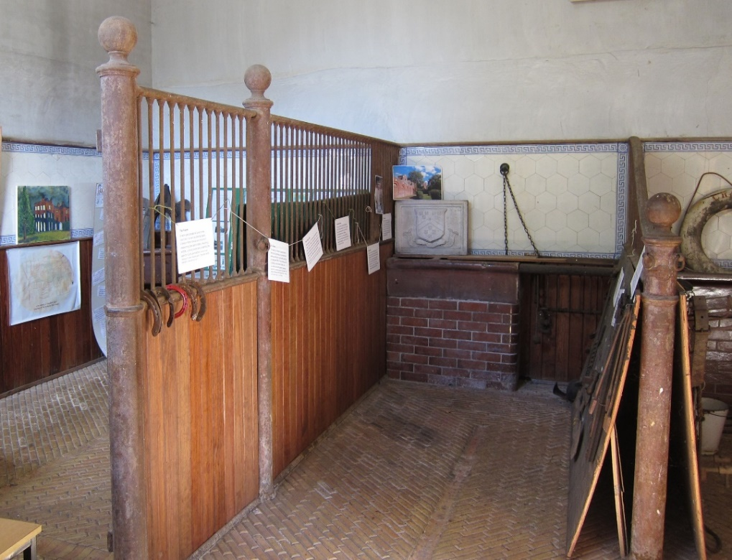
Stables West Side, Ground Floor
The ground floor on both sides have the original stalls, with timber and metal divisions. The western stable block has a loose box and two stalls, with 18th century mangers, troughs, hay baskets, wall tiling, stall dividers, retaining rings and a herring bone brick floor with drainage gullies. There is a ventilation shaft which passes through the ceiling and is opened and shut by a paddle on the landing above. The western Stables now house memorabilia and old photographs.
The eastern stable block has four stalls, again with its18th century fittings intact and the termination point for a ventilation shaft.
The clock in the Dutch gable is by Langley Bradley and its mechanism is still in place. It is dated MDCCXXI, shortly before the stables were built, and is believed to have come from Hampton Court Palace.

3.2 Condition of the Stables
The eastern block is in poorer condition than the western one, following the theft of lead from the roof and the ingress of water. In addition, a fire was lit by squatters in the stables at ground floor, when some of the dado panelling was used as fuel, causing smoke blackening and loss of fabric. Currently, both ground and first floor are propped with scaffolding internally.
A survey undertaken in March 2021 demonstrated that the floorboards in the room over the arch had considerable dry rot within them and at a higher level, within the wall timbers and some of the rafters, there was much evidence of insect infestation.
On the ground floor of the western block, there is evidence of damp on the western side and this has buckled the dado panelling, pushing it out from the wall. This has almost certainly been caused by the much higher ground level outside it to the west, which has bridged the slate damp proof course. This situation has also allowed considerable woodworm to develop. Other than this, the western side of the stables is in reasonable condition.
Both sides of the stables have suffered from repeated vandalism and break-ins, leading to the installation of metal gates across their openings. Unfortunately, windows have been smashed and the outer, boarded doors on both sides have been badly vandalised.
The Stables has been included on the Historic England’s ‘Heritage at Risk’ Register

3.3 Proposals for the Stables
The proposals would enable the re-use of all parts of the two stable blocks once again. The ground and first floor rooms on the eastern side would be let, and listed building consent for a toilet and kitchenette in the smallest of the first floor rooms was granted for this alteration in February 2020. Interest in renting the accommodation has been expressed by a group promoting affordable floor space for artists and the creative industries.
The first floor on the western side is to be used as office space for the on-site staff: Site Manager, Community Engagement Officer and Apprentice, to be employed as part of the Project. There will also be space for the Friends Group to meet and to store smaller items of equipment and materials. The ground floor on the western side is to be refurbished, set out and interpreted as stables once again, with a soundscape to complete the effect.

4.0 Garden Walls to North of Stables (Listed Grade II)
4.1 Description of the Garden Walls
The walls listed as being north of the stables are of two builds: the low wall circling the graveyard of St. Dunstan’s Church and the tall, red brick wall surrounding the courtyard at the rear of the stables. The section immediately to the north of the Stables and abutting it just below the staircase window, is about 3 metres in height, descending to 2 metres at its northern end. It is of dark red brick and has two blocked semi-circular headed doorways within it. Although the straight joint indicates that the wall post-dates the stable block, it is nevertheless likely to be of late 18th or early 19th century date. On mid19th century maps, a small building is shown on the eastern or graveyard side of the wall in this location and the blocked doorways are likely to have related to this.

4.2 Condition of Garden Walls

The section of wall immediately to the north of the Stables is in reasonable condition, although it does require repointing and there are patches of mortar adhering to the bricks in places, indicative of an adjoining building, since demolished.

5.0 Significance of the Listed Buildings

The architectural and historic significance of the listed stables lies principally in its southern façade, the survival of the stables and original fittings at ground floor in each of the two storey wings and the historical survival of such a key building from the Berkeley’s Cranford Park estate.

5.1 South Façade

The south façade is the historic face of Cranford Park. Its Dutch gable with clock, blind arcading, handed archways and symmetrical two storey blocks are of architectural importance and a considerable source of local pride. The Dutch gable is the emblem chosen for the logo of the Cranford Park Friends.

The front façade is somewhat obscured on the west side however by the ‘Secret Garden’. This is a rectangular open courtyard surrounded by red brick walls, some 3 metres high. It filled in the area between the Stables and the northern or service wing of the house. It has only one narrow doorway now, although there is evidence of many earlier openings, since bricked up. It has one greenhouse, though once there were two or three, a well with pump and a vine. It has been partially filled with flower beds, which are cultivated by the Cranford Park Friends.

The ‘Secret Garden’ is kept locked and its interior is only visible on open days, currently three times a year.

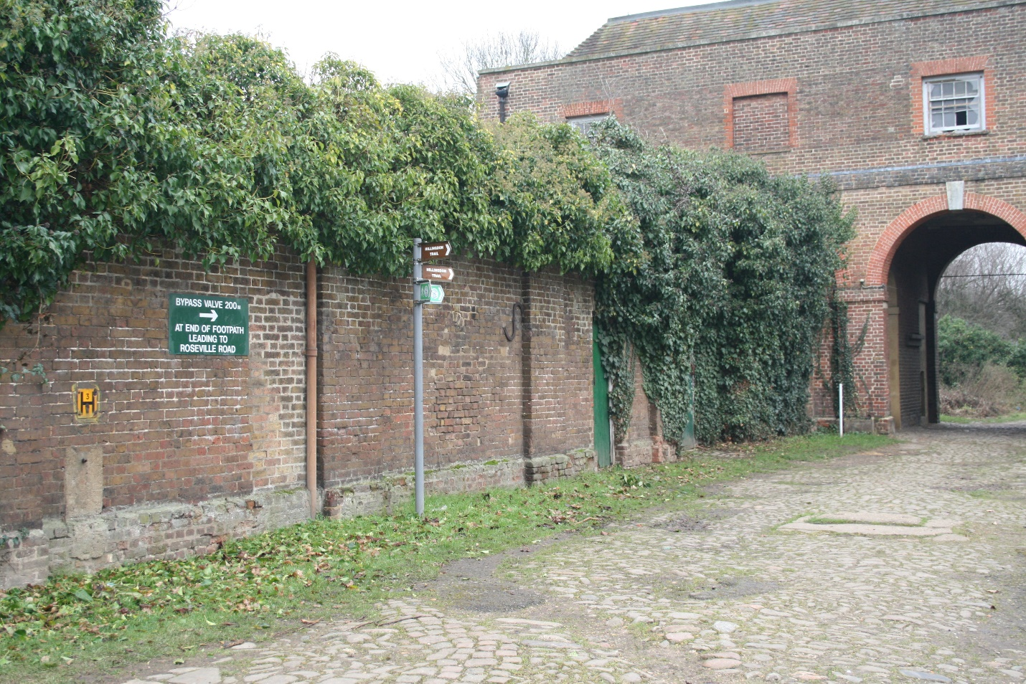

The ‘Secret Garden’ from the Courtyard
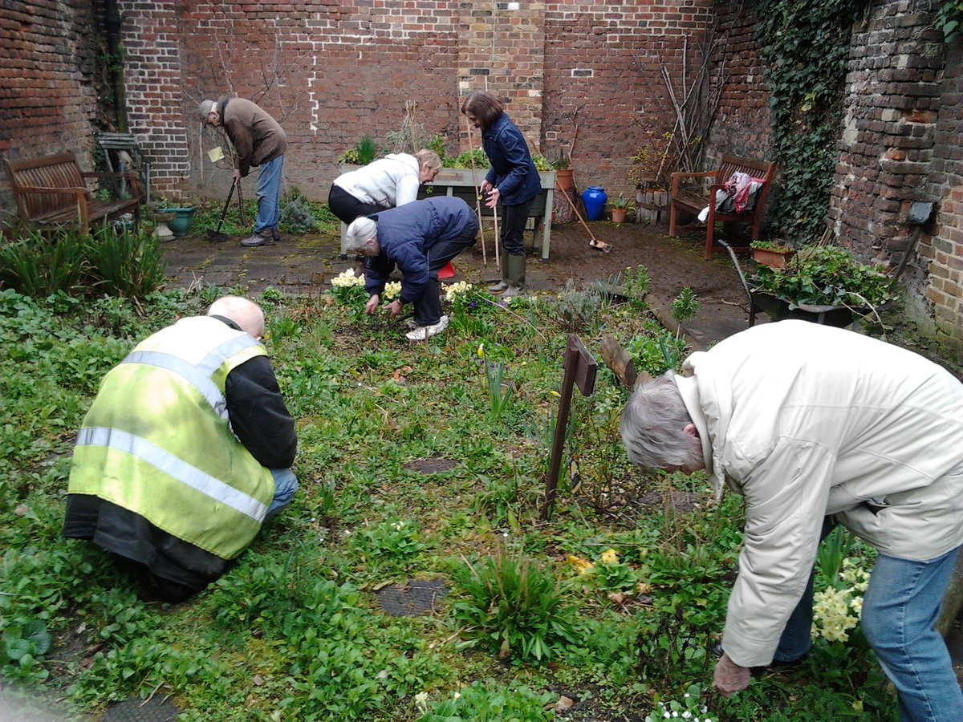

Volunteers at Work within the Secret Garden. The Stables Wall is in the background

5.2 Ground Floor Stables

These are a particularly good survival of early 18th century stables, with all of the original fixtures and fittings intact. They are greatly prized by both the Cranford Park Friends and visitors on Open Days. The project proposes to refurbish both western and eastern stables and interpret and open the western stables to the public on a regular if not daily basis. The eastern stables will be let for community use.

5.3 Historical Connection of the Stables with the Berkeley Family and the story of Cranford Park.

The Stables are an integral part of the Berkeley Family story. The house was used as a hunting lodge for much of its existence, and the stables, housing the family’s horses, were an important part of this. The fact that they survive so well, helps tell the Berkeley story.

6.0 Design Concept

6.1 Condenser Enclosures

The Stables need heating to enable a beneficial use and to bring in an income to sustain their maintenance in perpetuity. Without this, they will remain At Risk.

The most efficient energy source are condensers, which act as air source heat pumps. They are much less wasteful of energy than other options and give off no gases or particulates. These condensers (one for each floor) have to be sited externally and their service runs need to be taken around internally on both floors. The main considerations for their siting are:

Firstly, that they do not detract from the iconic south façade. One condenser enclosure is to be sited within the Secret Garden and the other at the rear of the building, which is of little interest visually.

Secondly, that they are protected from vandalism, accidental damage or interference. Both pairs of condensers are to be sited within locked areas, and will stand within treated softwood enclosures 1800 high, 2900 long and 1300 deep.

On the western side, the pipes will go through the wall at the rear of the condensers, and around the stables on the south and west walls at high level, with the heaters on the south wall and above the loose box on the north wall. The most significant views within the stables are of the north wall and particularly the two stalls. The proposed heaters are very similar to the wall mounted light fittings already in situ. At first floor, the pipes can be concealed behind the thermal insulation.

On the eastern side, the condensers will be sited against the Garden Wall to the north, away from the rear of the Stables. The pipe will go through the wall to the Churchyard side and through the wall of the Stables, continuing inside at a high level at ground floor with the heaters on the northern side, the main views of the horses’ stalls being towards the east.

At first floor, the pipes can be concealed behind the thermal insulation.

.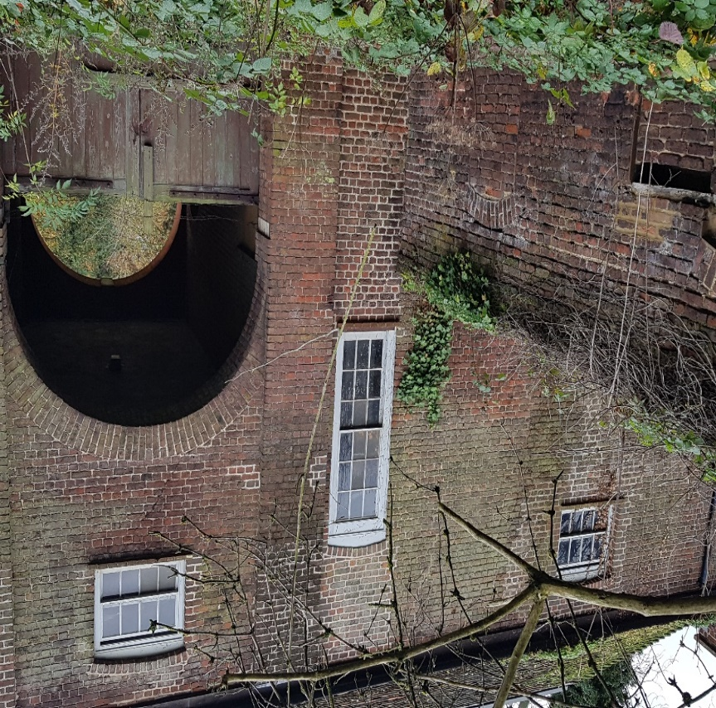
Garden Wall to the North of the East Side of the Stables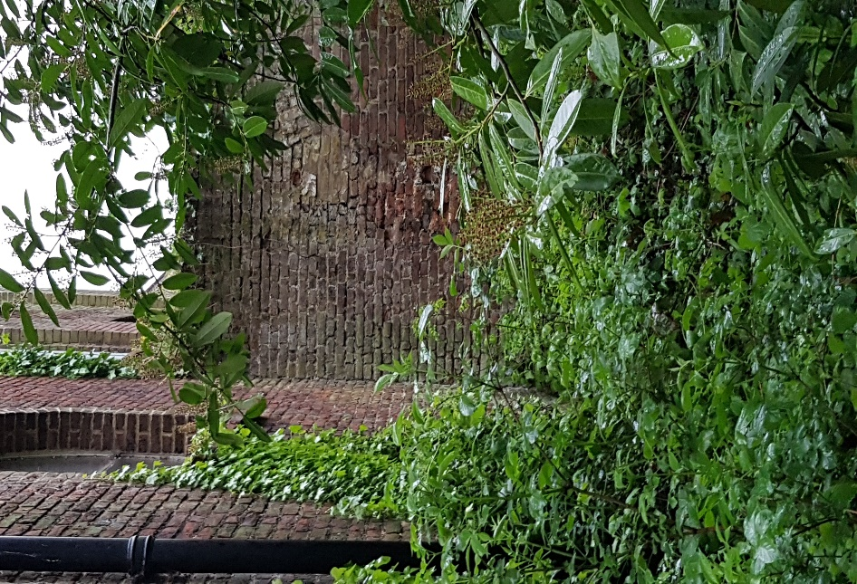
Garden Wall to the North of the East Side of the Stables, Churchyard Side
6.2 Insulation
To ensure that the heating is energy efficient, thermal insulation is needed to prevent heat loss. This insulation will only be applied to the inner faces of the exterior facing walls, at first floor, which is the minimum necessary to achieve the objective. Thus alterations to the areas of greatest architectural and historic significance will be avoided. Similarly, only the windows to the habitable rooms at first floor will have secondary double glazing, and this will respect the depths of the thermal insulation.

7.0 Accessibility
Whilst the Cranford Park site as a whole is to be made more accessible to visitors with disabilities, the Stables is a listed building with no means of making it fully accessible. It will thus only be accessible, as now, to disabled visitors at ground floor. However, the upper floors will not be open to the public being used as offices and workshops.

- Conclusion
The Stables have a very impressive south façade, great interest at ground floor and they played an important part in the Berkeley Family history. For these reasons, they are a source of great pride to the Cranford Park Friends and the local community.
They will be repaired and interpreted accordingly as part of the project. However, their long term future is in jeopardy if they are not given a sustainable use for offices and workshops, to bring in a modest rent. To achieve this, heating must be provided, in a manner which is as energy efficient as possible, with insulation at first floor to ensure there is a minimum of heat loss.
The design of these proposals has been carefully considered to produce the least impact on the views and the features of the Stables which have the greatest architectural or historic significance. Unfortunately, the accessibility of this listed building cannot be improved beyond the existing situation.

