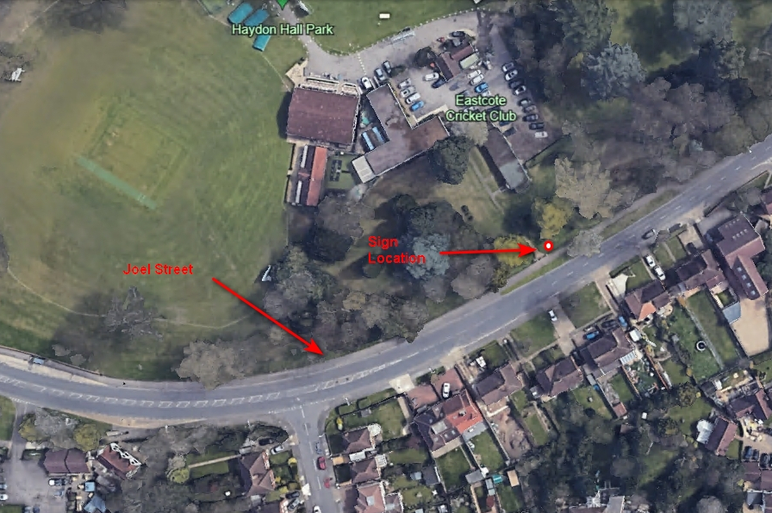
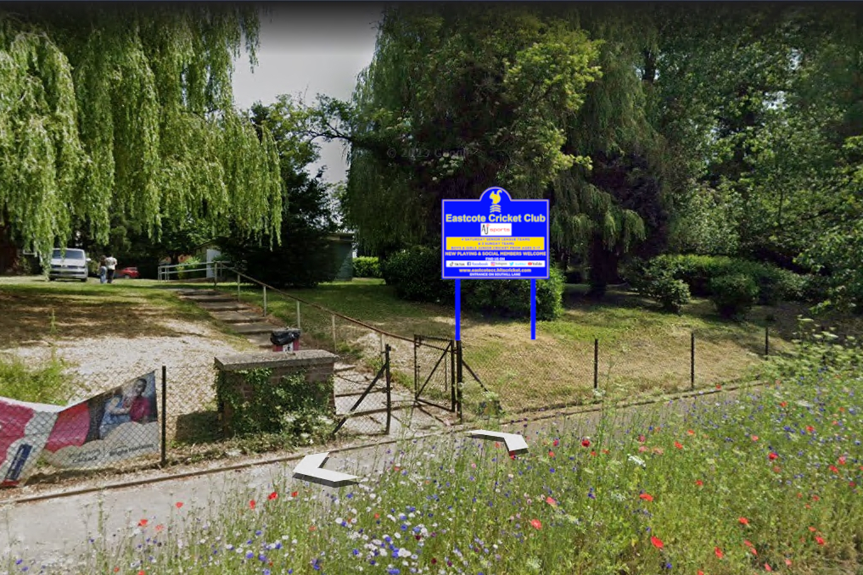
The sign will be opposite 282 & 284 Joel Street, situated about 10 metres back from road and 5 metres inside fence

