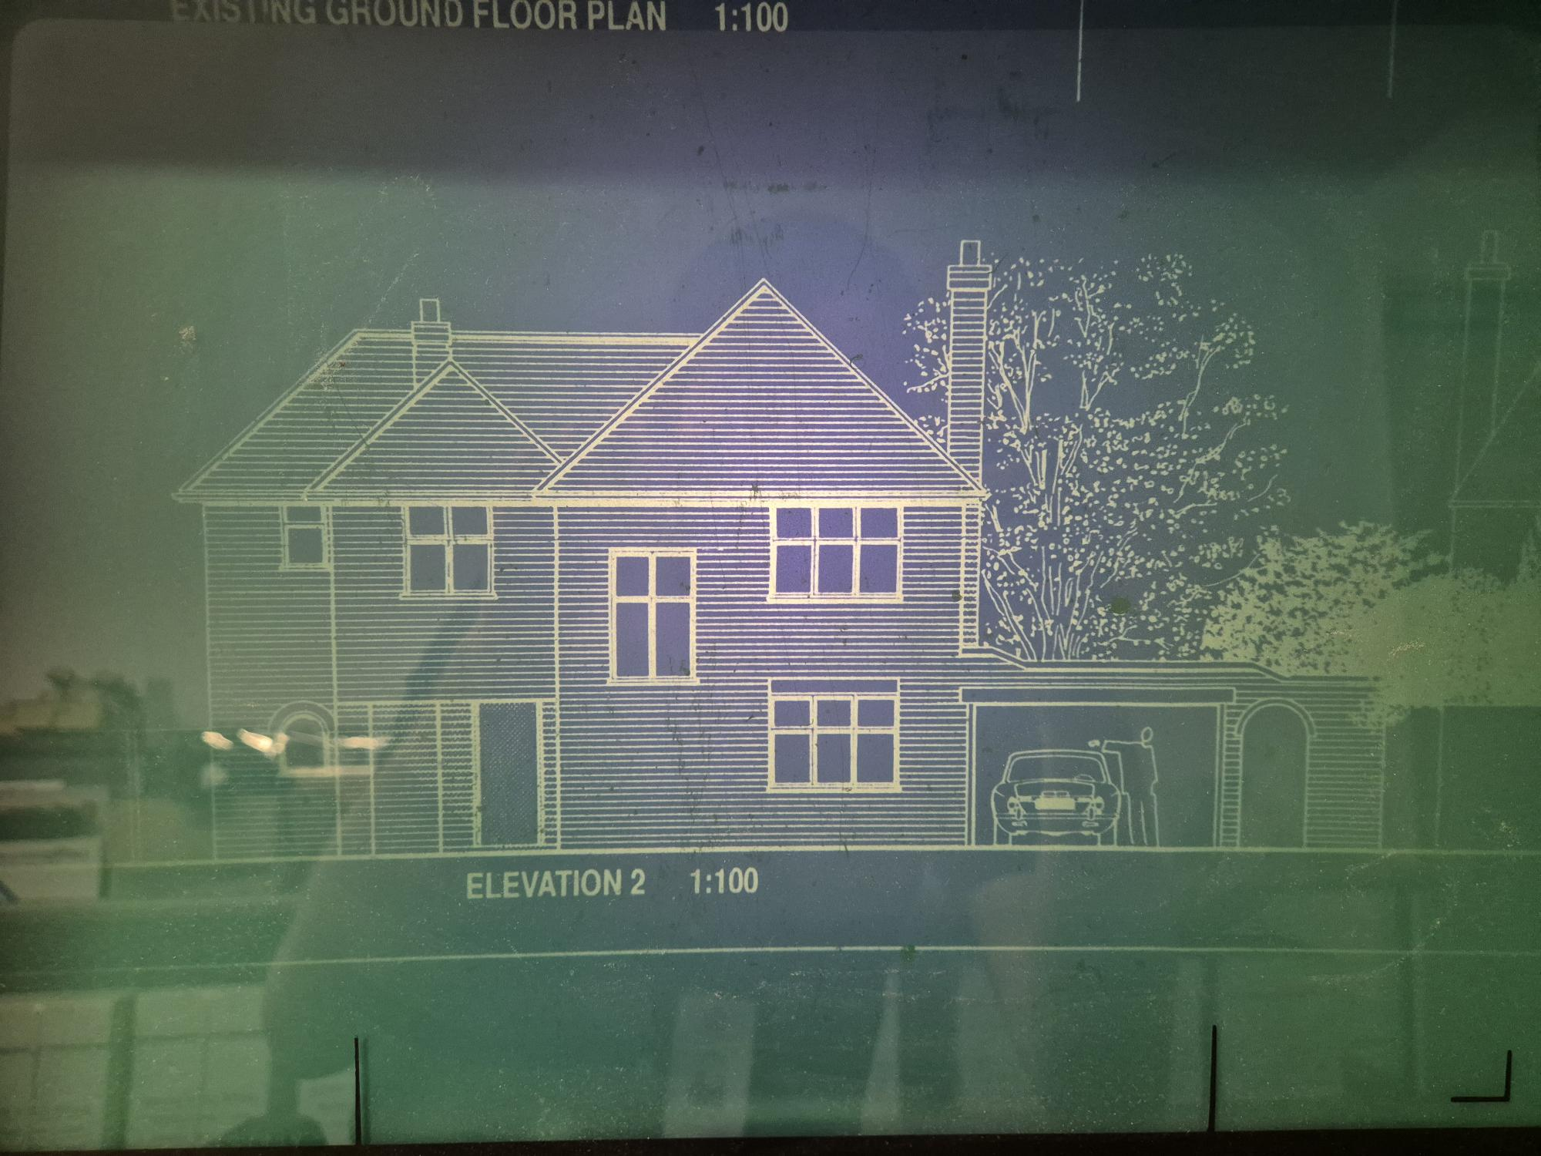
Front Elevation of 32 Ickenham Road, Ruislip in 1996

