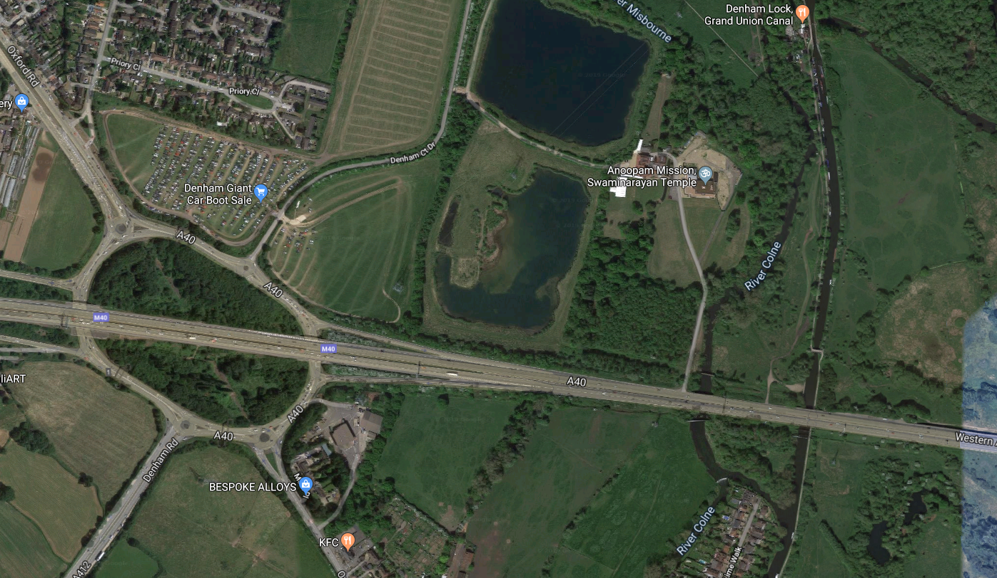
Location of A40 Western Avenue Eastbound carriageway delivery holding area.

