

SITE WASTE MANAGEMENT PLAN

At
Bourne Court
South Ruislip
HA4 6SW

01/07/19
REV. A

Contents

1.0 PROJECT DESCRIPTION 3
2.0 DEFINED ROLE HOLDERS UNDER SWMP REGULATIONS 3
3.0 KEY DATES 3
4.0 SITE WASTE MANAGEMENT PLAN STRUCTURE 4
5.0 CLIENT RESPONSIBILITY 5
5.1 PREPARATION OF THE SWMP 5
5.2 DECIDING WHICH SWMP SHOULD BE USED 5
5.3 BASIC INFORMATION FOR ALL SWMP’s 5
5.4 PRINCIPAL CONTRACTOR RESPONSIBILITY 6
5.5 UPDATING A STANDARD SWMP 6
5.6 UPDATING A MORE DETAILED SWMP 6
5.7 SWMP MANAGEMENT & REVIEW 6
5.8 PROJECT COMPLETION 6
APPENDIX 7
1.0 INTRODUCTION 7
2.0 APPENDIX A. SWMP CHECKLIST 8
3.0 APPENDIX B. SWMP DATA SHEET 11

1.0 PROJECT DESCRIPTION

The project relates to the erection of residential development comprising 69 residential units in 3 blocks of flats .

2.0 DEFINED ROLE HOLDERS UNDER SWMP REGULATIONS
Principal Contractor
Clearview Homes limited
201 Pinner Road
Northwood Hills
Middlesex
HA6 1BX
Contact Name: Telephone No: | 01923 840 048

Client
Clearview Homes Residential
201 Pinner Road
Northwood Hills
Middlesex
HA6 1BX
Contact Name: Telephone No: | 01923 840 048

3.0 KEY DATES

The project start date is expected to be | (est) Nov 2019
The project completion date is expected to be | (est) July 2021

4.0 SITE WASTE MANAGEMENT PLAN STRUCTURE
This Project is subject to the requirements of the Site Waste Management Plans regulations 2008 and all parties are required to act in accordance with these regulations. As part of the Site Waste Management Regulations 2008 which came into force 6th April 2008, all new projects with a tender value of 300k plus (ex VAT) Must prepare and implement a site waste management plan (SWMP) in accordance with the said regulations. Existing projects which have been planned prior to the enforcement date and which begin before 1st July 2008 are exempt from the regulations. It is the responsibility of both the Client and the Principal Contractor to ensure that a SWMP is prepared prior to the project commencing on site.

There are two types of Site Waste Management Plans used in preparing a SWMP which depends upon the size of the project. Projects with a tender value of between 300k and 500k (ex VAT) are required to implement a “standard” SWMP to control waste during the construction phase works. Projects of a greater tender or build value than 500k require “more detailed” information which requires a more in depth approach to managing waste during the construction phase works.

There are strict penalties in force for Client’s, Principal Contractor’s and anybody who obstructs the execution of duties in compliance with the SWMP Reg’s. Enforcement of the said regulations will be either the Environmental Agency, Local Government Area or any district or council.

The PC is responsible for ensuring that suitable and adequate resources are allocated to enable the effective development of the SWMP for the duration of the works. All works contractors have the responsibility of assisting the PC by providing information to enable the timely development of the SWMP during the construction phase.

The PC shall ensure that enough time and resource is allocated to ensure,
    - The effective coordination, planning and organisation of waste.
    - That a good management and coordination structure is in place.
    - That effective procedure’s for monitoring & communication are in place.
    - That suitable induction/further training needed is provided for all operatives.

The standard Site Waste Management Plan Template comprises: -
- Sheet 1 – Client Pre Construction Assessment.
- Sheet 2 – PC Construction Phase Assessment.
- Sheet 3 – Client Final assessment.

Both the Client and the Principal Contractor are responsible for ensuring that the SWMP is regularly reviewed and updated throughout the project. The waste hierarchy below Must be followed for All waste materials before finally disposing waste materials to land fill.

Waste Hierarchy
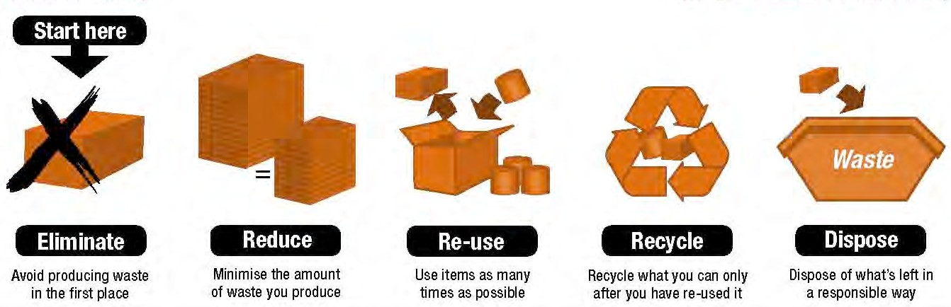

At the end of the project the Principal Contractor Must within three months, hand the completed Site Waste Management Plan back to the client for final assessment.

5.0 CLIENT RESPONSIBILITY

5.1 PREPARATION OF THE SWMP

Under the Waste Management Plans Regulations 2008, the client is ultimately responsible for preparing the site waste management plan as part of the planning phase of the project. The client is also responsible for appointing a Principal Contactor to manage the SWMP during the construction phase. In certain circumstances, a Principal Contractor is best placed to provide information to enable the client to prepare the plan. In such cases the Principal Contractor may be called upon to provide the necessary information and assist the Client in their role and thus allow for the timely preparation of the site waste management plan. The client shall ensure that the SWMP is handed over to the PC prior to the start of the construction phase. Should a construction project begin without a SWMP, then both the client and the PC are guilty of an offence.

5.2 DECIDING WHICH SWMP SHOULD BE USED
There are two types of SWMP’s. The type of SWMP to used on a1 construction project depends upon the size of the project in terms of the tender or build value. Projects with a
tender value less than 300k (ex VAT) are exempt for the SWMP regulations. Projects of a tender value between 300k & 500k (ex VAT) required a “Standard” SWMP to be used. Projects with a tender value of 500k (ex VAT) required a “more detailed” plan be adopted for managing waste during construction. The client is responsible at the planning phase for implementing the correct plan and handing the plan over to the Principal Contractor for the construction phase.

5.3 BASIC INFORMATION FOR ALL SWMP’s
Under the Site Waste Management Regulations 2008, all Site waste management plans
must include the information set out below as a min requirement.

    - Must identify the client.
    - Must identify the Principal Contractor.
    - Must identify the person drafting the SWMP. (responsible person)
    - Must describe the proposed construction work.
    - Must include the site location.
    - Must estimate the cost of the project.
    - Must include decisions made before drafting the SWMP on the nature of the project.
    - Must describe each waste type.
    - Must estimate the quantity of each type of waste.
    - Must identify each waste management action.
    - Must contain declaration from client and the Principal Contractor.

For a simple guide on understanding & developing Site Waste Management Plans, please visit http://www.netregs-swmp.co.uk for further information.

5.4 PRINCIPAL CONTRACTOR RESPONSIBILITY

Under the Site Waste Management Plans Regulations 2008, the Principal Contractor is responsible for the maintenance and development of the SWMP during the construction phase. As part of this management responsibility the Principal Contractor Must ensure;
    - That relevant information is obtained from sub-contractors.
    - The SWMP is updated at least every three months as the project progresses.
    - The SWMP is kept on site during the project
    - The location of the SWMP is known to all who attend site.
    - Access to the SWMP is made available to the client, contractors and site operatives.
    - The SWMP is handed back to the client once completed as part of the H&S File.
    - A copy of the SWMP is kept for a min of two years.

5.5 UPDATING A STANDARD SWMP

The standard SWMP that Must be adopted for projects between the tender or build value of between 300k and 500k (ex VAT). Information that shall be recorded is set out below.
    - The identity of the person who will be removing the waste.
    - The types of waste being removed from the site.
    - The site where the waste is being taken to.
    - Demonstrate that the plan has been regularly reviewed.
    - Explain any deviations from the plan.

5.6 UPDATING A MORE DETAILED SWMP

The more detailed SWMP that Must be adopted for projects that have a tender value of 500k plus (ex VAT). Information that shall be recorded is set out below.
    - The identity of the person who will be removing the waste.
    - The types of waste being removed from the site.
    - The waste carrier registration number.
    - Record a copy of the written description of the waste.
    - The site where the waste was taken to.
    - Record a copy of the site waste permit.

5.7 SWMP MANAGEMENT & REVIEW
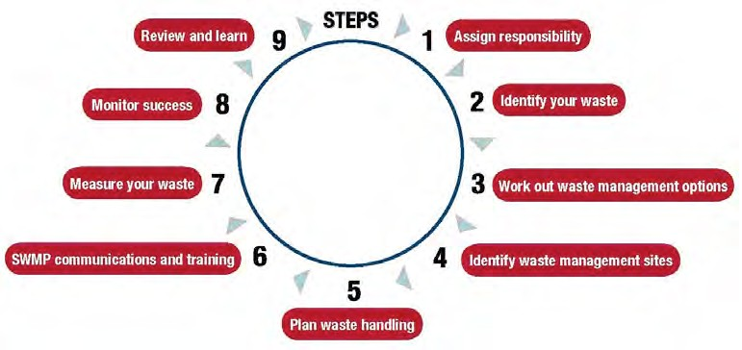

5.8 PROJECT COMPLETION
At the end of the project the PC Must hand over within 3 months the completed SWMP to the client for final analysis. The client Must review the completed SWMP and comment on the effectiveness of the plan and apply lessons learnt to future projects

APPENDIX
SITE WASTE MANAGEMENT PLAN

1.0 INTRODUCTION

All skips provided will:

1. Prevent spillages or leakages;
2. be corrosive resistant (to the weather elements);
3. Covered to prevent materials from being blown away and
4. Will prevent savaging from animals.

The segregation of wastes will be of the following types:

- Timber
- Inert: block work, bricks, rubble and concrete
- Ferrous Metals
- Nonferrous metals
- Plastics, packaging
- Cardboard, Paper
- Aluminium cans
- Rubbish / Mixed/General Waste (for all other wastes)
- Redundant concrete foundations, paving etc will be crushed on site/offsite. This fill will be re-used for the piling matt.

Subcontractor operatives will still be responsible for putting segregated waste into the designated space or skips/bins provided. All bins/disposal space on site will be labelled as necessary. Where appropriate, the storage of Materials onsite for potential reuse will be at locations agreed by Kingsbury Construction Co Ltd. Materials likely to be stored including waste timbers, pallets, bricks and metals.

The waste contractor will collect all of the skips. The segregated skips for metals, inert and
Timber will be recycled. The waste contractor will aim to recycle a large proportion of the mixed and plastic skips.

All hazardous waste will be removed by a Licensed Sub contractor. Enclosed locked drums or skips will be used for the collection of hazardous wastes. An accredited hazardous waste licensed carrier will collect the hazardous wastes to ensure legal disposal. Any subcontractor caught contaminating any non-hazardous waste skips with hazardous material will be contra-charged appropriately.

This SWMP will be communicated through project meetings and tool box talks.

Project Stages  2.0 APPENDIX A. SWMP CHECKLIST |  | Questions to consider | Y if ‘Yes’  N if ‘No’ | Comment:  If ‘yes’, what action have you taken/do you propose to take?  If ‘no’, why not?
Policy | 1 | Has your organisation adopted a waste management policy? | Y
 | 2 | Has the Principle Contractor signed the SWMP? | Y
 | 3 | Have the relevant sub-contractors signed the SWMP? | Y | Will be ongoing
Procurement | 4 | Has a careful evaluation of materials been made so that over-ordering and site wastage is reduced? | Y | Weekly internal meetings discuss the amount of materials being ordered. The Project Manager surveyors and Commercial Manager assess this.
 | 5 | Has full consideration been given to the use of secondary and recycled materials? | Y | Weekly internal meetings discuss the possible recycling and reuse on site or of site. The Project Manager surveyors and Commercial Manager assess this.
 | 6 | Has full consideration been given to pre-fabricated units / off site manufacture | Y | All temporary facilities are prefabs which shall be taken to next project on completion of Pears Road
 | 7 | Is unwanted packaging to be returned to the supplier for recycling or re-use? | Y | All timber pallets are to be returned for reuse
 | 8 | Can unused materials be returned to purchaser or used on another job? | Y | Material returned to supplier or used on other projects
Project planning | 9 | Has responsibility for waste management been assigned to a named individual at both main contractor and identified sub-contractors? | Y | Kanti Mayani, the site agent together with Romit Halai, the project surveyor will be responsible for the waste management on site. The Name of the sub-contractor is to be confirmed once sub-contractors have been appointed and this should be an ongoing process.
 | 10 | Has a project programme been developed to include likely waste arising (how much, when, and what types)? | Y | Discussed internally, and part of KCC budget
 | 11 | Has an area of the site been designated for waste management facilities i.e. bins or skips, including segregation of waste? | Y | Yes.
 | 12 | Have targets been set for the different types of waste likely to arise from the project? | Y
 | 13 | Have measures been put in place to deal with expected (and unexpected) hazardous waste? | Y | Waste company TBC.
 | 14 | Has disposal of liquid wastes such as wash-down water and lubricants been considered? | Y | Washing of plant and vehicles will only occur in a designated area. Any hazardous liquids will be disposed of in accordance with relevant Environmental legislation
 | 15 | Where relevant, has discharge consent been obtained from the Agency? | Y | Yes will be if required
 | 16 | Has agreement been sought from the sewerage company for trade effluent discharge? | N/A | No Hazardous chemical to be discharged in the drains
 | 17 | Have opportunities been considered for re-use of materials on site? | Y | As detailed in SWMP
 | 18 | Have opportunities been considered for re-use of materials off site? | Y | As detailed in SWMP
 | 19 | Have opportunities been considered for on-site processing and re-use of materials? | Y | As detailed in SWMP
 | 20 | Have opportunities been considered for reprocessing materials off-site? | Y | As detailed in SWMP
Project Stages |  | Questions to consider | Tick if ‘Yes’ | Comment:  If ‘yes’, what action have you taken/do you propose to take?  If ‘no’, why not?
 | 21 | Have you considered what are the most appropriate sites for disposal of residual waste from the project? | Y | Responsibility of waste management contractor
 | 22. | Are there opportunities for reducing disposal costs from waste materials which may have a commercial value? | Y | Responsibility of waste management contractor
Site operations | 24 | Has responsibility for waste management on site been assigned to a named individual? | Y | Kenny Mayani from KCC
 | 25 | Have toolbox talks been planned for all site personnel about waste management on site? | Y | Will be done as part of tool box once the site has commenced.
 | 26 | Are selected waste materials segregated to allow best value to be obtained from good waste management practices? | Y | Yes will be done, SCS site manager shall oversee this activity.
 | 27 | Are containers/skips clearly labelled to avoid confusion? | Y | Yes
 | 28 | Are Duty of Care procedures complied with i.e. provision of transfer notes and checking authorisation of registered waste carriers, registered exempt sites and licensed waste management facilities? | Y | See Appendix B
 | 29 | Are any checks made that excavation waste is received at the intended site? | N | Responsibility of waste management contractor.
 | 30 | Is implementation of agreed waste management procedures monitored? | Y | Responsibility of Site Agent

Waste Material | Waste Package | Estimated Quantity Volume (tones) | Actual Quantity Volume (tones) | Waste Minimisation opportunities
Hard-core | Excavation, Brick & Blockwork, landscaping | 43.59 | 41.05 | Segregate, land reclamation, reprocessed and reused in the construction industry
Insulation | Fit Out | 4.73 | 4.52 | Procure to uniform size, store correctly.
Packaging | All trades | 10.56 | 10.23 | Request minimal packaging and suppliers to take back packaging
Plasterboard | Dry Lining | 2.5 | 2.2 | Procure to uniform size, store flat, undercover in a secure compound
Timber | Fit Out, Frame | 19.55 | 19.47 | Correct ordering, Storage and Assembly
Metals | All trades | 4.3 | 4.2
Hazardous Waste | All trades | 5.64 | 5.49 | use solvent-free paints that are not disposed of as hazardous paint
Mixed waste | All trades | 6.78 | 6.71 | Correct ordering, Storage and Assembly
Other | All trades |  |  | Re-use where possible

3.0 APPENDIX B. SWMP DATA SHEET

PROJECT NAME | BOURNE COURT
PROJECT ADDRESS | BOURNE COURT, SOUTH RUISLIP, HA4 6SW
NAURE OF PROJECT | DESIGN AND BUILD 69no PRIVATE APARTMENTS  THIS INCLUDES SUBSTRUCTURE, SUPERSTRUCTURE, GROUNDWORKS, FINISHING, HARD AND SOFT LANDSCAPING.
PRINCIPLE CONTRACTOR | CLEARVIEW HOMES RESDIENTIAL
PRINCIPLE CONTRACTOR DETAILS | CLEARVIEW HOUSE  201 PINNER ROAD  NORTHWOOD HILLS  MIDDLESEX  HA6 1BX
PROJECT MANAGER | BHUPINDER VIRDEE
PROJECT MANAGER SIGNATURE
DATE | 01/04/19
REVISION | REV A

