
Bourne Court – Green Travel Plan

Travel Plan Overview
Clearview homes recognises that site activities and operations can result in impacts on society and the environment and is therefore working to reduce the negative effects of these operations whilst promoting positive outcomes where possible. Travel represents one such activity.

Whilst travel is necessary for operatives, Clearview is seeking to reduce the amount of impact of travel associated with by encouraging contractors and operatives to utilise green travel options.

The following are encouraged:
- Promoting and encouraging walking as a means of transport in its own right or as part of a journey in conjunction with other modes of transport.
The site is located within 5 minutes’ walk from South Ruislip providing access from various destinations.

- Promoting and encouraging cycling both as a form of private transport and as a link to public transport

- Promoting and encouraging the use of public transport

- Encouraging car sharing between operatives

Walking to Train Stations
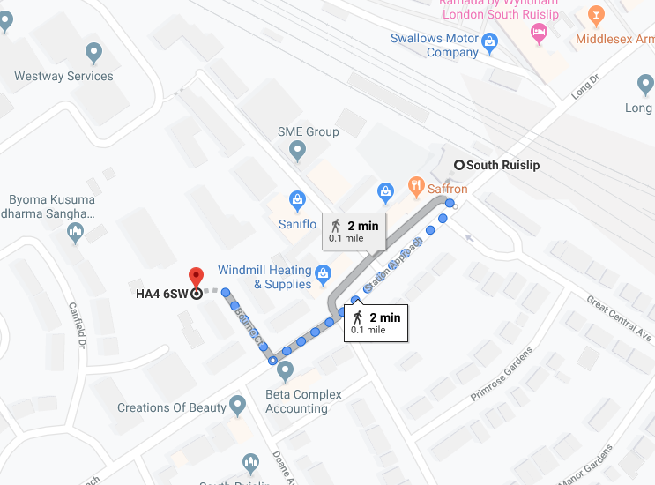

Bus route to Bourne Court
