

‘CONSTRUCTION METHOD STATEMENT’

At
BOURNE COURT
SOUTH RUISLIP
HA4 6SW

July 2019

Table of Contents
- DESCRIPTION OF WORKS
- EXISTING BOUNDARIES
- SITE TRAFFIC AND TRAFFIC MANAGEMENT HOLDING AREA
- EMERGENCY ROUTES AND THIRD PARTIES ACCESS
- EMERGENCY SERVICES
- LOCAL ENVIRONMENTAL CONSIDERATIONS
- SITE SET-UP
- TREE PROTECTION
- LOADING & UNLOADING OF PLANT AND MATERIALS
- STORAGE OF PLANT AND MATERIALS
- SITE WASTE MANAGEMENT PLAN
- SITE WORKING HOURS
- SITE ACCESS AND MANAGEMENT
- SITE SECURITY
- SITE HOARDING
- SECTION 50 – CROSSOVER LECIENCE
17. CONTACT DETAILS
18. MONITORING AND COMPLAINTS

19. NOISE POLLUTION & CONTROL

20. DUST POLLUTION & CONTROLS

21. NEWSLETTERS & COMMUNICATION WITH NEIGHBOURS

APPENDIX A: HP Architecture Drawing 19.345.01P2
APPENDIX B: Tree protection Barrier detail
APPENDIX C: HGV No Stacking & Traffic Flow (Offsite Holding Area)
APPENDIX D: Site Waste Management Plan (SWMP)
APPENDIX E: Green Travel Plan

1. DESCRIPTION OF THE WORKS
The project relates to the erection of residential development comprising 69 residential units in 3 blocks of flats.
The programme of works will begin with the initial enabling works for occupation of the site and then commencement of ground works for foundations, ground floor slabs, drainage and highways works. Once the groundworks are complete, superstructure works will commence up to and including works to roof levels allowing the structural shell of the building to be completed
Once the shell is completed and weathertight, internal trades will commence finishing works and services installations, including all ancillary highways, parking and other access works
2. EXISTING BOUNDARIES
All necessary temporary fencing / hoarding will be maintained in a safe and appropriate manner until such as the areas are ready for occupancy
The majority of the existing boundaries are formed by existing fences and building. During construction 2.4 high timber hoarding will be provided to public boundaries and fencing panels to private boundaries
The temporary boundary with the highway will be in accordance with our Proposed Site Plan as attached.
3. SITE TRAFFIC AND TRAFFIC MANAGEMENT HOLDING AREA
The management of traffic will be the responsibility of the demolition or groundworks contractor during demolition. During the groundworks phase prior to start of brickwork the groundworker will be responsible. Prior to commencement of superstructure walls, Clearview Homes will take over the traffic management for the duration of the project.
The responsible person will coordinate deliveries so that items such as muck away or concrete are at a minimum spacing of 15 minutes to eliminate stacking. All material orders are to be placed with a requirement that the driver has to phone site 15 minutes in advance to agree access will be available. The site manager books in all deliveries manages the driver’s arrival time to prevent duplicated arrival times and direct delivery driver’s to the designated waiting areas where necessary, if changes occur refer to Appendix C for holding areas.
ALL SITE TRAFFIC IS TO FOLLOW THE DIRECTIONS BELOW
ARRIVAL & DEPARTURE
Phone site prior to arrival
Approach to Bourne Court should be via South Ruislip.
On Site Induction everyone will be informed that there will be NO on-site parking for any sub-contractors, and that ALL contractors will be encouraged to use Local public transport in accordance with the Green Travel Plan. See Appendix E
Turn left or Right turning into site under guidance of banksman. Do not park on double yellow lines or areas of designated residential parking
All construction vehicles servicing the site will access the site Bourne Court where they will be banked safely onto the development for unloading as per drawing 19.345.01P2 It will also be indicated on the Traffic Management Plan displayed in the site office and conveyed to all site operatives at pre-commencement and during site inductions
When necessary a mobile jet wash and bowser will be employed to remove and mud from construction vehicles to prevent soiling the public highway. Periodically a road sweeper will be employed to clean the roads and the surrounding road network. Strict traffic management on site and the use of hardstanding areas should minimise the risk of vehicles tracking debris from the site. The banksman will remove any clods of soil that might drop on the highway if it occurs, however keeping deliveries on the hardstanding should avoid mud being deposited on site
The site is being developed over a period of approximately 12-18 months. The details below demonstrate the anticipated traffic movements to and from site -
Rigid Vehicles (7.5 – 20ton): 20 per week peaking typically at 45 per week
Vans (1.5ton): 2 per day
Concrete Lorries: 15 per week during foundation construction operations
Pedestrians passing the site are protected by means of a maintained 1.8m footpath on Bourne Court. The provision of a banksman to manage vehicles arriving and leaving the site also serves to protect pedestrians and cyclists.
4. EMERGENCY ROUTES AND THIRD PARTY ACCESS
The principle contractor’s site manager will be the responsible for the Implementation and maintenance of the entire site safety, health and environments procedures
Sub-contractors & suppliers will be made aware of all our safety, health and environmental procedures during the contract stage and again during the site based induction procedures. The Construction Director will review performance periodically and implement any improvement measures thru-out the duration of the project
5. EMERGENCY SERVICES:
The site manager will insist that all staff and subcontractors are made fully aware of all the emergency procedures during the construction phase in accordance with the Construction Phase and Traffic Management Plans. This will include safe and tidy access throughout the development, clear signage of exit routes, regular updates and reviews with site staff and subcontractor’s. This will be reviewed throughout the construction programme until completion.

6. LOCAL ENVIRONMENTAL CONSIDERATIONS
The existing goodwill and working relationship with the local residents will be important in the decisions of the site manager in his implementation of the build programme. This will include strict implementation of the working hours, due consideration to all complaints received via the site office, awareness of noise from plant and machinery, awareness of any potential dust issues, with additional precautions implemented during dry and windy weather conditions
The site and boundaries will be kept clean and records / audits will be reviewed by the site managers throughout the development. The site specific Construction Phase Plan will include all the above items and reviewed to reflect any changes within the build programme
7. SITE SET UP
A site office and first aid station, washroom, changing/drying room and canteen will be provided. All access and egress from the site will be as indicated on the attached plan.
8. TREE PROTECTION
Tree and root protection barriers will be established on site prior to any works in the vicinity of the trees taking place. The position of the protective fencing is indicated on drawing 19.345.01P2 and shall be implemented by first marking out on site using biodegradable paint. Once erected the fence shall be clearly marked with signs reading “CONSTRUCTION EXCLUSION ZONE” “NO ACCESS” The initial position for the protective fencing is indicated by the magenta line on the submitted drawing and shall be maintained until the NO DIG surfacing construction is to be undertaken on the development. At which time in order to enable access to execute the NO DIG works, the fencing shall be carefully dismantled and re-erected, along with its signage, on the blue protection line indicated on the drawing. The fencing will consist of protective barriers constructed in accordance with the details provided at appendix B of this document.
9. LOADING AND UNLOADING OF PLANT AND MATERIALS
Plant and material deliveries will be via Bourne Court and will be unloaded via a mobile crane or fork lifts from the unloading area within the site boundary as indicated on proposed site plan.
All delivery vehicles are to turn their engines off when stopped unless the engine is requires for operational purposes.
All CVR deliveries to be between 9:30 – 3:00 pm, including ALL contractors deliveries

10. STORAGE OF PLANT AND MATERIAL
Plant will be stored and secured behind fencing or in lockable containers and if necessary plant will be disabled outside of normal working hours
Materials will also be stored in either lockable steel containers for high value items or palletted loose materials for crane distribution. Some loose materials such as bricks and blocks may be offloaded into temporary storage areas closer to their intended final location to reduce crane or fork lift movements and such storage will be identified on the traffic management plan as the site progress.
11. SITE WASTE MANAGEMENT PLAN
A site waste management plan will be available upon commencement on site detailing our proposals to minimise waste and to reuse and recycle where possible – See Appendix D. A typically site example is attached showing monthly waste analysis reports, which Clearview Homes implement on all our sites which are reported on a monthly basis.
12. SITE WORKING HOURS
Site working hours are between 8.00am and 6.00pm Monday to Friday and 8.00am to 1.00pm on Saturday. No work will be undertaken on Sundays or Bank holidays.
13. SITE ACCESS AND MANAGEMENT
a. Pedestrian access to the site
Visitors access and egress the site via the walkways indicated on drawing 19.345.01P2
b. Wheel Washing Facilities and Control Measures for Minimising Dust
The site manager will monitor any operations which are, or have the potential to cause nuisance and/or dust on the site. Works will be reviewed and if necessary stopped until mitigation measures are fully implemented. Brick and concrete will be cut using only water fed machines
Wheel washing facilities will be in place near the site entrance and all vehicles entering and leaving the site, will be cleaned down prior to exiting the site. The roads will be swept and cleaned when required and the site manager will have an open order for road sweeping during the groundworks phase
c. Plant and Delivery Vehicles
All vehicles will travel on existing public roads, temporary haul roads or hardstanding’s to minimise the risk of raising dust. Where site operations require machinery to go off road, the machine drivers will be required to assess the individual situation and take recautionary measures if dust is likely to be raised and cause a nuisance.
d. Inclement Weather Conditions
During the course of the works there may be periods of inclement weather which may have an effect on the control of dust. This could be due to long dry spells or periods of strong winds or both. If such conditions are encountered and have an effect on air quality, the site manager may temporarily suspend site operations until the conditions improve
e. Site Roads
Where necessary the site roads will be dampened down using a road brush, this will have the effect of both removing dust and dampening the roads
f. Control Measures for Minimising Noise
The use of radios and musical equipment will be restricted and managed so as not to cause nuisance to the adjoining neighbours
14. SITE SECURITY
Out of hours the site will be monitored and reviewed periodically as the development is completed and occupied. The local Police will be consulted during the development to minimise any impact on the local residents surrounding the site, with measures such as CCTV and/or mobile patrols implemented as necessary
15. SECURITY HOARDING
The site will benefit from a 2.4m high hoarding to all exposed public boundaries, namely along Bourne Court, unless temporary works are undertaken where this will be replaced in sections by double clipped Heras fencing until reinstatement of the main hoarding is possible
These perimeter arrangements will be left in place as long as possible and will only be removed as areas of the site are completed. As works progress internally and residents move in to occupy individual houses, segregation and security will be by way of a 2.0m high double clipped Heras fencing panels, where required. Public access to our Sales areas will be maintained at all times once implemented, but with measures to restrict unauthorised access to the construction area strictly enforced. The Traffic Management plan will detail restricted areas during the course of construction.
16. SECTION 50 – CROSSOVER LICENCE
A Section 50 Street Works Licence application will be made to Highways Network Management NRSWA @ Hillingdon Council.
17. CONTACT DETAILS
Clearview Homes Head Office is available on 01923 840048 and the Site Manager will act as our emergency point of contact.
The site manager for Clearview Homes is still to be allocated and details will be posted at the site visible to members of the public and giving details of the name and contact telephone numbers.
18. MONITORING AND COMPLAINTS
During the demolition and groundworks phases the demolition and groundworks contractors will act as Principal Contractor, with all deliveries and orders being placed and managed by them. During this stage Clearview Homes will monitor the construction management plan during monthly progress meetings and by inspections at periodic but varied intervals
The site manager will inspect the highway outside the site at the end of each working day. In the event that any damage has occurred, Clearview Homes will liaise directly with Harrow Council Highways to determine the most appropriate means and timescale for repairs
In the event of a complaint, it should be addressed to Clearview Homes Ltd, Clearview House, 201 Pinner Road, HA6 1BX in the first instance, Tel 01923 840048.

19. NOISE POLLUTION & CONTROL

Noise control will primarily be dealt with at source. Mechanical plant and equipment will be selected and specified taking its noise profile into consideration. All plant and equipment will be of modern design and manufacture to benefit from up to date developments in technology for noise reduction. Any plant in excess of four years old will not be allowed on site to promote efficiency and to ensure that the site benefits from advances in technology. All plant must be regularly serviced to ensure that it is operating at maximum efficiently thus further reducing noise and air pollution.

Where possible, electrically driven plant will be used such as mortar silos as opposed to diesel driven mortar mixers. If petrol or diesel powered plant is required, as stated above this will be properly maintained and checked regularly.

Appropriate acoustic baffles will be fitted to air intake and exhaust systems. Stationary equipment, such as compressors will be fitted with shields to mitigate noise outbreak. Excavators, dumpers etc will have exhaust suppressors. All site operatives will be properly trained in loading, unloading, excavation and handling techniques to prevent improper use of equipment which can generate unnecessary noise. All plant operators will be advised to switch off the machines engines when plant is not in use to reduce noise and air pollution.

The construction of the building envelope will be carried out in as short a programme as possible to minimise any inconvenience to the local residents and businesses both in terms of noise and air pollution. This means that the enclosure of the building occurs early in the overall programme and any noise generating activities will be carried out internally, shielded from the external
environment.

Plant or equipment will be sited as far away as is practicable from the existing dwellings. The use of barriers, e.g. Soil mounds, site huts, and acoustic matts on fencing to deflect noise away from noise sensitive areas will be employed wherever practicable.

Where possible, building elements or components will be assembled off site in factory conditions e.g. precast concrete upper floors which will further reduce noisy activities on site.
All machinery to comply with the current legislation of 80 dB (A)

Noise assessments will be carried out as per Control of Noise at Work Regulations 2005.

Anyone who has a daily or weekly exposure to noise exceeding 80dB(A) or a peak pressure reading of 135dB (A) will be warned of the dangers of working in a noisy environment, advised of the systems being used by the company to reduce noise levels and issued with and trained in the use of ear protection. Health surveillance and enforced ear protection is compulsory if weekly noise levels of 85 dB or above or a peak sound pressure reading of 137 dB is reached.

Method statements from all subcontractors will be vetted to check that they adequately include the details on the need to manage excessive amounts of noise in accordance with this Construction Management Plan and reduce them as far as practically possible.

20. DUST POLLUTION & CONTROLS

Dust is defined as particles up to 75 μm in diameter and is produced through the action of crushing and abrasive forces on materials. A wide range of activities, including traffic movement, construction/demolition, mineral workings and general industry, generate nuisance dust.

Large dust particles can cause eye, nose and throat irritation, whilst the smaller fraction of particles with an aerodynamic diameter of 10 μm or less (PM10) is more of a health concern as the particles can enter the lungs causing breathing and respiratory problems.

21. NEWSLETTERS & COMMUNICATION WITH NEIGHBOURS

Clearview Homes will issue newsletters to local residents and businesses prior to commencement of the works and at regular intervals and when there are significant changes to the construction i.e. crane erections, large deliveries, road closures etc.

Communication with schools local to our sites is actively encouraged by Clearview Homes. We will approach the Head Teachers in the first instance to discuss giving a presentation to the pupils on the development as a whole; how we build in basic terms together with a section on Health & Safety and the risks of entering a construction site. We also will encourage a poster competition or similar in the case of the Primary School to take place, on building sites with prizes given to the best Safety poster(s). Site visits are also encouraged to show key stages with appropriate supervision and PPE

APPENDIX A

Site Proposed Site plan – HP Architecture Drawing 19.345.01P2

APPENDIX B

Specification for protective barrier

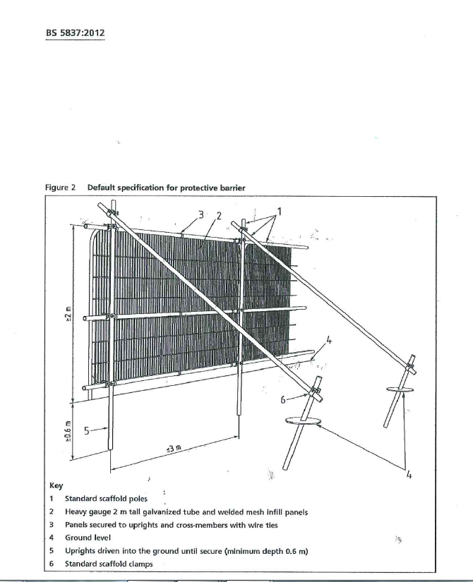

APPENDIX C

HGV No Stacking & Traffic Flow Delivery Management

APPENDIX D

Site Waste Management Plan (SWMP)

APPENDIX E

Green Travel Plan

