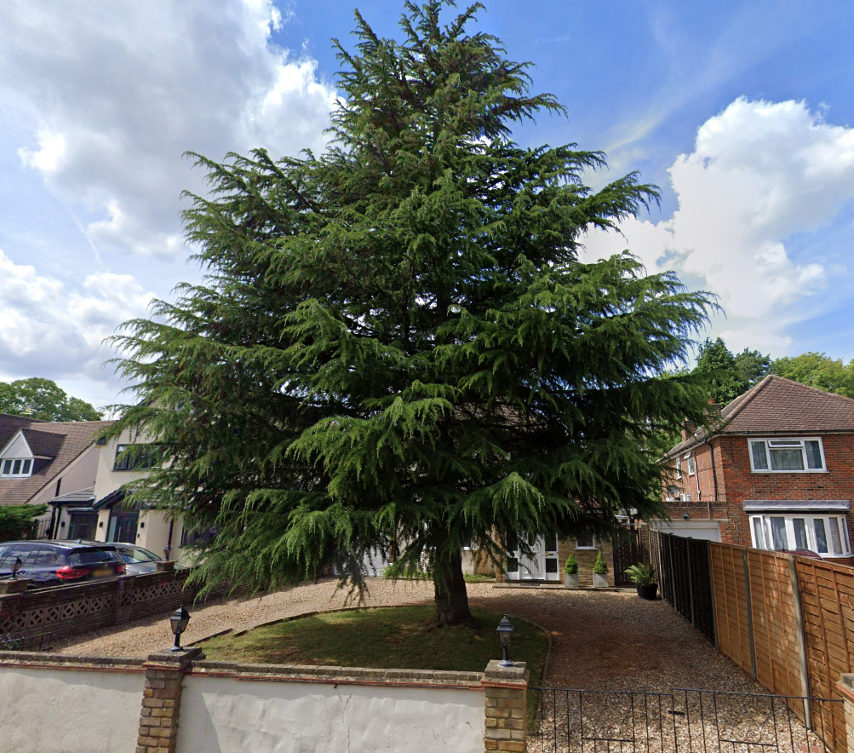

34 Frays Avenue
West Drayton, Greater London
UB7 7AG

Works to be done

T1 Cedar – Raise crown to approx 2m over driveway to allow for clearance of cars parked underneath and for people to walk freely under the tree without hitting their head,

