PROPOSED USE OF GARAGE BUILDING AS SELF-CONTAINED DWELLING, REPLACEMENT OUTBUILDING FOR USE AS SELF-CONTAINED DWELLING, EXTERNAL WORKS TO GARDEN OF EXISTING ANNEXE BUILDING TO PROVIDE LEVAL ACCESSIBLE AREAS WITH RETAINING WALLS AND NEW RETAINING WALLS TO GARDENS TO DEAL WITH FLOODING ISSUES.

AT
BLACK JACKS COTTAGE
PARK LANE
HAREFIELD
MIDDLESEX
UB9 6HL

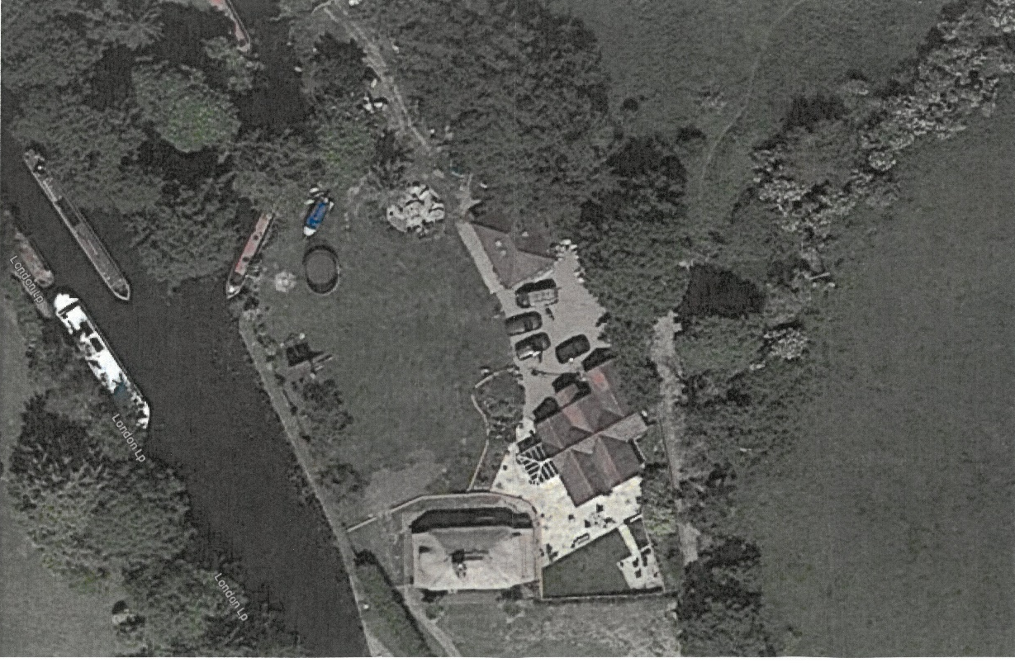

PLANNING, DESIGN & ACCESS
&
HERITAGE IMPACT STATEMENT

PROPOSED USE OF GARAGE BUILDING AS SELF-CONTAINED DWELLING, REPLACEMENT OUTBUILDING FOR USE AS SELF-CONTAINED DWELLING, EXTERNAL WORKS TO GARDEN OF EXISTING ANNEXE BUILDING TO PROVIDE LEVAL ACCESSIBLE AREAS WITH RETAINING WALLS AND NEW RETAINING WALLS TO GARDENS TO DEAL WITH FLOODING ISSUES.

AT

BLACK JACKS COTTAGE, PARK LANE, HAREFIELD, MIDDX. UB9 6HL

PLANNING, DESIGN & ACCESS AND HERITAGE IMPACT STATEMENT

1.0 INTRODUCTION & PLANNING HISTORY

  - This Statement has been prepared in support of an Application for Planning Permission and Listed Building Consent on behalf of Mr & Mrs Hendley for the retention of implemented works at the above property. These include the use of an existing garage building as a self- contained dwelling unit, the rebuilding of an existing outbuilding for use as a self-contained dwelling and external landscaping works around the existing annexe building to provide level accessible areas with enclosing retaining walls and retaining walls to the main garden area to deal with ongoing flooding issues.

  - The site is located at the end of Park Lane and lies between Black Jacks Lane and the Grand Union Canal and adjacent to Black Jacks Lock. The site has an approximate overall area of 0.75ha. There are several buildings on the site, including the Main Cottage, a detached Annexe building, a detached Garage building, a detached Garden Lodge Outbuilding together with an open Chicken run, a green house and some small storage sheds in the gardens.

  - Black Jacks Cottage itself is a Grade II listed property which largely dates from the early 17th Century or earlier. The building is of mainly two storey and of timber frame construction with brick infill and is covered with a thatched roof extending over lean-to additions. The property was Listed in September 1974.

  - The Annexe building is located to the east side of the Main Cottage and is a modern single storey building of brick construction and covered with intersecting low pitch tiled roofs. It is understood that the original elements of this building were constructed in the 1960’s and Planning Permission was granted in 1997 (Ref; 11615/M96?1935) to add single a storey extension and conservatory. In 2011, Planning Permission was granted for a further single storey extension ( Ref; 11615/APP/2011/1208) to provide a toilet and shower, at which time the building was already in use as a self - contained dwelling unit. Planning Permission was granted in 2017 (Ref; 11615/APP/2017/4262) for a replacement conservatory.

  - As part of 1996 Planning Application submission referred to above, Planning Permission was also granted for the construction of a detached double garage within the curtilage of the Cottage property. The garage was located just to the North side of the annexe building and adjacent to the boundary with Black Jacks Lane. A vehicular access from Black Jacks Lane and car parking/turning area within the site was located between the two buildings. The garage building was constructed in 1997 and is of traditional brick construction with a pyramidal pitched roof covered in plain tiles.

  - The Garden Lodge building is a more recent construction, commenced in 2019 and completed in 2020. I have been advised that the Lodge building was constructed on the base of an existing garden storage shed which was built in 2015 and is of timber frame construction with stained boarding externally and is covered with a flat roof.

2.0 USE

2.1 The whole of the site at Black Jacks Cottage is owned and occupied by members of the Hendley Family and the use of the site and all buildings on it is residential.

2.2 The Main Cottage property was once occupied by Mr & Mrs Hendley as their main residence. However, due to age and issues of accessibility, Mrs Hendley moved into the Annexe Building as her main residence and Mr Hendley had the garage building converted for habitable use in 2003. Shortly afterwards, in 2006 - 2007, Mr Hendley moved away and Mrs Hendleys daughter , Laura Hendley moved in to the garage to be near her mother as her health depreciated. Laura has continued to live in the garage building since then, bringing up her own family and continuing to look after her mother in the Annexe Building.

2.3 In 2019, Mrs Hendley’s son Robin health also started to decline and it was not possible for him to remain in the main cottage or use the garage accommodation. He needed to have a safe space of his own and in 2019, the garden shed was rebuilt to create a small self-contained living unit in the garden. The new building, which is single storey only, has a total gross internal floor area of 32.4 sq.m. and has small separate Living and bedroom spaces and very basic cooking and washing facilities.

2.4 In October 2021, Robin Hendley was diagnosed to be suffering from the impact of an aggressive brain tumour and having recently undergone two major surgical operations, he continues to use this building as the only peaceful space at Black Jacks Cottage where he can be safe and near the other members of his family so that they can look out for him.

3.0 DESIGN MATTERS

3.1 This Application submission does not involve any design changes to the external appearance of the Main Cottage, the Annexe Building or the Garage Building.

3.2 The new Garden Lodge outbuilding is located close to the side boundary along Black Jacks Lane. the building has a maximum height of 3.7m and due to the difference in ground levels, the roof of the building is barely visible above the existing boundary fencing.

3.3 Within the site, the external appearance of the outbuilding is designed to replicate that of the original storage shed that it replaced. The building is clad in stained timber horizontal boarding to all elevations with very modestly sized window and door openings. All window and door frames are in brown upvc and the flat roof is finished with a dark coloured perimeter to trim to blend in with the boarding.

3.4 When viewed within the site, the Lodge building is set against the backdrop of the higher boundary fencing and the line of mature trees to Black Jacks Lane and with it’s simple form and colouring, it does not adversely impact on views of the site from the canal opposite.

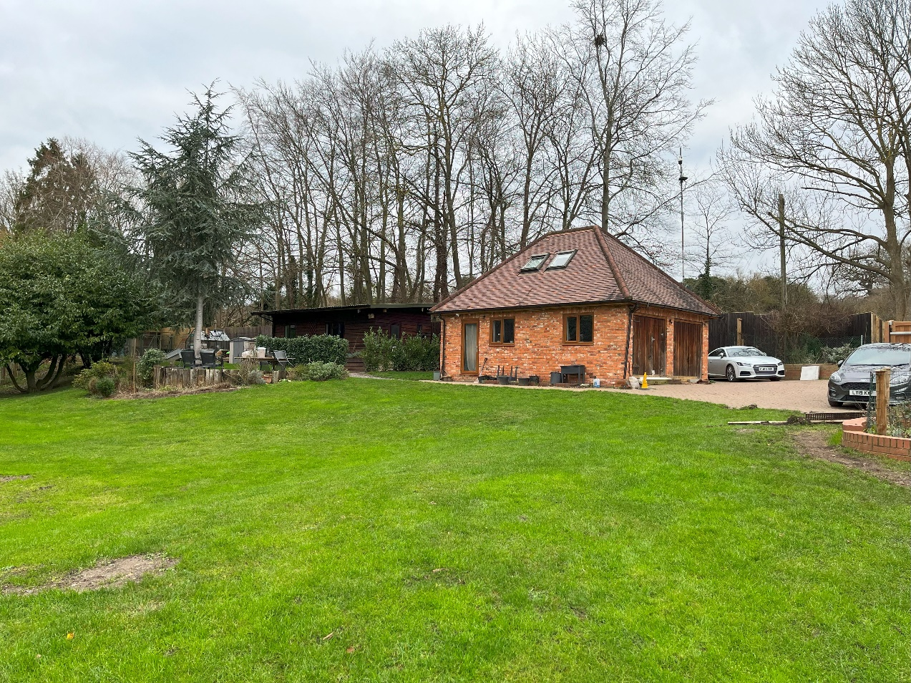
View to the Garage building with the Garden Lodge building in the background

3.5 The larger element of external works that has been implemented includes for the enlarging of the patio areas around the Annexe building involving the construction of retaining walls where the original ground levels have been lowered. The new retaining walls are in brick construction, generally following on from the lines of original walls and vary in height from 0.4m to 1.2m, stepping with the retained ground behind.

3.6 The Patio area has been enlarged to create a level and accessible garden area for Mrs Hendley who occupies the Annexe Building. As seen in the photos below, the original paved around this building was very small and restricted with steps down from the building itself and steps leading up to the main garden lawns. Due to issues of accessibility, Mrs Hendley was completely unable to use this area and it was necessary to remedy this situation.

3.7 The new patio area is level and provides for a usable enclosed garden for the Annexe building. It incorporates a seating area and raised vegetable bed. The patio is finished with sandstone paving laid in a random pattern, replacing the original brick paving which was quite utilitarian in appearance.

3.8 The retaining walls around the enlarged patio area are in brickwork, laid Flemish bond and covered with a brick on edge coping in keeping with the design and appearance of the remaining original walls.

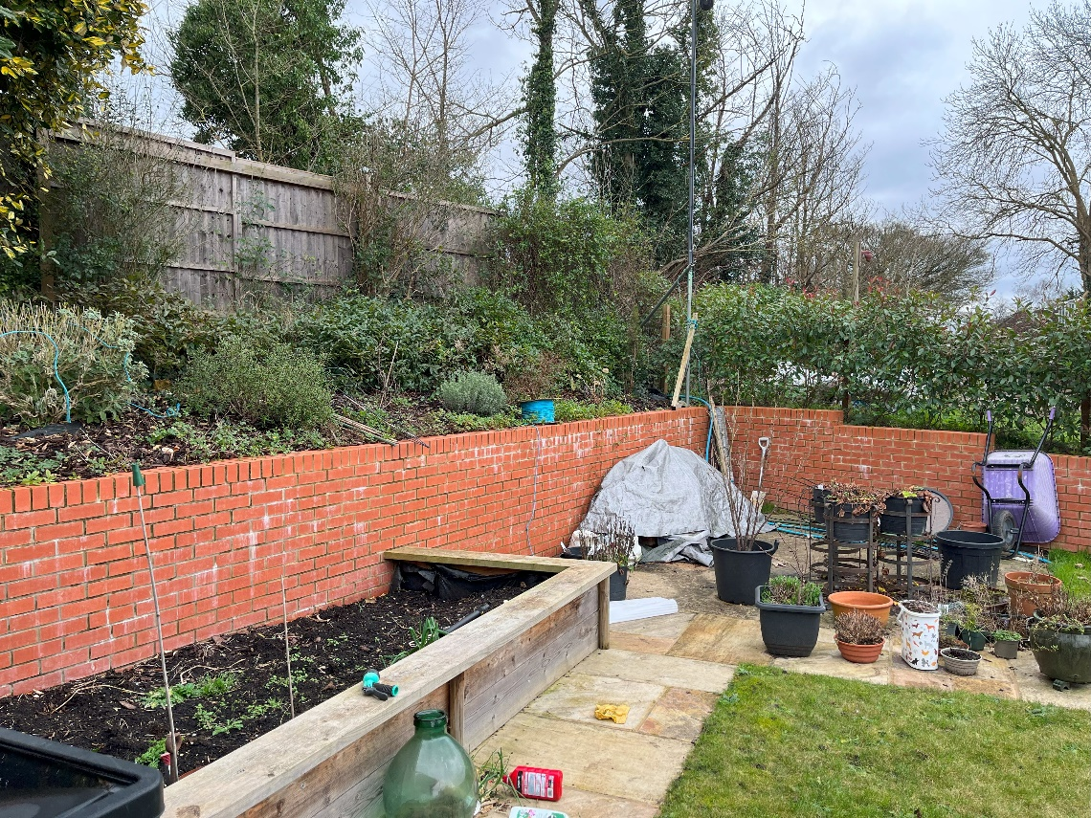

Views to the retaining walls and garden to the Annexe Building

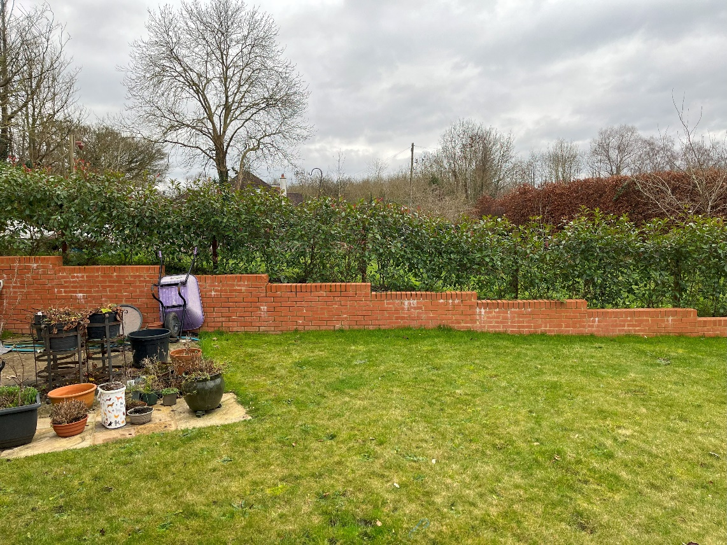

3.9 New retaining walls have also been constructed to the front of the Annexe Building and Main Cottage. These largely replaced original walls which were in very poor condition. These walls are designed to cope with flooding waters that come through Black Jacks Cottage from the adjacent fields to the East. In periods of heavy or prolonged rains, surface water run off from these fields can be excessive and it comes through the main access gateway to Black Jacks Lane and into the gardens of Black Jacks Cottage which is all at a lower level. The purpose of the retaining walls is to guide the water away from the Annexe Building and Main Cottage to discharge into the canal on the opposite side of the garden.

3.10 These walls are generally very low level – under 300mm high and are designed to enclose existing plant beds and paved areas in front of both buildings. The walls are constructed in engineering brickwork with a brick on edge coping as above so as to be as weather proof as possible as survive the impact of regular wetting during flooding.

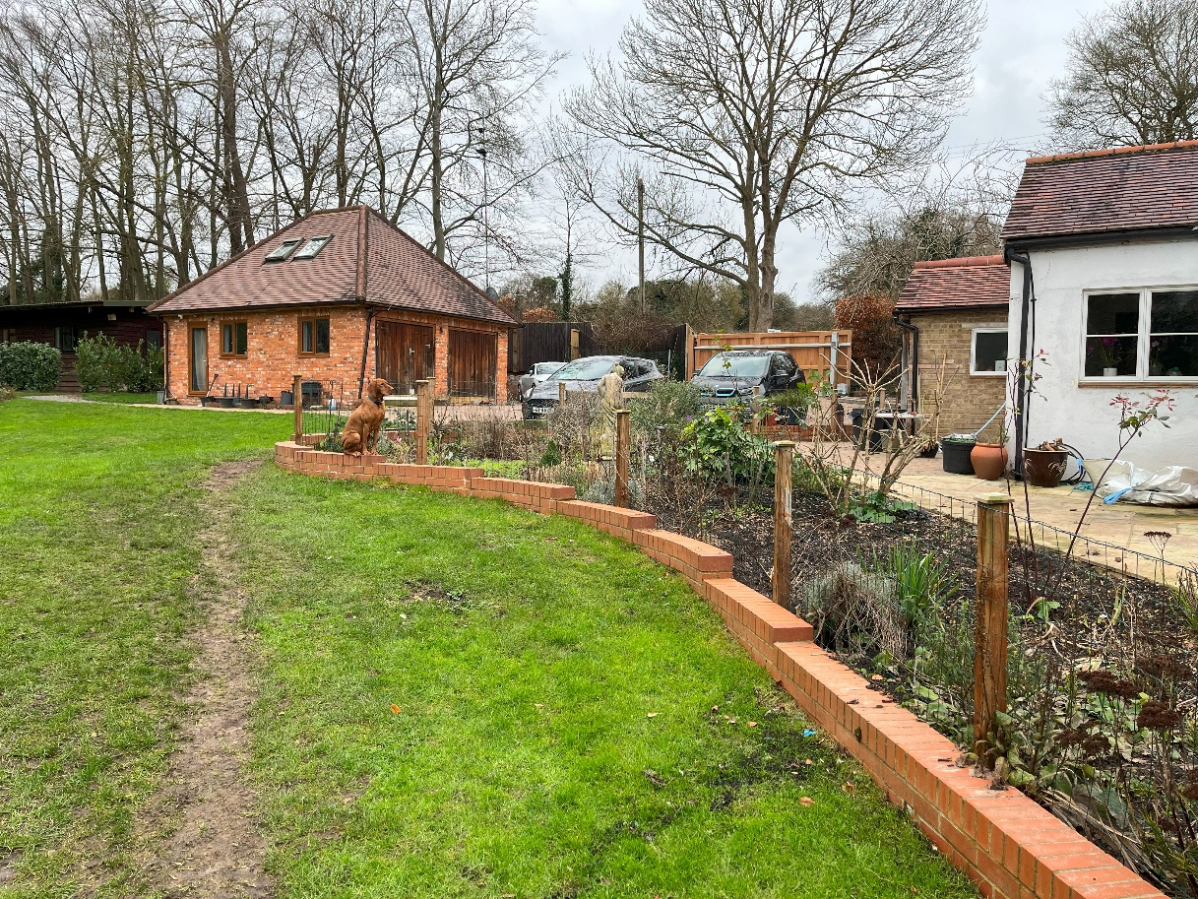
View to low level “flood” retaining walls to the garden

4.0 PLANNING CONSIDERATIONS

4.1 This property lies within the Black Jacks and Coppermill Lock Conservation Area and the Metropolitan Green Belt and as such, the proposed works take account of relevant Planning Policies with the London Borough of Hillingdon Unitary Development Plan Saved Policies (September 2012) relating to design criteria for residential new build projects have been observed in the design for this proposal.

4.2 The Garage Building.
This is a detached single storey building as approved in 1997. The building has a gross internal area of 40.5sq.m. on the ground floor and a further 23 sq.m. in the roof space. The internal accommodation comprises of an open plan Living area with Kitchen, wc and hallway area on the ground floor with a bedroom and shower room in the roof space. It is understood that the use of this building changed from garaging and storage to a habitable use in 2003 by Mr Hendley and has been occupied as such ever since by members of the Hendley Family. It is therefore proposed that this use has been established over this period. Externally, this building still retains the appearance of a domestic garage with the original double doors retained to the front.

4.3 The Garden Lodge
This is a detached single storey building recently erected on the footprint of an original garden shed. It has been constructed as a self- contained Living unit with a gross internal area of 32.4 sq.m. The internal accommodation comprises of an open plan Living area with Kitchen and separate Utility, bedroom and shower room.

4.4 This building has minimal visual impact within the site or on the surrounding area.

4.5 It is submitted that the present use of this building is temporary with the hope that Mr Hendley’s health improves over the coming year and that the use of this building could be reverted to a garden room / home office for general use by members of the Hendley Family.

4.6 It should be noted that whilst there are separate buildings on this site, all are served by single Water, Gas and Electricity incomming service supplies, ie all are on one meter. As such there is no desire or intention to subdivide this property into separate dwelling units for sale or rent.

5.0 SUSTAINABILLITY

5.1 Both the Garage building and the Lodge Building are fitted with external Air Source Heat Pumps to provide heating and hot water for day to day use. These units are located externally as shown on the submitted plans.

5.2 The general construction of the Garage and the Lodge outbuilding incorporates high levels of insulation to floors, walls and roofs within an air tight structural envelope.

5.3 All windows and doors to the Garage and Lodge buildings are fitted with factory manufactured with an integral thermal break and fitted with sealed double glazing and argon gas fill to minimise heat loss.

6.0 ACCESSIBILITY

6.1 Pedestrian and vehicular access to the property will be direct from the existing Black Jacks Lane to the East of the site.

6.2 The existing property can accommodate up to 5 car spaces which is considered sufficient to accommodate the occupiers of the site and any visitors.

6.2 It is proposed to install a new set of access gates to the main entrance to maintain a level of security for the property.

6.4 Ambulant access is now available to much larger areas of the property that previously with extended level paved areas, principally around the Annexe Building.

7.0 HERITAGE IMPACT ASSESSMENT

7.1 Building works
The Lodge outbuilding is located in a relatively remote part of the site and is sited in close proximity to the Eastern boundary with Black Jacks Lane. The building is modest in scale and form and is not from along Black Jacks Lane above the existing boundary fencing. It’s setting and appearance within the site is such that it does not detract from the generally character of the property and has no impact on the setting of the original Listed Cottage Building itself.

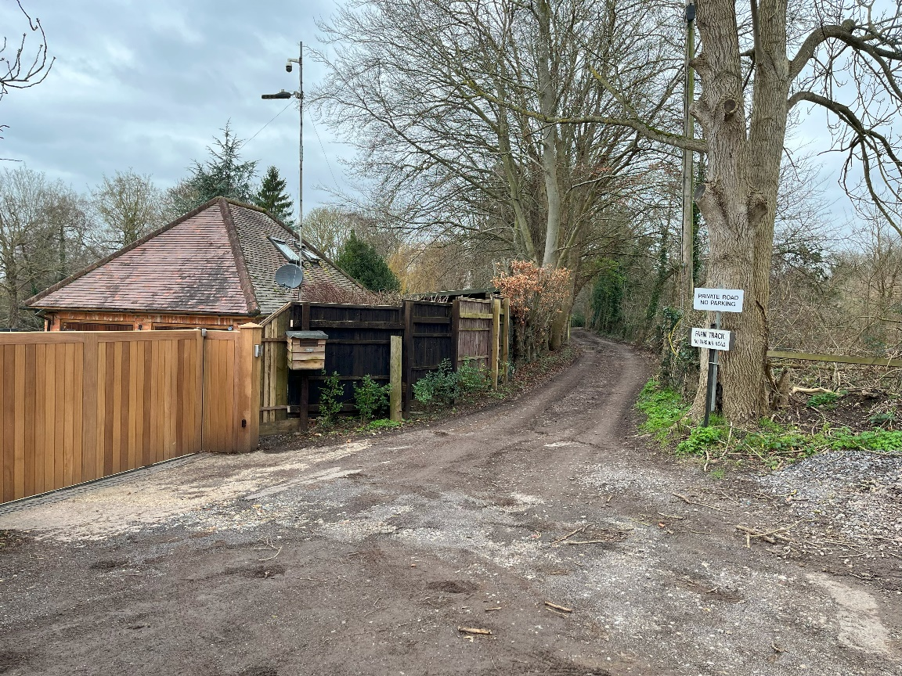
View along Black Jacks Lane to Garage and Lodge Buildings

7.2 External works
The completed external works, ie extended patio areas and retaining walls are completed to a high standard of workmanship and appearance with good quality materials and finishing. It is accepted that new materials of this nature appear quite visually prominent compared to the original but it is submitted that these will weather in extremely quickly in this environment. The scope of the works carried out is relatively modest in relation to the size of the property and have minimal visual impact within the site or on the setting of the original Cottage building.

Home Plans
January 2024

APPENDIX A
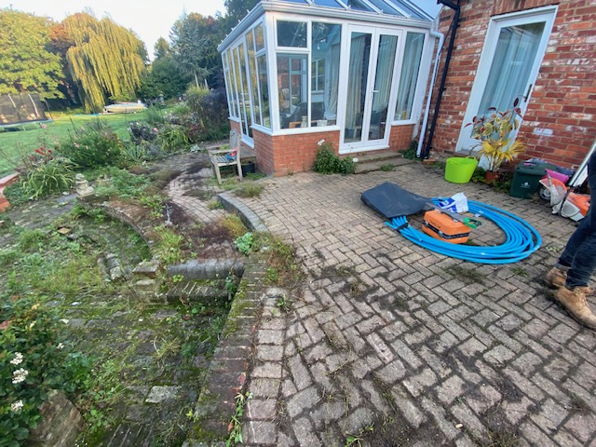
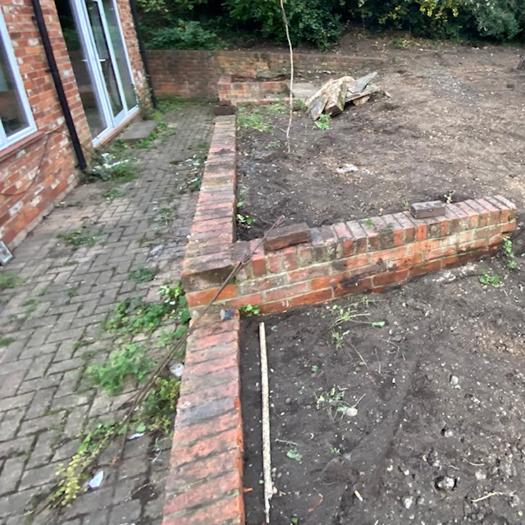
Views of original paved areas around the Annexe Building

