Alexander House, 106 Pembroke Road, Middlesex, HA4 8NW
Planning, Design and Access Statement January 2021

This statement has been prepared to support this application seeking planning permission for changes to the external façade of the building including, replacement shopfront; adding/rearranging/replacing openings; re-rendering; additions at second floor level and to the roof to the rear projection; installation of a lift; addition of 6 balconies and external alterations, that will improve the amenity for future occupiers/users of the building (in association with prior approval application ref: 10744/APP/2020/2240 for change of use of the building from office to residential).
In terms of principle of development, there is local and national support for efficiently using existing town centre buildings and to improve the amenity / quality of existing properties. Given the modest changes to the façade and the general improvements to the elevations being proposed, the development is considered to enhance the appearance of the existing building and the setting of the adjacent listed building and improve visual amenity of the wider area. The proposals are identical to the previously approved external changes under application ref: 107/APP/2020/2542 apart from the inclusion of a lift for level access to all flats of the residential development permitted under application 10744/APP/2020/2240. Therefore, the proposals will significantly improve the residential amenity for future occupiers.
Overall, the development would reflect the 12 core principles of sustainable development as set out in the NPPF, as well as the aims and objectives of local Council policy.
Site Description
The application site is located on the southern side of Pembroke Road, approximately 50m west of its junction with Victoria Road. The site consists of a 3 storey office block with commercial use at the front at ground floor level. The building is flat roofed and of modern character and its principle elevation is extensively glazed. The building extends to a considerable depth behind this broadly square street elevation and is faced with a mixture of brick and render.
To the East is a slightly lower period 3 storey flat roofed terrace, of mixed use and to the West is a part single storey, part two storey building which is the Grade II Listed Former Air Road Precautions Building, Windmill Hall. The site lies within the Ruislip Manor Town Centre as identified by the Local Plan Policies. The area is generally characterised by mixed use town centre building of varying styles and typology.
The site has a PTAL rating of 4 and is located in proximity of Ruislip Manor Tube Station. The land is also located in Flood Zone 1 which is not an area at risk of flooding.

Planning History
The existing building is 3 storeys with parking situated on either flank side of the building. Prior Approval Application ref: 10744/APP/2020/929 was consented in early 2020 for conversion of this office building to 23 residential units. Subsequently another Prior Approval Application ref: 10744/APP/2020/2240 was submitted for 23 units to replace the previous consent. This application was consented in October 2020. Planning application ref: 10744/APP/2020/2542 then consented changes to the external façade which sought to improve the appearance of the building and access to the already approved units. This new application is identical to the previously approved external changes application ref: 107/APP/2020/2542 apart from the 6 balconies and the inclusion of a lift for level access to all flats for future occupiers of the residential development permitted under application 10744/APP/2020/2240.

The Proposal
Planning permission is sought for changes to the external façade of the building including, replacement shopfront; adding/rearranging/replacing openings; re-rendering; additions at second floor level and to the roof to the rear projection; installation of a lift; six balconies and external alterations that will improve the amenity for future occupiers/users of the building (in association with prior approval application ref: 10744/APP/2020/2240 for change of use of the building from office to residential).

This application is identical to the previously approved application 10744/APP/2020/2542 apart from also seeking the addition of six balconies and installation of a lift for level access to all floors of the development to improve the amenity for future occupiers.
Policy Context
The proposed development would be assessed against the Development Plan Policies contained within the Hillingdon Local Plan comprising the Core Strategy and Development Management Plan (DMP), the London Plan, and the NPPF and supplementary planning guidance by Hillingdon and the Mayor of London. Principle of Development In terms of principle of development, there is local, regional, and national support for improvement of housing stock and enhancing the amenities for residents. The proposed installation of a lift to provide level access to all the flats is a particular positive aspect of the scheme.

Design and Heritage Impacts
The proposals include infill extensions at second floor level and at roof level to an existing single storey rear projection. The purpose of both of these additions is to increase the head height and internal quality of the space that will subsequently be available to residents.
Replacement/insertion/realignment of openings is also sought in order to improve the quality of the internal space and to enhance the appearance of the building (see existing and proposed elevations below). The existing building appears to have been neglected for a number of years and it appears to be in need of some modernisation. The use of a small element of render on the upper floor level would help tidy the appearance of the building and by replacing the windows throughout, the building will appear much more modern and have a clean cohesive finish.

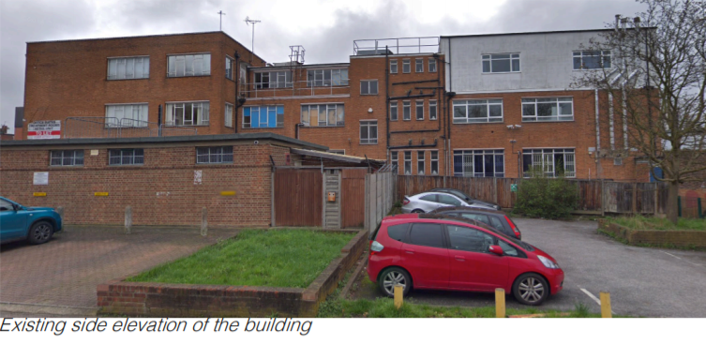

The existing arrangement of windows that can be seen above is poor and currently makes for a relatively unattractive building. The proposed changes to openings will significantly improve its appearance and the setting of the adjacent listed building.

With regards to the front elevation, the brick pilasters on each side that frame the frontage would be retained along with the metal detailing on the roof, thereby retaining the more positive elements of the existing character of the building. The new windows would be given a new more symmetrical finish that will respond positively with the rigid square framed character of the original building when viewed from the front. At ground level, larger display windows which include stall risers and fanlights will replace the existing two poor quality entrances. A new more central and accessible entrance will be provided in the middle of the building for the shopfront. The proposal will declutter the building and the changes sought are considered to give it a more balanced and uniform appearance.

The only change from the previously consented scheme ref: 10744/APP/2020/2542 relates to the addition of six balconies and to a lift with associated enclosure on the eastern side of the building. Given the modest changes to the façade and the general improvements to the elevations being proposed, the development is considered to enhance the appearance of the existing building and visual amenity of the wider area.
The proposal would also safeguard the setting of the adjacent listed building known as Windmill Hall. These proposals would improve the quality of the residential development approved under the extant prior approval consent to the benefit of future occupiers.
The proposals would be sympathetic to the character and appearance of the existing building, the setting of the adjacent listed building, and it would be in keeping with the appearance of this town centre location, in accordance with local, and national planning policies.

Accessibility Improvements
The proposal seeks changes to the pedestrian accesses to the office (future residential) and commercial ground floor unit which would improve accessibility for all users and future residents.
This new application also seeks to include a lift in the development where there is currently none. As such, future flats of the approved development will now benefit from level access to the upper floor levels. This was not included in any previous schemes and is considered to be a significant improvement to the accessibility of the building.
Impact on neighbours
The site is surrounded by mainly commercial or mixed used buildings with residential on their upper floor levels. There are no residential properties immediately to the North, West, or South. To the East, the nearest habitable room windows are located in excess of 21m from the building and all of the new openings are located on existing walls with openings facing in the same direction so there would be no greater level of overlooking than currently experienced. Therefore, the proposal would have no adverse impact on the amenity of neighbouring properties.
Conclusion
In terms of principle of development, there is local and national support for efficiently using existing town centre buildings and to improve the amenity / quality of existing properties. Given the modest changes to the façade and the general improvements to the elevations being proposed, the development is considered to enhance the appearance of the existing building and the setting of the adjacent listed building and improve visual amenity of the wider area.
The proposals are identical to the previously approved external changes under application ref: 107/APP/2020/2542 apart from the addition of six balconies and the inclusion of a lift for level access to all flats to benefit future occupiers of the residential development permitted under application 10744/APP/2020/2240. Therefore, the proposals will significantly improve the residential amenity for future occupiers. The proposal would include new openings elevations where there are existing openings. The existing and proposed openings are located in excess of 21m from the closest windows to neighbouring properties, therefore, the proposal would not raise any overlooking concerns or loss of privacy.
Overall, the development would reflect the 12 core principles of sustainable development as set out in the NPPF, as well as the aims and objectives of local Council policy.

