TOWN AND COUNTRY PLANNING ACT 1990
SECTION 78
HOUSEHOLDER PLANNING APPEAL SERVICE

On behalf of Mr Narinda Bhatti against the decision of

THE LONDON BOROUGH OF HILLINGDON

For the refusal of (a revised planning application) in respect of;

‘Single storey front/side extension (including conversion into habitable use); removal of existing pitched roof of rear extension; Increase in height of garage including single storey side/rear extension; first floor and roof level side windows; replacement rear doors/windows of existing ground floor rear extension (retrospective). Part single; part two-storey side/rear extension and rear patio..’

93 PINNER ROAD, NORTHWOOD,
MIDDLESEX,
HA6 1QN.

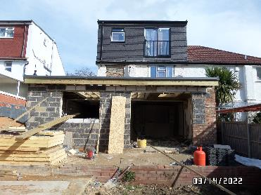

FASTRACK HOUSEHOLDER APPEALS SERVICE:
Written REPRESENTATIONS appeal

BACKGROUND

  - This planning appeal is made within the terms of Section 78 of the Town and Country Planning Act 1990, by way of the Written Representations, and the Fast-track Householder Appeals Service (HAS) procedure. The appeal will be lodged on-line, via the Planning Portal, along with the relevant Decision Notice, application forms, plans and other supporting reports and documentation, and we were provided with an acknowledgement Email from the Planning Inspectorate. The Planning Appeal (PINS) Case Reference will be provided in due course.

  - The REVISED planning application relating to this appeal was submitted to the London Borough of Hillingdon on 21st April 2022 and was allocated planning file reference: 62501/APP/2022/1311. Unfortunately, and despite further lengthy discussions with the Council, the application was subsequently refused by the London Borough of Hillingdon, on 16th June 2022, for the single reason shown on the Decision Notice, which we have already forwarded to the Planning Inspectorate, as part of the submission of this appeal on-line. However, for the purposes of this appeal, we have also provided the reason in full for the Inspector below, taken directly from the Decision Notice:


The proposed extensions, in particular the first floor side/rear extension element coupled up with the existing large rear dormer, by virtue of its , combined height, depth, and in particularity width, bulk and massing including the squat and boxy/flat crown roof, would result in a boxy, bulky, visually intrusive, disproportionate, incongruous, dominant and overbearing addition that would fail to harmonise with the architectural composition of the original dwelling, relationship with the un extended semi-detached pair of no.91 Pinner Road, character and appearance of the immediate stretch of properties along this part of Pinner Road and visual amenities of the streetscene.

Therefore, the proposal would be contrary to Section 16 of the National Planning Policy Framework (NPPF - 2021), Policies D1 and D4 of the London Plan (2021), Policy BE1 of the Hillingdon Local Plan: Part One - Strategic Policies (2012) and Policies DMHB 11, DMHB 12 and DMHD 1 of the Hillingdon Local Plan: Part Two - Development Management Policies (2020).

  - An Informative was added to the Decision Notice referring to the National Planning Policy Framework (NPPF), the relevant policies of the Adopted Unitary Development Plan, which is the Hillingdon Local Plan Part One (November 2012), and Part Two (January 2020), which supersedes Hillingdon’s Supplementary Planning Documents (SPD) entitled Hillingdon Design and Accessibility Statement (HDAS), entitled Residential Extensions.

  - Copies of the relevant policies will be provided by the London Borough of Hillingdon, as part of their questionnaire. So, this appeal is made on the grounds that the development could take place in accordance with:

Policy BE1 of the Hillingdon Local Plan: Part One - Strategic Policies (November 2012) and policies DMHB 11, DMHB 12 and DMHD1 of the Hillingdon Local Plan: Part Two - Development Management Policies (January 2020).

  - In addition, we will also refer to the regularly updated National Planning Policy Framework (NPPF), which provides guidance to Local Planning Authorities such as Hillingdon, in dealing with planning applications, including the more typical Householder Planning Applications such as this.

2.0 THE APPEAL PROPERTY:

  - No93 Pinner Road is a typical attractive semi – detached ‘inter – war’ house, which is located on the south western side of Pinner Road, so facing north east, and is located within the defined urban and Administrative area of the London Borough of Hillingdon. So Pinner Road is the main through roads connecting Pinner in the south with Rickmansworth in the north, with Northwood Hills Tube Station literally just around the corner, less than 5 minutes walk away, as shown on the map below:

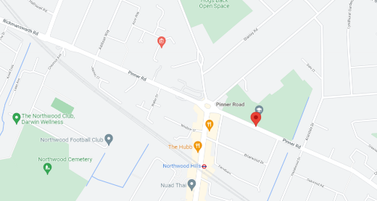

  - The area itself is a typical low density ‘sub-urban’ area of North West London, but it is located just north of the main commercial centre of Joel Street, which contains numerous retail premises, cafes, bars and other uses, as well as excellent transport links to Central London, some 40 minutes away.

  - As is typical for these detached homes, they have turned their respective front gardens over to parking, in this case providing off-street parking for 3-4 cars.

  - The properties in Pinner Road are of a similar semi-detached style, with a mixture of Mock Tudor detailing, part render and brickwork finishes, with tile hanging bay windows although a number of properties have been altered and extended over the years, as referred to in greater detail below.

  - An Ordnance Survey extract showing the location of the appeal property formed part of the original planning submissions, and was forwarded to the Planning Inspectorate as part of the on-line submissions, however to assist the Inspector in his/her determinations, we have provided this below:

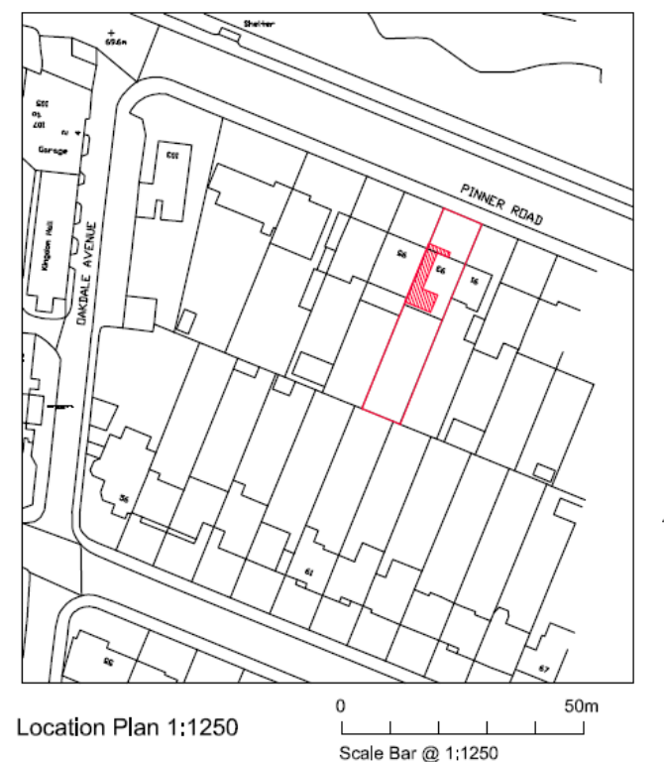

  - So, the area is a typical “sub-urban” residential area, and we will therefore respond to the single reason, as raised by the Local Planning Authority (LPA) in respect of the unwarranted potential adverse impact upon the area. We also note this broader area is not a defined Conservation Area, or Area of Special Local Character, which is a local Hillingdon – specific designation, where design considerations are more crucial.

  - We will also refer to the requirements of the Unitary Development Plan (UDP) policies, with a newly Adopted Hillingdon Local Plan 2020, which supersedes the former Design and Accessibility Statement Supplementary Planning Document (SPD).

  - So this application, and the extensions proposed would enable the Applicant and their family to remain, live and work in the Ruislip area and as such contribute towards the local economy, yet at the same time create a much improved home, which meets more modern Building Regulations standards.

  - Essentially this would create a much more eco-friendly-sustainable property, which will ensure this property meets current and emerging sustainable standards, as advocated by both Central and Local Government, in its ecological mandates-documents, including the Adopted Hillingdon Local Plan, as referred to in greater detail below.

  - The property is indeed located in this extremely sustainable location, just north of the main commercial centre of Northwood, with all its employment, recreational, retail and other opportunities, including being located close to alternative Public Transport nodes, including Northwood Tube stations, which form part of the Metropolitan Lines.

  - Clearly, the reason for mentioning the sustainable location is that the National Planning Policy Framework ‘golden thread’ running through it, is to encourage new development in sustainable locations such as this, which is shown on the Map below. The red symbols are restaurants nearby:
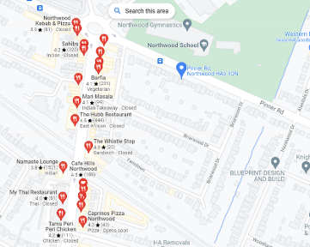

So, with regards the sustainable location, we note that the property is 4 minutes walk away from Northwood Tube Station, so an extremely sustainable location:

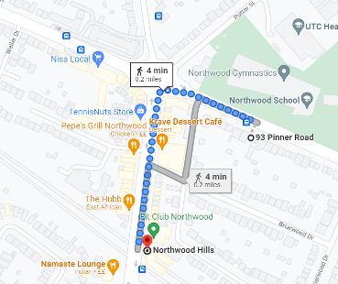

  - Now, as a Planning Consultant asked to prepare, lodge and monitor this appeal then the recent refusal seems an extremely subjective statement, in referring to the “disproportionate and incongruous addition” as an issue/reason for declining the application. The Local Planning Authority make this statement in respect of the “first floor side/rear extension” and the “existing dormer” too, however this Statement of Case sets out below why we consider this conclusion is an incorrect one.

  - Indeed, the National Planning Policy Framework, Amended July 2018, is quite explicit in its guidance to Local Planning Authorities in that they “should not get involved in detailed design issues”, but should “enable” new development to take place, but we will expand upon this shortly.

RELEVANT PLANNING POLICY:

  - The current Development Plan of the London Borough of Hillingdon comprises the London Borough of Hillingdon Local Plan, Part Two-Development Management Policies (2020). The relevant policies referred to in the reasons for refusal include policies from Part 2, so Policy DMHD1, Policy DMHB11 and Policy DMHB12. We remain of the view the proposed extensions subject to this appeal statement are compliant with these policies.

  - So, the current Development Plan of the London Borough of Hillingdon comprises the newly adopted Local Plan, Part 2, 2020 and is set out in full below:
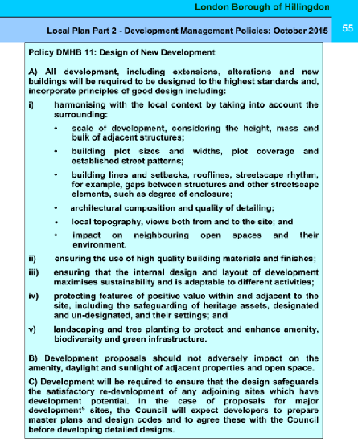

  - We consider this scheme has fully considered and meets the requirements – guidelines of Policy DMHB11, and that the proposed extensions would indeed “Harmonise with the local context” – environment. We also note that Policy DMHD1 specifically refers to “Alterations and extensions to residential dwellings” as this supersedes the former Residential Extensions SPD, which was the Policy – design guidance for many years, so this new Policy repeats much of the former SPD, and so we will refer to the relevant section of Policy DMHD1 shortly.

  - However, for the purpose of this appeal Appendix includes Policy DMBD1 in its entirety. This is discussed below under the Planning Considerations, and we will also refer to a number of local ‘precedents’ examples of similar side and rear extensions of a similar style, which have been approved by the Council, and that, in this broader context, the extensions proposed here would accord with what the Planners have approved close-by.

4.0 PLANNING – APPEAL CONSIDERATIONS:

  - With regards the planning issues, then we SUBMITTED A REVISED APPLICATION, which was specifically designed to overcome the previous refusal, and again note the London Borough of Hillingdon has not raised any objection to the scheme due to highways or amenity space. Therefore, we will not discuss the merits or otherwise of the other aspects of the scheme as part of this appeal, but will focus on the first floor side/rear extension.

  - So, firstly we are aware that, on the question of design, we wish to start by referring to the relevant Government Guidance, in the form of the National Planning Policy Framework (NPPF) (As amended) which reaffirms the previous earlier versions of the NPPF, and continues to indicate that Local Planning Authorities such as Hillingdon should not be too prescriptive in the application of their Local Development Plans, and on the specific question of design, stating:
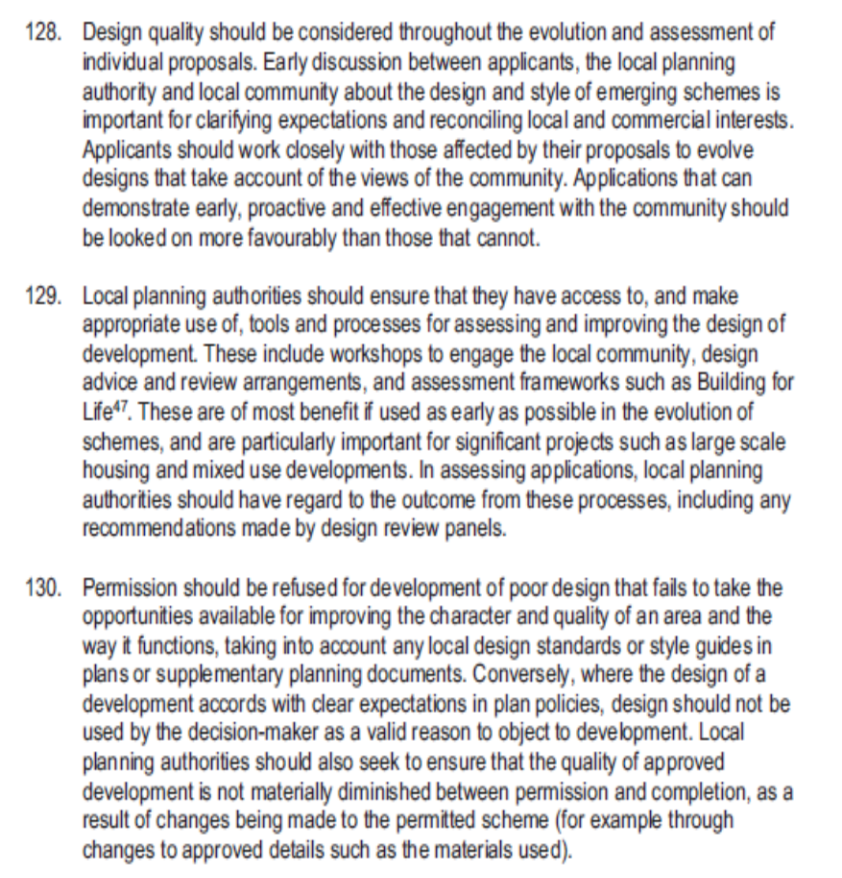

  - The most relevant paragraph above, of particular relevance from the National Planning Policy Framework, is that it states in respect of design:

“Conversely, where the design of a development accords with clear expectations in plan policies, design should not be used by the decision-maker as a valid reason to object to development.”

We remain of the view that the application involved mainly this simple first floor side/rear extension, which simply would involve a modest ‘wrap – around’ extension with a shallow and considerably subservient extension, which in our view does not compete with the main house and/or dormer above.

Indeed, the applicants took a strong steer and some comfort upon what they might secure Planning Consent for, with what several neighbours have done, as discussed below.

So, it was considered that the Local Planning Authority were using “design as a valid reason to object to this specific development”, contrary to the NPPF guidance. Simply put, then the extension would have minimal impact upon the area, using matching rendered walls, matching tile roof, matching eaves and angle of pitched roof and fenestration throughout.

So, from the main – Public perception, then in reality all that would change would be that the part side extension would barely be seen from the street, and certainly would not in our view, create a “squat and boxy” extension; again, we feel the Local Planning Authority (LPA) are being too prescriptive rather than “guiding” the overall development, as the NPPF advocates. So, as stated above, the design should not be used as a justification to object to a development.

In this case, the extensions would respect the scale of the original house, and as discussed earlier would entirely match in ALL respects, so matching ridge, materials, eaves, windows and doors and so on. We also note that the first reason specifically refers to:

“…the proposed extension…would…fail to harmonise with the architectural composition of the original dwelling, relationship with the unextended semi – detached pair of No91 Pinner Road…”

We are slightly confused by the second part of this reason, which specifically refers to the fact that, as No91 Pinner Road is “unextended”, then these extensions to the other half of the semi – detached property would upset the symmetry, yet hipped to gable and two storey side extensions to semi-detached properties have been permitted across London, in their thousands. The fact one has not (yet) been extended surely should not preclude all other extensions to semi-detached properties, which is the implication of this part of the reason?

Furthermore, clearly over time, as each half of any semi – detached property is extended or loft converted to a gable for example, then the ‘symmetry’ will surely return once the remaining half undertakes its own loft conversion, or two storey side extension.

So we have again quoted the most relevant sections of the above guidance, which we believe our scheme being in compliance:

- Extensions will be in scale with the original house;
- The original plan of the house will be respected;
- Materials and detailing would match the existing property.

  - In this case, the property and the proposed side and rear extensions would not be within any particular Conservation Area, where design is indeed acknowledged as being more critical in planning decisions. So we consider it would still entirely accord with the objectives of the NPPF, as the extensions would in our view enhance the property itself, whilst being barely visible from the wider street scene.

  - Essentially this is not a speculative proposal but is a genuine attempt to extend the Appellants home, in particular to create a much needed fourth bedroom, enabling the family to continue to live, work and ‘play’ in the area.

POLICY DMHD1

  - Policy DMHD1(A) ‘Alterations and Extensions to Residential Dwellings”: provides generic advice upon home extensions, suggesting; (i) “…there should not be any cumulative impact on the character, appearance or quality of the existing street or wider area.” (SEE APPENDIX A).

  - In response to this part of the policy, then this side/rear first floor extension would entirely match the house itself, whilst offering only a glimpse through from Pinner Road from the front and as such the extension would have little or no adverse impact upon the character, appearance or quality of the wider street – scene. This would also accord with the guidance contained in the NPPF, advising Local Planning Authorities not to get too involved in design issues.

  - Parts ii and v to Policy DMHD1(A) then refers to extensions having a satisfactory relationship with adjacent dwellings….and there is no unacceptable loss of outlook to neighbouring occupiers…and in this respect we note that the Case Officers report stated:

“4 neighbouring properties and the Northwood Hills Residents Association were consulted on the 1st October 2021 giving 21 days for comments. One comment was received stating to confirm whether there would be loss of light to rear
bedroom of no.91 Pinner Road..”

  - We note that the neighbour was concerned about loss of light to a bedroom, but ultimately Hillingdon did not refuse Planning Permission for this reason, but refused it on design and the unusual concern regarding the fact the extension to No93 Pinner Road would not match No91 Pinner Road, and “failed to harmonise with No91”. We have already set out earlier why we feel this conclusion must be wrong.

  - Part iv then requires extensions to “respect the design of the original house and be of matching materials…once again the proposal entirely accords with this aspect too, with a matching rendered and tile roof, as discussed, so matching materials, and also eaves, fenestration, angle of pitched roof, with hipped ends and so on.

  - Part vi refers to adequate garden being retained which it would, adequate parking remaining too, and trees and hedging retained, again which our scheme would.

  - Window patterns also closely match too, so overall and bearing in mind the NPPF guidance, the LPA are we feel being too prescriptive in terms of their design concerns, rather than guiding the overall design in this case, particularly bearing in mind the complete lack of objections from neighbours in respect of design, and/or the local Residents Association.

  - Policy DMHD1(B) “Rear Extensions” then specifically refers to “rear extensions” and Parts ii, iii, iv and v are not relevant, whilst Part vi specifically relates to first floor rear extensions stating they should not encroach into a notional 45 degree line of sight in relation to either neighbours rear windows, and the two storey rear section falls well outside this 45 line, (as shown on the Site – Block Plan, forming part of Drawing No:PLE/93PR/02), again in accordance with this aspect of Policy DMBH1(B).

  - Vii is not relevant, whilst part Viii requires the pitch of the roof to be of the same or similar angle of pitch and materials to both match, which in our case again the proposed extensions meets this guidance, also with eaves lining through and matching windows to all elevations.

  - Viii then suggests the roof needs to be “subordinate” and that larger Crown roofs are not acceptable, and in this case whilst the main roof is of a Crown design, this design considerably reduces the potential bulk of proposed roof, and as such then in our view the rear/side extensions generally accords with parts A and B of Policy DMHD1.

  - Policy DMHD1(C) “Side Extensions” We then note Part C refers to side extensions, and on this particular aspect, the first floor side extension and that Part (C) v suggests side extensions “should be set back a minimum of 1m,” but not that they must be set back, which implies there is indeed a degree of flexibility in this aspect of the policy. In this case, the first floor side extension on the RHS would be set considerably further back than the requisite 1m, also far exceeding this aspect of the Policy.

  - Policy DMHD1(E) “Roof Extensions”. Policy DMHD1(E)(i) to (iii) recommends roof alterations should not involve “raising of a main roof above an existing ridge line”, and our scheme again accords with this policy, by extending sidewards and rearwards, but considerably set down from the main ridge.

  - Finally, we wanted to provide the Inspector with a few examples of similar hip to gable roof extensions, and alterations – extensions which have clearly changed properties within the London Borough of Hillingdon, beyond recognition, from when they were first built:

PRECEDENTS:

No62 West End Road:

  - We have checked the Hillingdon planning records and have established Planning Permission was granted for two storey side and single storey extensions, (LBH ref:20921/APP/2020/1702, with the work now complete, so the street – scene is shown below:

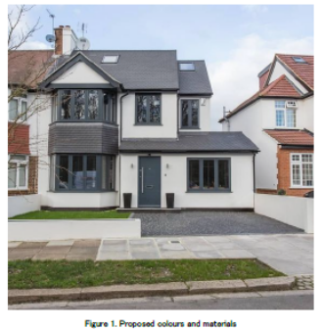

  - So, following this approval, the owners then sought planning permission for a first floor rear extension, which is identical to our current appeal scheme, (LBH Planning File ref: 20921/APP/2020/2698), and this was subsequently approved on 9th November 2020. We have therefore cut-and-paste both the approval at No62 West End Road and our 9 Pinner Road scheme as a direct comparison demonstrating they are indeed identical:
No62 West End Road:
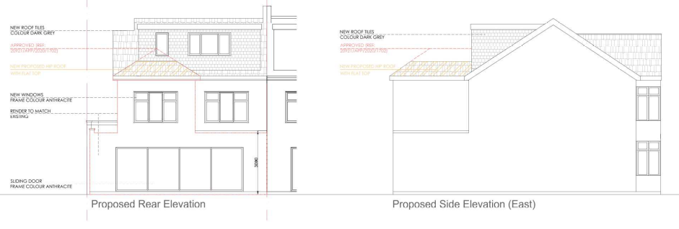

No93 Pinner Road:
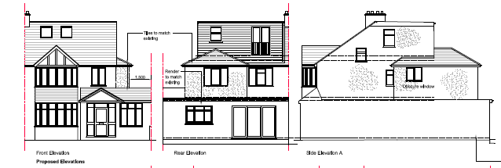

  - It is acknowledged these extensions to No62 were approved very recently, and so still relatively ‘new’ in planning history terms, and they demonstrate Hillingdon do indeed accept such first floor side – rear ‘wrap – around’ extensions. Given the identical nature of the extensions to No62 West End Road, we genuinely do not understand our refusal.

  - So, we note that the Case Officers report in respect of the approval at No62 West End Road concludes with regards the design:

“Above the side extension is proposed a first floor of 1.1m in width and 10.55m in depth, including a rear projection of 3.6m, which then return across the rear of the property for a further 2.65m…The rear extension is set beneath a hipped roof of 6.3m. Policy DMHD 1 advises that new extensions must respect the design of the original house…The proposed extensions would comply with policy guidance and in terms of appearance would be subordinate.

The rear extension at a depth of 3.6m would comply with policy guidance and the proposed two storey element would not contravene a 45 degree line of sight. As such it is not considered that the proposal would result in a significant loss of amenity to neighbouring occupiers. The principle windows will face the front and rear gardens and would not result in any additional overlooking or loss of privacy to that in existence. As such the proposal would comply with the requirements of policies DMHB 11 and DMHD 1 of the Local Plan: Part Two - Development Management Policies (2020).”

  - In our view then, this example demonstrates that Hilliningdon have accepted identical extensions, as being in keeping with the original house, including a rear facing dormer, whilst not adversely affecting the street-scene or neighbours. We believe therefore that Planning Permission should have been granted for our scheme.

  - Finally, then to reiterate, in terms of National guidance, of particular relevance from the National Planning Policy Framework, is that it also states in respect of design:

“Conversely, where the design of a development accords with clear expectations in plan policies, design should not be used by the decision-maker as a valid reason to object to development.”

  - So for the reasons highlighted above we maintain the proposals for this part first floor side, and part first floor rear extension would not “fail to harmonise with the architectural composition of the original dwellinghouse… and/or result in a boxy, bulky……addition”

  - So, these extensions would:

- Have the same angle of pitched-hipped roof on all sides;
- Having the same eaves level which line through at the same height;
- Having the same window proportions and colour
- Being of a rendered and tile roof to match.

  - So, in our view, for the above reasons, the proposed extension accords with National Policy Guidance, in the form of the National Planning Policy Framework (NPPF), as amended and we therefore maintain that, with regards to the first floor side and rear extensions, they would not conflict with the Adopted Local Plan 2020, as described above.

  - Consequently, in consideration of this submission and having regard to these reasons it is respectfully requested that the Inspector upholds this appeal, and grants Planning Permission for the extensions as submitted to the London Borough of Hillingdon.

CONDITIONS:

5.1 Without prejudice to the Inspectors decision, the following conditions are recommended, should the appeal be upheld:

1. 3 year time limit;
2. Materials to be submitted and agreed;
3. No further windows to be installed at first floor level in the side elevations of the first floor side and rear extension, which might otherwise overlook neighbours.

- APPENDIX A:

