TOWN AND COUNTRY PLANNING ACT 1990
SECTION 78
HOUSEHOLDER PLANNING APPEAL SERVICE

On behalf of Mr and Mrs Thakrar against the decision of

THE LONDON BOROUGH OF HILLINGDON

For the refusal of Planning Permission for;

‘Double storey rear extension, first floor side extension and garage conversion.

AT
14 BRIDLE ROAD, RUISLIP,
MIDDLESEX,
HA5 2SJ.

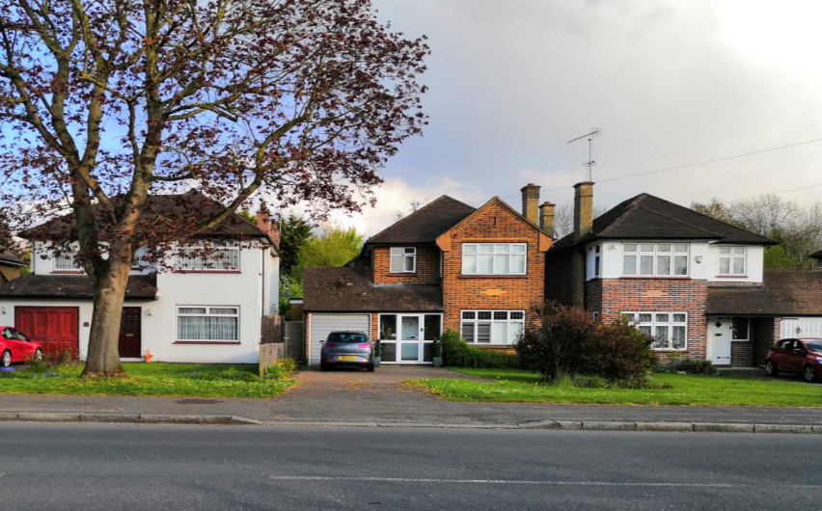

HOUSEHOLDER APPEALS SERVICE:
Written REPRESENTATIONS appeal

BACKGROUND

  - This planning appeal is made within the terms of Section 78 of the Town and Country Planning Act 1990, by way of the Written Representations, and the Householder Appeals Service (HAS) procedure. The appeal was lodged on-line, via the Planning Portal on 4th March 2022, along with the relevant Decision Notice, application forms, plans and other supporting reports and documentation, and we were provided with an acknowledgement Email from the Planning Inspectorate, and the Planning Appeal (PINS) Case Reference provided was:

APP/R5510/D/22/3294226

  - The original planning application relating to this appeal was submitted to the London Borough of Hillingdon on 2nd October 2021 and was allocated planning file reference: 6860/APP/2021/3713.

  - Unfortunately, and despite further lengthy discussions with the Council, the application was subsequently refused by the London Borough of Hillingdon, on 27th January 2022, for the two reasons shown on the Decision Notice, which has already been forwarded to the Planning Inspectorate, as part of the submission of this appeal on-line.

  - However, for the purposes of this appeal, we have also provided the reason in full for the Inspector below, taken directly from the Decision Notice:

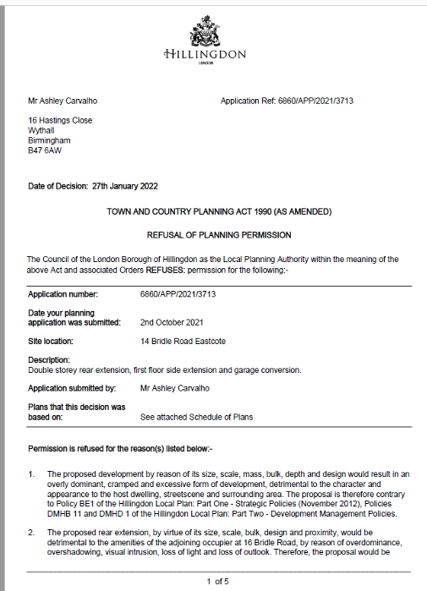

  - An Informative was added to the Decision Notice referring to the National Planning Policy framework, the relevant policies of the Adopted Unitary Development Plan. An Informative was added to the Decision Notice referring to the National Planning Policy Framework (NPPF), the relevant policies of the Adopted Unitary Development Plan, which is the Hillingdon Local Plan Part One (November 2012), and Part Two (January 2020).
  - (This new 2020 plan supersedes Hillingdon’s Supplementary Planning Documents (SPD) entitled Hillingdon Design and Accessibility Statement (HDAS), entitled Residential Extensions.)

  - Copies of the relevant policies will be provided by the London Borough of Hillingdon, as part of their questionnaire. So, this appeal is made on the grounds that the development could take place in accordance with:

Policy BE1 of the Hillingdon Local Plan: Part One - Strategic Policies (November 2012) and policies DMHB 11, DMHB 12 and DMHD1 of the Hillingdon Local Plan: Part Two - Development Management Policies (January 2020).

  - In addition, we will also refer to the regularly updated National Planning Policy Framework (NPPF), which provides guidance to Local Planning Authorities such as Hillingdon, in dealing with planning applications, including the more typical Householder Planning Applications such as this.

2.0 THE APPEAL PROPERTY:

  - No14 Bridle Road is a typical attractive detached ‘inter – war’ and ‘sub-urban’ house, which is located on the south eastern side of Bridle Road, so facing north west towards the road, with its rear garden on the south eastern side of the house. These properties are located within the defined urban and Administrative area of the London Borough of Hillingdon. So Bridle Road runs from north east to south west, as shown on the Ordnance Survey (OS) extract below:

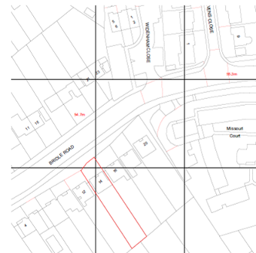

  - The area itself is a typical low density ‘sub-urban’ area of North West London, but it is located just north of the main commercial centre of Field End Road, which contains numerous retail premises, cafes, bars and other uses, as well as excellent transport links to Central London, via Eastcote Station, with central London approximately 40 minutes away. As is typical for these detached homes, they have attractive front gardens, but also with parking and turning area, in this case providing off-street parking for 3-4 cars.
  - The properties in these adjacent roads are of a similar large detached or semi-detached style, with a mixture of Mock Tudor detailing, part render and brickwork finishes, with tile hanging bay windows although a number of properties have been altered and extended over the years, as referred to in greater detail below.

  - So, the area is a quiet “sub-urban” residential area of particularly quiet character and quality, and we will therefore respond to the TWO reasons, as raised by the Local Planning Authority (LPA) in respect of the unwarranted potential adverse impact upon the area, and potential impact upon No16 Bridle Road. We also note this broader area is not a defined Conservation Area, or Area of Special Local Character, the latter of which is a local Hillingdon – specific designation, where design considerations are more crucial.

  - We will also refer to the requirements of the Unitary Development Plan (UDP) policies, with a newly Adopted Hillingdon Local Plan 2020, which supersedes the former Design and Accessibility Statement Supplementary Planning Document (SPD).

  - So this application, and the extensions proposed would enable the Applicant and their family to remain, live and work in the Ruislip area and as such contribute towards the local economy, yet at the same time create a much improved home, which meets more modern Building Regulations standards.

  - Essentially this would create a much more eco-friendly-sustainable property, which will ensure this property meets current and emerging sustainable standards, as advocated by both Central and Local Government, in its ecological mandates-documents, including the Adopted Hillingdon Local Plan, as referred to in greater detail below.

  - The property is indeed located in this extremely sustainable location, just north of the main commercial centre of Field End Road, with all its employment, recreational, retail and other opportunities, including being located close to alternative Public Transport nodes, including Eastcote Tube stations, which form part of the Metropolitan and Piccadilly Lines.

  - Clearly, the reason for mentioning the sustainable location is that the ‘golden thread’ running through the National Planning Policy Framework is to encourage new development in sustainable locations such as this, which is shown on the Map below:
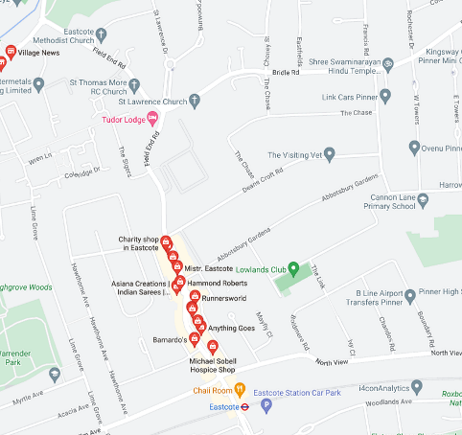

  - Now, as a Planning Consultant asked to prepare, lodge and monitor this appeal then the recent refusal seems an extremely subjective statement, in referring to the “dominant, cramped and excessive form of development” as an issue/reason for declining the application. The Local Planning Authority make this statement in respect of (Reason 1) the “development” and (Reason 2) the specifically refers to the “rear extension” too, however this Statement of Case sets out below why this conclusion is indeed an incorrect one, in our view.

  - Indeed, the National Planning Policy Framework, Amended July 2018, is quite explicit in its guidance to Local Planning Authorities in that they “should not get involved in detailed design issues”, but should “enable” new development to take place, but we will expand upon this shortly.

RELEVANT PLANNING POLICY:

  - The current Development Plan of the London Borough of Hillingdon comprises the London Borough of Hillingdon Local Plan, Part Two-Development Management Policies (2020). The relevant policies referred to in the reasons for refusal include policies from Part 2, so Policy DMHD1, Policy DMHB11 and Policy DMHB12;

We remain of the view the proposed extensions subject to this appeal statement are compliant with these policies. So, the current Development Plan of the London Borough of Hillingdon comprises the newly adopted Local Plan, Part 2, 2020 and is set out in full below:
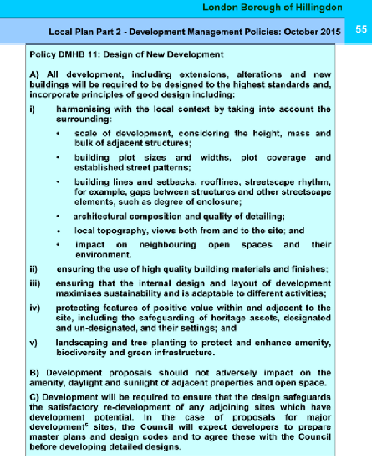

  - We consider this scheme has fully considered and meets the requirements – guidelines of Policy DMHB11, and that the proposed extensions would indeed “Harmonise with the local context” – environment. We also note that Policy DMHD1 specifically refers to “Alterations and extensions to residential dwellings” as this supersedes the former Residential Extensions SPD, which was the Policy – design guidance for many years, so this new Policy repeats much of the former SPD, and so we will refer to the relevant section of Policy DMHD1 shortly.

  - However, for the purpose of this appeal Appendix includes Policy DMBD1 in its entirety. This is discussed below under the Planning Considerations, and we will also refer to a number of local ‘precedents’ examples of similar two storey side and rear extensions of a similar style, which have been approved by the Council, and that, in this broader context, the extensions proposed here would accord with what the Planners have approved close-by.

4.0 PLANNING CONSIDERATIONS:

  - With regards the planning issues, then we note the London Borough of Hillingdon has not raised any objection to the scheme due to highways or amenity space. Therefore, we will not discuss the merits or otherwise of the other aspects of the scheme as part of this appeal, but will focus on the rear extension.

  - So, firstly we are aware that, on the question of design, we wish to start by referring to the relevant Government Guidance, in the form of the National Planning Policy Framework (NPPF) (As amended) which reaffirms the previous earlier versions of the NPPF, and continues to indicate that Local Planning Authorities such as Hillingdon should not be too prescriptive in the application of their Local Development Plans, and on the specific question of design, stating:
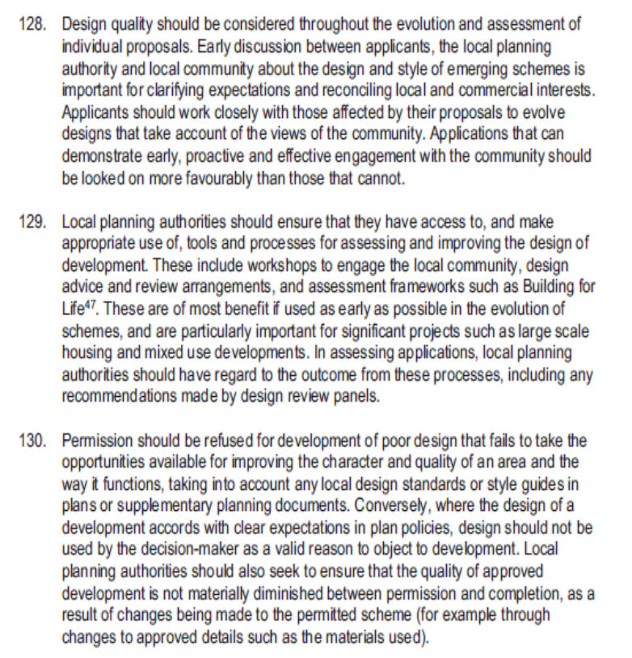

  - The most relevant paragraph above, of particular relevance from the National Planning Policy Framework, is that it states in respect of design:

“Conversely, where the design of a development accords with clear expectations in plan policies, design should not be used by the decision-maker as a valid reason to object to development.”

We remain of the view that the application involved mainly first floor side and two storey rear extensions, which simply would extend the ridge line at the same height (on the rear extension), and a slight reduction and degree of ‘subordination’ in the ridge height over the side extension, creating a cohesive finish to the extended dwelling, along with a corresponding first floor side element, which ultimately would create a more symmetrical appearance to the dwelling, similar in style, size and proportions to No16 Bridle Road, immediately to the south west of the appeal property.

Indeed, the applicants took a strong steer and some comfort upon what they might secure Planning Consent for, with what No16 had done, as discussed below.

So, it was considered that the Local Planning Authority were using “design as a valid reason to object to this specific development”, contrary to the NPPF guidance. Simply put, then the extensions would have minimal impact upon the area, using matching rendered walls, matching peg tile roof, matching eaves and angle of pitched roof and fenestration throughout.

So, from the main – Public perception, then in reality all that would change would be that the existing cat-slide roof on the left hand side of the main – forward facing gable would be replaced with a brick built extension, identical to the right hand side, creating a more symmetrical appearance.

In this case, the extensions would respect the scale of the original house, and as discussed earlier would entirely match in ALL respects, so matching ridge, materials, eaves, windows and doors and so on.

  - So, in our view, the first floor side extension to the LHS would create a much more symmetrical appearance to the property, similar in style to the extensions to No16, which now appears more symmetrical too.

  - So we have again quoted the most relevant sections of the above guidance, which we believe our scheme being in compliance:

- Extensions will be in scale with the original house;
- The original plan of the house will be respected;
- Materials and detailing would match the existing property.

  - In this case, the property and the proposed side and rear extensions would not be within any particular Conservation Area, where design is indeed acknowledged as being more critical in planning decisions. So we consider it would still entirely accord with the objectives of the NPPF, as the extensions would in our view enhance the property itself, whilst being marginally visible from the wider street scene.

  - Essentially this is not a speculative proposal but is a genuine attempt to extend the Appellants home, in particular to create a much needed fourth bedroom, enabling the family to continue to live, work and ‘play’ in the area.

POLICY DMHD1

  - Policy DMHD1(A) ‘Alterations and Extensions to Residential Dwellings”: provides generic advice upon home extensions, suggesting; (i) “…there should not be any cumulative impact on the character, appearance or quality of the existing street or wider area.” (SEE APPENDIX A).

  - In response to this part of the policy, then these rear extensions would entirely match the house itself, whilst offering only glimpses through from Bridle Road from the front and as such the main rear extensions would have very little impact upon the character, appearance or quality of the wider street – scene, which would also accord with the guidance contained in the NPPF. This advises Local Planning Authorities not to get too involved in design issues, particularly where they have already permitted extensions to adjacent properties, as referred to in more detail below.

  - Parts ii and v to Policy DMHD1(A) then refers to extensions having a satisfactory relationship with adjacent dwellings….and there is no unacceptable loss of outlook to neighbouring occupiers…and in this respect we remain of the view that the depth of the two storey section of the rear extension, at just 3 metres , does not infringe a 45 degree line of sight in relation to BOTH neighbours windows.

  - This strongly indicates this specific development would not harm the neighbours amenities, or the broader street scene, and in our view supports the general consensus that these extensions are surely acceptable.

  - Part iv then requires extensions to “respect the design of the original house and be of matching materials…once again the proposal entirely accords with this aspect too, with a matching red brick finish – peg tile roof, as discussed, so matching materials, and also eaves, fenestration (windows and doors), angle of pitched roof, with hipped ends and so on.

  - Part vi refers to adequate garden being retained which it would, adequate parking remaining too, and trees and hedging retained, again which our scheme would.

  - Window patterns also closely match too, so overall and bearing in mind the NPPF guidance, the LPA are we feel being too prescriptive in terms of their design concerns, rather than guiding the overall design in this case.

  - Policy DMHD1(B) “Rear Extensions” then specifically refers to “rear extensions” and Parts iii, iv and v are not relevant, whilst Part vi specifically relates to two storey rear extensions stating they should not encroach into a notional 45 degree line of sight in relation to either neighbours rear windows.

  - With regards the rear extension the depth alongside No16 Bridle Road, has been reduced to no more than 4 metres, such that it will not infringe a 45 degree line of sight, whilst the two storey rear section falls well outside this 45 line, (as shown on the Site – Block Plan, forming part of Drawing No:1050/Revision A), again in accordance with this aspect of Policy DMBH1(B). We would also note that these gardens are south – south east facing and so received good all-day round sunlight and direct daylight.

  - Vii is not relevant, whilst part Viii requires the pitch of the roof to be of the same or similar angle of pitch and materials to both match, which in our case again the proposed extensions meets this guidance, also with eaves lining through and matching windows to all elevations.

  - Viii then suggests the roof needs to be “subordinate” and that larger Crown roofs are not acceptable, and in this case whilst the main section of rear roof lines through, there is a subordinate side extension too, and so just the roof over the small area of first floor Crown roof. Overall, then the two storey rear/side extensions generally accords with parts A and B of Policy DMHD1.

  - Policy DMHD1(C) “Side Extensions” We then note Part C refers to side extensions, and on this particular aspect, the first floor side extension and that Part (C) v suggests side extensions “should be set back a minimum of 1m,” but not that they must be set back, which implies there is indeed a degree of flexibility in this aspect of the policy. In this case, the first floor side extension on the LHS would be set back almost 2½ metres, behind the forward facing two storey gable, in excess of this aspect of the Policy.

  - So, this two storey gable on the front of the property would not be altered and would remain as a rendered Mock Tudor finish, and therefore this rendered first floor side extension on the LHS would match the rendered extension on the RHS, so contrasting with the brick two storey gable, thereby surely creating a more symmetrical finish to the house.

  - As discussed, this design approach has been accepted on neighbouring properties in this same street.

  - Policy DMHD1(E) “Roof Extensions”. Policy DMHD1(E)(i) to (iii) recommends roof alterations should not involve “raising of a main roof above an existing ridge line”, and our scheme again accords with this policy, by extending sidewards, at a subordinate height and rearwards at the same height, but no higher.

  - However, at the same time, we note there is often a large degree of flexibility in interpretation of these policies, with Hillingdon Case officers accepting an increase in ridge heights, as shown below. So, we wanted to provide the Inspector with a few examples of whole roof extensions, larger two storey side and rear extensions, and alterations – extensions which have clearly changed properties within the London Borough of Hillingdon, beyond recognition, from when they were first built:

PRECEDENTS:

  - At this juncture, we would like to refers to other Appeals we have dealt with at 5 Sherwood Avenue and 4 Almond Avenue, both of which involved two storey side and rear extensions and both of which were allowed, plus another case at Park Avenue. The proximity of these cases to the appeal site are shown below, with the appeal site shown by the yellow dot, Sherwood Avenue shown by the blue dot and Almond Avenue shown by the Orange dot, and Park Avenue shown by the Black dot:
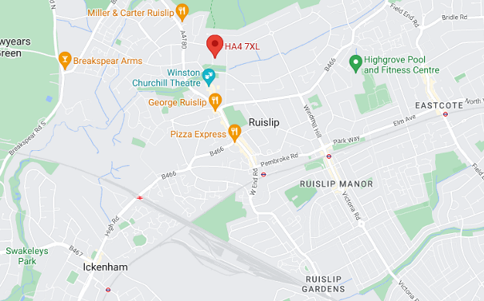

76 PARK AVENUE:

  - This is a local precedent, where the Council considered a full width and increased ridge height was acceptable, as recently as 2020. Hillingdon Planning File: 11788/APP/2019/904, approved on 16th October 2019, again with Officers support, stating:

“The main ridge of the roof would be raised by 0.5 metres. As the properties along Park Avenue vary in size and design, including a variety of heights…

…it is considered that the raising of the ridge would not appear out of keeping within the local area. The pitch and style of the roof would match the existing and so it is considered that it would not change the overall character of the original. The rear extension would have a maximum depth of 4 metres over both floors in compliance with HDAS recommendations.

Although the roof height would match the proposed ridge height and so would not appear subordinate, it is considered that it would allow the roof style and pitch to match the original property. As the rear would be highly visible from the public domain, it is considered that the roof design and pitch which matches the original would appear more in keeping than a subordinate, but differing roof design. As such, it is considered that on balance the rear extension would be acceptable.

Subsequently, it is considered that the proposed alterations would not be detrimental to the architectural character of the existing property and would not have a detrimental impact on the street scene and surrounding area.

  - Again, we have shown the approved plans below, for the Inspectors consideration – comparison, with the front, side and rear elevations below showing a completely full width two storey rear extension, whose ridge is actually raised above the existing:

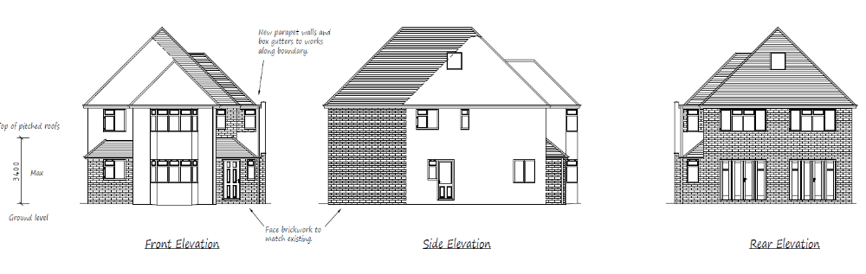

4 ALMOND AVENUE:

  - This further example actually also went to appeal, and is very similar to the current appeal here at Bridle Road. Appeal Reference: APP/R5510/D/21/3270366, which was allowed on 6th July 2021. This particular property also fell within Ickenham Village Conservation Area:

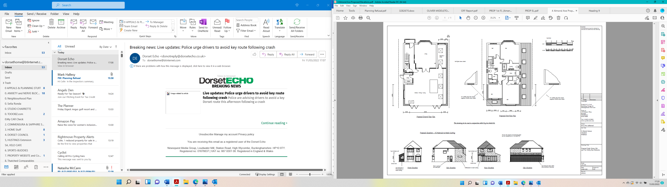

  - In that case the Inspector concluded:
“9. The proposed pitched roof of the side extension would complement the area in recognition of the variety of designs of local side extensions. Furthermore, this element of the proposal would include a window design and materials that would enable it to integrate with the front elevation. This would also maintain the gap at first floor and the rhythm of development along the street. Consequently, the proposed side extension would be successfully assimilated with the character of local built form.

10. The rear extension would project beyond the existing rear of the dwelling but maintain its width and height. Its roof design, window form and pebble-dash finish would ensure that this part of the proposal would complement the features of the existing house. It would therefore enable the proposed rear extension to integrate well with the form and design of the existing dwelling. Although it would be visible from adjacent rear gardens, the rear extension would not dominate such views.
The proposal would also satisfy policies DMHB1, DMHB4, DMHB11 and DMHB12 of the LP2 which seeks development to not result in the harm of a heritage asset and to harmonise with the scale and integrate with the local context.”

  - Much of the Inspectors conclusions here are salient to our appeal, with the proposed extension “…assimilating into the local character, compliment the features of the existing house…Although it would be visible from the rear gardens, the rear extension would not dominate such views.”

  - The Inspector then refers to Living Conditions, and notes that:

“The two-storey element of the proposed rear extension would be around three metres deep closest to No 3. The proposed first-floor element complies with the Council’s 45-degree code as specified by paragraphs A1.24-26 and policy DMHD 1(B)(vi) of the LP2. Other rear facing windows of No 3 would not be affected due to their distance and location in relation to the proposal. As a result, due to its separation distance, the proposed rear extension would have no substantive impact on the outlook of occupiers of the neighbouring dwelling”
  - Interestingly we note the proposed extension would be 3 metres deep, whilst the first floor element would comply with the Council’s 45 degree code…which is exactly the same as our scheme, and that our plans show the first floor extension is also outside the 45 degree ‘code’.

5 SHERWOOD AVENUE

  - Finally, we also wanted to discuss this scheme, which was also allowed at appeal, and is more radical than our current appeal scheme. The appeal reference is APP/R5510/D/21/3270369, and the appeal was allowed as recently as 24th September 2021:

7. There would be a sizeable extension over two storeys at the rear, but it would not increase the overall width of the property or materially increase its overall height…The proposed extension would continue the hipped roofs and projecting gable bays which are a characteristic feature of the existing house and other properties in the local area. The bulk and massing would be reduced by the set back of the extensions under hipped roofs on either side of the projecting extension under a gable roof. This would continue the rhythm of development found within the local area.

8. I am satisfied that the form, scale and design of the proposed extensions would respect the character and appearance of the local area, taking into account the pattern of development in the vicinity.

9. I therefore conclude that the proposed extensions would not harm but would respect the character and appearance of the existing building and of the local area. There would be no conflict with Policy BE1 of the Hillingdon Local Plan: Part One – Strategic Policies (2012) and Policies DHMB11 and DHMB12 and of the Hillingdon Local Plan: Part Two – Development Management Policies (2020)…”

  - The elevations are shown below:

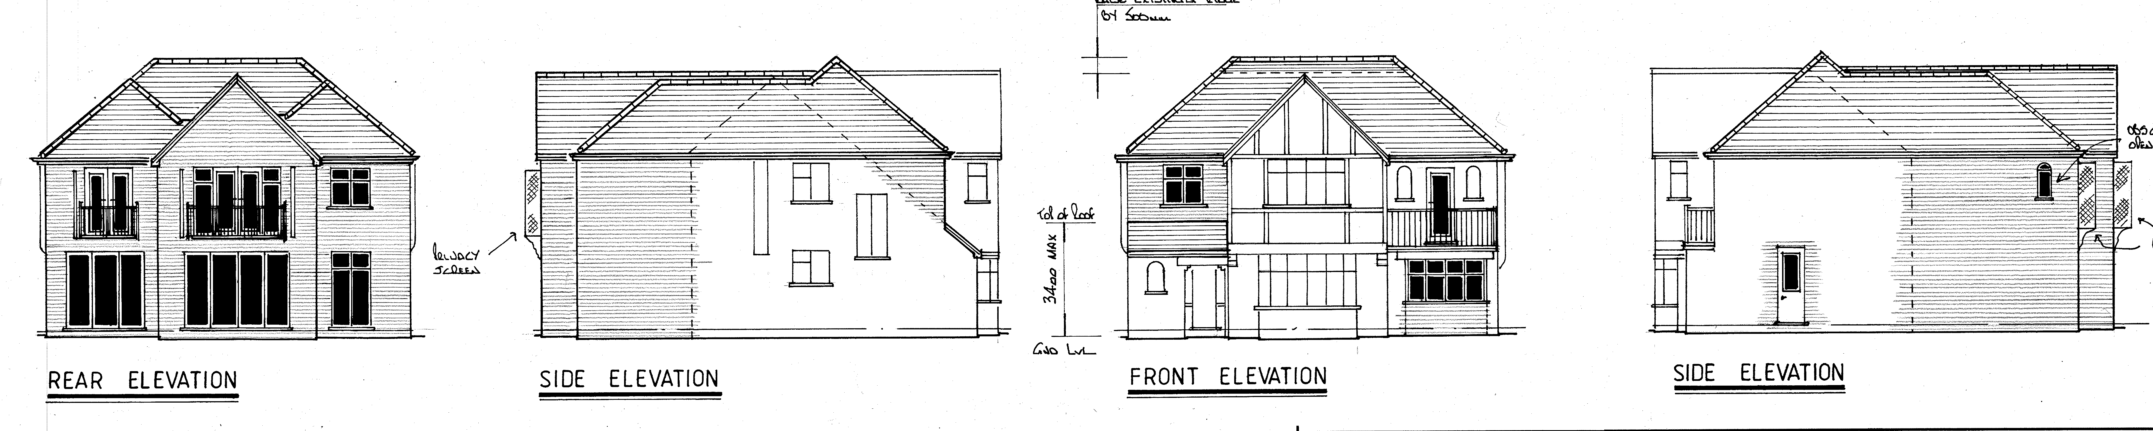

  - Clearly, this scheme is more radical than our current appeal scheme but does indeed demonstrate that first floor side and two storey rear extensions, which extend rearwards at the same height, with little or no subordination, do not detract from the character and appearance of the area or neighbours amenities.

  - So, then to reiterate, in terms of National guidance, of particular relevance from the National Planning Policy Framework, is that it also states in respect of design:

“Conversely, where the design of a development accords with clear expectations in plan policies, design should not be used by the decision-maker as a valid reason to object to development.”

  - So, in this case, it would appear the Local Planning Authority (LPA) are indeed using ‘design’ as a reason for objecting to this development, contrary to the above NPPF guidance, as in our view the proposal does accord with the Hillingdon Policies, in particular DMHD1.

  - So for the reasons highlighted above we maintain the proposals for this part first floor side, and two storey rear extension would:

- Have the same angle of pitched-hipped roof on all sides;
- Having the same eaves level which line through at the same height;
- Having the same window proportions and colour;
- Being of a matching brick, render and peg tile roof to match.

  - So, in our view, for the above reasons, the proposed extension accords with National Policy Guidance, in the form of the National Planning Policy Framework (NPPF), as amended and we therefore maintain that, with regards to the first floor side and two storey rear extensions, they would not conflict with the Adopted Local Plan 2020, as described above.

  - Consequently, in consideration of this submission and having regard to these reasons it is respectfully requested that the Inspector upholds this appeal, overturns the decision and grants Planning Permission for the extensions as submitted to the London Borough of Hillingdon.

CONDITIONS:

5.1 Without prejudice to the Inspectors decision, the following conditions are recommended, should the appeal be upheld:

1. 3 year time limit;
2. Materials to be submitted and agreed;
3. No further windows to be installed at first floor level in the side elevations of the two storey rear extension, which might otherwise overlook neighbours.

- APPENDIX A:

