TOWN AND COUNTRY PLANNING ACT 1990

APPEAL STATEMENT

IN RESPECT OF

THE DEMOLITION and REPLACEMENT OF AN EXISTING DETACHED BUNGALOW and ASSOCIATED GARAGE, and

ERECTION OF A PAIR OF SEMI – DETACHED HOUSES,

and A DETACHED HOUSE

AT

34 ACACIA AVENUE, RUISLIP, MIDDLESEX.

DECEMBER 2021

BACKGROUND TO THE APPEAL:

This appeal was lodged via the Planning Portal – PINS website on 7th November 2021, and we were provided with the Planning Inspectorate Case Reference: APP/R5510/W/21/3286382. Ultimately the application was refused 25th October 2021, and a copy of this Decision Notice has already been forwarded to the Planning Inspectorate, via the Planning Portal website:


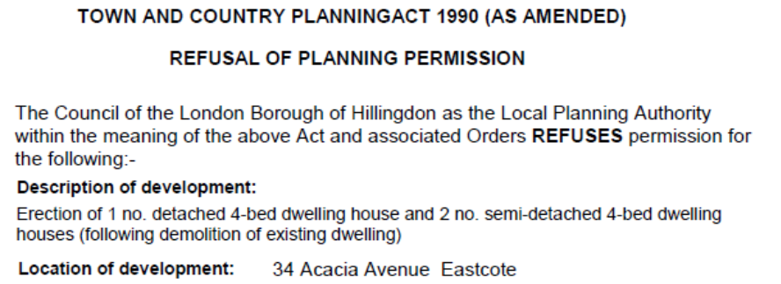
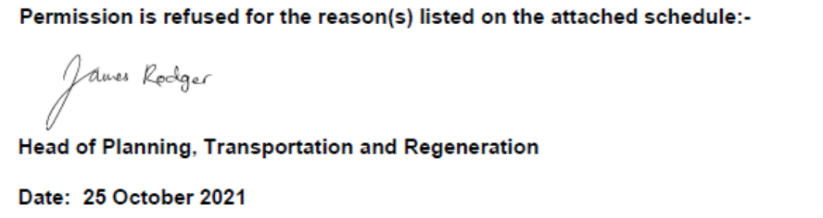

So, this statement constitutes our full Statement of Case, bearing in mind the broader National policy objectives as set out within the National Planning Policy Framework to build more homes in urban areas and other more local policy guidance, in the form of the Core Strategy or Adopted Local Plan or even more detailed Supplementary Planning Guidance (SPD’s).

In this case, the Agent who submitted the original applications was Gary Pottle, a locally based and experienced Building Surveying Company, with many years Surveying, planning and architectural experience in London Boroughs, in particular the London Borough of Hillingdon, and is also cognisant with Lifetime Homes, DDA compliant elements and also Listed Buildings.

The London Borough of Hillingdon is a large predominantly urban borough which covers a large part of North West London, including Ruislip. We are also aware that the National Planning Policy Framework (NPPF) refers to such changes of use and new – replacement dwellings such as that proposed here, so we will refer to this National guidance, where relevant, plus refer to more local – Hillingdon Adopted Planning Policies too.

In the meantime, as a Freelance and Agency Planning Consultant, I was asked to provide a professional opinion upon the refusal, and whether indeed it should be appealed. So, this Statement of Case (SoC) has been prepared to support this appeal, for the demolition of the existing modest bungalow, and the erection of a pair of semi – detached houses, and detached house, with associated minor alterations such as sub-division of the rear garden, to provide a garden for each new house, plus on – site parking to the front.

So, the stating point for this formal Planning Appeal are that the main issues for the Agent – Applicants to consider in submitting this appeal are set out below.

THE SITE and the PROPOSALS:

So No34 Acacia Avenue is a sprawling – wide fronted detached bungalow set in this linear “sub-urban” street, in an area of similar parallel linear roads, including Acacia Avenue, Myrtle Avenue and Elm Avenue all running parallel to each other, and Elm Road is a main arterial road running East – West through the area. So the Application property is just west of Field End Road, which also contains many commercial, retail and cultural facilities, as discussed below.

Eastcote Tube Station is located on Field End Road, less than 5 minutes walk to the north east of the appeal property, whilst Ruislip Manor Tube and shops is also just 5 minutes away, both of which are in Travelcard Zone 5, with a connection to central London via both the Metropolitan line and Piccadilly line, between Eastcote and Ruislip Manor stations, 40 minutes away. The area generally therefore enjoys an excellent sustainable location, so close to Eastcote and Ruislip Stations and therefore with easy access to Central London.

At the same time Hillingdon itself is located on the north western “fringe” – edge of North West London, where space for new homes remains extremely limited, and much of London is clearly surrounded by Metropolitan Green Belt or includes Metropolitan Open Land, where new development is not permitted.

We would also point out this scheme is very similar to a scheme we also secured Planning Permisssion at 59 Elm Avenue, via an appeal in 2019, at the junction with Oak Grove, which also involved demolition of a bungalow and the erection of two houses, on a prominent corner plot. Hillingdon file reference for this is: 60130/APP/2019/1369, refused on 23rd April 2019, but with a subsequent appeal allowed. That approval was in respect of:

“Two x 2-storey, 3-bed detached dwellings with associated parking and amenity space involving demolition of existing bungalow.”

We will refer to that specific case and the Inspector’s conclusions in allowing that appeal, in due course. So, No34 Acacia Avenue is quite a sprawling detached bungalow on this unusually large plot located within the London Borough of Hillingdon, a predominantly urban Local Planning Authority on the north western side of London, but clearly fringing on to the Metropolitan Green Belt. The property is shown below fronting Acacia Avenue, and backing onto Myrtle Avenue to the north:

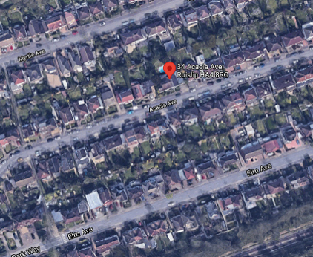

So, as background to this appeal, and the principle of new development – homes, it is considered the scheme, would clearly provide 3 new homes in north west London, where as we suggest new homes are not readily available, and clearly it would make considerably better use of this sustainable site (in terms of proximity to shops, employment, leisure and other uses) than the unsustainable (in terms of construction and insulation qualities, etc) and extremely old and dated bungalow.

So, 3 new family home would be constructed of considerably more modern sustainable materials and onerous Building Regulations standards, and essentially would be much more eco – friendly – sustainable properties, which will ensure they meet current and emerging sustainable standards, as advocated by both Central and Local Government, in its sustainable mandates – documents, including Lifetime Homes for example.

This planning application was submitted to Hillingdon on 13th August 2021, and provided with the file Reference: 1788/APP/2021/3141, however despite entering a dialogue with the Planners, including discussions, Emails to/from the Case Officer, the application was refused Planning Permission on 17th July.

MATERIAL PLANNING CONSIDERATIONS:

So, there are clearly several main materials considerations for the Planning Inspector to consider:

- the principle of residential re-development in this urban location, and replacing one small dwelling with three family homes, in this sustainable location;
- Design issues;
- Highways and the accessible location;
- Amenity Space, and any other issues -Trees, etc.

Principle of Development:

So the National Planning Policy Framework (NPPF), amended July 2018, states there is a presumption in favour of sustainable development.

“As a core planning principle the effective use of land is encouraged by re-using land that has been previously developed (brownfield land).”

The site currently comprises of a modest detached bungalow, and essentially, the “Carbon footprint” of the three new dwellings would be considerably lower than that of the existing bungalow, as they would have to be to more onerous current Building Regulations exacting standards, and we must again reiterate that, an important consideration is the sustainable location of the property, as discussed earlier, and discussed in greater detail below.

NATIONAL GUIDANCE – THE NPPF:

So, on the principle of new residential development in our towns and cities, the recently amended and updated NPPF again reiterates its views upon design, (in the form of the National Planning Policy Framework (NPPF) (Amended JULY 2018), at Paragraphs 127 and 130 stating respectively. We have underlined the most salient parts of the NPPF:

“.. Planning policies and decisions should ensure that developments:

a) will function well and add to the overall quality of the area, not just for the short term but over the lifetime of the development;
b) are visually attractive as a result of good architecture, layout and appropriate and effective landscaping;
c) are sympathetic to local character and history, including the surrounding built environment and landscape setting, while not preventing or discouraging appropriate innovation or change (such as increased densities);
d) establish or maintain a strong sense of place, using the arrangement of streets, spaces, building types and materials to create attractive…places to live, work and visit;
e) optimise the potential of the site to accommodate and sustain an appropriate amount and mix of development (including green and other public space) and support local facilities and transport networks; and
f) create places that are safe, inclusive and accessible and which promote health and well-being, with a high standard of amenity for existing and future users…”

In the case of this appeal, we believe the scheme should have been approved, as being specifically visually attractive and especially sympathetic to the local character, which does indeed contain a broad mix of bungalows, chalet bungalows and houses of this typical ‘sub-urban’ location on the North West side of London. It also follows (uses) the linear street spaces along Acacia Avenue, following the distinct building line along the street too, and being of potentially similar building materials, which would be the subject of potential Pre-Commencement – Occupation conditions.

Importantly, this scheme would clearly “optimise the potential of the site” providing 3 new – sustainably constructed AND located much needed family homes, in place of one unsustainable bungalow. We will discuss this aspect in greater detail shortly.

DESIGN:

In addition, with regards design, Paragraph 130 of the National Planning Policy Framework also states:

“Permission should be refused for development of poor design that fails to take the opportunities available for improving the character and quality of an area and the way it functions, taking into account any local design standards or style guides in plans or supplementary planning documents. Conversely, where the design of a development accords with clear expectations in plan policies, design should not be used by the decision-maker as a valid reason to object to development.”

So in this case, the planning application would represent good design, in terms of the visual – impact (design) of the new homes, as they would replicate the design of the numerous new houses permitted elsewhere within Hillingdon, as referred to in greater detail under the ‘Precedents’ section below.

So, in this case, the creation of three additional modest 4 bed houses from this site would accord with the general objectives of the SPD, creating three family homes from one particularly modest bungalow on this large plot, with a wide frontage, which is considerably wider than it’s immediate neighbours.

In this case, the new dwellings have been designed as part brick, part render and plain tiles, which would closely match the pallet of materials in the area, which consists of a broad range of bricks, render and roofing materials. The general built up nature of the area, and broader streetscene would not be harmed, and the Local Planning Authority also can control the potential finish, in terms of materials, window sizes, eaves, doors, etc, by imposing relevant and enforceable planning conditions, requiring approval of materials. Indeed, we will provide examples – precedents later on within this statement.

In this case, then the simple design solution, has taken on board the National NPPF guidance above and the more local planning policy stance, as set out in Policies DMH6, DMHB11 and DMHD1, shown below at Appendix A and B respectively, which we will now refer to in greater detail below. Indeed Policy DMH6 appears the most relevant policy, as shown below:
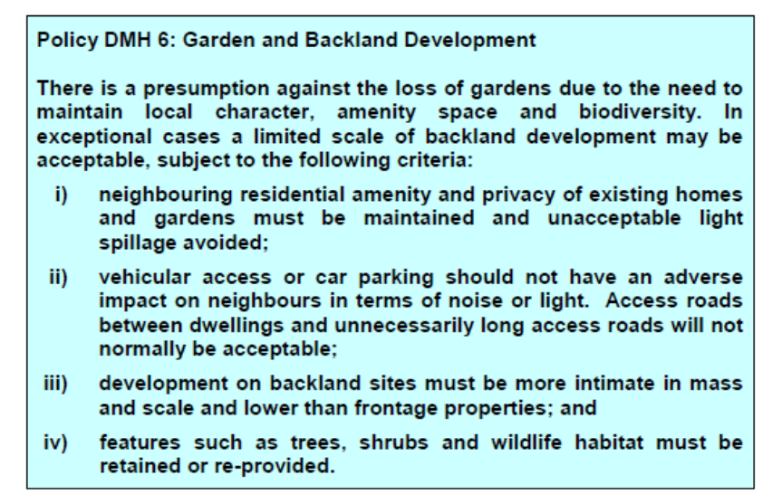

REASON 1:

This refers to various design and layout aspects, including the narrow frontages, excessive height and insufficient garden size to Plot 3. In response to these aspects, then in my independent view as a Planning Consultant, rather than an Architect or Draughtsman, so in my layman’s terms this is a subjective view regarding design, particularly bearing in mind the above NPPF guidance on design, and in my view the dwellings certainly would not be particularly narrow?

On the contrary, the front elevations shown on Drawing: 4505/02 show a particular wide fronted pair of houses, (Plots 2 and 3) with a projecting central gable and wide frontage either side of this, whilst the detached house (Plot 1) would also have a relatively wide frontage too, particularly by comparison to the mass – housing estates being constructed elsewhere within the Borough.

Indeed, these 3 houses I might suggest are considerably larger in terms of their overall footprint and room sizes than many newer Estates in the area; this is particularly evident from the floorplan of Plot 1 shown below:

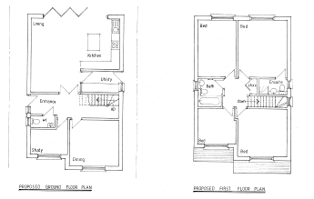.

One specific point we would take issue with in respect of reason one is, despite the fact the above floorplans show larger than typical room sizes, yet the Reason suggests the houses have “narrow front elevations and narrow plot widths” which clearly contradicts the statement that the dwellings would be “oversized”.
We would suggest not; as Acacia Avenue contains a broad pallet of bungalows, chalet bungalows and two storey dwellings, and therefore this scheme would not be out of character – scale – height with the other 2 – 2 ½ storey developments.

This reason then also specifically suggests Plot 3 “would provide inadequate amenity space”, yet again we would suggest that, by comparison to many ‘infill’ developments across London and new housing estates, 91 square metres is exceptionally large?

REASON 2

This then is also quite specific in the concern regarding the room sizes, which we would again suggest is contrary to the NPPF, and the recommendations that Local Planning Authority’s should “guide” the overall design and scale of development, rather than imposing their design objectives. In this case, we have a run-down, dated bungalow which has stood on this site for 50+ years, is constructed of materials of that age too, whereas, these new dwellings would be of the highest – current insultation levels, and would meet the ever more onerous Building Regulations standards, ideally with such new ‘technologies’ ground water heat source pumps, solar panels, water recycling, etc.

Essentially, the comments regarding bedroom sizes runs contrary to the National Planning Policy Framework, with its ‘golden thread’ being one of a ‘pragmatic’ approach and so recommending Local Planning Authority’s such as Hillingdon, really need to be more flexible in applying strict parking – room sizes – materials and other ‘limitations’ upon new homes, at a time when there is a serious shortage of new homes being built across the UK.

REASON 3

Again, this is extremely specific in the ‘design’ concerns, at a time when Central Government edits are recommending otherwise. This reason specifically refers to “the entrance levels” of the dwellings not complying with:

“Diagram 27 of Approved Document M to the Building Regulations…Requirement Part M4(2)”.
Whilst acknowledging the submitted plans do refer Lifetime Homes standards, etc surely, this specific matter would indeed be dealt with by a subsequent Application for Building Regulations Approval, assuming for one moment Planning Permission might be granted, and should not a ‘Material Consideration’ in respect of this current planning application. Indeed Gary Pottle, a local Building Surveyor and Agent in respect of the original planning application has been submitting applications to Hillingdon (and other London Boroughs) for over 30 years, for both Planning Permission and Building Regulations Approval during that time.

Therefore, as stated, he is extremely familiar with and aware of such Building Regulations requirements, including Part M and the need for extensions and new dwellings to be ‘DDA Compliant – under the Disabilities Discrimination Act, and therefore meet such specific requirements as ‘Level thresholds’, low level light and toilet fittings, disabled ramps, etc.

REASON 4

This specifically refers to Plot 3, and the slightly “undersized” private amenity space, however again in my experience as someone who has worked for a major housebuilder in the past, at 91 square metres, this far exceeds the 40 to 50Sq.m provided on much higher density sites. So, to demonstrate this we have highlighted the OS location plan below, showing that 3 houses here (Appeal site highlighted in Orange) would sit on comparable plots to those adjacent or close by, shown highlighted in Green and Blue:
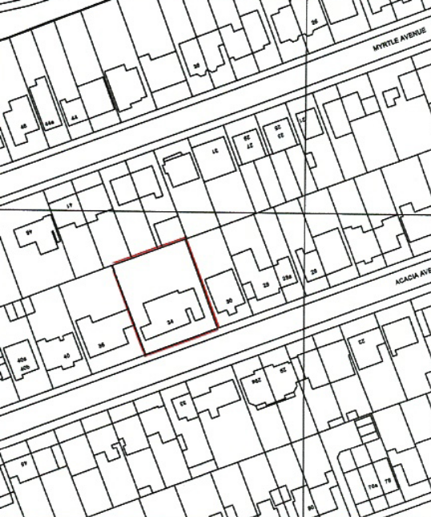

In this case too, Acacia Avenue is a typical linear street, where gardens to the rear and either side of these potential new homes are of an identical size, so surely the gardens shown to all three potential new homes are of a more-than adequate size serving these modest, new family homes, in this sustainable location, and constructed of the highest – new sustainable construction techniques.

Therefore, also in terms of the overall layout and plot sizes, design, scale and appearance, this scheme would not detract or fail to harmonise with the wider street scene, and the development would not conflict with Policies DMH6, DMHB11 or DMHD1 of the Adopted UDP, or result in a development that would not be in keeping with the architectural style of the area – which does indeed contain a broad pallet of single storey, chalet and two storey properties.
So, in this respect, we remain of the view that the proposed dwellings are visually attractive as a result of good architecture, layout and indeed the design. As such, then we do not believe the three new homes would detract from the character and visual amenities or openness of the location, and therefore would meet the Adopted 2020 Hillingdon Local Plan Part 2, Adopted 16th January 2020, particularly in relation to new housing development and new ‘infill’ dwellings as being sought here.

3: HIGHWAYS and ACCESSIBILTY:

So the National Planning Policy Framework (NPPF), as amended, states there is a presumption in favour of sustainable development…as a core planning principle the effective use of land is encouraged by re-using land that has been previously developed (brownfield land), OR making better use of land in our villages, towns and cities, such as here in ‘sub-urban’ West London, so entirely in accordance with this National guidance.

As discussed above, Acacia Avenue is located in this extremely sustainable location, close to Ruislip Manor to the west and Field End Road in the east, just 5 minutes walk away, with both areas containing a broad range of commercial, retail, leisure, religious and other uses. In addition, Ruislip and Eastcote Underground Stations, which connects the area to central London, just 40 minutes away, as shown below, by the black circles:

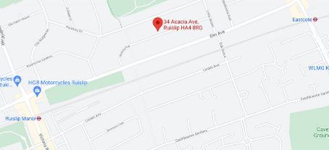

On this aspect the National Planning Policy Framework (As amended) does indeed suggest to Councils throughout the UK and refer to ‘Making more effective use of land’ and suggests that Planning Policies and decisions should:

c) “…give substantial weight to the value of using suitable brownfield land within settlements for homes…

d) promote and support the development of under-utilised land and buildings, especially if this would help meet identified needs…where land supply is constrained and available sites could be used more effectively…”

So, with the above National guidance in mind, then this application would create THREE new family homes, which would be created by demolishing this relatively modest bungalow and replacing it three new FOUR bedroom two storey homes, in this area which is charatcerised by a broad mix of single, one-and-half and two storey homes, and as discussed above they would be positioned in this excellent sustainable location.

More locally, the recently Adopted local Development Plan for Hillingdon is the 2020 Adopted Local Plan Policies, as set out below, which we will refer to shortly in support of this application:

- Policy DMH6 Garden and Backland Development;
- Policy DMHB11: Design of new development;

So with regards to Highways and Accessibility as Hillingdon often refer to, Section 4 of the SPD, then also (as quoted above), Hillingdon will assess sites in relation to their “accessibility” in relation to Public transport, shops, services and community infrastructure. They use what is termed a “Public Transport Accessibility Level” or PTAL.

With regards parking, then there are indeed 2 spaces per dwelling situated typically in front of each new property, so a total of 6 spaces, and there is also scope for some low level planting between various bays, providing an element of soft landscaping too, but which will not interfere with visibility for cars entering and exiting the site.

We assume therefore the Local Highways Authority considered two spaces per dwelling as a reasonable level of car parking provision, given the proximity to Public transport – buses and trains (underground) either side of the application site.

Consequently, once again it is contended that the proposed dwellings here would accord with both National (the NPPF) guidance, offering new family homes in an extremely sustainable location where other (non car) modes of transport are available and also in accordance with more local (SPD) guidance too, as outlined and discussed earlier.

4. AMENITY Space and other issues:

Finally, there are no issues relating to trees of as far as we are aware flooding. With regards to amenity space provision, as discussed earlier, the rear gardens would be, by comparison to newer housing development on estates, by major housebuilders, then it would far exceed the amenity-garden space provision provided on those developments. Indeed, the overall garden depth is approximately 14m deep, and between 10 and 7m wide for the detached and semi-detached dwellings respectively.

We note that the Hillingdon SPD requirement is for 100sq.m per 4 bed unit and that in this case one of the gardens (Plot 3) is 91sq.m in area, however such a modest shortfall would clearly not prejudice the family’s enjoyment of their relatively large garden, particularly by comparison to the much more limited amenity space on newer ‘suburban’ housing estates across the Borough. We also note cycle stores and bins presentations points will be provided too.

PRECEDENTS:

To conclude this appeal, we would like to refer to local recent precedents, where new infill housing has been permitted:

No7 to 9 Hawthorne Avenue:

The two sites below are similar ‘infill’ sites, between existing dwellings either side, so similar to the proposals here at Acacia Avenue. The first is a development of land between No7 and 9 Hawthorne Avenue, which was approved in 2005/2006. These were approved under the following file references 61379/APP/2005/3356 and 2006/2030 respectively. The 2006 plans are not available but the 2005 Block plan is shown below, and clearly shows a very similar layout being sought here at Acacia Avenue, with an infill development between existing frontage properties either side:

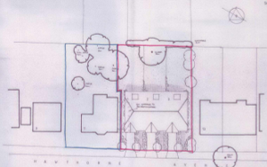

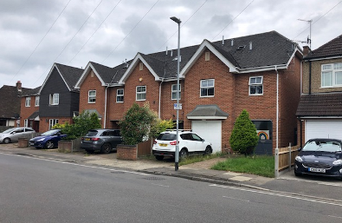
53 Hawthorne Road:
Another similar infill development is here at 53 and 53A Hawthorne Road, approved more recently in 2018, under LBH Planning file reference: 15248/APP/2018/3353:

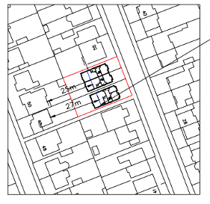
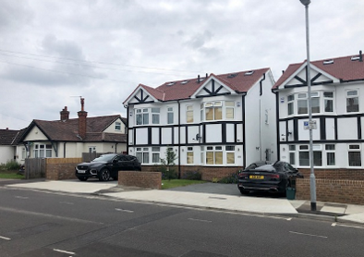
We note that this approval in 2018 had the recommendation of the Case Officer who stated:

“Policy BE1 of the Hillingdon Local Plan: Part One requires all new development to improve and maintain the quality of the built environment in order to create successful and sustainable neighbourhoods. Policies BE13 and BE19 of the Hillingdon Local Plan: Part Two - Saved UDP Policies (November 2012) states that new development should complement or improves the character and amenity of the area whilst safeguarding the design of existing and adjoining sites.

In addition, Policy BE22 states that buildings of two or more storeys in height should be set back a minimum of 1 metre from the side boundary of the property for the full height of the building. The proposed dwellings would be located 1 metre from the Northern and Southern side boundaries by 1 metre. In addition there would be a gap of two metres between the detached and semi-detached properties. The proposed replacement dwelling at No.53 would now be set further away than the existing bungalow.

Although the neighbouring property at No.51 is a bungalow there would be a distance of 3 metres from the side boundary of 51 due to the public footpath. The replacement welling at No.53A would be closer to the boundary than the existing, however, No.55 is a two storey property and the 1 metre set in is still maintained. Therefore, it is considered that on balance the proposal is acceptable and would not appear as an over-dominant or cramped on site. The open character and appearance of the surrounding area and the visual amenities of the street scene are therefore maintained.

117 to 119 Elm Avenue:
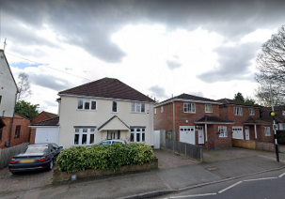

THE APPEAL AT 59 ELM AVENUE:

Finally, whilst appreciating this example is corner plot, I can confirm we acted on behalf of a previous applicant – appellant at 59 Elm Avenue, which was a similar detached bungalow fronting Elm Avenue, but positioned on the corner of Oak Grove. We appealed a refusal of Planning Permission here at 59 Elm Avenue, (PINS Ref: APP/R5510/W/19/3232952), and this appeal was allowed, on 8th November, with the approved block plan shown below:

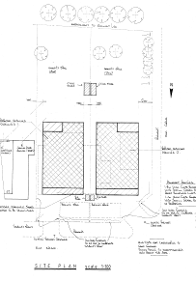

We lodged the appeal as it was considered better utilising this similar plot also containing a large bungalow, and providing two 3-4 bedroom houses, which would also accord with both National (NPPF) and local Development plan and SPD guidance too, as outlined above. We note that the Inspector did indeed agree with our case and in allowing the appeal confirmed:

“The proposed dwellings would be modest in size and would be in keeping with the scale of built development in the area. Whilst the proposed properties would appear prominent on the corner plot, they would not be visually intrusive due to the separation with neighbouring properties. The highway junction and surrounding verges maintains visual relief within the built form.

The proposal, due to its size and positioning would not encroach on this visual gap and would not have a detrimental effect on openness. The proposed dwellings are sensitive in scale and would not appear as cramped or dominating features within the street scene or surrounding area.

…the proposed development would not have a harmful effect on the character and appearance of the surrounding area. These matters would not result in the proposal having a harmful effect on the surrounding environment including the living conditions of neighbouring occupiers.

For the reasons set out above, the proposed development would accord with the development plan and therefore having had regard to all other matters raised the appeal should be allowed.”

In order to demonstrate the proximity of that appeal site to ours, and help the Inspector locate that site, if he/she wanted to inspect it (I do not know if that site has been redeveloped as yet), the Appeal site and 59 Elm Avenue are indeed shown below, with No59 highlighted by the Blue circle:

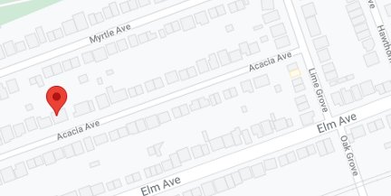

Importantly, we hope that the above examples demonstrate to the Planning Inspector that new houses which replace existing bungalow(s) have been accepted close to this application/appeal site, and equally that such new houses in place of bungalows can be developed, without detriment to the wider street – scene. We do acknowledge the street scene will change from an overtly single storey point with the street, however the Inspector will note at the forthcoming appeal site visit Acacia Avenue

CONCLUSION:

To reiterate, we consider this particular site is also in an extremely sustainable location, as it is equidistant between Eastcote Tube Station and Ruislip Manor Tube Station which in turn offers a short trip to get into central London, whilst Eastcote Station is located on Field End Road, a main – designated (in the Local Plan) Shopping core area, so with retail, leisure, religious and other uses.

Therefore, also in accordance with the NPPF, this slightly more intense – density of residential development makes much better use of this urban site, where other “non – car” modes of (Public) transport are available. As a Planning Consultant I have advised the Agent that I am happy to assist in this appeal, and provide any further information to the Inspector in due course.

Finally, we note the CIL contributions and ultimately we can confirm that the Appellant would (without prejudice) agree to such CIL contributions as necessary, and those necessary and enforceable planning conditions, relating to such matters as the approval of materials, and this would accord with the advice contained in the Circular 11/95, ‘The use of Planning Conditions’.

CONDITIONS:

Without prejudice to the outcome of this appeal, should the Inspector decide to allow this appeal and grant Planning Permission, the following conditions are recommended:

3 year time limit;

Materials to be approved;

Car parking and dropped kerbs to be provided;

Refuse storage to be provided;

