Appeal Statement
Against the decision of the London Borough of Hillingdon to refuse planning for:
‘Proposed extension to and conversion of front of roof from hip to gable end and 4 side dormers’
70 The Chase Ickenham, Uxbridge, UK, UB10 8ST
LPA Reference: 39228/APP/2021/2920
14th October 2021

Contents
1 Introduction 2
2 Site description 3
3 Relevant planning history 3
4 Policy context 4
5 Case for the Appeal 8
6 Conclusions 11
List of Appendices
- Precedence set by Hillingdon Council Planning approvals
- Recessed gable end design
- Photographic evidence: Balconies within the area
- Photographic evidence: The Chase & Halford Rd street scene

Introduction
On the 28th of July 2021, an application was submitted to The Council of the London Borough of Hillingdon for a ‘Proposed extension to and conversion of front of roof from hip to gable end and 4 side dormers’ for the property at 70 The Chase Ickenham, Uxbridge UB10 8ST. On 22nd September 2021, The Council of the London Borough of Hillingdon refused permission for this application as the Local Planning Authority (LPA) within the meaning of the Town and Country Planning Act 1990 (as amended) and associated orders.
This report will provide an overview of relevant planning policy and outline the case for the appellant. It will demonstrate that the proposal complies with relevant national, regional and local policies and that planning permission should therefore be granted.

Site description
The site comprises of a detached bungalow which is located on the eastern side of The Chase. The property has been extended to the rear and at roof level to provide habitable space in 2001 under planning approval (39228/APP/2001/2399). This development converted the use of the property from a standard bungalow to a chalet bungalow. Figure 1 below shows the front of the property taken from the street.

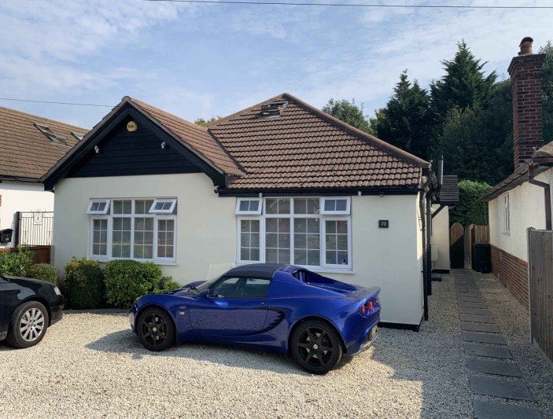
Figure 1: No. 70 The Chase, Ickenham, Uxbridge
Neighbouring properties (No.72 and No.68) are located to the north and south of the property respectively. The site itself is located on The Chase which comprises almost exclusively of detached chalet bungalows. The Chase is adjacent to Halford road which is very similar to The Chase in that it also comprises primarily of detached chalet bungalows. The Hillingdon Townscape character study 2013 describes this area as ‘Plotland development’. The property is not located within a conservation area and does not host any other designated heritage assets. Figure 2 below outlines the location of the property on The Chase.
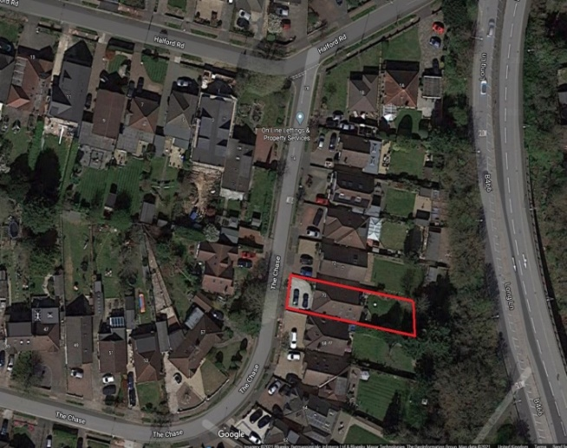
Figure 2: Site location plan

Relevant planning history
Table 1 below outlines the relevant and recent planning history for No.70 The Chase.
Reference | Location | Proposal | Received | Status
39228/APP/2021/138 | 70 The Chase Ickenham | Single storey rear extension | 13-01-21 | Approval
39228/APP/2021/150 | 70 The Chase Ickenham | Single storey side extension (Application for a Certificate of Lawful Development for a Proposed Development) | 13-01-21 | Approval
39228/APP/2020/3384 | 70 The Chase Ickenham | Single storey outbuilding to rear for use as a home office/gym (Application for a Certificate of Lawful Development for a Proposed Development) | 20-10-20 | Approval
39228/APP/2020/3386 | 70 The Chase Ickenham | Single storey side and rear extension, extension to and conversion of front of roof from hip to gable end and 4 side dormers | 20-10-20 | Refusal (P)
39228/APP/2012/2583 | 70 The Chase Ickenham | Extension of habitable roof space to include a side dormer and conversion of roof from hip to gable end with a new gable end window, single storey detached outbuilding to rear for use as a garden room. | 22-10-12 | Approval
Table 1: Relevant planning history

Policy context
This section provides analysis of the Planning Policy context in which the proposed development should be considered. Section 38(6) of the Planning and Compulsory Purchase Act 2004 makes clear that determinations of planning applications must be made in accordance with the development plan unless material considerations indicate otherwise. The following policies and supplementary planning guidance and documents are considered material considerations and sections relevant to this appeal will be examined. The appellant will underline key policy text that is relevant to this appeal and would like to emphasise this to the Planning Inspectorate.
Policy | Relevance | Appeal Section
The National Planning Policy Framework (NPPF) (2012) | National | 4.1
The London Plan (2021) | Regional | 4.2
Hillingdon Local Plan Part One: Strategic Policies (Adopted November 2012) | Local | 4.3
Hillingdon Local Plan Part 2: Development Management Policies (Adopted January 2020) | Local | 4.4
Hillingdon Townscape Character Study (November 2013) | Local | 4.5
Supplementary Planning Document HDAS: Residential Layouts (December 2008) | Local | 4.6
Table 2: Relevant Policy context

The National Planning Policy Framework (NPPF) (2019)
At the heart of the NPPF is a presumption in favour of sustainable development. Plans and decisions should apply a presumption in favour of sustainable development.

Section 38
- Local planning authorities should approach decisions on proposed development in a positive and creative way. Decision-makers at every level should seek to approve applications for sustainable development where possible.

Section 127
- Planning policies and decisions should ensure that developments are visually attractive as a result of good architecture, layout and appropriate and effective landscaping, are sympathetic to local character and history, including the surrounding built environment and landscape setting, while not preventing or discouraging appropriate innovation or change.

Section 130
- Where the design of a development accords with clear expectations in plan policies, design should not be used by the decision-maker as a valid reason to object to development.

Section 131
- In determining applications, great weight should be given to outstanding or innovative designs which promote high levels of sustainability, or help raise the standard of design more generally in an area, so long as they fit in with the overall form and layout of their surroundings.

The London Plan (2021)

LPP D3 – Optimising site capacity through design-led approach
- 1) enhance local context by delivering buildings and spaces that positively respond to local distinctiveness through their layout, orientation, scale, appearance and shape, with due regard to existing and emerging street hierarchy, building types, forms and proportions
- 11) respond to the existing character of a place by identifying the special and valued features and characteristics that are unique to the locality and respect, enhance and utilise the heritage assets and architectural features that contribute towards the local character
- 12) be of high quality, with architecture that pays attention to detail

LPP D6 – Housing quality and standards
- A) Housing development should be of high quality design and provide adequately-sized rooms

Hillingdon Local Plan: Part 1 - Strategic Policies (Adopted November 2012)
The Hillingdon Local Plan: Part 1- Strategic Policies is the key strategic planning document for Hillingdon and will support the delivery of the spatial elements of the Sustainable Community Strategy.

Policy BE1: Built Environment
- Policy BE1 aims to achieve a high quality of design in all new buildings, alterations, extensions and the public realm which enhances the local distinctiveness of the area and that proposals should be designed to be appropriate to the identity and context of Hillingdon's buildings, townscapes, landscapes and views

Hillingdon Local Plan Part 2: Development Management Policies 16 Jan 2020 (Adopted 2020)

Policy DMHB 11: Design of New Development
- 5.37 The Council is seeking to ensure that all new development complements and where possible, improves the character and appearance of the area in which it is proposed. Buildings should be of a high quality design, materials and finish.
- 5.38 The Council will aim to ensure that there is sufficient privacy for residents and it will resist proposals where there is an unreasonable level of overlooking between habitable rooms of adjacent residential properties.
- 5.39 Design and Access Statements submitted with planning applications should address the criteria in Policy BE1: Built Environment of the Local Plan Part 1 and DMHB 11: Design of New Development. They should demonstrate how relevant elements of these policies and the content of Hillingdon's Townscape Character Study and the Hillingdon Landscape Character Assessment have been taken into account.

Policy DMHB 12: Streets and Public Real
- Ensure public realm design takes account of the established townscape character and quality of the surrounding area.

Policy DMHD 1: Alterations and Extensions to Residential Dwellings
(Note to Inspectorate: All text and diagrams in this policy refer to a two story house, not a bungalow. e.g. under Roof Extensions it states ‘roof extensions should be located on the rear elevation only’.
- A1.5 Many houses in Hillingdon have a distinctive 1930s character and have been developed to a standard design providing consistency in terms of density and appearance. The Hillingdon Townscape Character Study 2013 sets out the building types which gives the Borough its particular sense of place’
- A1.6 Good design of residential alterations and extensions will enhance the appearance of a house, and thus its value, as well as improving the appearance of the local area. Well-designed alterations and extensions, using quality materials, should be of a scale and form in keeping with the house, and sympathetic to existing character, proportions, and floor plan.
Roof Extensions:
- i) Roof extensions should be located on the rear elevation only, be subservient to the scale of the existing roof and should not exceed more than two thirds the average width of the original roof. They should be located below the ridge tiles of the existing roof and retain a substantial element of the original roof slope above the eaves line
- A1.20 The design of roof extensions should not create a dominant ‘top heavy’ appearance out of proportion with the rest of the building. It should be lower than the height of the main ridge and sit well above the eaves and away from the roof's hips and valleys.
- A1.21 A dormer window should be no larger in size than those on the first floor and comprise an individual window and roof.

Hillingdon Townscape Character Study (November 2013)
The Hillingdon Townscape Character Study 2013 describes the townscape of the London Borough of Hillingdon. It forms part of the suite of documents that have been prepared to inform local planning policy. Sixteen specific types have been identified in Hillingdon. The study has identified that the street and surrounding area in which the appellants property is located is characterised as ‘Plotland’ as illustrated in Figure 3 below.

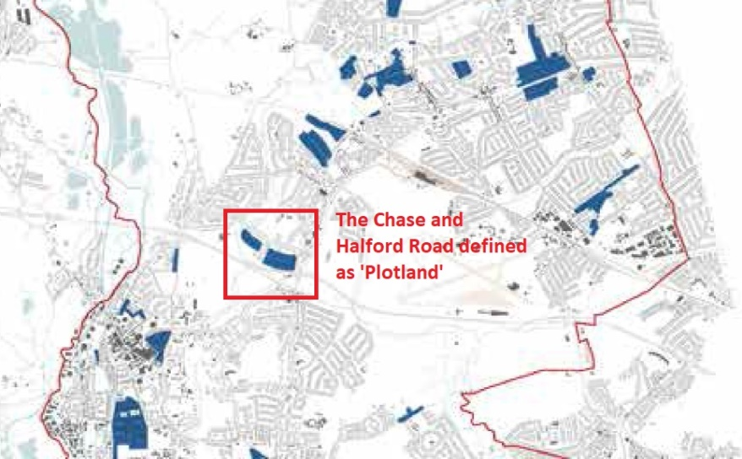
Figure 3: The Chase and Halford Road defined as ‘Plotland’
Below is the text from the character study regarding Plotland.
- Plotland development share many features with the Metroland character type. It usually features a simple perimeter block form, is built to a similar overall density and many of the buildings incorporate similar use of materials and details.
- However, Plotland development differs significantly in that, unlike the large estates which were built to a relatively high degree of conformity by major public or private developers, these areas of development were built piecemeal. Streets were laid out and individual plots constructed to the wishes of a builder working speculatively on one or two plots or by a purchaser commissioning a house to suit their wishes.
- As a result, Plotland development has a number of distinctive features. The buildings are almost all detached, despite the relative compactness of the plots. They tend to be relatively simple volumes and many of the houses present a gable to the public realm with the ridge running perpendicular to the street. In some areas bungalows predominate, although variations and adaptations over time mean that some have accommodation in the roof space. As with other areas of development, a gradual modification to properties by successive owners has continued to change the character of these buildings from their original design. However, whereas planned estates could be said to have a clear identity or collective design which is worthy of protection, plotland development has always enjoyed a more diverse and fragmented character.
- Plotland areas are more likely to be able to accommodate gradual change over time as variation between plots is an essential feature of the type.

Supplementary Planning Document HDAS: Residential Layouts
- 2.2 The Council understands that every property is slightly different and that there may be particular issues that relate to your home (such as changes in ground level, smaller rear gardens etc.) that do not relate to your neighbour’s property. The Council will take account of the characteristics of your home and surrounding neighbourhood in considering your application.

Case for the Appeal
This appeal is against the decision by Hillingdon council to refuse planning permission for the ‘proposed extension to and conversion of front of roof from hip to gable end and 4 side dormers’ for the property at 70 The Chase Ickenham, Uxbridge UB10 8ST. This section will examine the LPA officers Schedule of Reasons for refusal, the main planning issues specified in the officers report and provide detailed counter arguments as to why the Planning Inspectorate should rule in favour of the appeal. All references to the LPAs report will be in italics.

General points

References to HDAS document
The appellant would like to draw to the Inspectors attention that the Hillingdon Design and Accessibility Statement (HDAS) Supplementary Planning Document which Hillingdon Council has taken into material consideration in the LPA officers report only refers to two storey houses (detached, semi-detached or terraced) in all cases. There is no references or design guidelines that refer to bungalows. It therefore argues that it is impossible to fairly assess the appellants planning application when using the supplementary planning document as the property types and guidelines are very different in design, size, bulk, scale, and footprint. The appellant further argues that as per the HDAS document section 2.2, the Council has failed to abide by its guideline ‘The Council understands that every property is slightly different and that there may be particular issues that relate to your home’. ‘The Council will take account of the characteristics of your home and surrounding neighbourhood in considering your application’

Errors in the Councils refusal Decision Notice and Officers report

Decision Notice
- The ‘Standard informatives’ in the Decision Notice from the Council states that the decision to REFUSE planning permission has been taken having regard to local policies and all relevant material considerations including ‘The London Plan - The Spatial Development Strategy for London consolidated with alterations since 2011 (2016)’. However, the appellant notes that no reference to any policies within this document has been stated. Instead the council has stated the following in the ‘standard informatives’:
- LPP D4 (2021) Delivering good design
- LPP D6 (2021) Housing quality and standards
It is therefore assumed that the Council is actually referring to ‘The London Plan March 2021’ and will consider this document in this appeal.
- The LPA officer’s report states a reason for refusal in respect to the roof alterations/extensions is the ‘size, scale, bulk, and design of the side dormers windows’. However, the appellant considers that the reference to ‘windows’ is an error and that the main argument for the council is not the windows, but the size, scale, bulk and design of the dormers. However, for the purpose of completeness, the appellant it would like to state that the dormer windows in the proposal are all within local policy guidelines in terms of height, size, opening and glazing.

Officers report
- Section 1.1 ‘site and locality’ states ‘This application site relates to a detached bungalow located on the western side of The Chase’. This is incorrect. The property is located on the eastern side of The Chase.
- Section 1.2 ‘Proposed Scheme’ states ‘The application proposes the erection of a single storey side and rear extension and extension to existing roof to form a new front gable and 4 x side dormers’. This is incorrect. There is no application for a single storey side or rear extension in the appellants planning request.
- Section 1.3 ‘comment on planning history’ states ‘39228/APP/2020/3386- Refused. This application seeks permission for the same scheme externally, with a minor interior alteration involving the removal of the study’. This is incorrect. The planning application submitted under 39228/APP/2021/2920 is significantly modified to the refused application under 39228/APP/2020/3386’, in particular:
- The removal of the side extension and associated roof alterations
- The removal of the rear extension and associated roof alterations
- Architects drawings to reflect the current roof structure as illustrated in the schedule of plans
- Section 5 ‘Main Planning issues’
- Subsection ‘Policy DMHD1 E) Roof Extensions’, reference to ‘Conservation Areas, Areas of Special Local Character and on Listed and Locally Listed Buildings’. None of these apply to the appellant’s property and therefore are considered irrelevant to the planning application and the LPA officers report.
- ‘The frontmost dormer would be 2.6 metres wide and 1.6 metres in height. The rearmost dormer would be 4.9 metres in width and 1.6 metres in height’. This is incorrect. The frontmost dormers (closest to the main highway) are proposed to be 4.9M in width, and the rearmost dormers (furthest from the highway) are stated as 2.6M in width. This error is of particular importance when considering the councils argument that the proposal ‘add further bulk and massing towards the rear of the bungalow’.
The appellant argues that the magnitude and frequency of these errors in the LPAs assessment suggests that the council has not taken due care and attention in its role as the planning authority when assessing the appellants planning application.

Detailed analysis – Reason for refusal
This section will examine each aspect of the LPA reason for refusal below (citing the officer’s statements in italics where appropriate) and provide compelling, evidence backed counter arguments as to why planning permission should be granted.

Design of the front hip to gable end

Appellant arguments:
- The appellant agrees with the LPA officer’s statement that ‘the existing bungalow is of a traditional design’. However, the appellant feels that the existing traditional design is un-compelling and ‘boxy’ with no redeeming features and would like to draw attention to the successful appeal for 38 Halford Road (APP/R5510/D/18/3213099) which started life as exactly the same type of hipped roof bungalow as the appellants property (Ref appendix A). There are many like this type of bungalow on the Chase and Halford road. In this appeal, the same argument was raised by the council, and the response to the change in design from the Inspectorate was ‘I share the Council’s view that the character and appearance of the host property would largely be lost, subsumed within what would amount to be a substantially altered and extended structure. This factor would attract significant weight if I considered that the original structure was worthy of preservation for its intrinsic architectural merits. That, however, is not the case. The bungalow, to my mind, exemplifies architectural ordinariness, and the appeal scheme represents an improvement in visual terms on that which currently exists.
- The basis of the appellants proposal is to improve the design making it visually attractive as a result of good architecture as per NPPF section 127 whilst staying true to its type and form as a chalet bungalow. The proposal aims to improve the design by including a recessed gable and roof overhang to improve the character and aesthetic appeal by providing a sense of depth; something that is missing from the existing property. A flat gable end design would not provide the same effect and would only add to the ‘boxy’ design. It is felt that the recessed gable design will enhance the appearance of the property as well as improving the appearance of the local area in accordance with local policy DHMD 11, A1.6. The use of glass panels and cedar wood panelling within the rest of the gable area illustrates the use of modern materials that will enhance the design of the property through its detailing. The architecture should contribute to the creation of a cohesive built environment, which is often best achieved by ensuring new buildings reference, but not necessarily replicate, the scale, mass and detail of the predominant built form surrounding them. It is felt that the council has failed to consider that great weight should be given to outstanding or innovative designs which promote high levels of sustainability, or help raise the standard of design more generally in an area as per NPPF section 131.
- The Council also referred to the proposal as a ‘highly contemporary design’. The appellant agrees that the proposed design is contemporary, and would argue that instead of this being a negative point, contemporary architecture should be encouraged. The design features of the recessed gable end provides a contemporary approach to the traditional chalet bungalow typology. Appendix B provides examples of this type of design which has provided inspiration for the proposal. Furthermore, the appellant would argue that contemporary design has already been approved by the Council and is present only 50 metres from the appellants property on 3 Halford road. This scheme was approved under planning permission and illustrates the lack of consistency by the Council in citing ‘contemporary design’ as a reason for refusal. Please refer to Appendix A for more detail on this case.
- The Council stated that ‘Balconies are not a feature of the area and would not be appropriate in this location’. The appellant has found no less than 57 individual properties that all present a balcony on the front elevation of the property that faces the main road within the area (1 mile radius). Please refer to Appendix C for details. These properties range from chalet bungalows like the appellant’s property, through to detached houses, semi-detached houses and flats. Furthermore, a number of these properties are the only examples of properties with balconies on the street/road they are on, so there is no precedence that properties with balconies are only found in groups either. Therefore the appellant argues that balconies are very much a feature of the area and would be appropriate to the location by providing an architectural design detail to enhance the chalet bungalow form of the appellant’s property.
- The Chase and neighbouring Halford road have been characterised by the Hillingdon Landscape Character assessment as ‘Plotland’ (reference section 4.5), which describes the area and type as having a high degree of unconformity. It adds that where planned estates could be said to have a clear identity or collective design which is worthy of protection, Plotland development has always enjoyed a more diverse and fragmented character. It goes further by stating that Plotland areas are more likely to be able to accommodate gradual change over time as variation between plots is an essential feature of the type’. A simple walk along The Chase and Halford road will show that no two bungalows are the same, with variations in height, depth, design, materials used, alterations and even colour schemes (reference Appendix D). The appellant argues that this variation is consistent with the type and character of the area and that individual design should be given great weight in deciding the case.
- The appellant would like to take the Hillingdon Townscape character study into account as stated in Policy DMHB11 to emphasise that rather than conforming to the same design as all the other bungalows on The Chase, the proposed design is appropriate to the identity and context of Hillingdon's buildings, townscapes, landscapes and variation in design as stated in the study are essential to the character of the area.

Size, scale, bulk, and design of the side dormers window

Appellant arguments
- In reference to the size and scale of the dormers, the officer’s report describes their height, width and position in relation to the ridge of the roof correctly, but has stated the configuration of the dormers incorrectly as stated in section 5.1.2.2.
- In reference to the bulk and massing of the dormers, The LPA officer states that ‘the dormers would add significant bulk and massing to the property at roof level and would fail to appear subordinate to the main dwelling house’. The appellant disagrees with this opinion and uses data below to illustrate why:
- The existing roof has a volume of 162.5m3
- The rear dormers represent an additional 5m3 each (10m3 in total) and add 6.1% volume to the existing roof in total.
- The front dormers (closest to the main highway) represent 9.25m3 each (18.5m3 in total) and add 11.4% to the existing roof in total.
- Total volume added by the dormers at roof level is 28.5m3, or 17.5% to the existing roof
- The data above proves that the dormers (considered either individually, in pairs or as a collective) do not add ‘significant bulk and massing to the property at roof level’ and are aligned to Policy DMHD1 A1.20 in that they ‘do not create a dominant top heavy appearance that is out of proportion with the rest of the building’
- The appellant would like to further highlight in respect to the size of the dormers, that if the Planning Inspector still finds the dormers not to be subordinate to the main roof, to take consideration the wider street scene on The Chase and Halford road where multiple bungalows, either through Planning or Permitted Development have created very large, over dominant dormers, many of which are in line with or even above the ridge line (ref. Appendix D). In the successful appeal APP/R5510/D/19/3221062 for 56 Pole Hill Road, Uxbridge, UB10 0QB, the Planning Inspectorate wrote ‘It is suggested that many of the existing dormer windows would have been constructed under permitted development rights but I do not have the specific details of the various cases before me. Regardless of whether they were constructed under permitted development or were given the express benefit of planning permission, they are an important characteristic of the street scene’. It is therefore argued that irrespective of the planning route, these types of development are now a visual characteristic of the street scene and should be taken into consideration.
- In reference to the design of the dormers, every effort has been taken to minimise the impact of these on the overall roof structure. The colour of the tiles on the dormer sidewalls will be the same as the roof slope to ensure they blend into the overall roof. The dormers design are also are in accordance with Policy A1.20 which states roof alterations ‘should be lower than the height of the main ridge and sit well above the eaves and away from the roof's hips and valleys’.

Conclusions
- It is felt by the appellant that the LPA have made a number of errors and contradictions in their assessment of the planning application where they failed to:
- Pay care and attention when assessing the planning application
- Consider National, Regional and Local planning policy that encourages innovative design and positive change
- Consider Hillingdon Character study regarding the character of the area and the property type
- Consider the property specifics when assessing against supplementary design guides
- Use supplied measurements to determine the size / bulk of the proposed roof alterations
- Consider that balconies are very much a feature of the area
- The appellant argues that the proposal is:
- In accordance with National, Regional and Local planning policy
- Well designed, sustainable and proportionate to its type and form as a chalet bungalow and providing a distinctive character through the enhancement of the frontage to a recessed gable with thoughtfully designed and well-proportioned side dormers.
- Considerate to its neighbouring properties, local character and a positive influence on its context
- A visual improvement to the street scene and local area
- Taking into account all of the above, the Planning Inspectorate is respectfully requested to allow the appeal and grant planning permission, subject to any conditions deemed reasonable and necessary.
*** Document end ***

