Appendix D – Photographic evidence: The Chase & Halford Rd street scene
The section provides a sample of the street scene surrounding the appellant’s property.

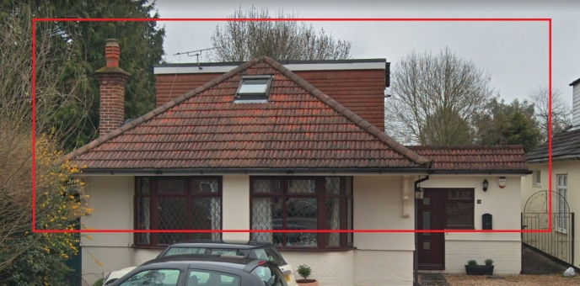
1a The Chase

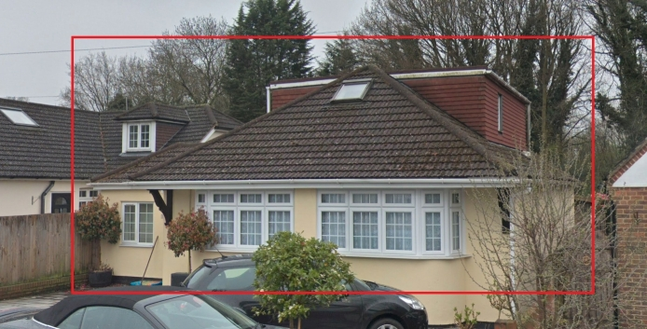
2a The Chase
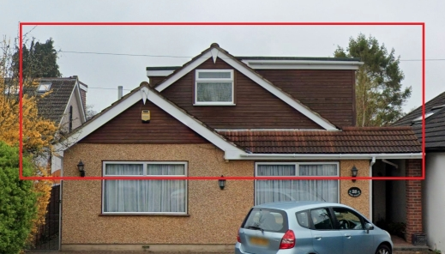
25 The Chase
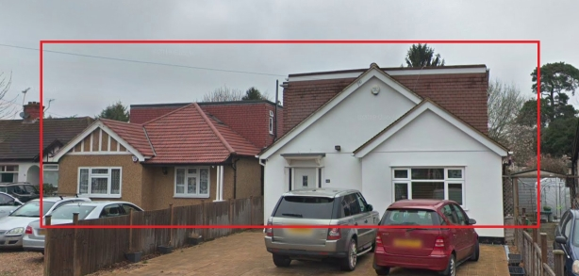
41 and 43 The Chase
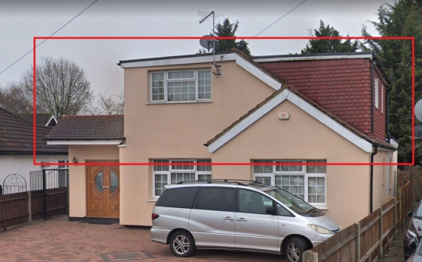
58 The Chase

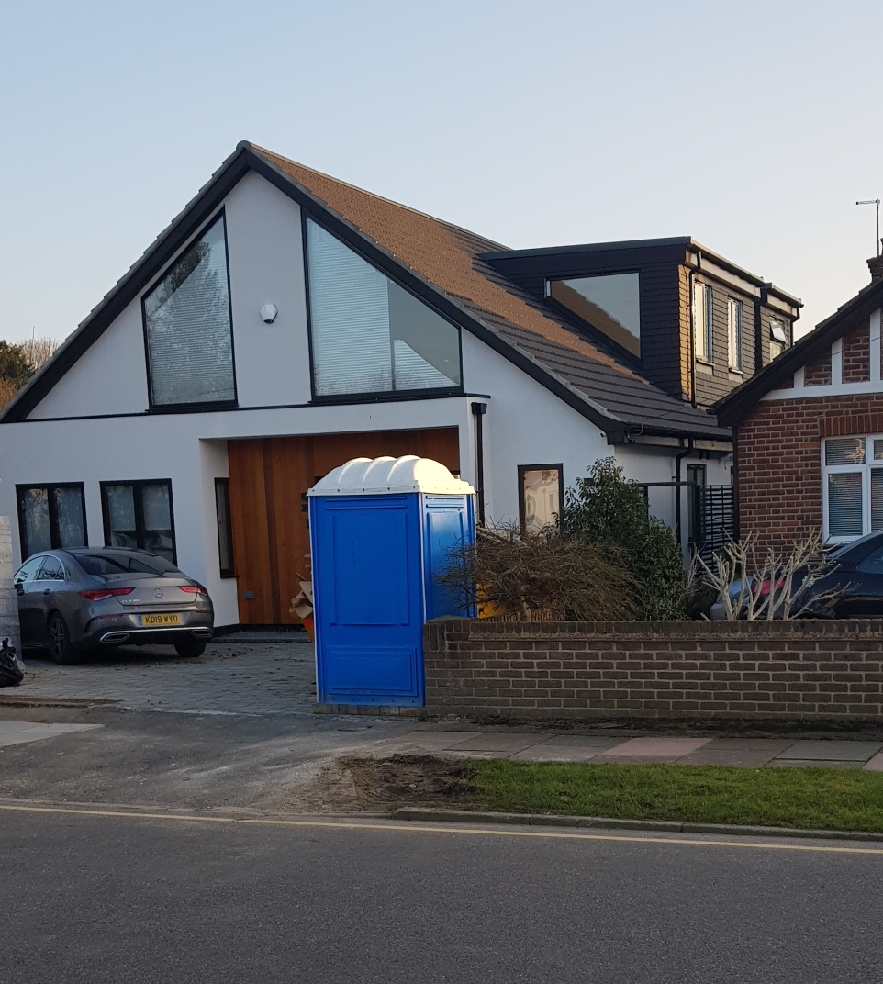
3 Halford Road

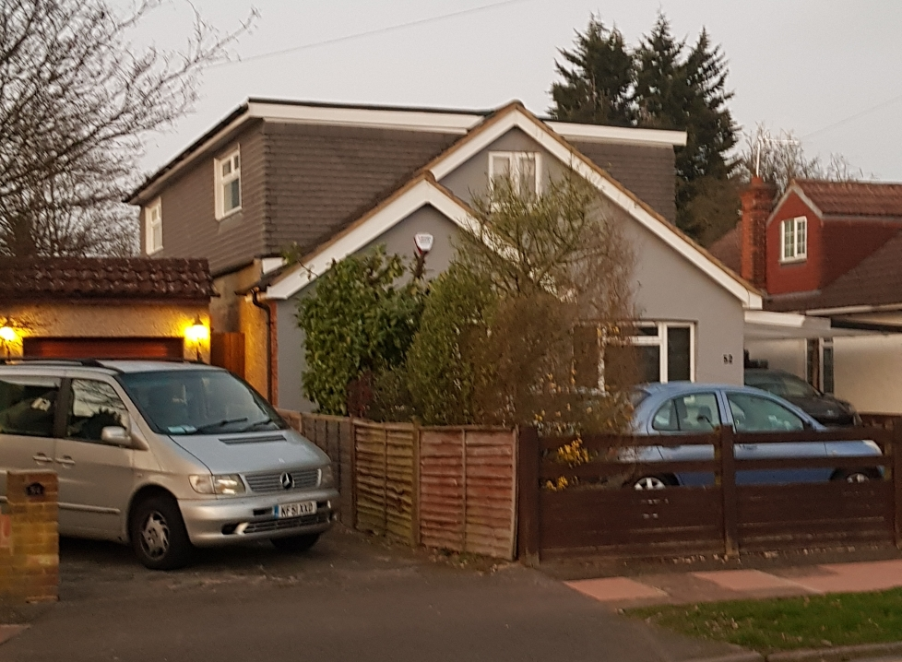
52 Halford Road

