Appendix C – Photographic evidence: Balconies within the area
This Appendix shows 57 individual properties, ranging from Chalet Bungalows like the property in question, through to detached houses, Semi Detached houses and flats, all within the ward of Ickenham, all under one mile radius of 70 The Chase.
3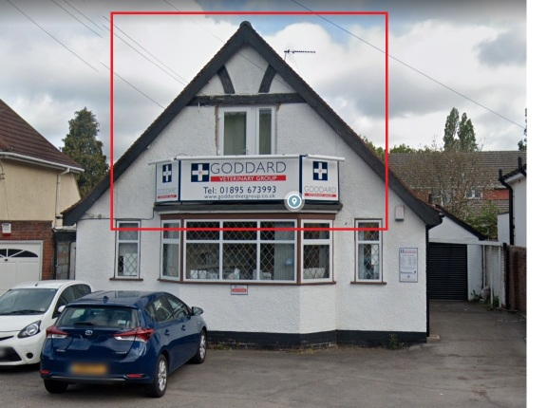
90 Swakeleys Road, Ickenham
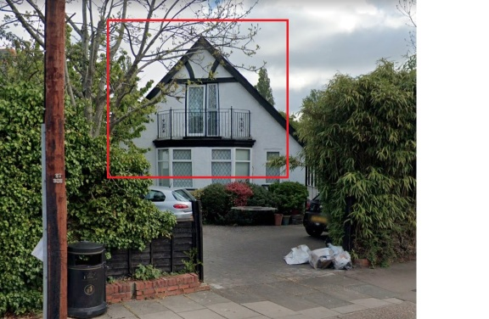
98 Swakeleys Road, Ickenham

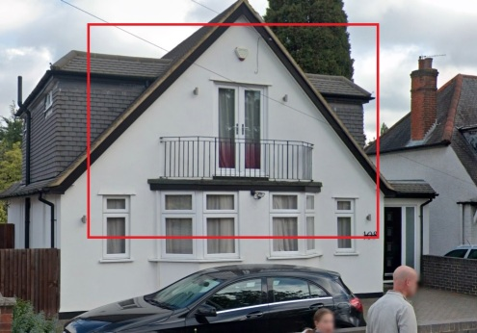
108 Swakeleys Road, Ickenham
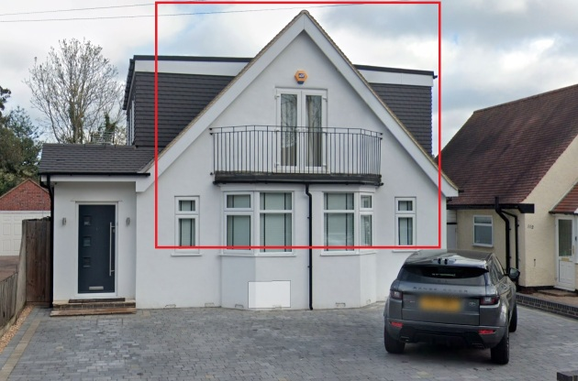
114 Swakeleys Road, Ickenham

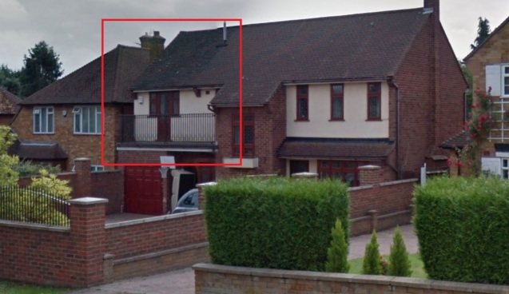
44 Warren Road, Ickenham
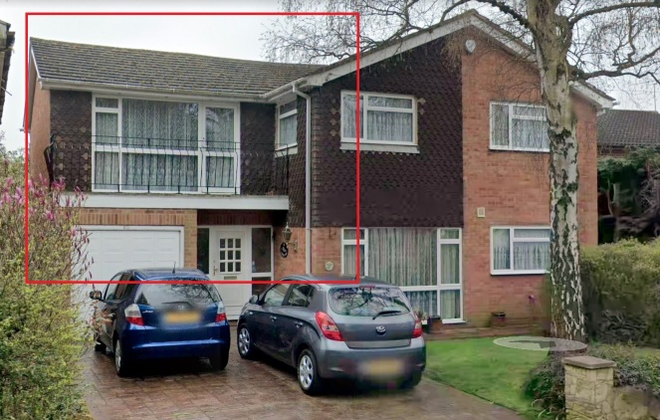
3A Court Road
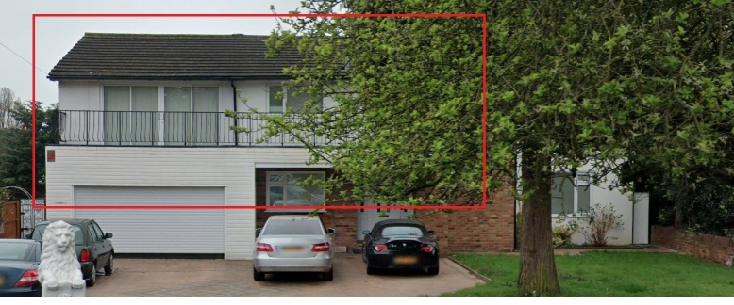

Court Road, Ickenham
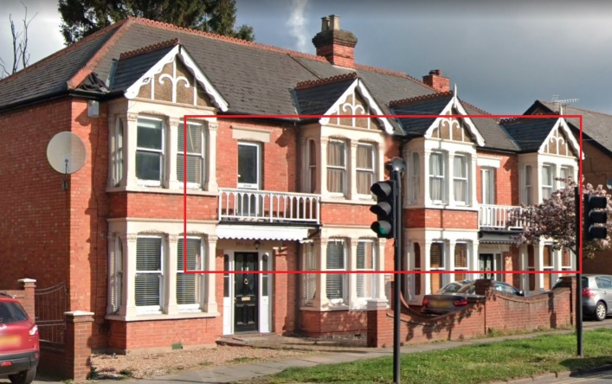
71 and 73 High Road, Ickenham
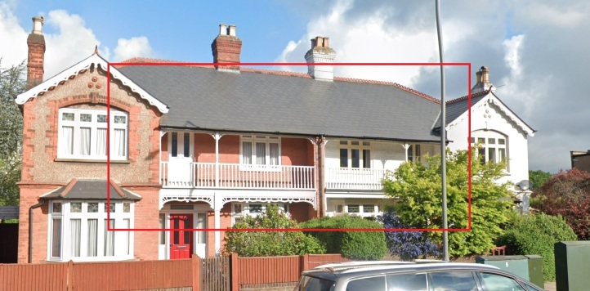
77 and 79 High Road, Ickenham
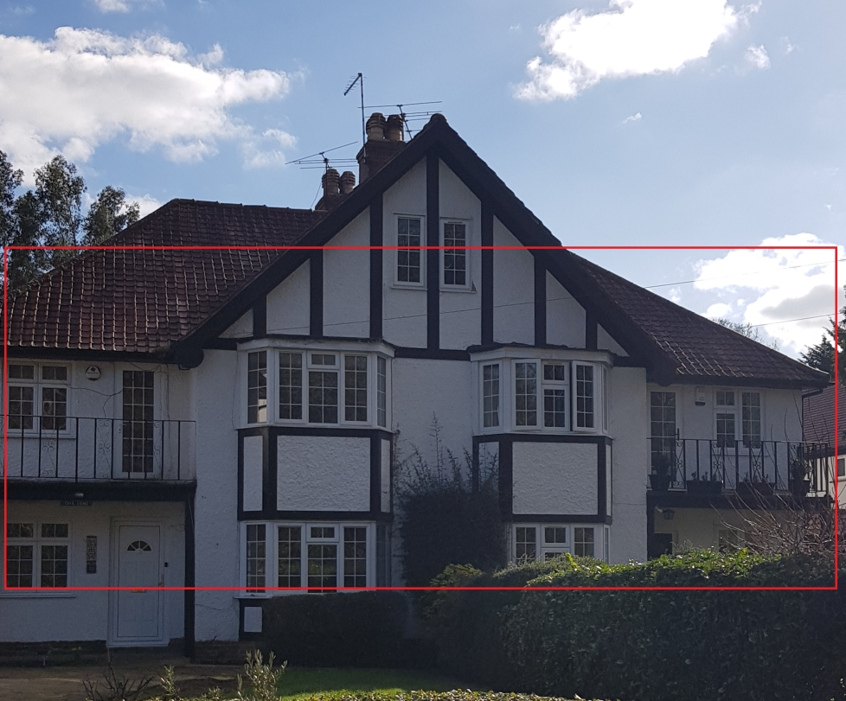
The Avenue, Ickenham

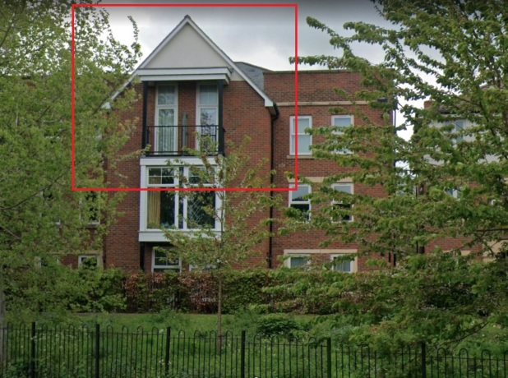
61 High Road, Ickenham
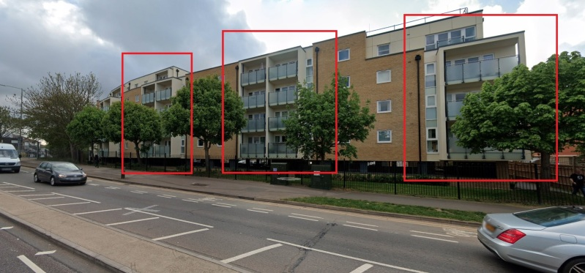
Multiple flats at 89 High Road, Ickenham
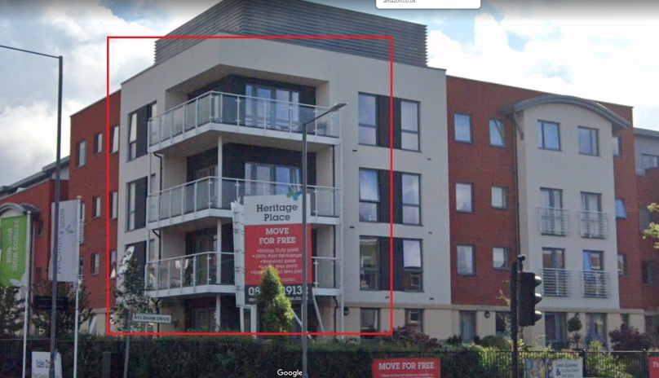
Multiple Properties on Asylum Drive, Ickenham
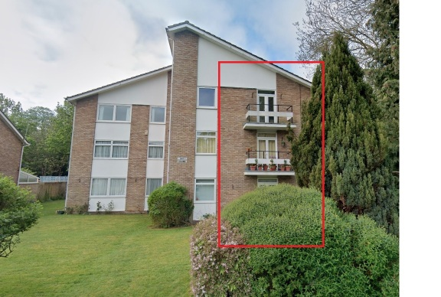
Bay House, Milton Road, Ickenham
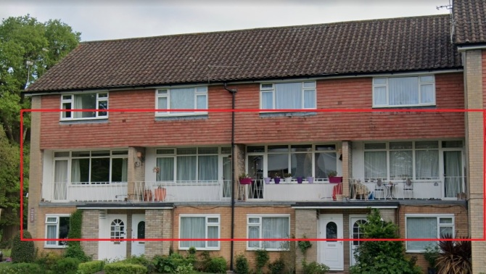
Multiple Town Houses on Milton Road, Ickenham
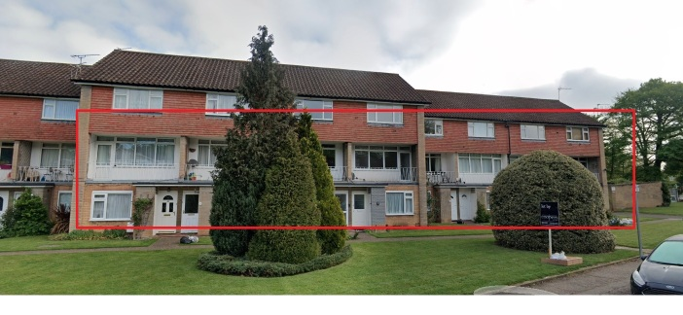
Multiple Town Houses, Milton Road, Ickenham

