Appendix B – Supporting evidence: Recessed gable end design
This appendix illustrates contemporary chalet bungalow design and has provided the inspiration for the planning proposal. The use of modern materials such as Cedar wood and glass to bring the design to life. The examples illustrate how the design may look in 3D, compared with the front and side elevations in the planning drawings. Example 1 below is an actual ‘good design principle’ example from the National Design Guide 2021 Ministry of Housing, communities and local Government.
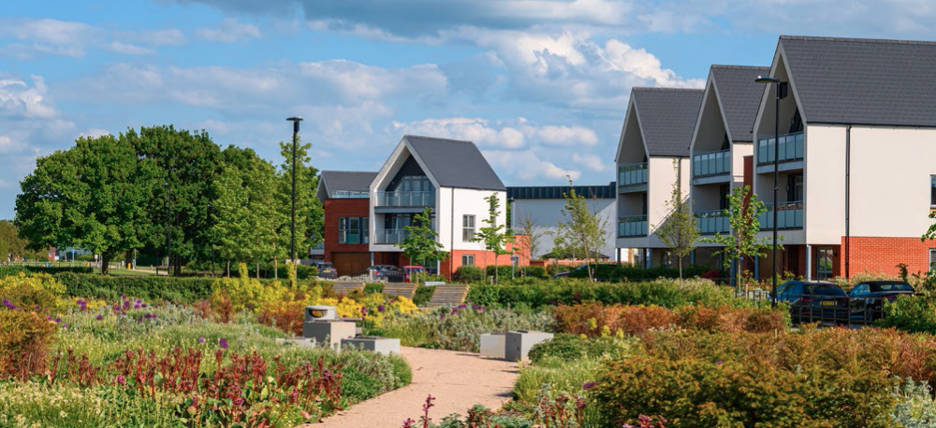
Recessed Gable End design with Balcony – Example 1 (Taken from the National Design Guide 2021, Ministry of Housing, communities and local Government)
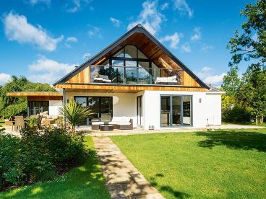
Example 2 - Recessed gable end with Balcony Design - Chalet Bungalow
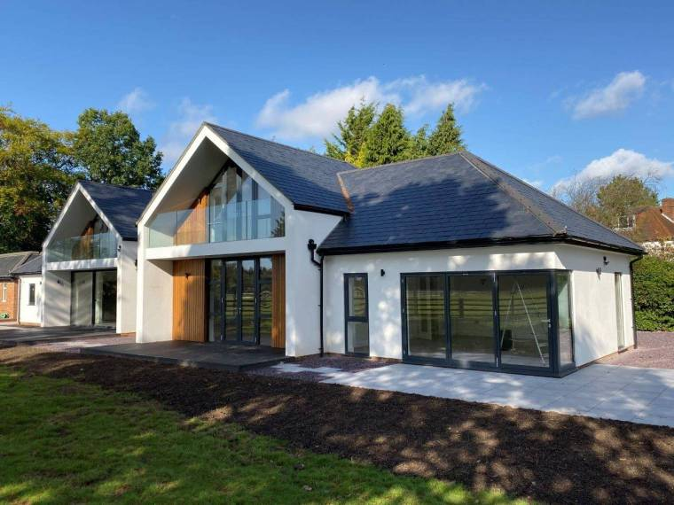
Example 3 - Recessed Gable End design with Balcony on Chalet Bungalow
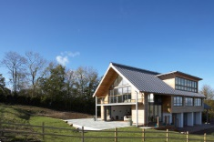
Example 4 - Recessed Gable End design with Balcony and dormer on Chalet Bungalow

