Appendix A – Precedence set by Hillingdon Council Planning approvals
The following section will outline other relevant planning applications for bungalows on The Chase and Halford Road that have been approved by Hillingdon Council and will highlight where it is felt it is relevant for the appellant’s case. The diagrams are from the planning drawings and show existing and proposed plans.

10 The Chase
- Ref: 68755/APP/2012/2868
- Proposal: Conversion of roof space to habitable use to include 2 side dormers and a new gable end window (Application for a Certificate of Lawful Development for a Proposed Development)
- Date Granted: 17th March 2013
- Notes: Overly large dormers, even though granted under Permitted development have set a precedent on the Chase and changed the street scene.
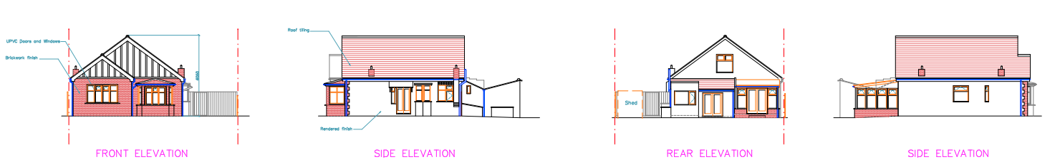Existing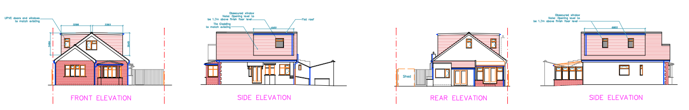
Proposed

3 Halford Road, Ickenham (Contemporary design)
- Ref: 18476/APP/2019/2199
- Proposal: Rear/side/front extension and raising and enlargement of roof to include 4 side dormers and 6 side rooflights to create habitable roofspace and installation of new boundary wall and gates to front involving the demolition of the existing garage
- Date Granted: 26 September 2019
- Note: The scheme, including the contemporary gable design with large expanse of glass and large dormers was approved by Hillingdon Council through the planning process.
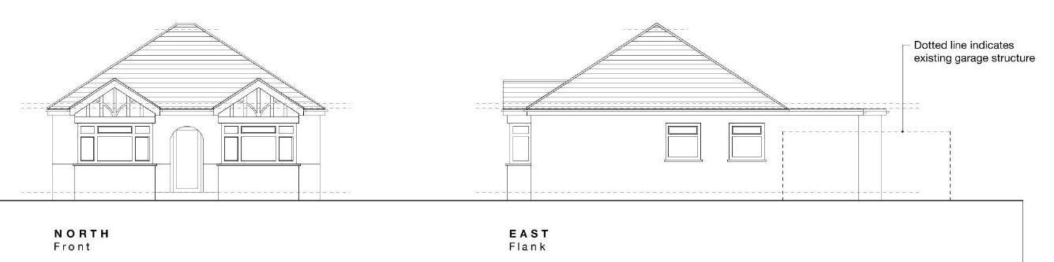
Existing
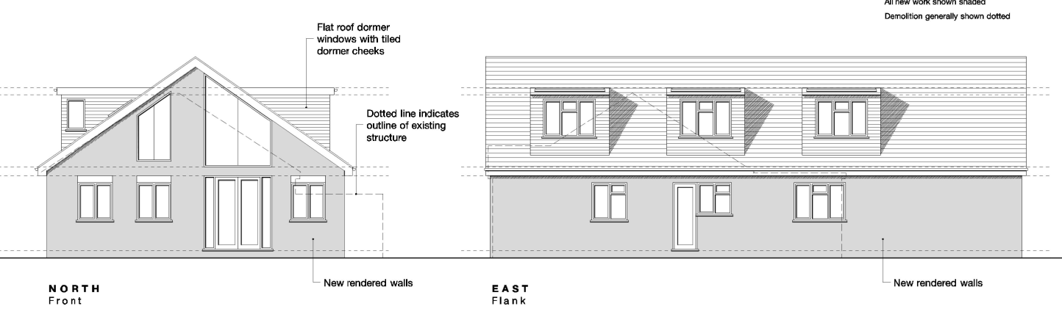
Proposed

38 Halford Road, Ickenham
- Appeal ref: APP/R5510/D/18/3213099
- Proposal: Side Extension and Alterations to Roof Form to Provide Rooms in Roof Space, including Demolition of Garage
- Date Granted: 19 December 2018
- Notes: The original property style bungalow (top left) has exactly the same frontage as the appellant’s property which was converted to a gable end.
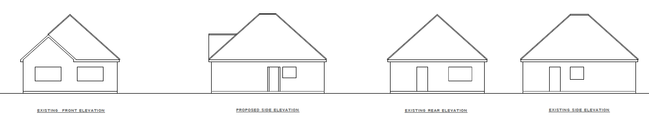
Existing
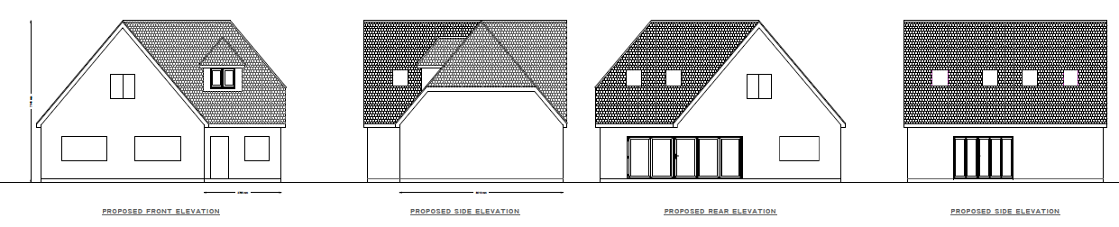
Proposed

23 Halford Road, Ickenham
- Ref: 1474/APP/2016/2904
- Proposal: Part single storey, part two storey rear extension and raising the roof level and conversion of roofspace to habitable use to include 6 side dormers and conversion of front and rear of roof from hip to gable with new gable end windows
- Date Granted: 21-09-16
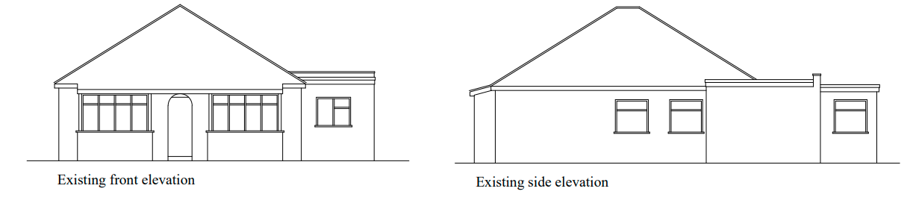
Existing
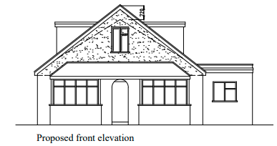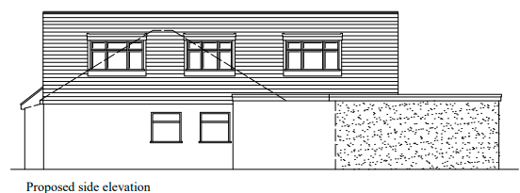
Proposed

31 Halford Road
- Ref: 27295/APP/2019/3865
- Proposal: Single storey front and rear extension, porch, attached garage to side and raising and enlargement of roof to allow for the conversion of roof space to habitable use to include 3 side and 1 rear dormers and 4 side roof lights involving demolition of existing garage
- Date Granted: 10-02-20
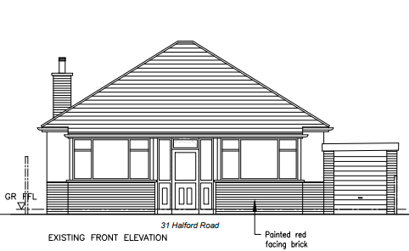
Existing
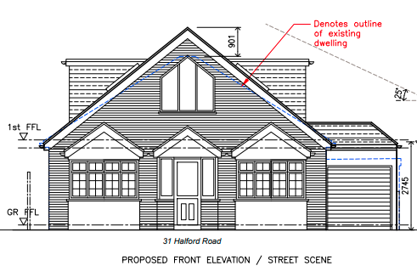
Proposed

75 Halford Road
- Ref: 14595/APP/2020/3708
- Proposal: Conversion of roofspace to habitable use to include raising of ridge and conversion of front and rear of roof from hip to gable end and 2 side dormers
- Date Granted: 07-01-21
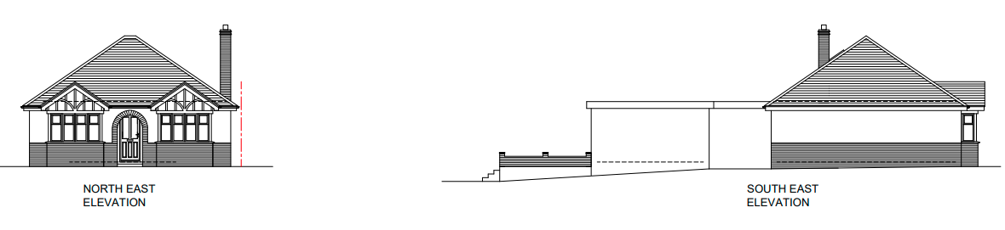
Existing
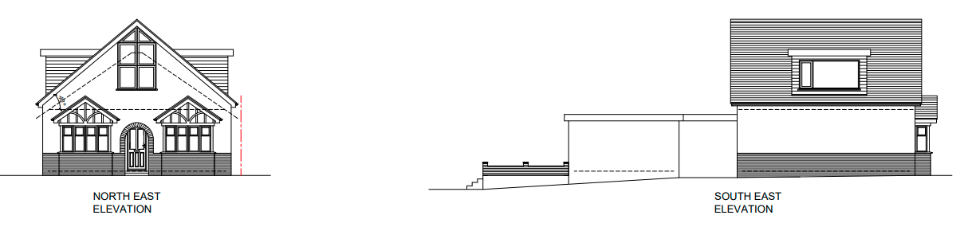
Proposed

