Silver Birches, Old Priory, Tile Kiln Lane, Harefield, UB9 6LU

History of road
Tile making was carried out in the area from the 15th to 19th century. The immediate area of what is now known as Tile Kiln Lane originally had Tile Kilns and three “Tile Houses” were sited in a 1587 survey as being liable to pay rent for “Loam and Clay for their necessary uses”. I believe these were Woodbine Cottage circa 1500’s, Old Clack Farm circa 1500’s and third building which has long since disappeared. The third building may have been on the site of now house called Anneville or the bungalow opposite Woodbine Cottage called Tile Kiln. I believe the road name has changed from Old Clack Lane, to Tile Kilns Lane, to Tile Kiln Lane and the final change was the part of the road where Silver Birches is in being renamed Old Priory.
(see the following link for info on history of Tile Kiln Lane recorded properties)
https://books.google.co.uk/books?id=l4eIAwAAQBAJ&pg=PT130&lpg=PT130&dq=tile+kiln+hamlet&source=bl&ots=yugISLqW6O&sig=ACfU3U0vfmo6m0nTF1mOZdvu8fPT0R2N5w&hl=en&sa=X&ved=2ahUKEwi-uYDDypLpAhVCZcAKHfzcCHsQ6AEwA3oECAgQAQ#v=onepage&q&f=false

The start of the modern road commenced in the early 1900’s when the Old Clack Farm was purchased 1928 and restored by Captain Davis and his wife Ver Davis. After restoring Old Clack farm in the late 20’s they decided to build a series of houses and call the road Tile Kiln Hamlet.
Friars Pardon was the prototype completed 1934/35 with Lantern House following 1938.

https://books.google.co.uk/books?id=l4eIAwAAQBAJ&pg=PT130&lpg=PT130&dq=tile+kiln+hamlet&source=bl&ots=yugISLqW6O&sig=ACfU3U0vfmo6m0nTF1mOZdvu8fPT0R2N5w&hl=en&sa=X&ved=2ahUKEwi-uYDDypLpAhVCZcAKHfzcCHsQ6AEwA3oECAgQAQ#v=onepage&q&f=false

The main section of the road I believe was called Old Clack Lane which branched into Clack Lane. The road later became wholly named Tile Kiln Lane, with the old Clack Lane section falling out of use and becoming a footpath. The lower section of Tile Kiln Lane where the Hamlet of 8 houses were built became known as Old Priory.

Extract from local historian
https://edithsstreets.blogspot.com/search?q=old+clack+farm
(Tile Kiln Lane section)
Tile Kiln Lane
Tile making was carried on in the immediate area from the 15th to the 19th.
Old Clack Farm. This is a 16th or earlier timber framed house with exposed square framing. The site was almost certainly in use for tile making in 1586
Barn. Small weather boarded
Lanterns House. Built by Capt Morris Davies of Old Clack Farm in the 1930s. Morris recycled items from demolished houses in this and the adjacent buildings.
Woodville Cottage. In the 16th this was a timber framed cottage and another section was added in the 18th. The Woodman family lived here in the 19th. The site was almost certainly in use for tile making in 1586 and the house is on the parish boundary.
Anneville. This was originally called Cavendish and built in 1921, using the bricks of burnt down Ebenezer Cottage. It was previously a pub called the Prince Albert. The site was almost certainly in use for tile making in 1586.
The Corner. Cottage which is the other side of the boundary and is in Ickenham Parish
The Paddocks. Built around 1920 and including much material from Erith Castle, Kent. It seems to be one of the original hamlet houses.

Modern Tile Kiln Lane and Old Priory
The road has some extremely large houses many of which have been extended substantially. Comparing the land registry site map associated with Silver Birches dated 1962 (pre the construction of Silver Birches) it is easy to see how small the surrounding houses were and how much they have been permitted to grow within the Greenbelt. Google Earth really shows the scale of the additions made to so many of the houses in the lane.
Old Priory is the Tile Kiln Hamlet section of the road comprised of 10 houses surrounding a large meadow which seven of the residents own. The meadow is a private area of grass with no public right of way. The houses are situated in a private road, with private meadow in front and are not accessible by the public or visible by the public from any non-private vantage point.

Extensions marked in green
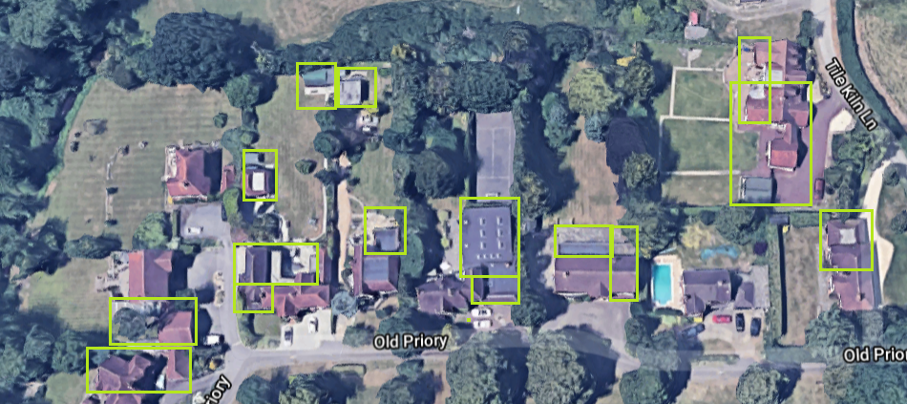
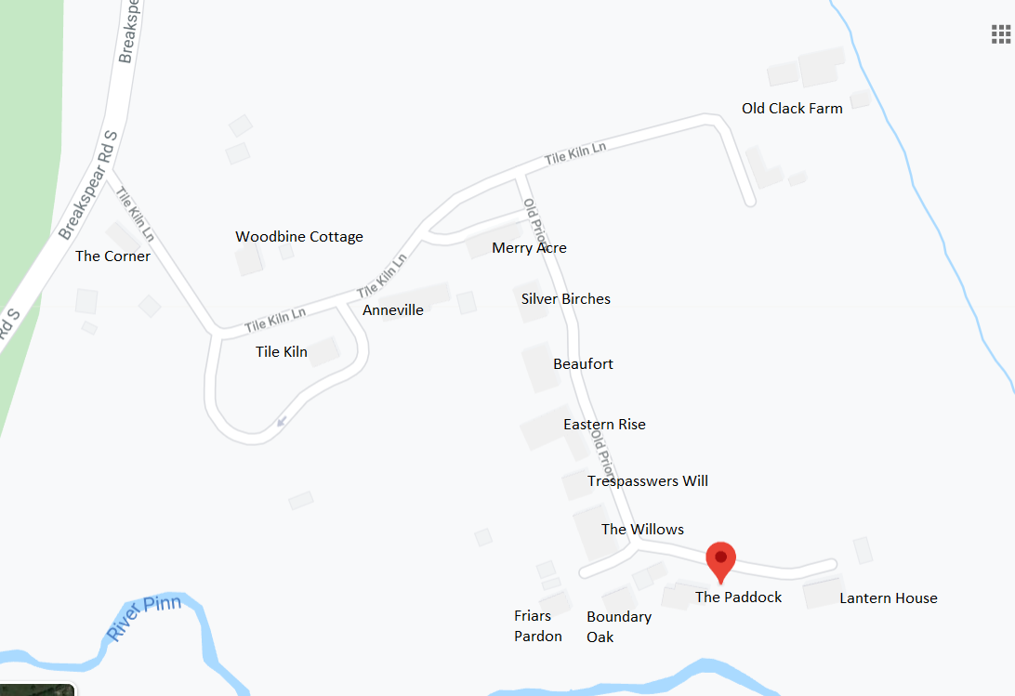

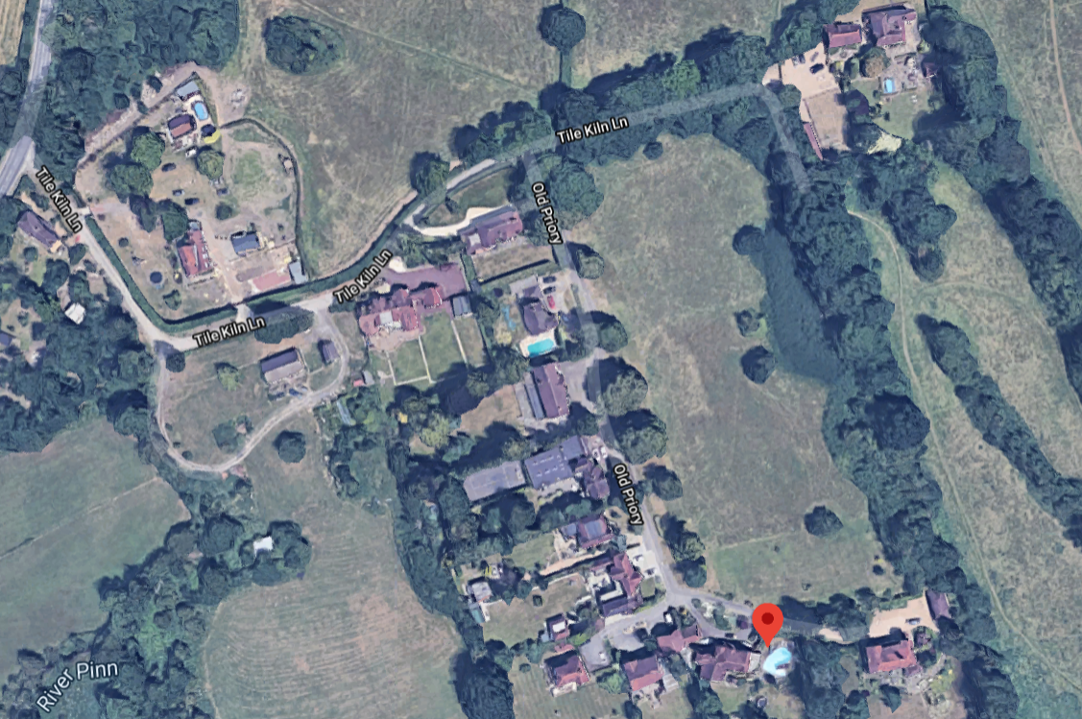

Houses in the road (majority have been massively extended)
I can prove this easily by searching land registry title deeds and location plans which show outline of the original buildings. I compared these on each house built after the Green Belt came into force in 1955 and can see some dramatic differences.
House original name | Current Name | Listed | Extended | Built | Approx. era extended | nature of extension
The Corner | The Corner | no | yes | 1800's | 1900's & 2019 | Connection of two buildings into one. Rear single storey for kitchen
Woodbine Cottage | Woodbine Cottage | yes | yes | 1500's | 16, 17th, 18th and 20th century | Multiple additions, final being triple garage, conservatory
Unknown | Tile Kiln | no | yes | 1500's | around 1950's | the previous old cottage demolished and new bungalow built
Cavendish | Anneville | no | yes | 1920's | Mid 90's extended beyond recognition | Previously a bungalow and extended upwards, outwards and sideways to create a 6 bedroom house
Old Clack Farm | Old Clack Farm | yes | yes | 1500's | changes since 1500's | multiple changes
Merry Acre | Merry Acre | no | yes | 1950's | mid 90's | Two storey side (width of house) extension and attached garage
Benedict | Silver Birches | no | no | 1960's
Beaufort | Beaufort | no | yes | 1940's | 1987 and mid 90's, 2020 new plans granted for substantial additions | Full rear extension single storey. Two storey side extension
Eastern Ride | Eastern Ride | no | yes | 1930's | 70's | Full rear extension to create pool house
Trespassers Will | Trespassers Will | no | yes | 1960's | 80’s | Rear extension and garage later built at end of garden
Faragher | The Willows | no | yes | 1930's | 90's and early 2000's | rear and two storey side extension
Boundary Oak | Boundary Oak | no | yes | 1970's | 80's | two storey side
Friars Pardon | Friars Pardon | no | no | 1930's | unknown | unknown
The Paddocks | The Paddocks | no | yes | 1930's | 80's | Large side extension full depth of house
Lantern House | Lantern House | no | no | 1930's | Built 1938 as part of original Tile Kiln Lane Hamlet | unknown

Main houses to use as precedent

Anneville (situated behind Silver Birches) extended section in green
Full conversion from small bungalow to 5/6 bedroom detached house with linked double garage and second detached double garage. Conversion into loft, side and rear of property. Size increase since 1962 Land Registry map tells all.

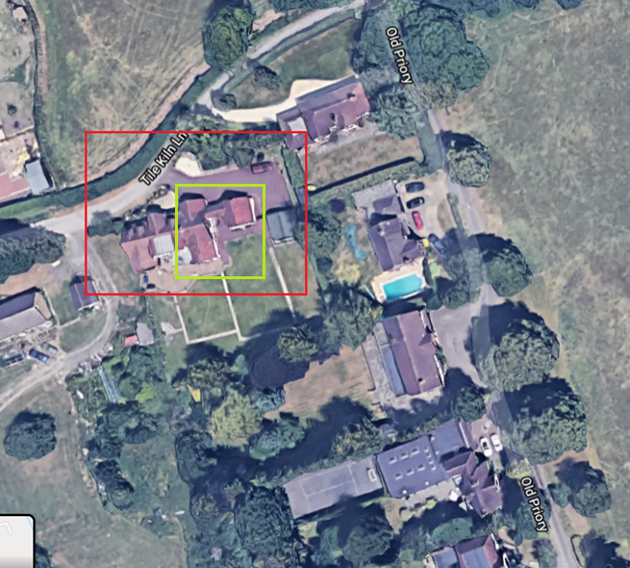

Merry Acre (Situated to left of Silver Birches)
Full two storey (full house depth) extension to create second rear gable end to match original of house. Also attached double garage.
Added section in green
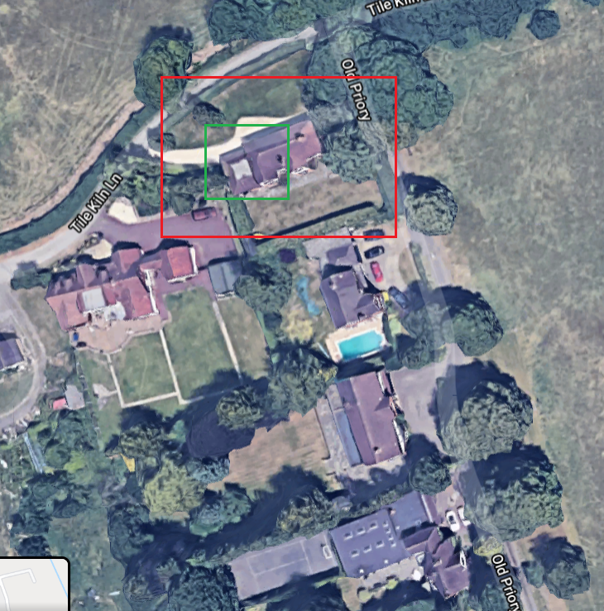
Silver Birches (house under appeal)
Land was purchased from owners of Merry Acre in 1962 and planning permission sought to build on the site shown below. Land changed hands several times before the site was purchased by Mr Green of Prowting homes who built the house after receiving planning permission late 1967. It is my understanding work may have been completed in quiet cycles during local building projects, but was completed totally by around 1970. By mid 1970 the house is registered as Benedict and later sold to the Compton’s (previous owners to the Willmott’s who purchased the property 1981). House name changed to Silver Birches in 1978.
The house features a mock Tudor wood front and corresponding porch with single mock Tudor support. The main garage has always been connected to the house during original construction it was connected to the house via a lobby and porch and has been such ever since. The roof design was planned to reduce flat roof area. The rear of the garage block is unchanged. The far garage rear was replaced like after the rear damaged beyond repair in the 1987 hurricane.

Original house marked in blue. The far garage wall is inset from the boundary with edge of roof within the existing boundary wall. (effectively two walls side by side, the boundary wall and directly next to it is the garage wall)

Notes on Silver Birches
House is one of smallest in the road. Roof line ridge is lower than Merry Acre to left and Beaufort to right.
House is in line with building line which follows the road.
Garages have always been connected to the house with utility rooms to the rear of the garages.
House next door which has won appeal has a full two storey side extension full depth of house including rear single storey, full length rear extension and recent approval for larger front gable and second storey rear extension complete with rear gable. The requested extension at Silver Birches is far smaller than their already approved extension.
If I compare Silver Birches plans to that of Beaufort the proposal is smaller. Silver Birches already has a side garage which will be replaced as garage. The proposal seeks a rear extension and a second storey extension above the current joined double garage. This is far smaller than the multitude of schemes approved at Beaufort.

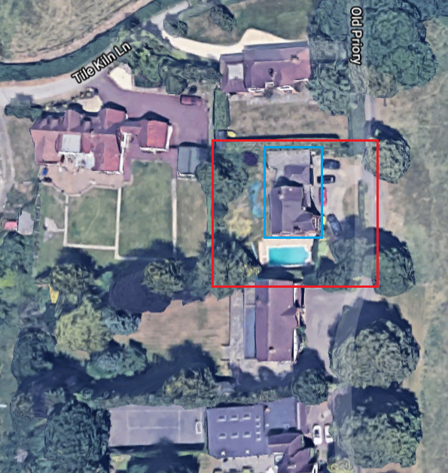

Beaufort (house to right of Silver Birches)
Full length rear extension.
Full two storey side extension and rear single storey.
Newly approved larger front gable, second storey rear extension and rear gable. Work has not yet started.
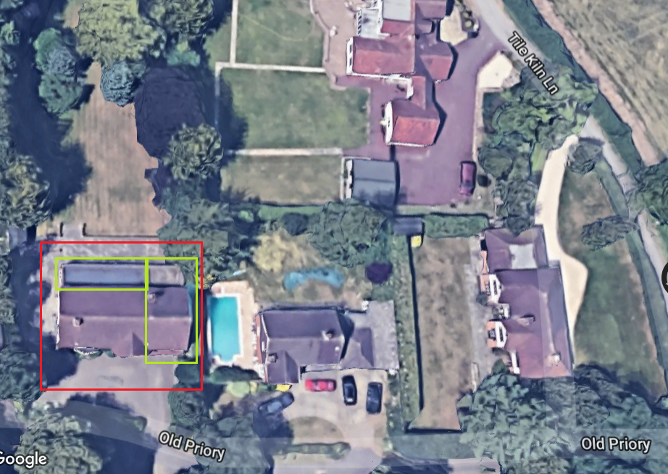

Eastern Ride
Two storey side extension and incredibly large rear single storey extension

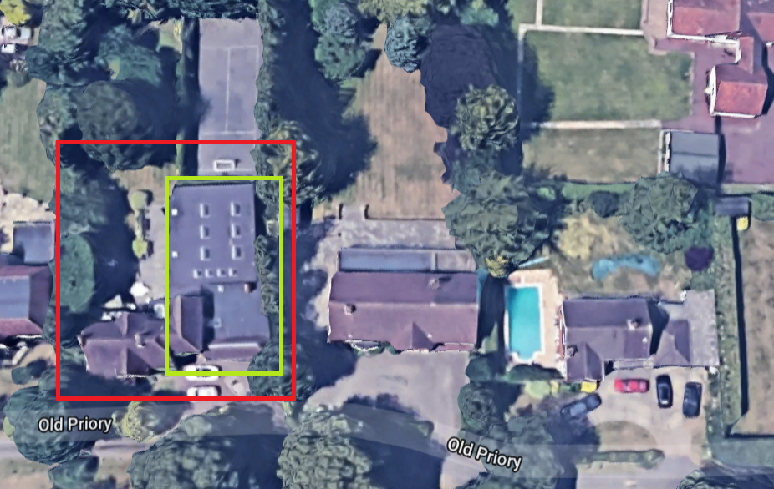

Trespassers Will
Rear extension and detached double garage

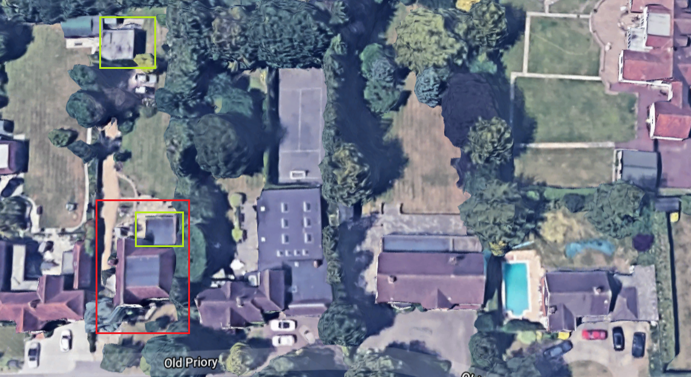

The Willows
Mass of extensions from original house which was a house with a small side building connected to make a L shaped development. House has since undergone full two storey side and rear extension as well as additions to the rear single storey and large detached garage and outbuilding.

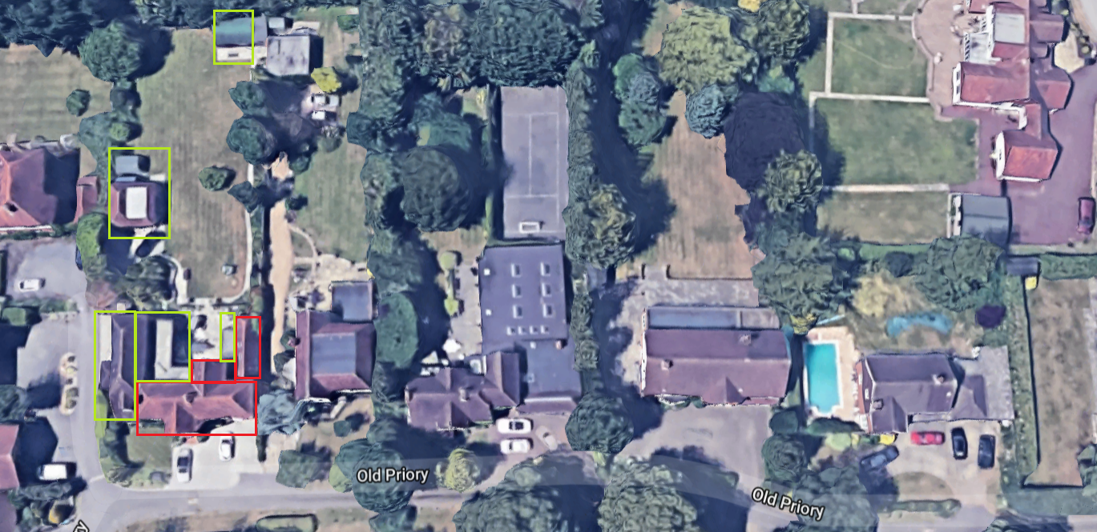
Boundary Oak
Rear single storey extension and full two storey front and rear extension to create double garage at front with rooms above and behind.

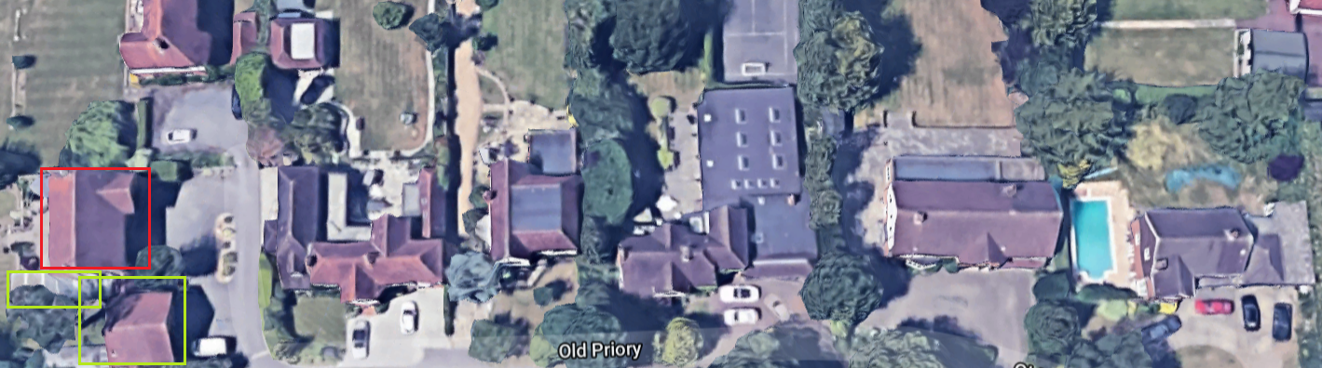

The Paddocks
Large extension to double size of house, complete with dormer windows in some sections and creation of large double garage.

