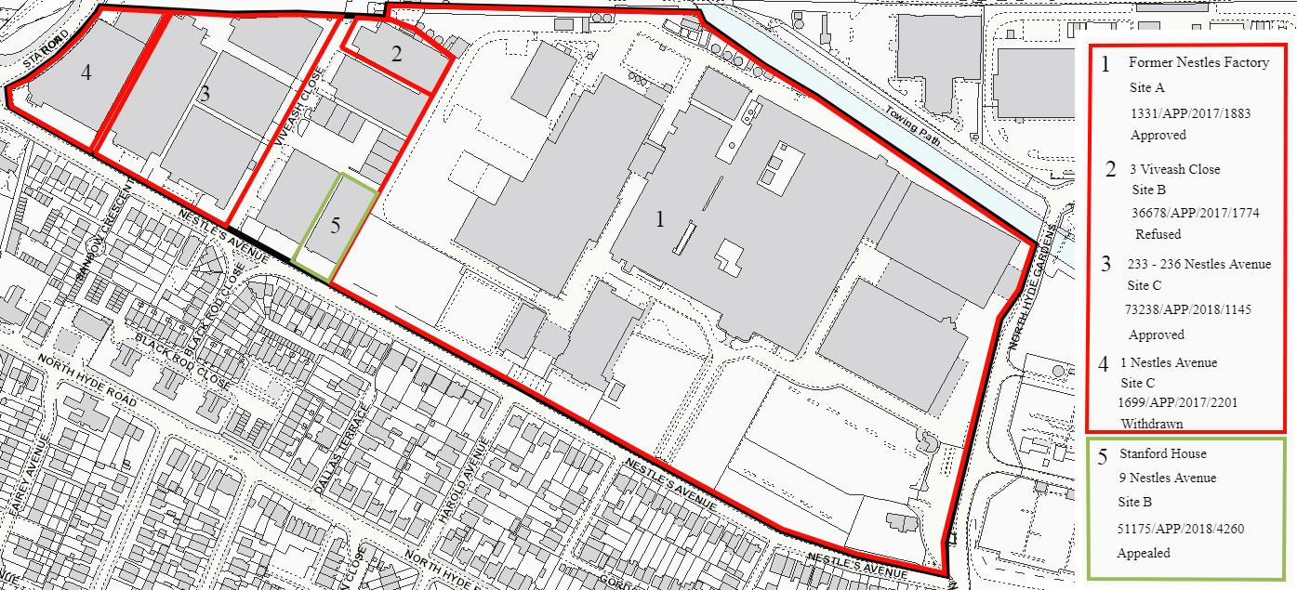
6 - Squirrels Industrial Estate SA5 Allocation: Site B - Industrial use
5 - Stanford House, 9 Nestles Avenue SA5 Allocation: Site B - Industrial use 51175/APP/2018/4260 - Proposed residential, commercial and community uses Appealed
4 - 1 Nestles Avenue SA5 Allocation: Site C - Industrial use 1699/APP/2017/2201 - Proposed storage, office, cafe and residential Application withdrawn
3 - 233-236 Nestles Avenue SA5 Allocation: Site C - Industrial use 73238/APP/2018/1145 - Proposed residential, office, retail and cafe uses Decision: Approved subject to S106
2 - 3 Viveash Close SA5 Allocation: Site B - Industrial use 36678/APP/2017/1774 - Proposed residential and commercial uses Decision: Refused 18/10/18 and Appeal Dismissed 19/07/19
1 - Former Nestles Factory SA5 Allocation: Site A - Industrial use 1331/APP/2017/1883 - Proposed residential, office, retail, community and leisure uses Decision: Approved 28/06/18
6

