Technical Standard - Specification for historic environment project plans and location specific written schemes of investigation
Document no.: HS2-HS2-EV-STD-000-000036

Revision | Author | Checked by | Approved by | Date Approved | Issued for/Revision details
P01 | ETM | M Court | HJ Glass | 15.02.16 | DRAFT
P02 | ETM/HS2 | HJ Glass | M. Bailey | 15/11/16 | Updated to reflect associated document revisions and stakeholder comments
P03 | ETM/HS2 | HJ Glass | M. Bailey | 17/5/17 | Revisions following page turn

Contents
1 Introduction 1
1.1 Purpose 1
1.2 Objectives 2
1.3 The Process 3
1.4 Scope 3
1.5 Guidance 4
1.6 General requirements 5
1.7 Engagement 5
1.8 Information management 6
2 Project Plan 7
2.1 Introduction 7
2.2 Structure of Project Plan 8
3 Location-Specific Written Scheme of Investigation 12
3.1 Introduction 12
3.2 Structure of LS-WSI 13
4 Glossary of terms 17

List of Figures
1 Structure of the GWSI: HERDS 2
2 Historic Environment Works Development Process 3
Conventions
Mandatory clauses
The following convention is used to indicate mandatory clauses.
Mandatory clauses are differentiated from the main text of this document by use of a ‘black box’. They contain the word ‘shall’ to indicate their status as a requirement.

Departures

Any intention to not comply with a mandatory clause is considered to be a departure from this Technical Standard.
It is recommended that the designer discusses any proposed departures with HS2’s Technical Directorate at an early stage.
Guidance
The following convention is used to indicate guidance.
NOTE – Guidance is differentiated from the paragraph to which it relates by use of italic type and use of the words “should” or “may”.

- Introduction
  - Purpose
            - This document is the Employer’s specification for the production of project plans and Location-Specific Written Schemes of Investigation (LS-WSIs) for all historic environment investigation and recording works across Phase One of HS2 to be prepared and delivered by the Contractor.
            - Historic environment investigations encompass archaeological, historic landscape and built heritage investigation and recording works.
            - For clarity Project Plans and LS-WSIs are defined as:
- Project Plans – For each specific package of activity, identified by the Contractor, e.g. a geophysical survey, a building recording survey, archaeological excavation or palaeo-environmental sampling scheme, the Contractor shall prepare a project plan for agreement with the Employer. The project plans will be prepared in response to the specific objectives of the GWSI: HERDS (HS2-HS2-EV-STR-000-000015) and be delivered by the Contractor. See Section2 for further details.
- Location Specific WSIs – The Contractor will assemble one or more project plans within LS-WSIs for areas of land that will largely be defined to meet construction needs. The LS-WSIs will be agreed with the Employer and will provide a costed and programmed approach to delivering outcomes.
            - The following diagram (Figure 1) illustrates where these documents sits within the historic environment works. It is imperative that the production of the project plans and LS-WSIs are undertaken in the overarching knowledge and comprehensive understanding of the GWSI: HERDS (HS2-HS2-EV-STR-000-000015).
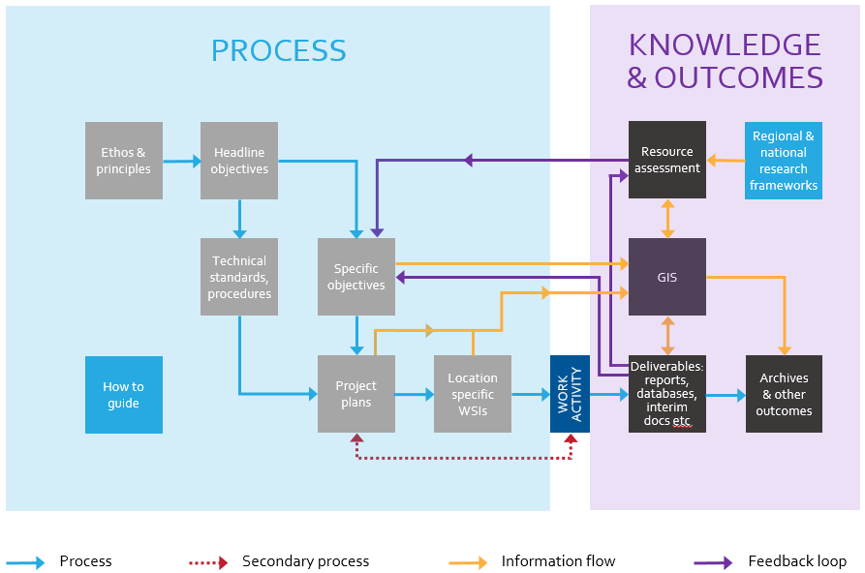
Figure 1: Structure of the GSWI: HERDS

  - Objectives
            - The objectives of this document are as follows:
- To ensure that the Generic Written Scheme of Investigation: Historic Environment Research and Delivery Strategy (GWSI: HERDS (HS2-HS2-EV-STR-000015)) is at the forefront of investigation design;
- To provide a common framework for the production of project plans and LS-WSIs to ensure scheme-wide conformity;
- To ensure that each identified location is investigated using the most suitable techniques that address the Specific Objectives set out in the GWSI: HERDS;
- To inform further investigation strategies; and
- To ensure that the project plans and LS-WSIs provides accurate and legible information in order that all parties understand their responsibilities in facilitating archaeological works and which will inform the programme.
  - The Process
            - The diagram below (Figure 2) outlines the sequence of activities necessary to produce project plans and LS-WSIs.
Figure 2: Historic Environment Works Development Process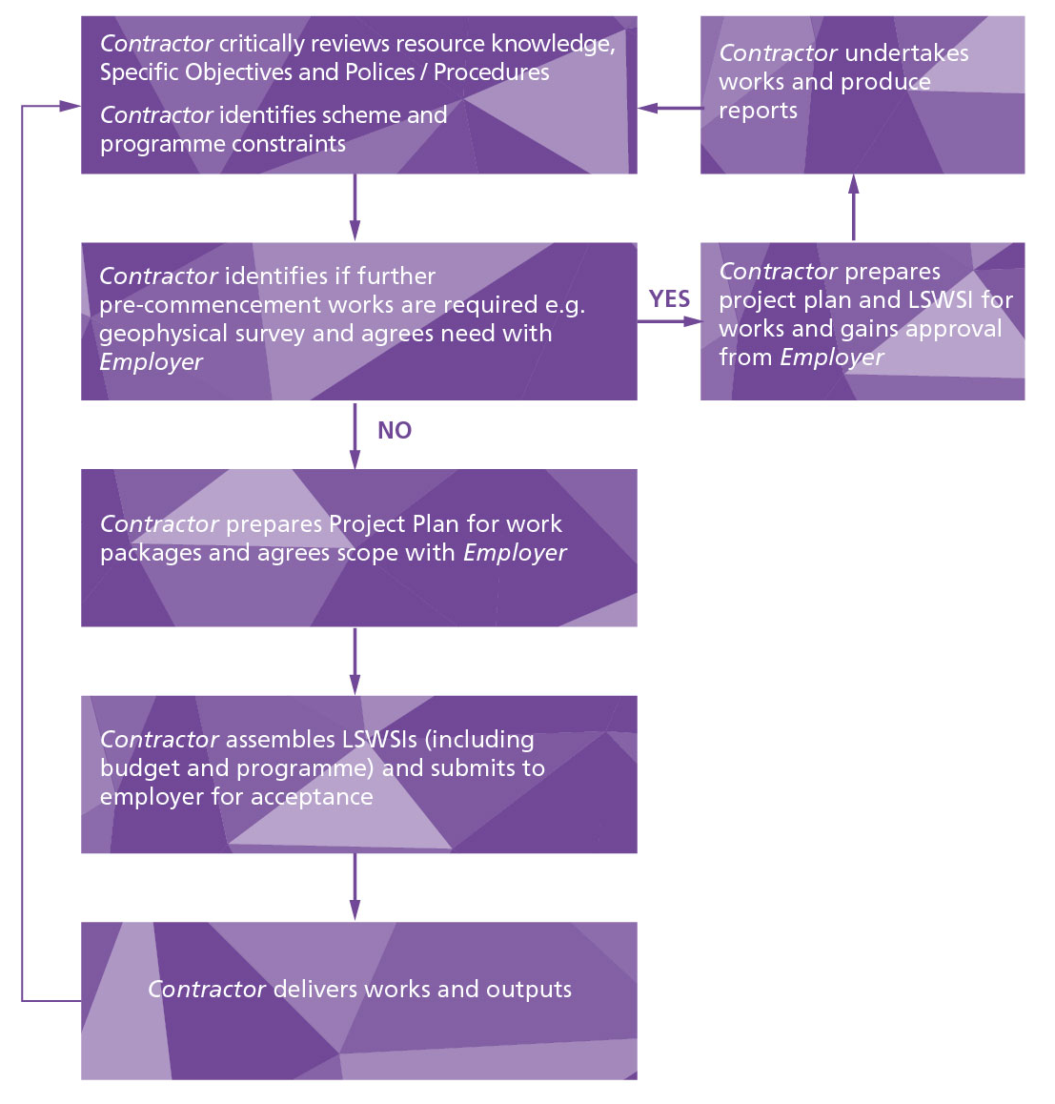
  - Scope
    - Technical scope
            - The project plans and LS-WSIs shall detail all of the anticipated historic environment investigation, recording and analytical techniques that will be necessary to achieve the objectives of the specific location.
            - This document will ensure a consistent approach to the detailed methodology undertaken in during historic environment investigations. This will cover evaluation, investigation, post-excavation and reporting with specialist methodologies provided in the supporting document: Technical Standard: Specification for historic environment investigations (HS2-HS2-EV-STD-000-000035) and other relevant historic environment strategies, technical standards and procedures.
    - Geographic scope
            - This document shall be used for all historic environment investigations across the Phase One HS2 route.
            - The geographic scope of each project plan will reflect the extent of the asset being addressed or Specific Objective being addressed.
            - The geographic scope of each LS-WSI will reflect the construction works package boundaries, the Schedule 17 (to the Act) planning consents packages and Phase One HS2 programme.
    - Temporal scope
            - The project plans and LS-WSIs will cover historic environment investigation throughout the duration of the enabling works, construction phase and post-construction. As such, they will be evolving documents and will be updated as the project progresses.
            - The Contractor may propose that historic environment works, e.g. archaeological excavation, be carried out as an extension to evaluation works, if the scope of such works is readily incorporated into the Project Plan and LSWSI and reflects the need to address specific objectives. The detailed method for this work shall be agreed between the Contractor and the Employer at a site meeting and subsequently in writing as an addendum to the existing project plan and LS-WSI.
            - The project plans and LS-WSI will identify key stages in the construction programme where historic environment investigations are necessary. This may include a phased approach including stages of evaluation and investigation that will need to be integrated with the construction programme from the outset.
            - It will be necessary, when designing historic environment investigations, to work closely with construction planners, in order to ensure both the integrity of the historic environment investigations and the construction programme.
  - Guidance
The Technical Standard: Specification for Historic Environment Investigation (HS2-HS2-EV-STD-000-000035) provides generic and adaptable text to insert into specific sections of the project plan and LS-WSI templates, although not all paragraphs will be relevant. It will be necessary for the Contractor to use both this Technical Standard (HS2-HS2-EV-STD-000-000036) and the Technical Standard: Specification for Historic Environment Investigation (HS2-HS2-EV-STD-000-000035) when compiling a Project Plan and LS-WSI.

            - The Employer has developed a robust suite of strategies, technical standards and procedures to ensure that works are delivered in a consistent and cohesive manner that reflects the Secretary of State's commitments to the historic environment. The Contractor shall comply with them all.
  - General requirements
            - Project Plans and LS-WSIs shall identify any specialist roles required to advise on issues such as geoarchaeology, Palaeolithic archaeology, quaternary studies, specific finds and environmental topics, buildings archaeology, historic landscape and other specialist areas as appropriate.
            - Project plans and LS-WSIs shall be designed and implemented by the Contractor (or other party) responsible for historic environment investigations at any given location.
            - The Project Plans and LS-WSIs shall be agreed with, and accepted by the Employer prior to the commencement of any historic environment investigation work at that location. Refer to the GWSI: HERDS (Section 7) for fuller details on the process for developing and delivering Project Plans and LS-WSIs.
  - Engagement
            - The Heritage Consent Strategy (HS2-HS2-EV-STR-000-000008) details the requirements and timescales and nature of consultation and engagement with Historic England and local planning authority specialist during the preparation of project plans, LS-WSIs and, in the case of Schedule 18 and 19 Heritage Agreements, method statements. The Contractor shall comply with that Strategy.
            - During the construction and post-excavation stages, the Contractor shall continue discussions with Historic England and the local authorities as project plans and LS-WSIs are developed. The Contractor shall include discussions relating to the design of evaluation and investigation works and may include requests for specific information. In preparing revisions of the project plans and LSWSIs, account will be taken of observations made by Historic England and the local authority.

  - Information management

GIS/BIM requirements
            - Historic environment investigations must adhere to a standard approach to GIS deliverables that is set out in the Employer’s Cultural Heritage GIS Specification (HS2-HS2-GI-SPE-000-000004). The Employer’s standard templates for reports and maps will be used. Mapping and spatial data deliverables will conform to a standard approach to ensure consistency across all the contracts.
            - All data shall have data limitations specified in the associated metadata, set out to the INSPIRE metadata convention.

Mapping
            - Historic environment investigations will specify the following with regard to mapping outputs:
- All maps will be produced using the formal ES A3 landscape map template which forms part of the HS2 GIS Map Templates (HS2-HS2-GI-TEM-000-000016);
- all maps will have the HS2 logo on the map. Map name and codes are defined below;
- maps will generally be at 1:10,000 scale. Larger scales will be acceptable if the area is small and the scale would improve clarity (as will be the case with the burial grounds);
- maps will utilise where practicable the symbology for features used in the formal ES. Symbology for new features is to be agreed with HS2 Ltd in advance of the final submission of maps;
- maps are to include as standard and where relevant the following features;
  - Construction boundary and the hybrid bill alignment (Standard formal ES symbology/terminology).
  - Local Authority district boundaries (Standard formal ES symbology/terminology).
  - Community forum boundaries (Standard formal ES symbology/terminology).
  - 1:10,000 basemapping should be standard OS Vectormap.
  - 1:5,000 mapping should be standard OS Mastermap topo lines only (no colour fill); and
- maps will be uploaded into eB when approved.

Spatial Data
            - All data, not previously issued by HS2 Ltd, is to be submitted with the final Condition A maps, in accordance with HS2 Ltd standards HS2-HS2-GI-STD-000-000002. Data delivery must include feature classes used for data driven pages;
            - Template schema will be provided to the Contractors following award of contracts.
            - Any amendments required to the template schema, should be communicated to HS2 Spatial Data Management Team, so that it can be updated and re-issued to all contracts. There should be close collaboration between Contractors to ensure the schema is fit for purpose. Additional attribute fields added to the template schema, not agreed with the Employer, will result in the data being rejected when submitted.
- Project Plan
  - Introduction
            - The Contractor shall comply with the following methodology (Section 2) during the preparation of Project Plans.
            - In preparing the Project Plans the Contractor shall seek to avoid the use of ambiguous language and include a summary of key terms and a glossary.
            - When preparing the Project Plan for any form of historic environment investigation the following general points and comments should be noted and taken into account:
- the detail, length and complexity of the Project Plan should reflect the nature of the proposed investigation and the nature of the Specific Objectives being addressed. For example, a Project Plan for a detailed desk-based assessment of a small rural area would be considerably more concise than a Project Plan for a major area of open area excavation with complex stratigraphy and a multi period remains;
- Project Plans should focus on addressing specific objectives identified in GWSI: HERDS. The primary purpose of a Project Plan is to set out an agreed programme of activities to meet specific objectives;
- Project Plans need, whatever possible, to include provision for community engagement and training and skills activities;
- Project Plans should be developed in collaboration with other Contractors along the route and in discussion with the Employer. Project Plans must interrelate to ensure that the specific objectives set out by GWSI: HERDS are fully addressed by the works;
- Project Plans are archival documents and shall be produced to a high and consistent standard.
  - Structure of Project Plan
            - Each Project Plan shall have the following structure:
- Executive Summary
- Location and Site Background
- Aims and Objectives
- Scope and Methodology
- Post-investigation reporting and archiving
- Information Management
- Quality Assurance Processes
- Evidence of engagement
- Figures
- References and glossary of terms
            - The following sections provide more detail on each element

Executive Summary
            - This section will provide brief text on the project context and purpose of the particular Project Plan, with a particular emphasis on describing the Specific Objectives the Project Plan is seeking to address.

Location / Site Background
            - This section will provide information on the area / site / asset which is the subject of the proposed works, the section will include illustrative figures including:
- A site location plan;
- Detailed location plan, where necessary;
- Site photos (where relevant);
- Illustrations (where relevant); and
- Any relevant reproductions of cartographic sources (where relevant).
The Employer’s standard templates for reports and maps will be used for all data and reports produced. The final report deliverable will comply with the standard approach set out in the Employer’s Cultural Heritage GIS Standard (HS2-HS2-GI-SPE-000-000004)
            - The section will provide information on:

Baseline
            - Concise text that does not repeat the information presented in the ES and any DDBA, where applicable. This section will only include relevant data in a summary form and will cross-reference other documents. The information will be obtained from the HS2 Environmental Statement Volume 5 Cultural Heritage, the Detailed Desk Based Assessment (if completed) and the results of any preceding surveys, evaluations and investigations.
            - This section will reference cartographic data, historic landscape character data as well as archaeological and historical information.

Site Conditions
            - This section will include a summary of information concerning the most pertinent geological and topographic data at the site.
            - Where appropriate to the form of investigation proposed the details of the locations of anticipated buried services, basements, obstructions or other causes of previous disturbance within the site and estimated and known levels of archaeological deposits will be presented.
            - The following list provides an example of sources to use for the information contained within this section:
- HS2 Environmental Statement;
- HS2 Detailed Desk-Based Assessment (if available);
- HS2 surveys;
- Utilities plans;
- Ecological constraints (where relevant). The investigation shall be designed in consultation with the Contractor’s ecologists/environmentalists to ensure the requirements are met. Ecological information, including historic hedgerows, shall be considered during the design of investigations to ensure the Phase One HS2 ecological standards (HS2-HS2-EV-STD-000-000017);
- Walkover survey. Where a DDBA has not been completed for an area and the Project Plan is not for a DDBA or other form of non-site based activity, then a walkover survey of the project plan area will be undertaken during the design phase, if access can be achieved. This will utilise the methodology set out in the DDBA section of the Specification for Historic Environment Investigation;
- British Geological Survey maps showing bedrock and superficial deposits;
- Borehole logs held by the British Geological Survey; and
- Results of any ground investigations where available.
            - This section will be accompanied by figures, where appropriate. These could include interpretation of borehole logs, plans of identified areas of disturbance, sections showing estimated depth and types of archaeological and geoarchaeological deposits, and utilities locations plans.

Building context
            - Where an investigations includes historic building, then concise material relating to the buildings and their setting / context will be included.

Aims and objectives
            - This section will set out the Specific Objectives being addressed by the activity and the rationale for the chosen objectives.

Scope and Methodology
            - This section will describe the type of historic environment investigation(s) proposed and ensure that it is adequately justifies in relation to the Specific Objectives being addressed.
            - The section will be largely formed by the generic and adaptable sections taken from the Specification for Historic Environment Investigations. The information presented will be entirely dependent on the nature of proposed actives and the nature of the area / asset being addressed. Where appropriate it will include detailed methodologies for environmental, dating and specialist sampling techniques.

Post-investigation reporting and archiving
            - This section will be formed from the generic and adaptable text taken from the technical standard for Historic Environment Investigation (eB ref) The nature of the section will reflect the nature of activity being undertaken.

Information management
            - This section will include:
- GIS/BIM requirements;
- Mapping requirements; and
- Spatial data requirements.

Quality Assurance Processes
            - This section will describe how the project will be delivered to an excellent standard and will detail the check and approve process.

Evidence of Engagement
            - Evidence of collaboration with other Contractors, the Employer and external stakeholders will be presented in this section and, for example, any correspondence, minutes of meetings, will be appended.

References
            - All references will follow the HS2 system of referencing.

Figures
            - The Contractor shall prepare all figures shall be in accordance with the relevant HS2 Ltd BIM, GIS (HS2-HS2-GI-STD-000-000002) and CAD standards (HS2-HS2-IM-PRO-000-000001).
            - The following is a list of figures that will, or may, be required:
Figure title | Description
Site location  (required) | The Location Plan will identify the location and extent of the proposed investigation. The location plan will be produced at a scale such that it is easily legible at A3, it might therefore be necessary to produce more than one location plan of the proposed investigation.
Heritage assets  (required) | This figure will show the locations of known heritage assets within the site and any in the surrounding area relevant to the investigation.
Previous investigations  (required) | This will show the extent and relevant reference numbers for any previous investigations undertaken within and in the vicinity of the proposed investigation
Scheme design  (required) | This figure will show a detailed plan of all of the proposed works within the site. This might be a phased plan and require several pages – one for each phase.
Site disturbance  (where relevant) | This figure will show all areas of previous ground disturbance within the site and any potential or identified historic environment features.
Potential archaeological sequence  (where relevant) | This figure would identify known and interpreted soil deposits within the site and will identify the depth of potential archaeological deposits.
Cartographic data  (where relevant) | This will present only the most pertinent cartographic reproductions. The aims will be to show the locations of any potential historic environment features identified on historic maps and also to identify any disturbance within the site boundaries.
Site photographs  (where relevant) | Site photographs will be reproduced in this figure. Photographs will show relevant and significant features or areas of disturbance. The locations of photographs will be displayed on an accompanying site plan. Each photograph will be displayed at such a scale as to be easily visible on an A3 page.
Utilities locations  (where relevant) | The locations of all underground and overhead utilities will be shown in this figure. Each utility will be clearly labelled and easily identifiable. The acquisition of this information does not preclude the need for the area to be scanned prior to breaking ground.

Glossary of terms
            - This will be reproduced, where necessary, from the glossary appended to the Specification for Historic Environment Investigation. Only terms relevant to the proposed investigation will be included.
- Location-Specific Written Scheme of Investigation
  - Introduction
            - The Contractor shall comply with the following methodology (Section 3) during the preparation of LS-WSIs.
            - In preparing the LS-WSIs the Contractor shall seek to avoid the use of ambiguous language and include a summary of key terms and a glossary.
            - When preparing an LS-WSI the following general points and comments should be noted and taken into account:
- LS-WSIs may include one or more Project Plans and may relate to a full range of works. Consequently their complexity and length will vary considerably. The content of all LS-WSIs should therefore be proportionate to the nature of the proposed investigations;
- LS-WSIs are a delivery vehicle for one or more Project Plans. They should focus on matters of delivery; identifying a clear programme and resource requirement;
- LS-WSIs are archival documents in their own right and should be produced to a high and consistent standard.
  - Structure of LS-WSI
            - Each LS-WSI shall have the following Structure
- Executive summary
- Site location, extent and condition
- Overview of Project Plans
- Scheme design elements
- Programme
- Methodology
- Delivery Interfaces
- Health, Safety and Environment
- Information Management
- Site Monitoring and engagement
- Quality Assurance Processes
- Resourcing requirements and budget
- Fieldwork sign off sheet
- References and Glossary of terms
- Figures
- Appendices
  - Project Plans
  - Borehole logs (where relevant)
  - Risk Assessment Method Statement (RAMS)

Executive Summary
            - This section will provide brief text on the project context and purpose of the particular LS-WSI and highlight which Project Plans are being included and the rationale for their grouping and delivery.

Site location, extent and conditions
            - This will identify the location and extent of the proposed area addressed by the LS-WSI. It will also summarise the relevant site conditions drawing on the material presented in the Project Plans.

Overview of Project Plans
            - Concise section summarising the Project Plans being addressed and highlighting the interrelationships (if any) between them.

Scheme design elements
            - This section will detail the proposed works within the area covered by the LS-WSI. This will include the extents and the depth of groundworks and the description of alteration or demolition methodology for buildings.

Programme
            - This section will detail the programme of the proposed works. If a phased approach is necessary this will be described and shown in a table with a schedule of dates which also details all planned site activities within the timeframe, including non-historic environment activities, such as construction works.

Methodology
            - Where relevant, this section will provide information on:
- Site set-up process;
- Details of site access;
- Description of any plant and methodology for its use;
- Description of main work packages, their phasing and how they will be delivered;
- Provision for unexpected remains, clearly identifying what is expected and what would constitute unexpected remains for that location; and
- Provision of sampling facilities to support requirements established by Project Plans.

Delivery Interfaces
            - All parties will follow the Employer’s protocols for intra- and inter-project communication. When developing the LS-WSI, the author of the document will need to liaise with the Contractor to ensure the compatibility of the investigations with the following:
- Detailed design;
- Programme;
- Health and Safety; and
- Temporary works and logistical arrangements.
            - This section will describe and outline the interface and consultation undertaken and the results of the constraint review and deign exercise.

Health, Safety and Environment
            - Information regarding services (buried and overhead) and location-specific health and safety and environmental information will be included in this section. Reference will be made to the RAMS which will be appended to the LS-WSI.
            - When developing the LS-WSI, location specific constraints will need to be investigated and solutions determined prior to the start of works. Consideration must be given to:
- Site access;
- Agriculture;
- Unexploded Ordnance (UXO);
- Ecology;
- Plant noise;
- Utilities;
- Site safety and security;
- Construction traffic;
- Local community and general public; and
- Neighbouring properties and businesses.
            - These aspects will need to be evidenced in this section, where relevant.

Information management
            - This will include information relevant to :
- GIS/BIM requirements;
- Mapping requirements;
- Spatial data requirements.

Site Monitoring and engagement
            - Details for monitoring and engagement will be included.

Quality Assurance Processes
            - This section will describe how the project will be delivered to an excellent standard and will detail the check and approve process.

Fieldwork sign off sheet
            - All fieldwork will require sign off from the Contractor and the Project Manager. A sign-off sheet for all historic environment investigation has been prepared (HS2-HS2-EV-FRM-000-000030) and relevant sections will need to be completed at LS-WSI stage.

References
            - All references will follow the HS2 system of referencing.

Figures
            - The Contractor shall prepare all figures shall be in accordance with the relevant HS2 Ltd BIM, GIS and CAD standards.
Figure title | Description
Site location  (required) | The Location Plan will identify the location and extent of the proposed LSWSI area. The location plan will be produced at a scale such that it is easily legible at A3, it might therefore be necessary to produce more than one location plan of the proposed LSWSI area.
Heritage assets  (required) | This figure will show the locations of known heritage assets within the site and any in the surrounding area relevant to the investigation.
Previous investigations  (required) | This will show the extent and relevant reference numbers for any previous investigations undertaken within and in the vicinity of the proposed investigation
Scheme design  (required) | This figure will show a detailed plan of all of the proposed works within the site. This might be a phased plan and require several pages – one for each phase. The plan will be produced at a scale such that it is easily legible at A3, it might therefore be necessary to produce more than one location plan of the proposed LSWSI area showing all the different proposed activities (Project Plans).
Site disturbance  (where relevant) | This figure will show all areas of previous ground disturbance within the site and any potential or identified historic environment features.
Potential archaeological sequence  (where relevant) | This figure would identify known and interpreted soil deposits within the site and will identify the depth of potential archaeological deposits.
Utilities locations  (where relevant) | The locations of all underground and overhead utilities will be shown in this figure. Each utility will be clearly labelled and easily identifiable. The acquisition of this information does not preclude the need for the area to be scanned prior to breaking ground.

Glossary of terms
            - This will be reproduced, where necessary, from the glossary appended to the Specification for Historic Environment Investigation. Only terms relevant to the proposed investigation will be included.

Appendices

Project Plans
            - The relevant approved Project Plans will be appended.

Borehole logs
            - Relevant borehole logs will be reproduced in the appendices.

Risk assessment method statement (RAMS)
            - The RAMS will be appended to the LS-WSI.
- Glossary of terms
            - The following terms have been used in this report:
- Contractor – the organisation undertaking the historic environment fieldwork and reporting on behalf of the Employer.
- Detailed Desk Based Assessment – analytical document that builds on the information gathered previously in the Environmental Statement to address particular issues, questions or uncertainties within a given area. It may be developed to provide a more detailed understanding of the resource in an area to inform design development or construction programming.
- Generic Written Scheme of Investigation: Historic Environment Research and Delivery Strategy – the framework for delivering all historic environment investigations undertaken as part of the HS2 Phase 1 programme.
- Intervention – any exploratory hole (e.g. borehole or core), trial pit, evaluation (trial) trench or area excavated for archaeological purposes.
- Location – a specific HS2 worksite or group of worksites that are being addressed as a combine historic environment investigation programme of assessment, evaluation and investigation.
- Location Specific WSIs (LSWSI) – specification document assembling one or more Project Plans within an area of land defined primarily for construction programme purposes. The LS-WSIs will be agreed with the Employer and would provide a costed and programmed approach to delivering outcomes.
- Project Plans – specification document for each specific package of activity (e.g. a survey, desk based assessment, excavation, recoding project). The plans would respond to the Specific Objectives set out in the GWSI: HERDS and be delivered within an agreed budget.
- Works – the specific historic environment assessment, evaluation or investigation works at each location.

Some community-led and academic projects, if implemented, would be delivered by volunteers, academics and other non-professionals.

